Mechanism of grievance and redressal

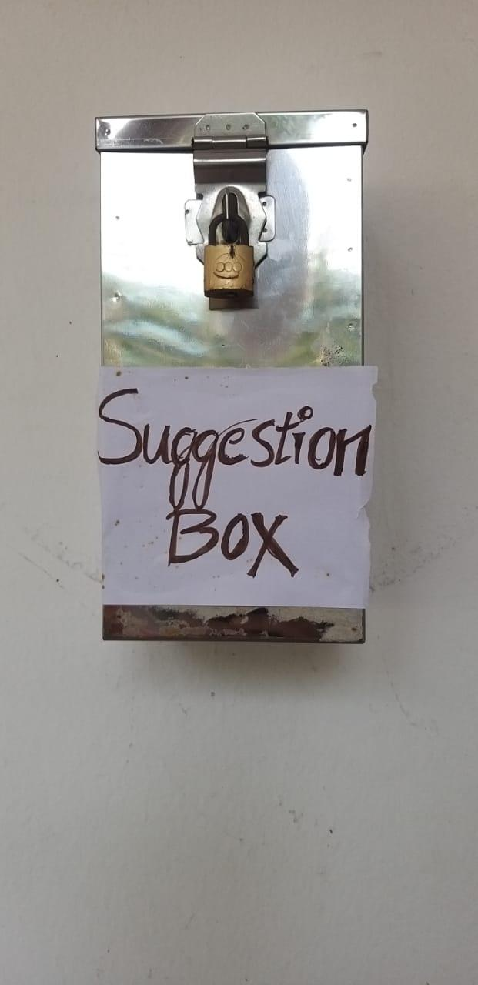

Suggestion box will be opened by Principal Vice Principal and college council members .

Every second Saturday this box will be open