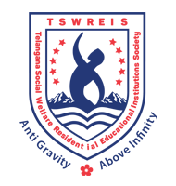**OFFICE OF THE PRINCIPAL**

**TELANGANA SOCIAL WELFARE RESIDENTIAL DEGREE**

**& PG COLLEGE FOR WOMEN IBRAHIMPATNAM**

**AT ANKUSHAPUR**

**College Code: 61527 OU College Code : 2814**

**Dr H Radhika *Mcom, MBA, NET, SET, Ph.D***

**E-mail:prl-rdc-ibpm-swrs@telangana.gov.in**

**PRINCIPAL Mobile No.: 9121004526**

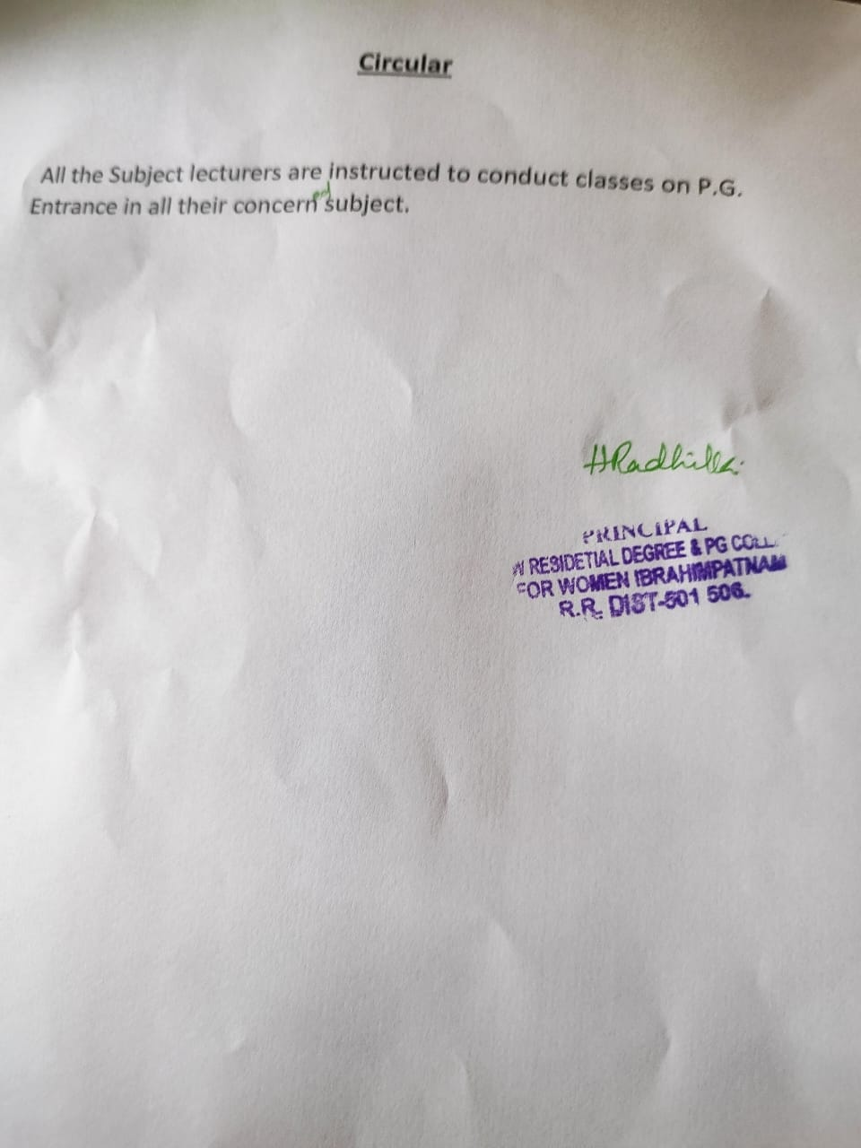

PG CLASSES COACHING

