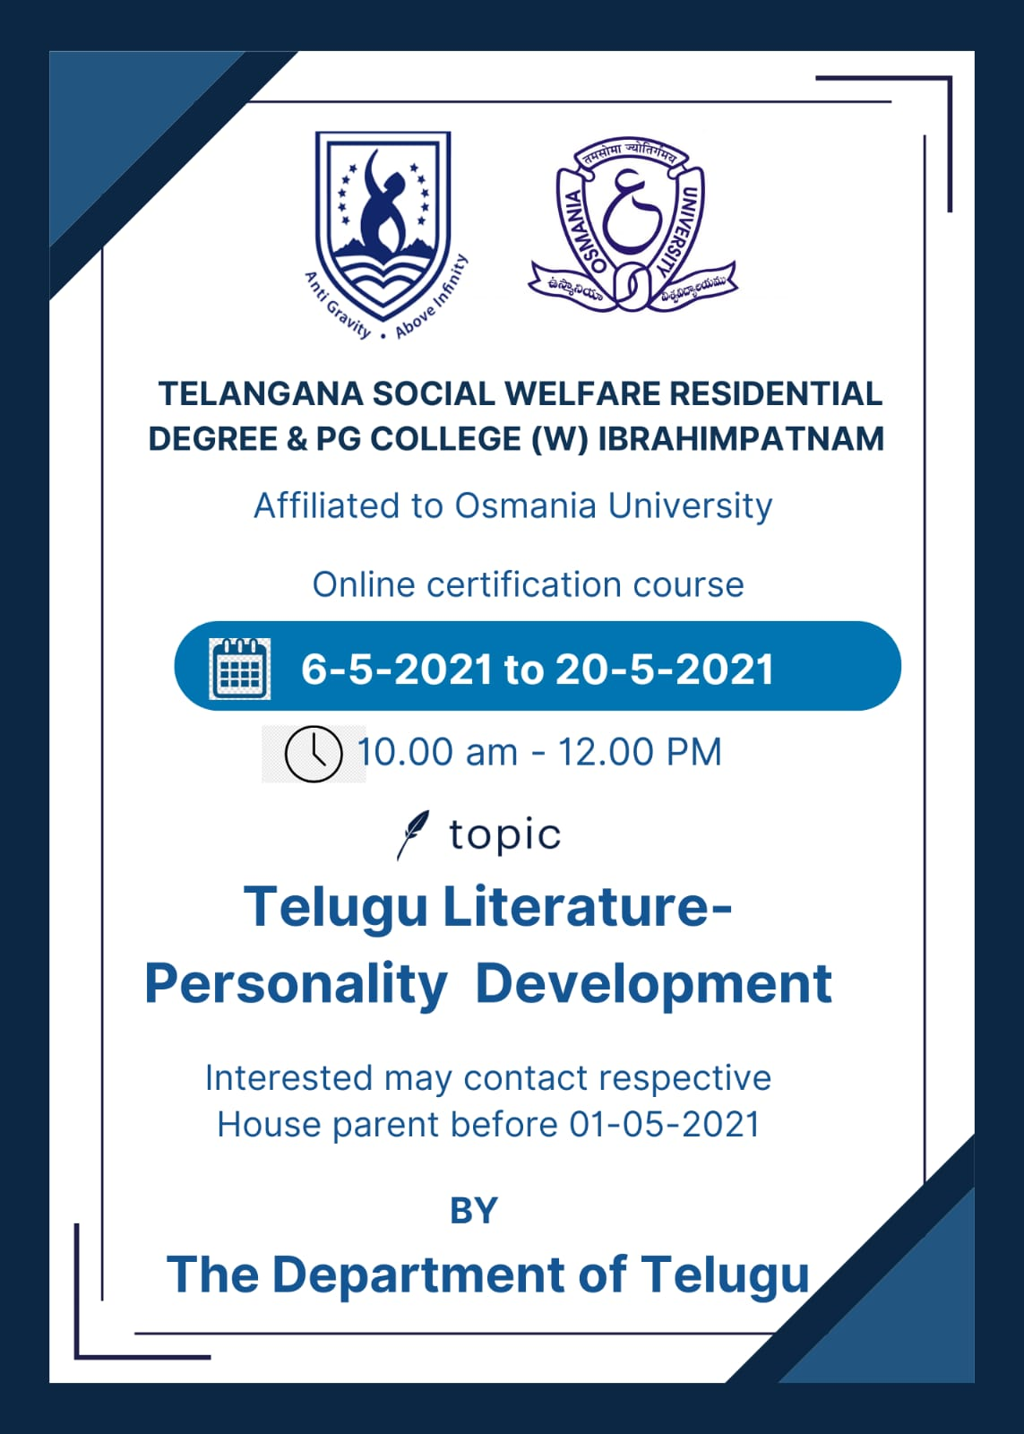

**Outcomes of the 15-Day Certificate Course on Telugu Literature and Personality Development**

Understanding Literature as Social Welfare: Literature is perceived as a means for societal well-being, aiming to create a world filled with values.

Introduction to Oral Literature:

Oral literature involves one person speaking and another listening. For example, children learn values even from lullabies like "Jo Achyutananda Jo Jo Mukunda."

Written Literature: Books like "Sahiti Manjeera," "Sahiti Kinnera," and "Sahiti Dundubhi" contain significant aspects of personality development. Literature nurtures the mind.

Cultural Values in Telugu

Literature: Telugu literature is rich with values, reflected in our festivals and celebrations, such as Bathukamma and Bonalu. Stories often contain elements of personality development.

Development Through

Education: Development equates to enlightenment, primarily achieved through education.

Nature as the First Teacher: Nature, books, parents, and teachers all serve as guides.

The Importance of Education: Among donations of food, clothing, and shelter, the donation of education is the greatest. Education leads to mental growth.

Personality Development in Ancient and Modern Literature:

Both ancient and modern literature encompass aspects of personality development. For instance, "Gajendra Moksha" and the eloquence of Dharmaraju teach various facets of personal growth.

Patriotism and Personal Development: Patriotism involves caring for one another. Through personal development, students can become exemplary citizens.

These are the lessons students learn through the "Telugu Literature and Personality Development" course.

**Syllabus for the certificate course:**

Literature that teaches well-being.

Analysis of Oral Literature.

The deeper meaning in lullabies.

Explanation of Written Literature.

Personality development in your Telugu textbooks.

What is culture?

The deeper meaning in festivals.

Personality development in ancient literature.

Patriotism in modern literature.

Literature that helps in becoming exemplary citizens.

The connection between literature and society.

Language, literature, and society.

Patriotism.

Life values.

Personality development as the foundation or national development.

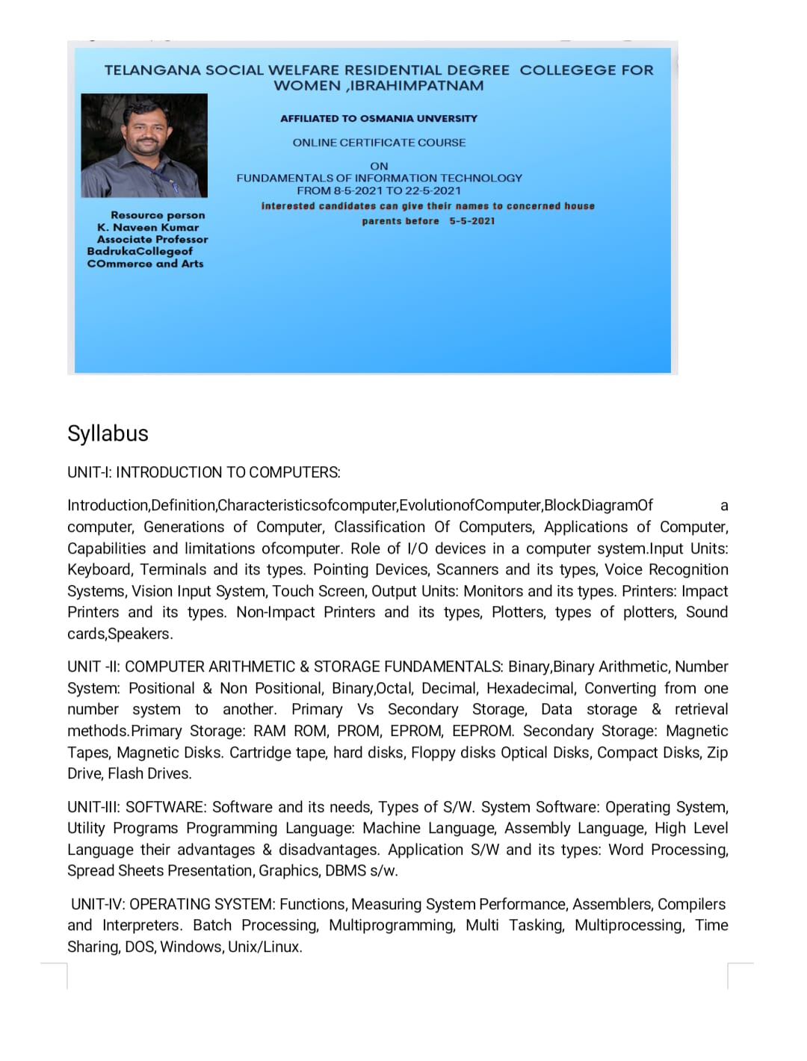

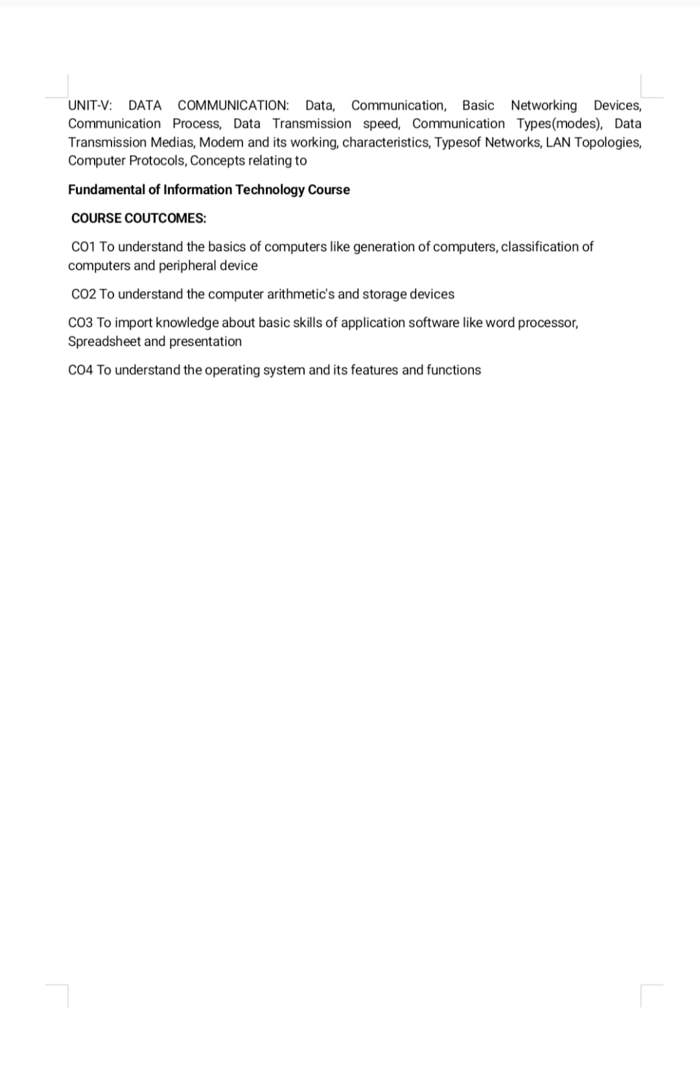

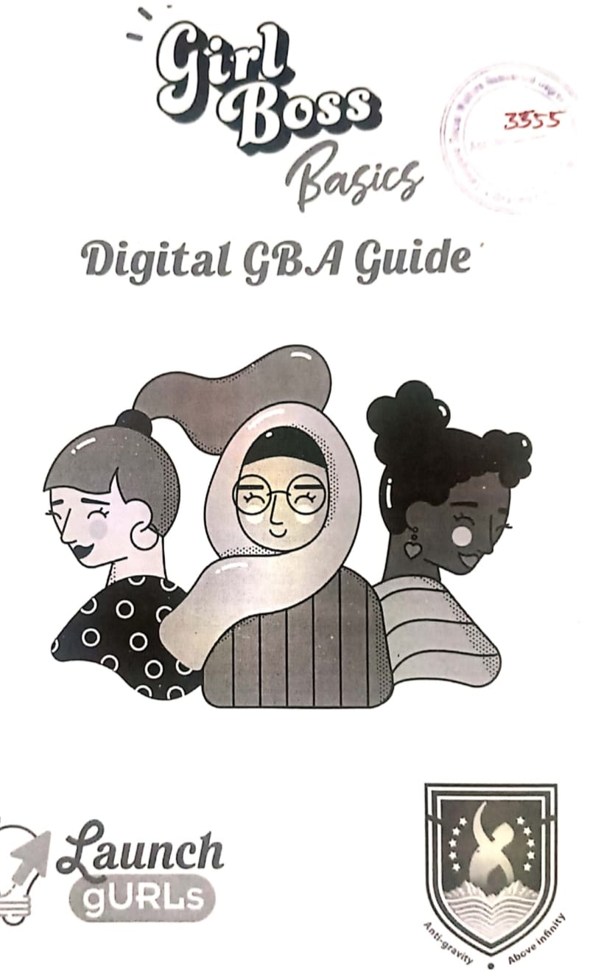

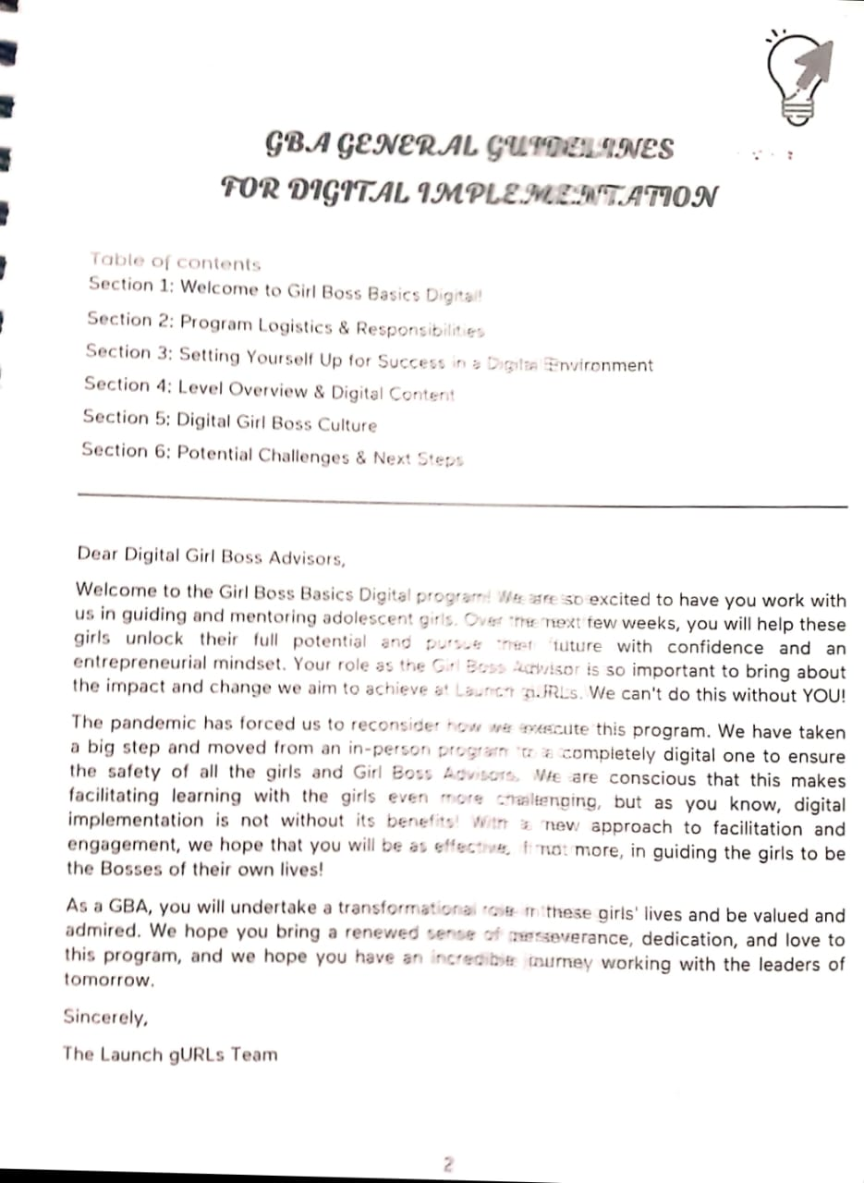

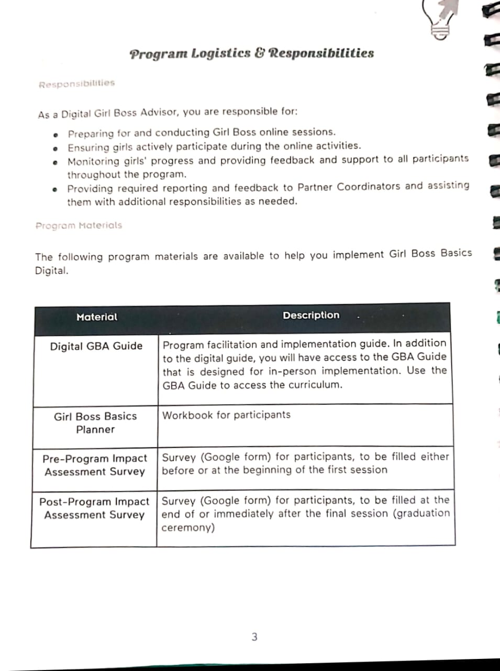

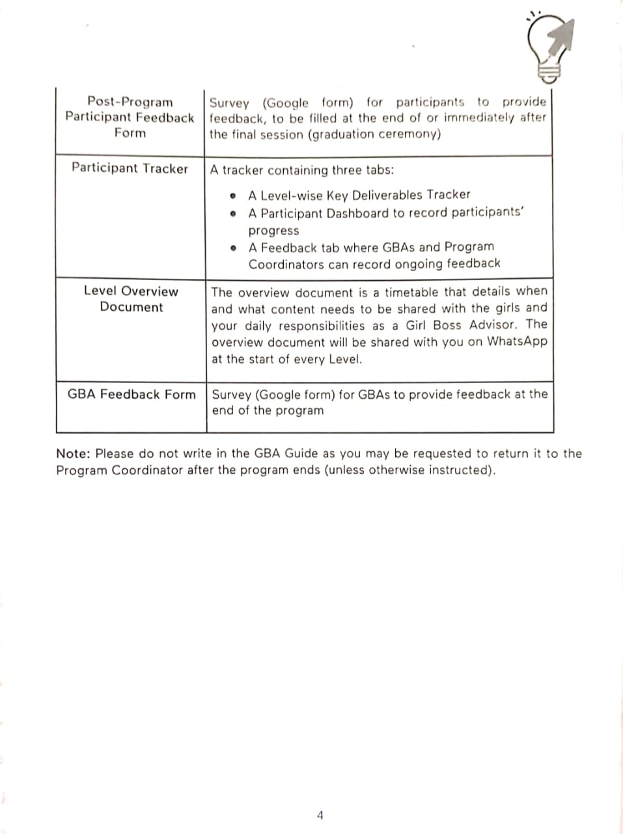

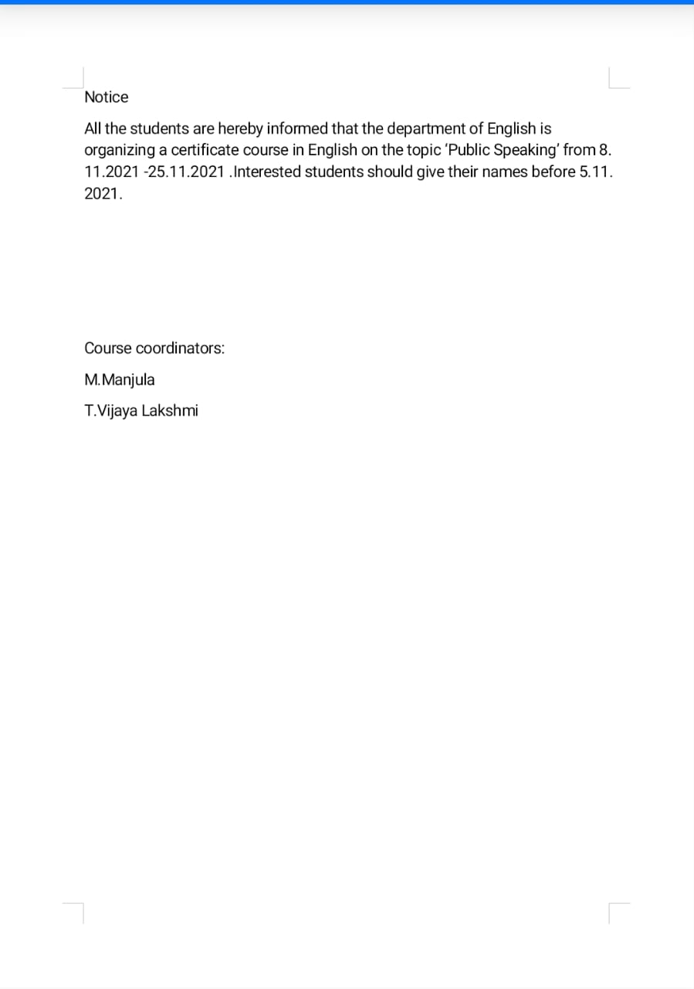

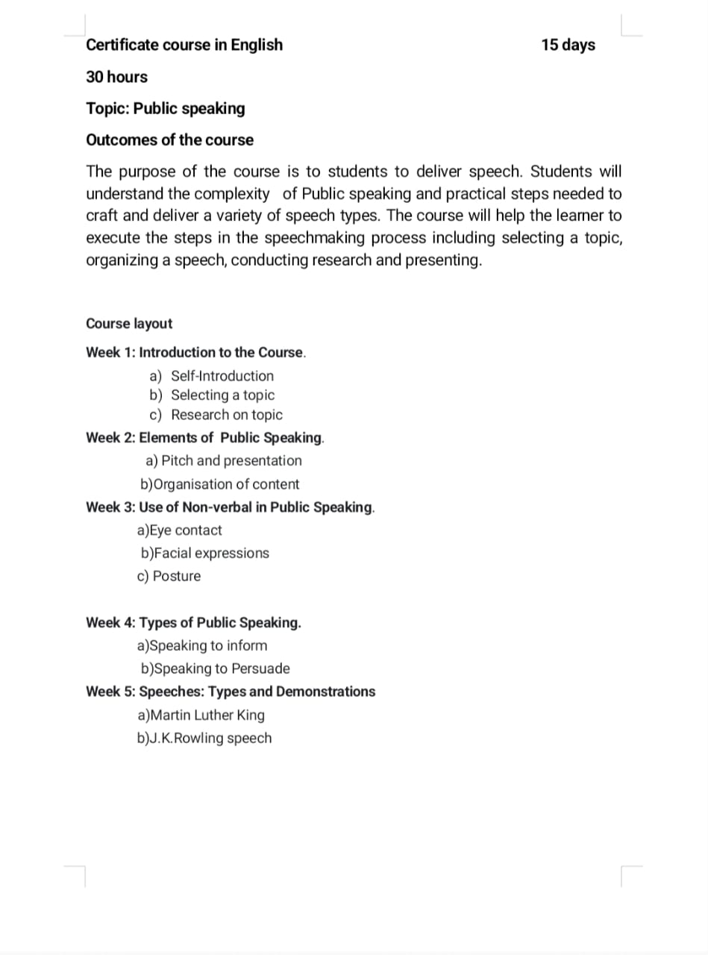

**CIRCULAR**

All the students of B.A are informed that the Department of Economics

is going to organize a 30 hours Certificate Course on the “Financial Literacy” from 08-11-2021 to 24-11-2021. The interested students can register their names on or before 05-11-2021

Department of Economics

R.Rekha

Dr.P.Hemamalini

Financial Literacy Syllabus and Outcomes

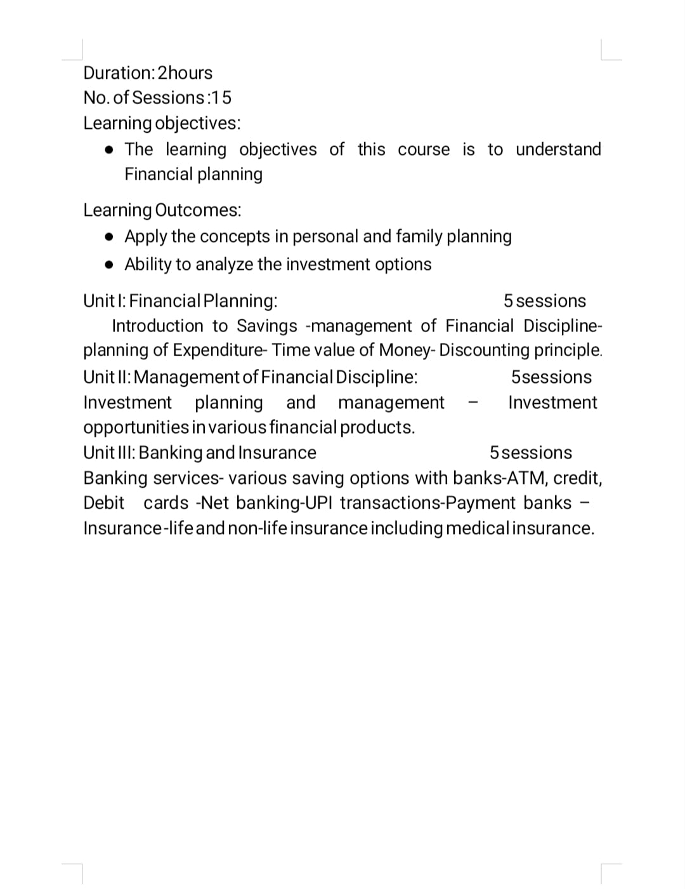

**CIRCULAR**

All the students of B.A are informed that the department of Political Science is going to organize a 30 hours Certificate Course on the “Ethics and Value Education” from 12-09-2022 to 30-09-2022. The interested students can register their names on or before 10-09-2022.

Dr. Vijaya Kota

Head Dept. of Political science

**Telangana Social Welfare Residential Degree and PG College for Women, Ibrahimpatnam**

**Certificate Course on ETHICS AND VALUE EDUCATION**

**From 12-09-2022 To 30-09-2022, 15 days 30 hours**

**Course Objectives:**

⮚ Understand the concept and types of values.

⮚ Learn universal values like moral values, patience, honesty, etc.

⮚ Get and insight into the strategies of inculcation of values among students.

⮚ Develop awareness about the different agencies working in the sphere of value education.

⮚ Gain the Sources of value education.

⮚ It develops the personality of the students.

⮚ The students should develop in all dimensions so that they can serve the nation more democratic, cohesive, socially and responsibly.

**Course Outcomes:**

⮚ Development of good manners and responsibility towards citizenship

⮚ To understand the way of thinking and living

⮚ To give the students a progressive way for their future and also helps them to know the real purpose of their life

⮚ This makes it clear to them, the best way to live life that can be helpful to individuals as well as people around

⮚ Value Education helps students to become more responsive and practical.

⮚ This helps them to better reorganize the perception of life and lead a positive life as responsible resident

⮚ It helps in developing a strong relationship with family and friends.

**Name of the Resource Person:**

Dr.Vijaya Kota - Lecturer in Political Science

**Content of the course:**

**Module I: Scope and Definition (5 hours)**

a. Ethics and Moral Values: Origin & changing definitions

b. Scope of Ethics and Moral Values

c. Significance of Ethics and Moral Values.

**Module II: Values and Ethics in Modern Western thought (8 hours)**

a. Modern Western thoughts of 19th and 20th century:

b. Utilitarian view

c. Kantian approach

d. Moral and Political Philosophy of Thomas Hobbes

e. Ethics of Hegel and Karl Marx.

**Module III: Values and Ethics in Modern Indian thought (10 hours)**

a. Modern Indian approach to Values and Ethics:

b. Raja Ram Mohan Roy

c. Swami Vivekananda

d. Jyotiba Phule and Savitribai Phule

e. Acharya Jagadish Chandra Bose

f. Mahatma Gandhi

g. B.R. Ambedkar

**Module IV: Ethics, Moral Values and Culture (8 hours)**

a. Values and Ethics represented in Children’s literature: Fairy Tales etc.

b. Importance of values and ethics in myth, fables and folk lore

c. Literature, Morality and recent trends.

**Module V: Social Ethics (9 hours)**

a. Definition

b. Importance of values and ethics in developing psychological balance for a healthy society

c. Importance of harmony in the society, adjustment in the domestic sphere

d. Social Work/Charitable efforts

e. Concept of Justice and Equality

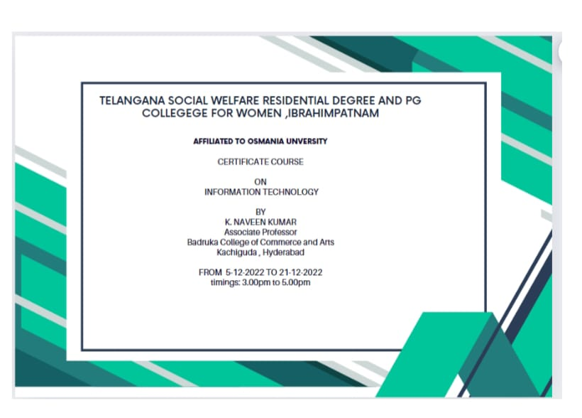

**Syllabus of Information Technology**

UNIT-I: INTRODUCTION: Introduction to computers - Generations of computers – An overview of computer system - Types of computers - Input & Output Devices. Hardware: Basic components of a computer system - Control unit – ALU - Input/output functions - Memory – RAM – ROM – EPROM - PROM and Other types of memory.

UNIT-II: OPERATING SYSTEM (OS): Meaning - Definition & Functions - Types of OS - Booting process - DOS – Commands (internal & external) - Wild card characters – Virus & Hackers – Cryptography & cryptology. Windows: Using the Start Menu –Control Panel – Using multiple windows – Customizing the Desktop – Windows accessories (Preferably latest version of windows or Linux Ubuntu).

UNIT-III: WORD PROCESSING: Application of word processing - Menus & Tool Bars - Word processor – Creating – Entering - Saving & printing the document - Editing & Formatting Text - Mail Merge and Macros (Preferably latest version of MS Word or Libre Office Writer).

UNIT-IV: SPREAD SHEET: Application of work sheet/spread sheet - Menus & Tool bars - Creating a worksheet - Entering and editing of numbers - Cell reference - Worksheet to analyze data with graphs & Charts. Advanced tools: Functions – Formulae – Formatting numbers - Macros – Sorting - Filtering - Validation & Consolidation of Data (Preferably latest version of MS Excel or Libre Office Calc).

UNIT-V: POWER POINT PRESENTATION: Application of Power Point Presentation – Menus & Tool bars – Creating presentations – Adding - Editing and deleting slides - Templates and manually – Slide show – Saving - Opening and closing a Presentation –Types of slides - Slide Views - Formatting – Insertion of Objects and Charts in slides - Custom Animation and Transition (Preferably latest version of MS Power Point presentation - Libre Office Impress). Internet & Browsing: Services available on internet – WWW – ISP – Browsers. Multimedia: Application of multimedia – Images – Graphics - Audio and Video – IT security.

Information Technology-

COURSE OUTCOMES:

CO1 Students are able to prepare a 10 minute presentation on various basic concepts of Computers suitable for a student seminar.

CO2 Difference between an operating system and an application program

CO3 Describe the role of information technology and information systems in business

CO4 Relate the current issues of information technology to the firm

CO5 Understand the leadership role of Management Information Systems in achieving business competitive advantage through informed decision-making.

CO6 Effectively communicate various alternatives to facilitate decision-making.

CO7 Get familiar with various functions of multimedia

CO8 Describe different realisations of multimedia tools and the way in which they are used

CO9 Understand the various types of Office management Applications

CO10 Understanding of how the different categories of Office Management Applications function in real life

CO11 A detailed knowledge of database management systems, their uses and their benefits

**CIRCULAR**

All the students of B.A are informed that the department of Sociology is going to organize a 30 hours Certificate Course on the “NGO MANAGEMENT” from 1-11-2022 to 17-11-2022. The interested students can register their names on or before 29-10-2022.

G.SOUJANYA

Head of The Department

Sociology

**Telangana Social Welfare Residential Degree and PG College for Women, Ibrahimpatnam**

**Certificate Course on NGO MANAGEMENT**

**From 1-11-2022 To 17-11-2022, 15 days 30 hours**

**Course Objectives:**

To introduce the students to NGO Sector and provide an overview of NGOs to provide basic managerial skills for NGO personal

**Course Outcomes**

CO1: Understand the concept of NGO. its types and registration procedure

CO2: Ability to critically analyse challenges faced by NGOS

CO3 Develop Knowledge & skills with regards to fund raise strategies

CO4: Analyse the various schemes provided by the government.

CO5: Understand the process of projects and its management.

**NGO MANAGEMENT**

**SYLLABUS**

**Unit-I: ( 15 HOURS )**

Concept of Volunteerism: Charity, Welfare and Development - Non-Governmental Organization (NGO): Its Characteristics, Types, Functions, Approaches and Models – Legal Framework for Establishment of NGO - Vision, Mission and Goals of NGOs - Resource Mobilization: Methods and Techniques of Fund Raising - Rules and Regulations of Income Tax Exemption (80-G, 12-A, & 35AC) - Foreign Contributions and Regulation Act (FCRA).

**Unit-II: ( 15 HOURS )**

NGO Management: Staffing, Recruiting, Induction and Training - Office Procedure and Documentation - Basics of Accounting – Budgeting. Project Management: Identification – Need Assessment – Problem Tree - Formulation Project Proposal - Project Appraisal: Technical, Economic and Financial Feasibility. Project Management in NGO: Projects Implementation, Monitoring and Evaluation (PERT, CPM, PRA/PLA, SWOT).

**References:**

Clark John. (1991): Voluntary Organizations: Their Contribution to Development. London: Earth Scan.

Jain R.B. (1995): NGOs in Development Perspective. New Delhi: Vivek Prakasan

Sakararan and Rodrigues. (1983): Handbook for the Management of Voluntary Organization. Madras: Alfa

Joel S.G.R Bhose. (2003): NGOs and Rural Development Theory and Practice. New Delhi: Concept.

Julie Fisher. (2003): Non-Governments – NGOs and the Political Development of the Third World. New Delhi: Rawat

Ginsbery Leon. H. (2001): Social Work Evaluation – Principles and Methods. Singapore: Allyn and Bacon.