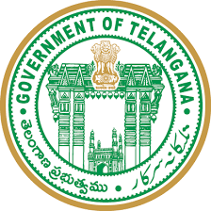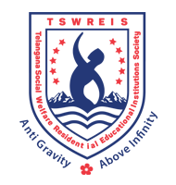

**OFFICE OF THE PRINCIPAL**

**TELANGANA SOCIAL WELFARE RESIDENTIAL DEGREE**

**& PG COLLEGE FOR WOMEN IBRAHIMPATNAM**

**AT ANKUSHAPUR**

**College Code: 61527 OU College Code : 2814**

**Dr H Radhika *Mcom, MBA, NET, SET, Ph.D***

**E-mail:prl-rdc-ibpm-swrs@telangana.gov.in**

**PRINCIPAL Mobile No.: 9121004526**

**3.2.2.1 Total Number of Workshops/seminars/conferences including on Research Methodology, Intellectual Property Rights (IPR)and entrepreneurship conducted last five years**

**Webinar conducted by Economics Department**

# On Severity of COVID-19 pandemic in India | Prof. S. Indrakant

**Date 19th June 2020**

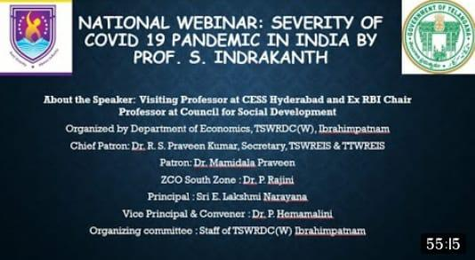

Session link <https://www.youtube.com/live/_PKDb8tgJ04?feature=share>

**Workshop conducted by Economics Department**

**5days 7th September to 11th September 2020**

**On Stistics for Economics Introduction to Stistics**

**Day 1:**

**Link** [**https://youtu.be/JxQWU0akHKA**](https://youtu.be/JxQWU0akHKA)

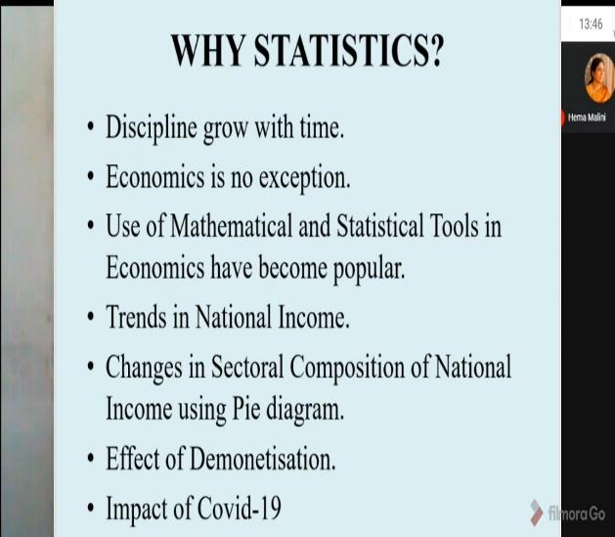 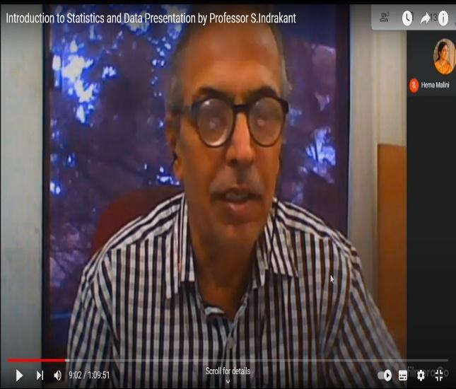

**Day 2**

**Link:** [**https://youtu.be/j5OifXQAqkc**](https://youtu.be/j5OifXQAqkc)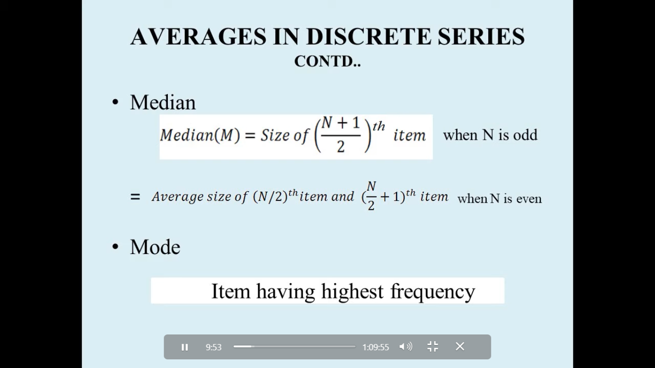

**Day 3**

**Link:** [**https://youtu.be/Tpz8UJjHkpA**](https://youtu.be/Tpz8UJjHkpA)

[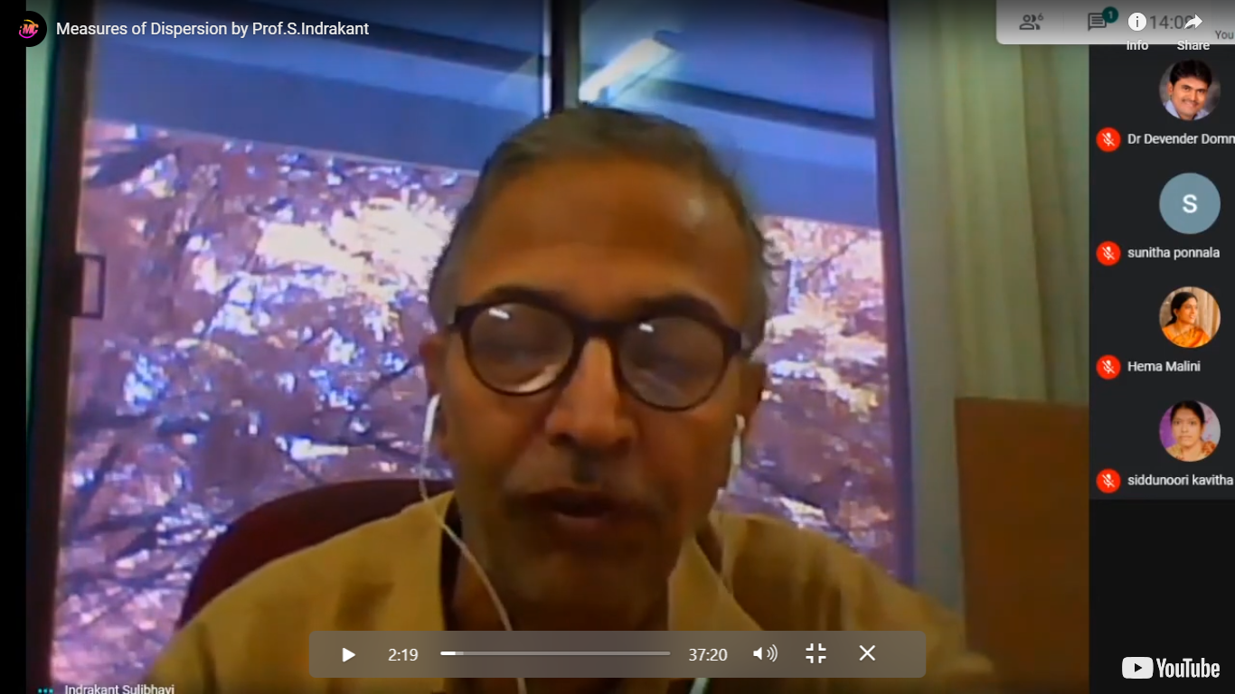](https://youtu.be/j5OifXQAqkc)

**Day 4**

**Link:** [**https://youtu.be/KoiTfAJN_08**](https://youtu.be/KoiTfAJN_08)

**Day 5**

**Link** [**https://youtu.be/eFLshXgIohY**](https://youtu.be/eFLshXgIohY)

**Webinar conducted by Economics Department**

**On Investing in Mutual Funds- Risks and Rewards**

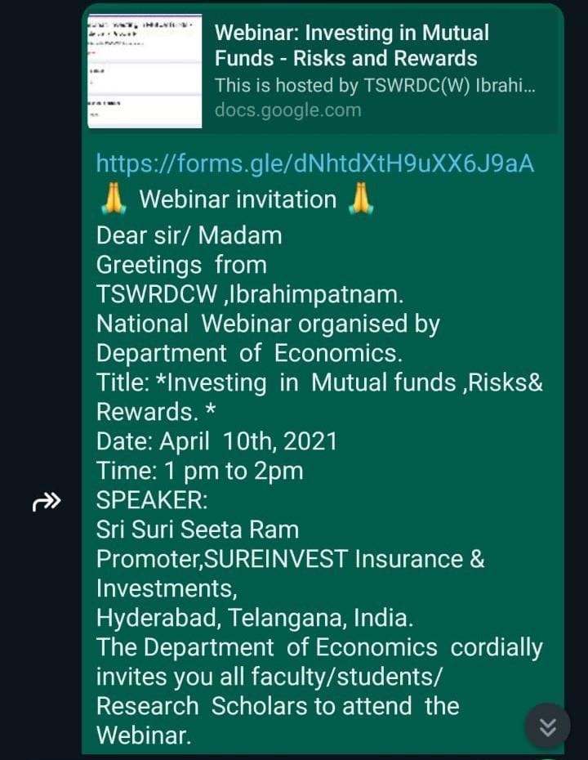**Date 10th April 2021**

**Webinar conducted by Telugu Department**

**Date 29-04-2021**

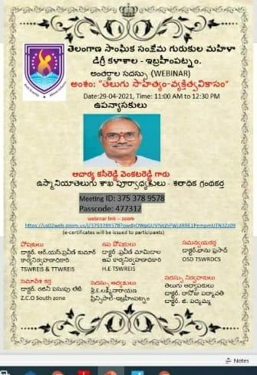

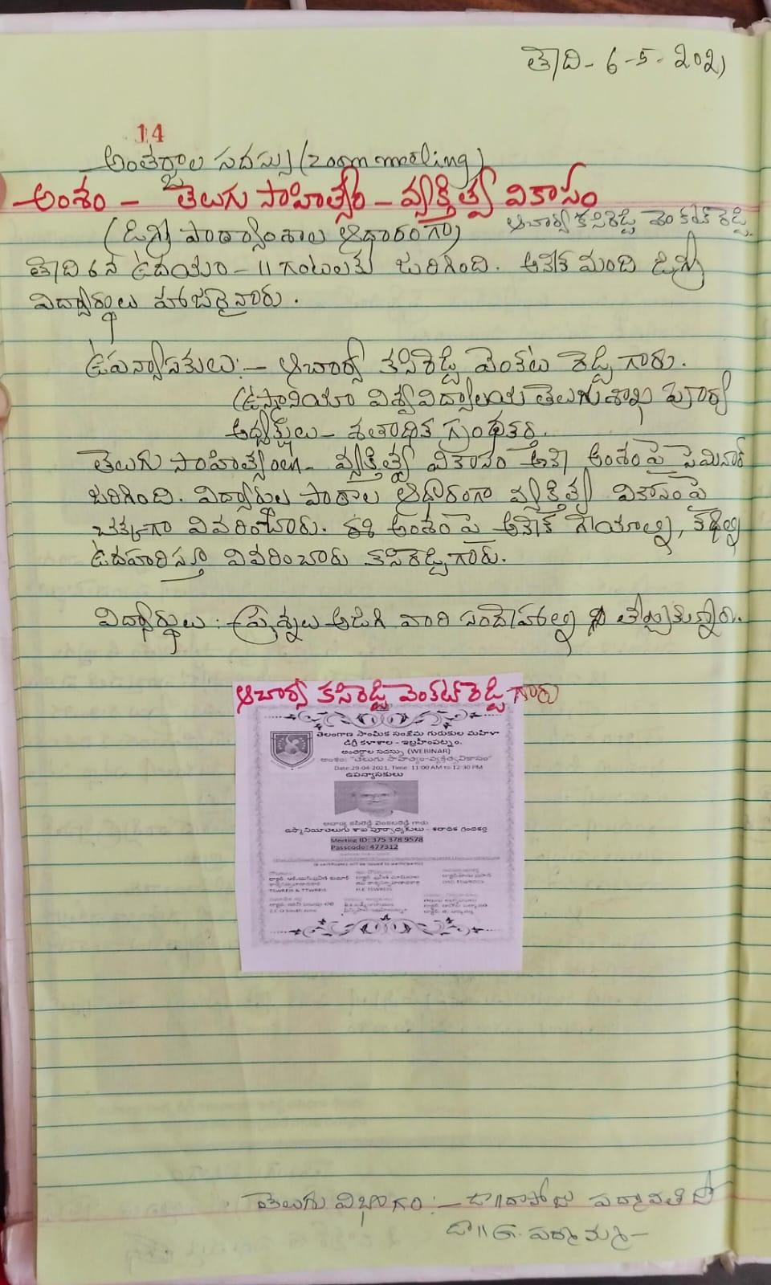

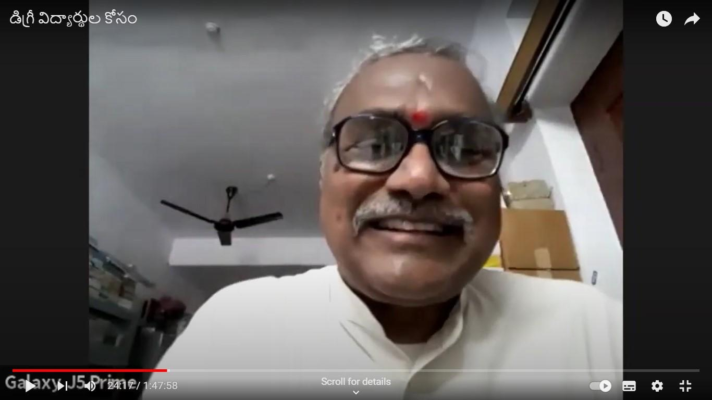

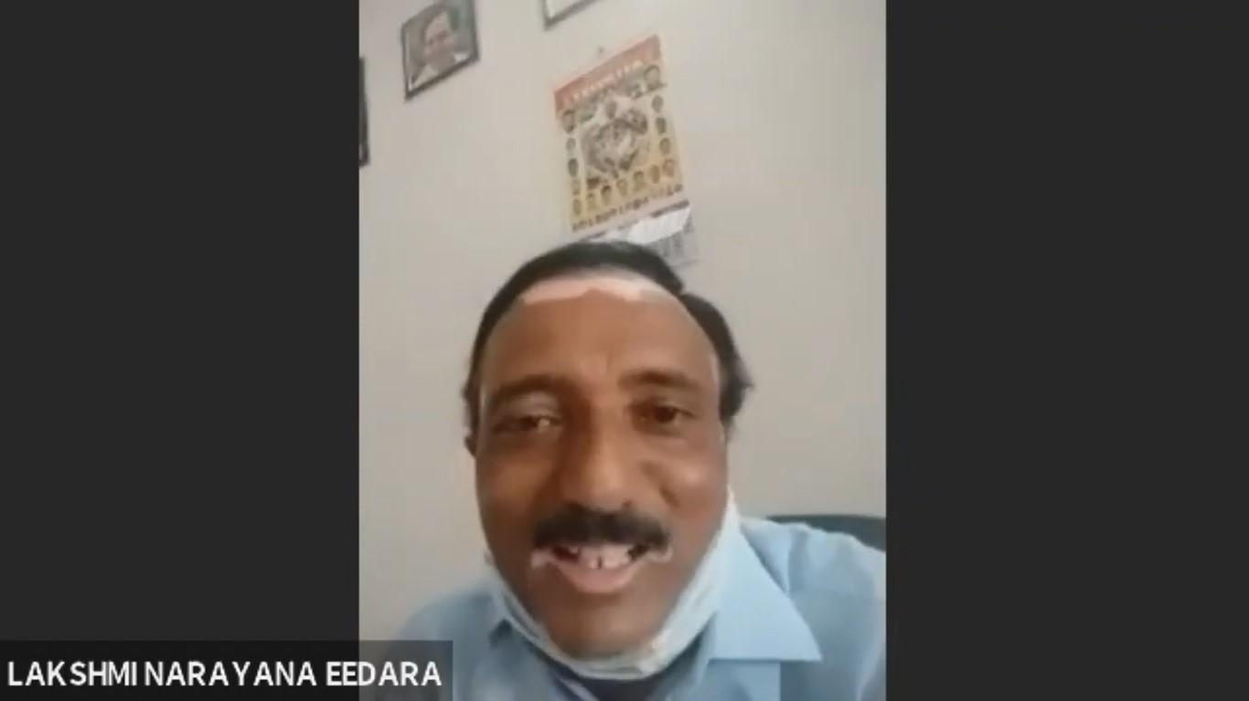

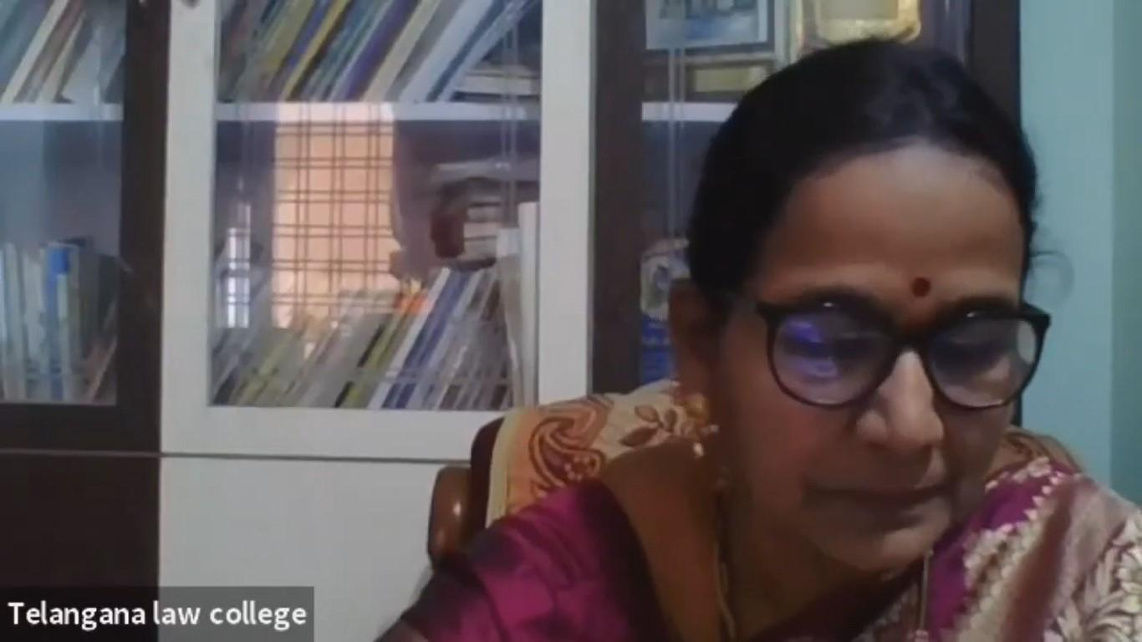

Orientation Programme for PG Teachers, Dept of English, OU

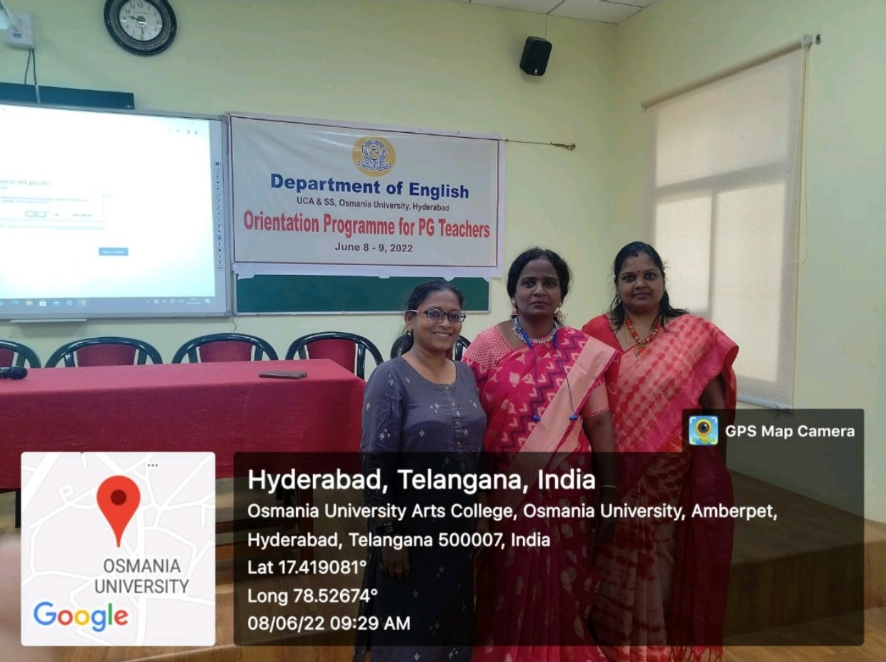

International Seminar On Higher Education - Global Perspectives and Challenges

