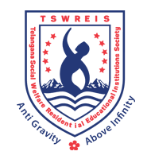**OFFICE OF THE PRINCIPAL**

**TELANGANA SOCIAL WELFARE RESIDENTIAL DEGREE**

**& PG COLLEGE FOR WOMEN IBRAHIMPATNAM**

**AT ANKUSHAPUR**

**College Code: 61527 OU College Code : 2814**

**Dr H Radhika**

***Mcom, MBA, NET, SET, Ph.D***

**E-mail:prl-rdc-ibp-swrs@telangana.gov.in**

**PRINCIPAL Mobile No.: 9121004526**

TSWRDC & PGCW, Ibrahimpatnam



**OFFICE OF THE PRINCIPAL**

**TELANGANA SOCIAL WELFARE RESIDENTIAL DEGREE**

**& PG COLLEGE FOR WOMEN IBRAHIMPATNAM**

**AT ANKUSHAPUR**

**College Code: 61527 OU College Code : 2814**

GUEST LECTURE

18.04.2023

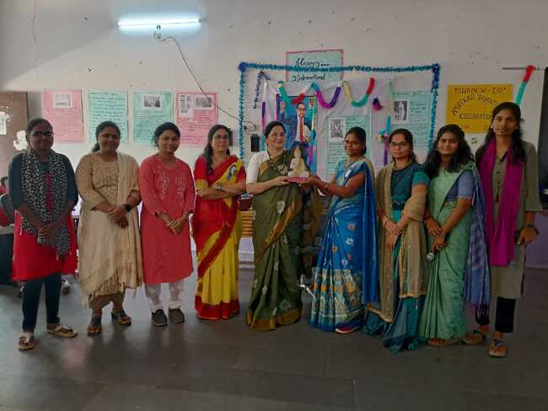

A guest lecture was organized by the department of Political Science as a part of Ambedkar Jayanthi celebrations. The guest of honor was Dr.Pragnya mam,Professor from Gitam University, Vizag.



**OFFICE OF THE PRINCIPAL**

**TELANGANA SOCIAL WELFARE RESIDENTIAL DEGREE**

**& PG COLLEGE FOR WOMEN IBRAHIMPATNAM**

**AT ANKUSHAPUR**

**College Code: 61527 OU College Code : 2814**

Motivational seminar

20.07.2023

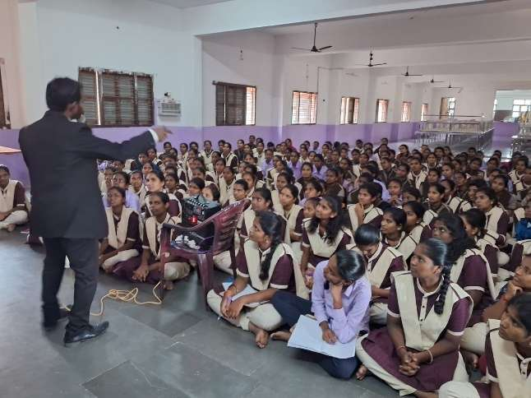 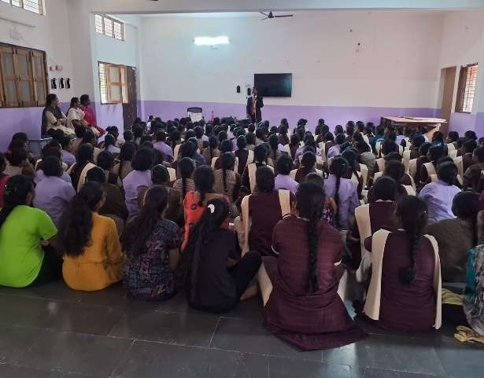

A motivation seminar on Stress management and How to succeed in life by Mr. Laxmi Mahesh.



** OFFICE OF THE PRINCIPAL**

**TELANGANA SOCIAL WELFARE RESIDENTIAL DEGREE & PG**

**COLLEGE FOR WOMEN IBRAHIMPATNAM**

**AT ANKUSHAPUR**

**College Code: 61527 OU College Code : 2814**

Farewell ceremony

27.07.2023

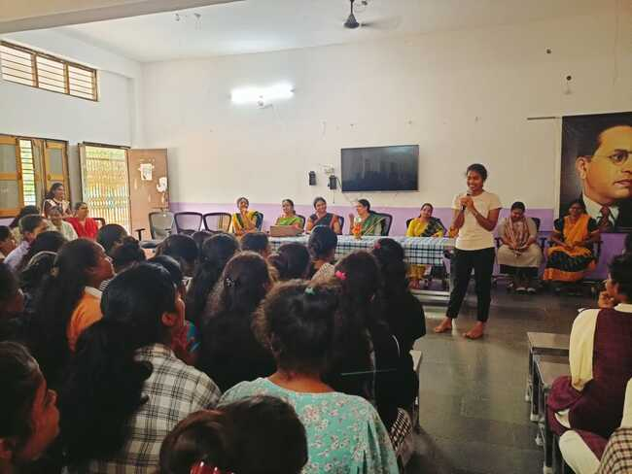 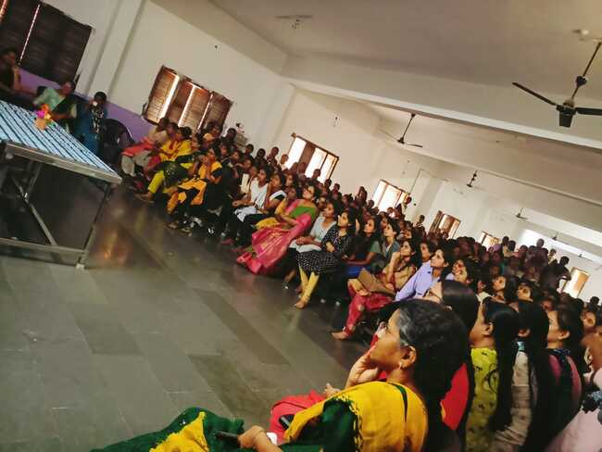

**FAREWELL, doesn’t mean a good-bye,but infact welcomes the new beginnings. From being together to getting apart will be quite emotional, but it’s a mere fact that nothing is permanent .**

**LIFE HAS TO MOVE ON……**



**OFFICE OF THE PRINCIPAL**

**TELANGANA SOCIAL WELFARE RESIDENTIAL DEGREE**

**& PG COLLEGE FOR WOMEN IBRAHIMPATNAM**

**AT ANKUSHAPUR**

**College Code: 61527 OU College Code : 2814**

CoUNCIL ELECTIONS

02.08.2023

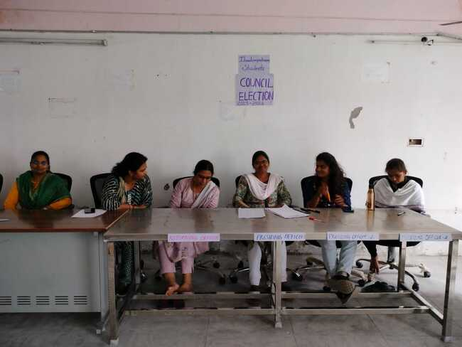

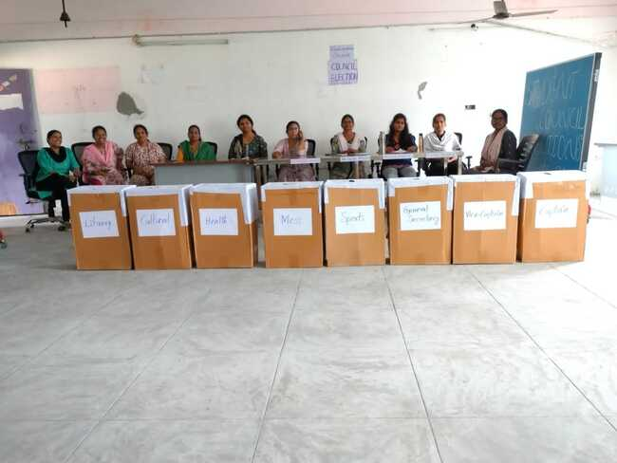

Student Council play a major role in communicating as well as acting as a bridge between the students and staff.The Student council elections were conducted to elect the college council for the smooth functioning of the institution.



**OFFICE OF THE PRINCIPAL**

**TELANGANA SOCIAL WELFARE RESIDENTIAL DEGREE**

**& PG COLLEGE FOR WOMEN IBRAHIMPATNAM**

**AT ANKUSHAPUR**

**College Code: 61527 OU College Code : 2814**

WEBINAR

07.08.2023



A webinar was conducted to all the final year students on career counselling and oppurtunities in the present society.



** OFFICE OF THE PRINCIPAL**

**TELANGANA SOCIAL WELFARE RESIDENTIAL DEGREE & PG**

**COLLEGE FOR WOMEN IBRAHIMPATNAM**

**AT ANKUSHAPUR**

**College Code: 61527 OU College Code : 2814**

A Tribute to gaddar

08.08.2023

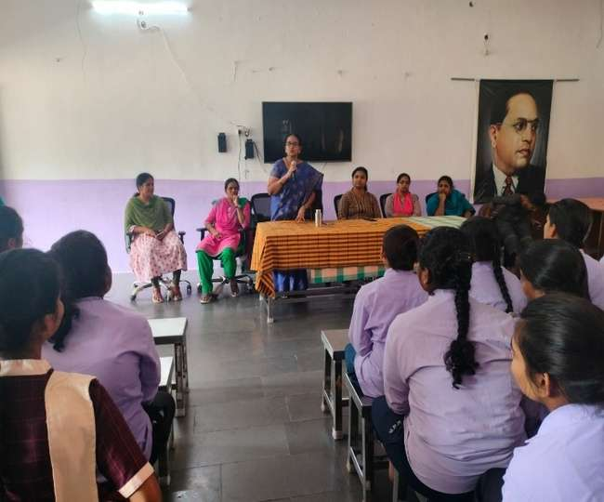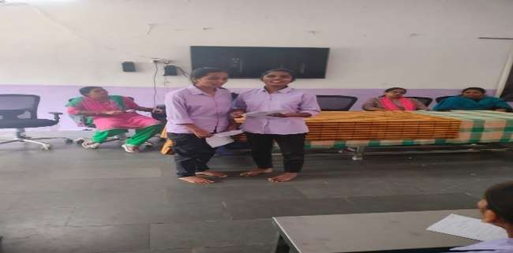

A tribute to GADDAR paid by the staff and students of TSWRDCW,IBRAHIMPATNAM on his sudden demise. Remembering his struggle and his role in the formation of Telangana state.



** OFFICE OF THE PRINCIPAL**

**TELANGANA SOCIAL WELFARE RESIDENTIAL DEGREE & PG**

**COLLEGE FOR WOMEN IBRAHIMPATNAM**

**AT ANKUSHAPUR**

**College Code: 61527 OU College Code : 2814**

INDEPENDENCE DAY CELEBRATIONS

15.08.2023

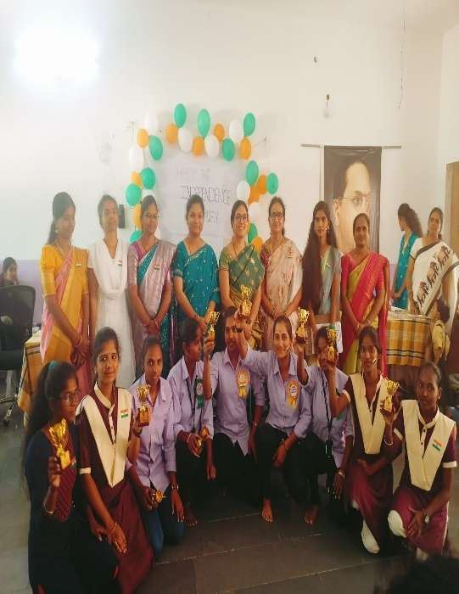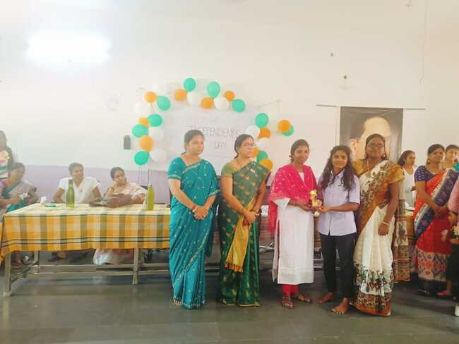

As we celebrate the victory of our independence every year on 15,August every year various competitions will be conducted for the students and will be hoisting the national flag.



** OFFICE OF THE PRINCIPAL**

**TELANGANA SOCIAL WELFARE RESIDENTIAL DEGREE & PG**

**COLLEGE FOR WOMEN IBRAHIMPATNAM**

**AT ANKUSHAPUR**

**College Code: 61527 OU College Code : 2814**

MOBILE EXHIBITION ON GENE HEALTH

16.08.2023

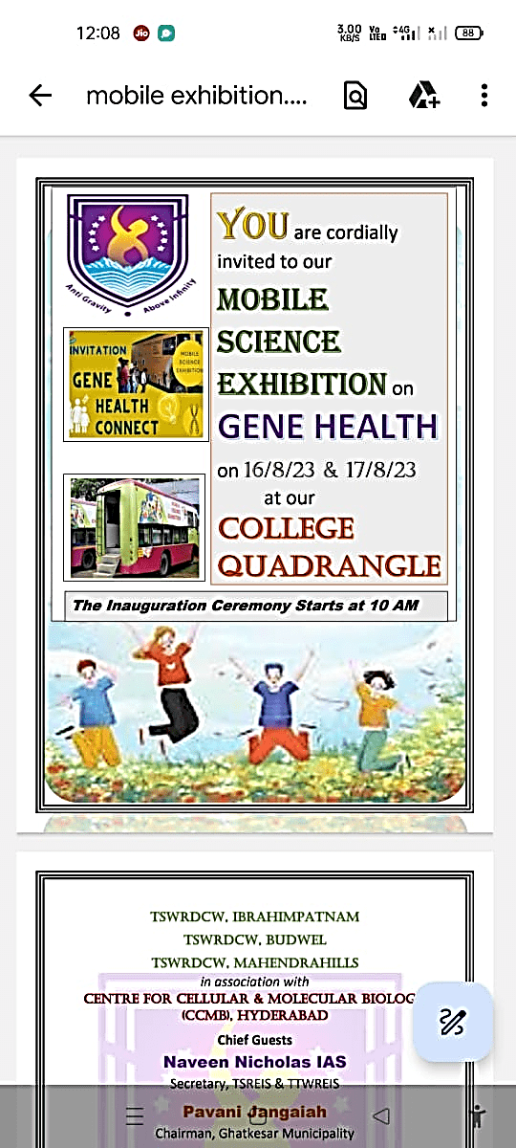

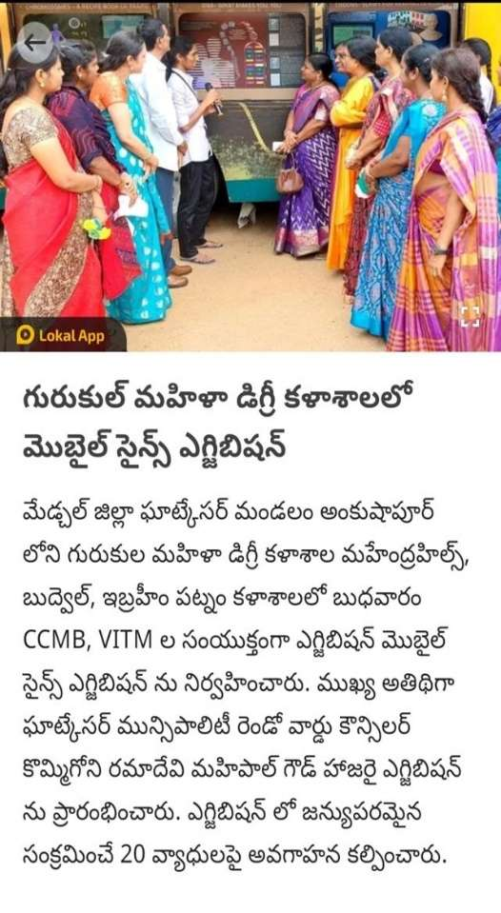



** OFFICE OF THE PRINCIPAL**

**TELANGANA SOCIAL WELFARE RESIDENTIAL DEGREE & PG**

**COLLEGE FOR WOMEN IBRAHIMPATNAM**

**AT ANKUSHAPUR**

**College Code: 61527 OU College Code : 2814**

STUDENT COMPETITIONS

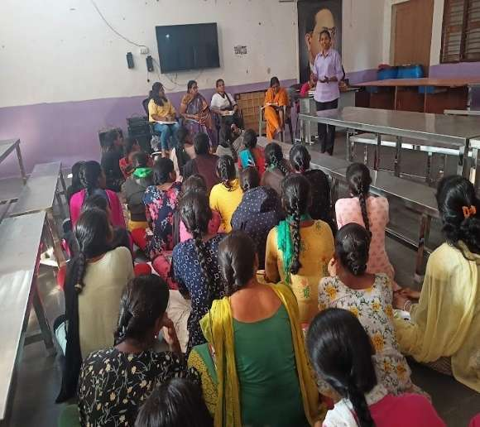 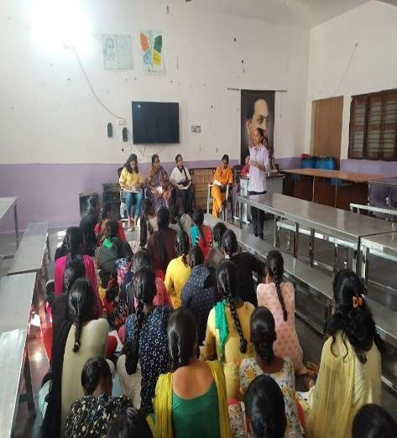



** OFFICE OF THE PRINCIPAL**

**TELANGANA SOCIAL WELFARE RESIDENTIAL DEGREE & PG**

**COLLEGE FOR WOMEN IBRAHIMPATNAM**

**AT ANKUSHAPUR**

**College Code: 61527 OU College Code : 2814**

GUEST LECTURE ON ECONOMICS BY APU

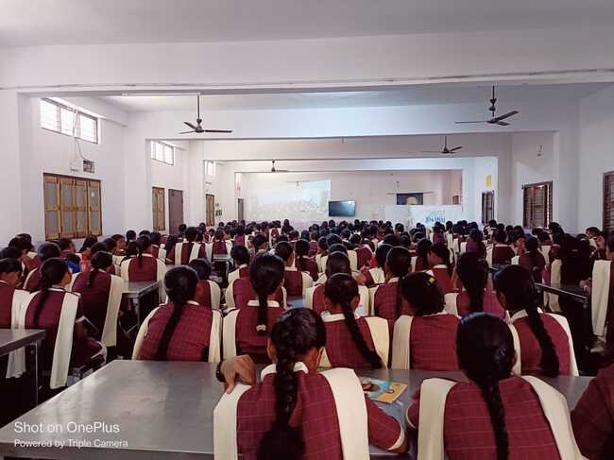

A guest lecture was organized by the research scholars of Azim Premji University on creating awareness on Emerging oppurtunities in Economics in various fields.



** OFFICE OF THE PRINCIPAL**

**TELANGANA SOCIAL WELFARE RESIDENTIAL DEGREE & PG**

**COLLEGE FOR WOMEN IBRAHIMPATNAM**

**AT ANKUSHAPUR**

**College Code: 61527 OU College Code : 2814**

NATIONAL SPORTS DAY

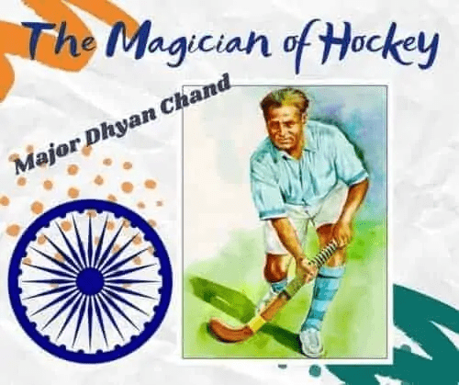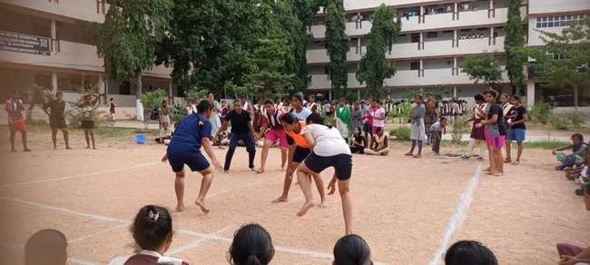

National Sports day will be celebrated on 29th August every year on the remembrance of Major Dhyanchand ,the famous Hockey player.



** OFFICE OF THE PRINCIPAL**

**TELANGANA SOCIAL WELFARE RESIDENTIAL DEGREE & PG**

**COLLEGE FOR WOMEN IBRAHIMPATNAM**

**AT ANKUSHAPUR**

**College Code: 61527 OU College Code : 2814**

FRESHERS PARTY

02.09.2023

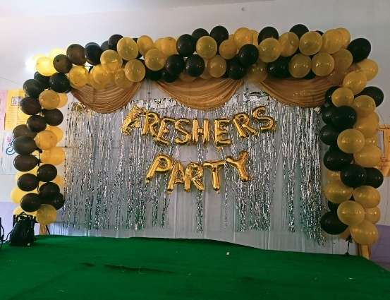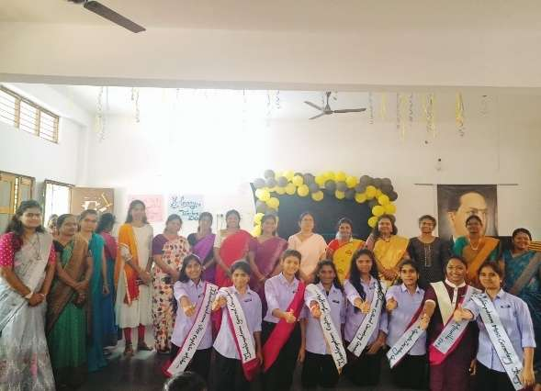

**FRESHERS,** welcoming the newly joined young minds with lots of love and affection and introducing them to the college with utmost responsibility,and also the investiture ceremony of the college council by taking the oath of fulfilling the aims and aspirations of the college.



** OFFICE OF THE PRINCIPAL**

**TELANGANA SOCIAL WELFARE RESIDENTIAL DEGREE & PG**

**COLLEGE FOR WOMEN IBRAHIMPATNAM**

**AT ANKUSHAPUR**

**College Code: 61527 OU College Code : 2814**

TEACHERS DAY celebrations

05.09.2023

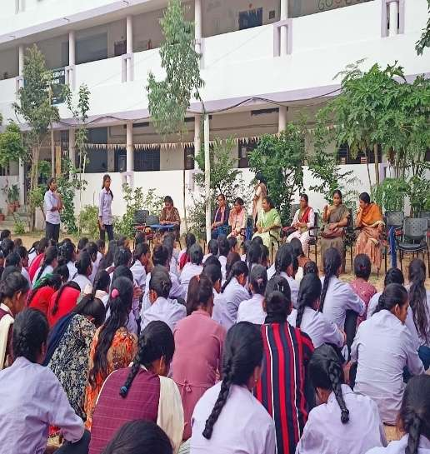 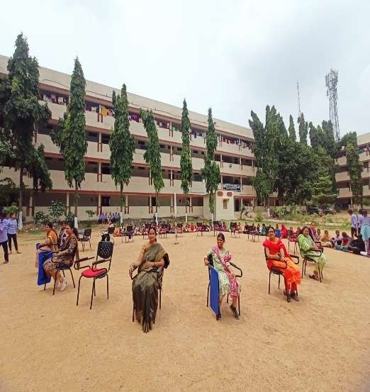

On the remembrance of Dr. Sarvepalli Radhakrishnan we celebrate the teachers day every year on 5th September.



** OFFICE OF THE PRINCIPAL**

**TELANGANA SOCIAL WELFARE RESIDENTIAL DEGREE & PG**

**COLLEGE FOR WOMEN IBRAHIMPATNAM**

**AT ANKUSHAPUR**

**College Code: 61527 OU College Code : 2814**

KRISHNASHTAMI

07.09.2023

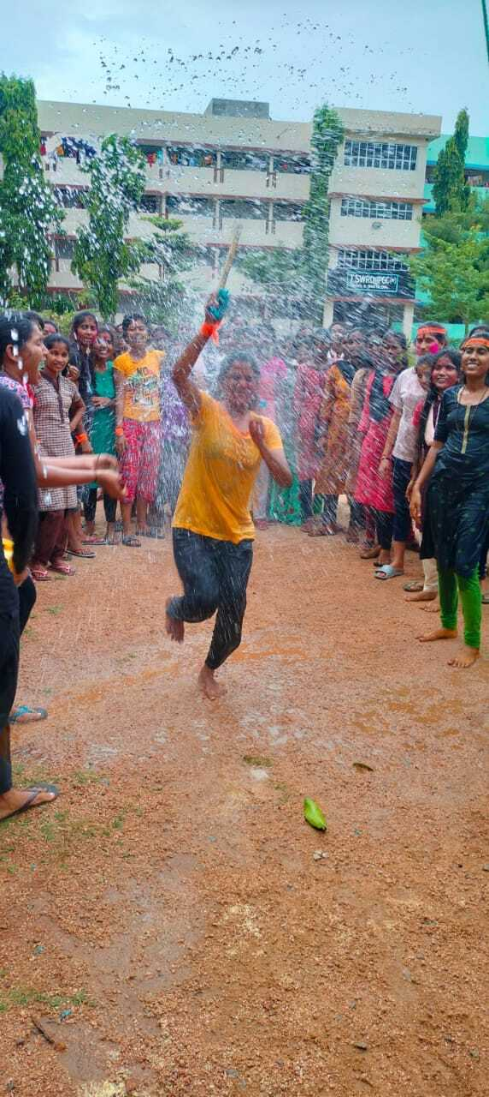

Krishnashtami will be celebrated on the occasion of lord Krishna’s Birth Anniversary. On this day we celebrate the occasion by offering puja and famous UTLA pandaga.



** OFFICE OF THE PRINCIPAL**

**TELANGANA SOCIAL WELFARE RESIDENTIAL DEGREE & PG**

**COLLEGE FOR WOMEN IBRAHIMPATNAM**

**AT ANKUSHAPUR**

**College Code: 61527 OU College Code : 2814**

PARENTS UNION ELECTIONS

09.09.2023

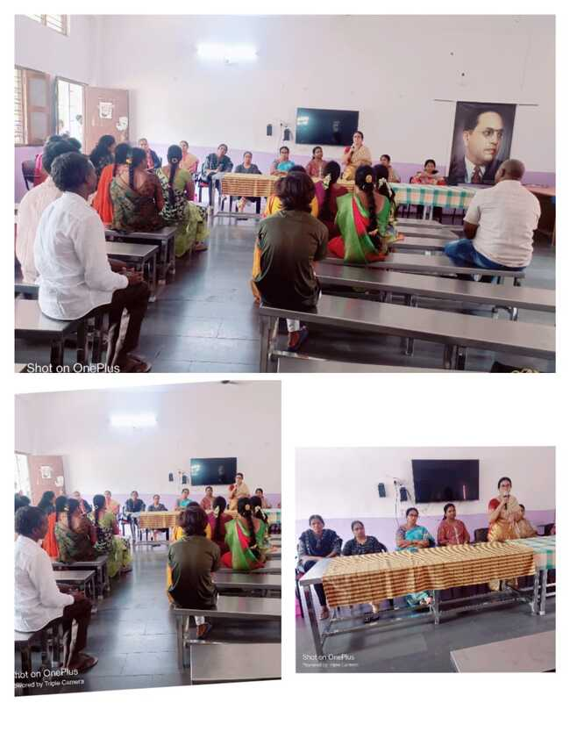Parents Union will be formed every year by electing the parents for various posts like Pre sident,Vice President, General secretary,Treasurer in order to communicate the information on behalf of all the parents for ensuring the smooth functioning of the college.



** OFFICE OF THE PRINCIPAL**

**TELANGANA SOCIAL WELFARE RESIDENTIAL DEGREE & PG**

**COLLEGE FOR WOMEN IBRAHIMPATNAM**

**AT ANKUSHAPUR**

**College Code: 61527 OU College Code : 2814**

PARENTS MEET

09.09.2023

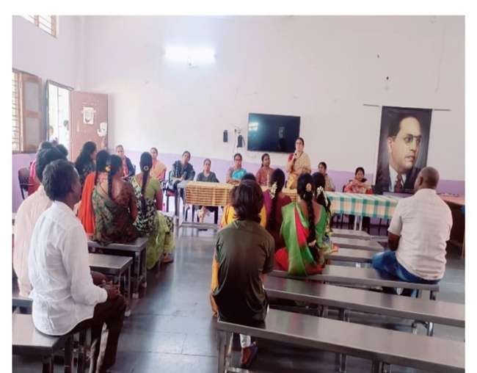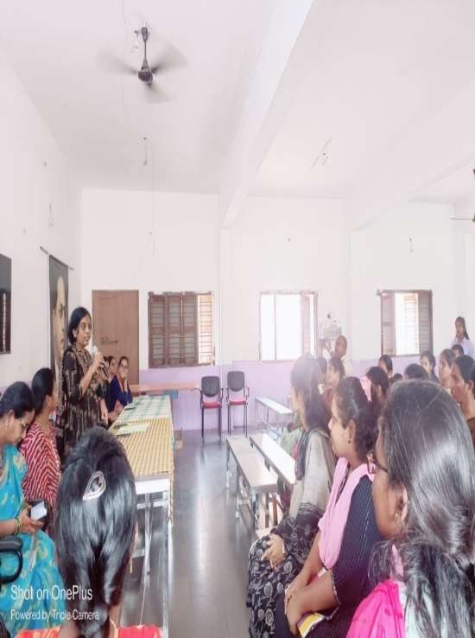

Every 2nd Saturday will be a parents Saturday where parents will be allowed to see their wards and spend time with them.



** OFFICE OF THE PRINCIPAL**

**TELANGANA SOCIAL WELFARE RESIDENTIAL DEGREE & PG**

**COLLEGE FOR WOMEN IBRAHIMPATNAM**

**AT ANKUSHAPUR**

**College Code: 61527 OU College Code : 2814**

ANTI RAGGING

11.09.2023

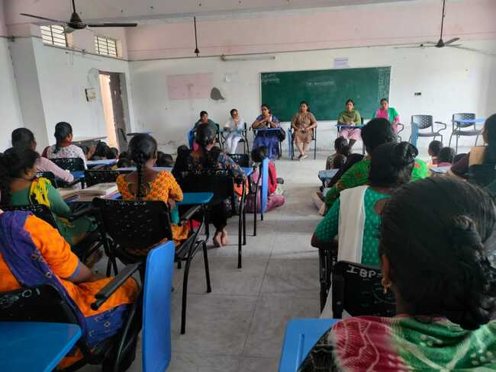

An orientation session was conducted by Vice Principal and the staff of TSWRDCW,IBRAHIMPATNAM on the evil effects of ragging and established an anti-ragging cell in the college



** OFFICE OF THE PRINCIPAL**

**TELANGANA SOCIAL WELFARE RESIDENTIAL DEGREE & PG**

**COLLEGE FOR WOMEN IBRAHIMPATNAM**

**AT ANKUSHAPUR**

**College Code: 61527 OU College Code : 2814**

NANDINI SUCCESS MEET

14,09.2023

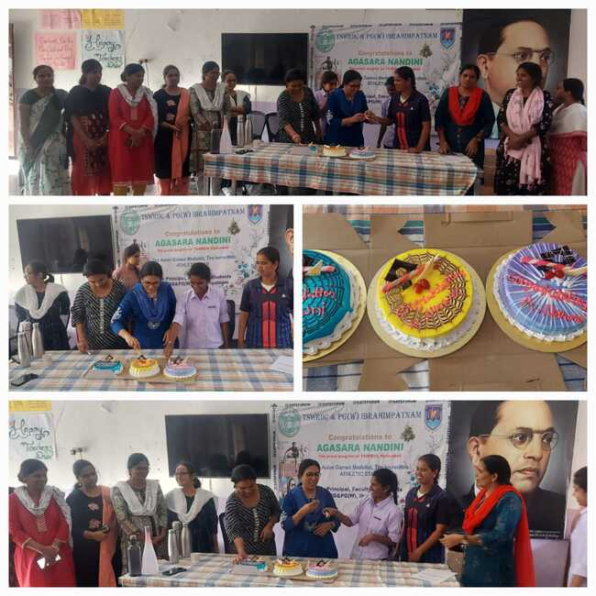

AGASARA NANDINI,Our Social welfare students has won the medal in Asial games and stood as a pride for the whole TSWREIS society. Celebrating her success with immense pride and gratitude.



** OFFICE OF THE PRINCIPAL**

**TELANGANA SOCIAL WELFARE RESIDENTIAL DEGREE & PG**

**COLLEGE FOR WOMEN IBRAHIMPATNAM**

**AT ANKUSHAPUR**

**College Code: 61527 OU College Code : 2814**

VINAYAKA CHAVITHI

19.09.2023

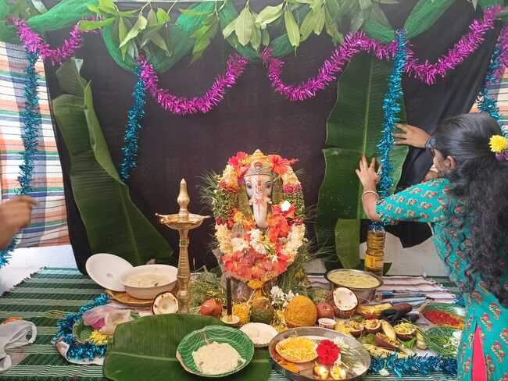

Lord Ganesha, who is being considered as the god of protecting the people from all the obstacles and protecting the people to follow the right path. Every year we celebrate Ganesh Chathurthi on the eve of his birthday.

** OFFICE OF THE PRINCIPAL**

**TELANGANA SOCIAL WELFARE RESIDENTIAL DEGREE & PG**

**COLLEGE FOR WOMEN IBRAHIMPATNAM**

**AT ANKUSHAPUR**

**College Code: 61527 OU College Code : 2814**

GANDHI JAYANTHI

02.10.2023

ar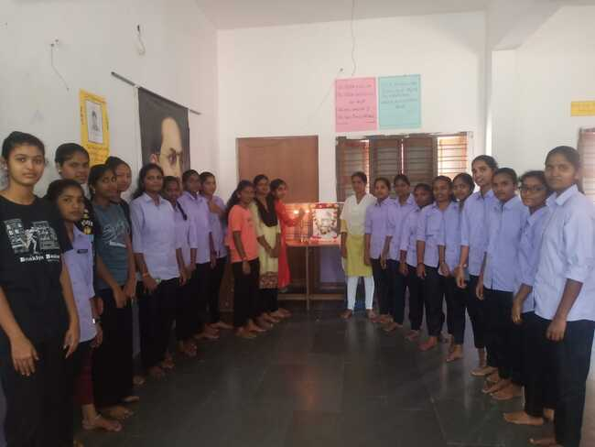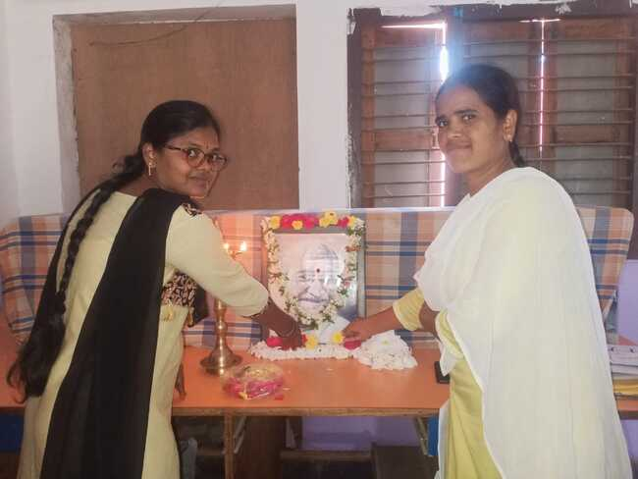

Every year october 2nd is celebrated as Gandhi jayanthi remembering the birth anniversary of Mahatma Gandhi, the father of the nation.

** OFFICE OF THE PRINCIPAL**

**TELANGANA SOCIAL WELFARE RESIDENTIAL DEGREE & PG**

**COLLEGE FOR WOMEN IBRAHIMPATNAM**

**AT ANKUSHAPUR**

**College Code: 61527 OU College Code : 2814**

BATHUKAMMA CELEBRATIONS

13.10.2023

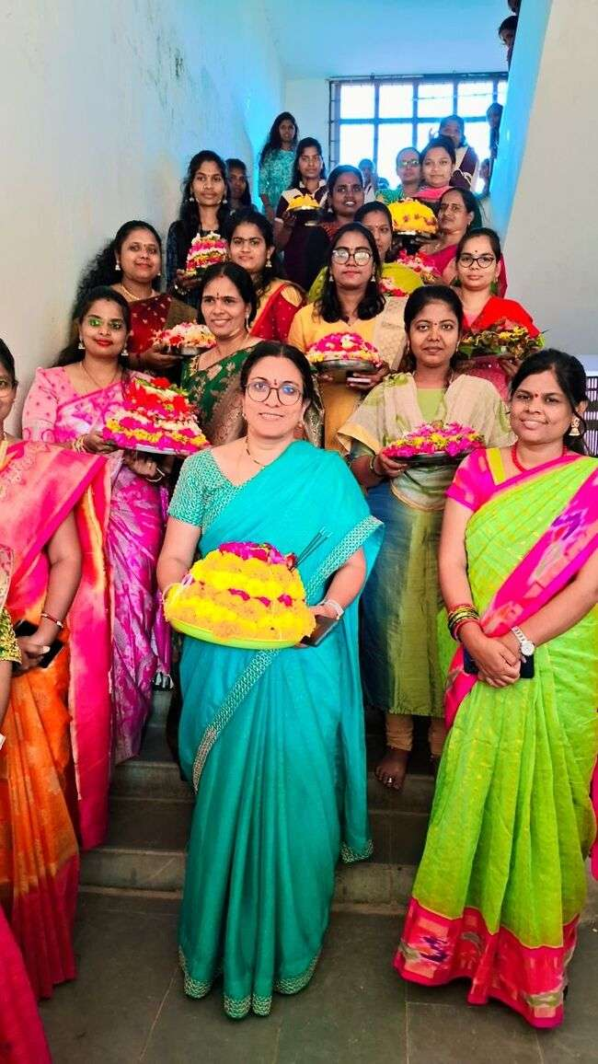

**BATHUKAMMA,** the festival of flowers is being celebrated throughout the entire state**.** It symbolises the way of living and it was believed that it is on this day the good wins over the evil**.**

** OFFICE OF THE PRINCIPAL**

**TELANGANA SOCIAL WELFARE RESIDENTIAL DEGREE & PG**

**COLLEGE FOR WOMEN IBRAHIMPATNAM**

**AT ANKUSHAPUR**

**College Code: 61527 OU College Code : 2814**

MAGAZINE LAUNCH

20.10.2023

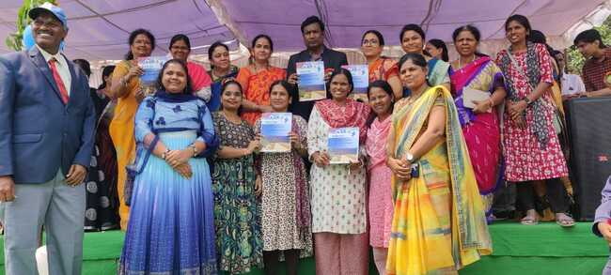

The college magazine was launched by the then Secretary of TSWREIS Dr.Naveen Nicholas sir,which comprises of all the literary works of the students as well as the faculty and all the events and programs conducted as a part of the college activities.

** OFFICE OF THE PRINCIPAL**

**TELANGANA SOCIAL WELFARE RESIDENTIAL DEGREE & PG**

**COLLEGE FOR WOMEN IBRAHIMPATNAM**

**AT ANKUSHAPUR**

**College Code: 61527 OU College Code : 2814**

AIDS DAY

01.12.2023

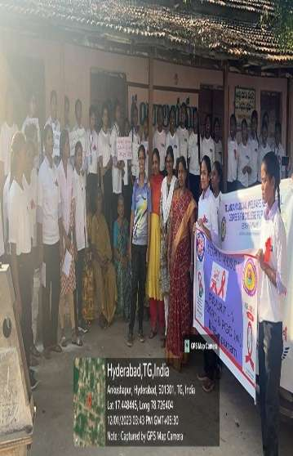 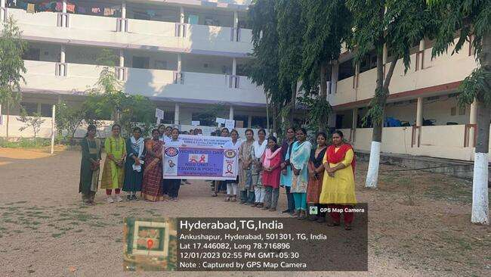 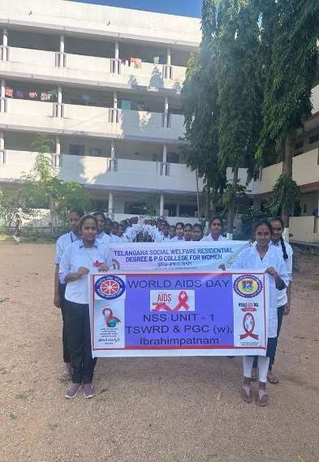

As a part of NSS axctivity, Our students have taken an initiative to spread the awareness among the public on AIDS on World Aids Day.They took a rally to Ankushapur village and performed a skit on creating awareness on AIDS

** OFFICE OF THE PRINCIPAL**

**TELANGANA SOCIAL WELFARE RESIDENTIAL DEGREE & PG**

**COLLEGE FOR WOMEN IBRAHIMPATNAM**

**AT ANKUSHAPUR**

**College Code: 61527 OU College Code : 2814**

SEMI CHRISTMAS

22.12.2023

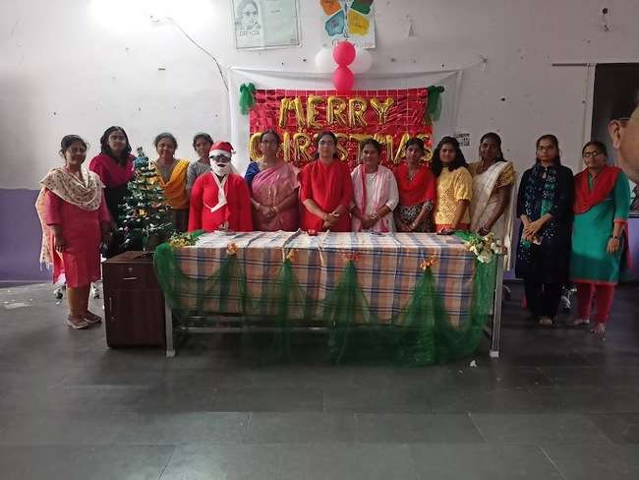

On the eve of Christmas ,we have celebrated semi Christmas in the college with the active participation from the students and faculty.

** OFFICE OF THE PRINCIPAL**

**TELANGANA SOCIAL WELFARE RESIDENTIAL DEGREE & PG**

**COLLEGE FOR WOMEN IBRAHIMPATNAM**

**AT ANKUSHAPUR**

**College Code: 61527 OU College Code : 2814**

SAVITRIBAI PHULE JAYANTHI

03.01.2023

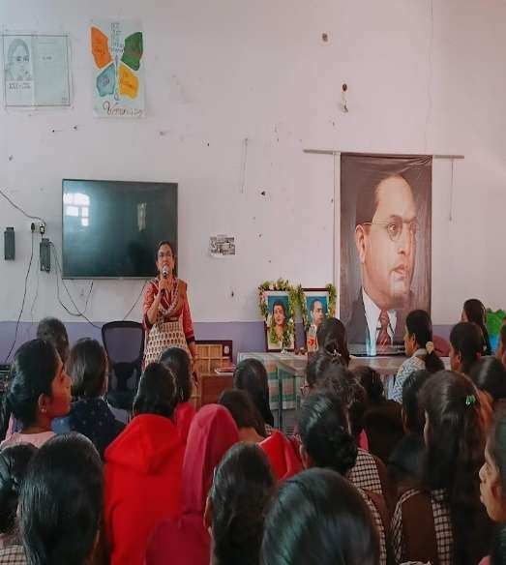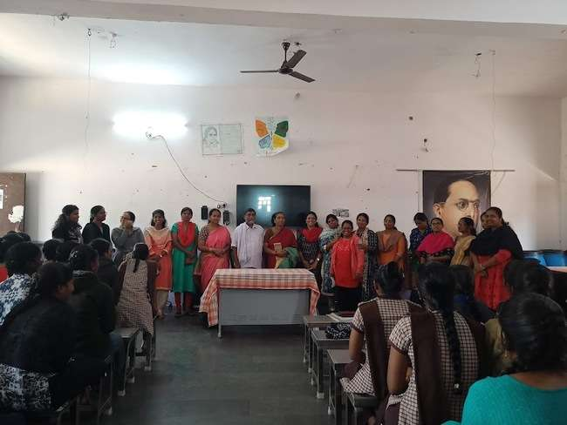

Savitribai Phule, the first women teacher who relentlessly strived and worked for the women education along with Jyothirao phule .She was a great teacher,social activist who fought for the empowerment of women.

** OFFICE OF THE PRINCIPAL**

**TELANGANA SOCIAL WELFARE RESIDENTIAL DEGREE & PG**

**COLLEGE FOR WOMEN IBRAHIMPATNAM**

**AT ANKUSHAPUR**

**College Code: 61527 OU College Code : 2814**

NATIONAL VOTERS DAY

25 JANUARY 2024

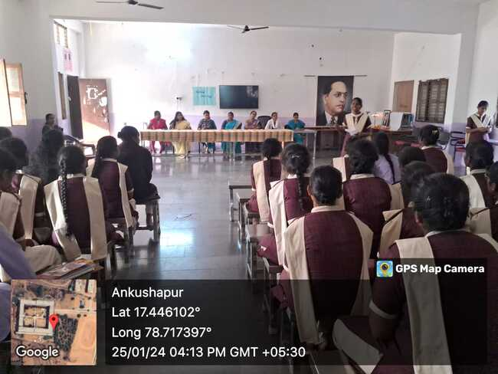

The Government of India has decided to celebrate 25th January every year as “National Voters Day”. It has been started from 25th January 2011 to mark the foundation day of Election Commission of India. It is also celebrated to create awareness among the youth and make them know that voting is their basic right.

The theme for the year 2024,National Voters Day **–“Nothing like Voting, I vote for sure”.**

** OFFICE OF THE PRINCIPAL**

**TELANGANA SOCIAL WELFARE RESIDENTIAL DEGREE & PG**

**COLLEGE FOR WOMEN IBRAHIMPATNAM**

**AT ANKUSHAPUR**

**College Code: 61527 OU College Code : 2814**

**REPUBLIC DAY**

26 JANUARY 2024

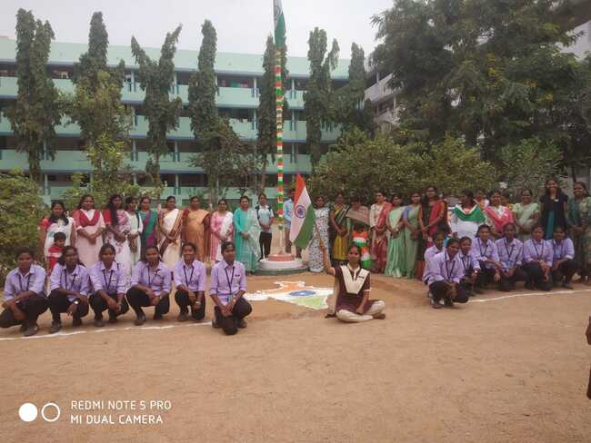

Republic day is celebrated on 26th January every year to commemorate the adoption of our Indian Constitution. It is on this day our Indian Constitution came into force. It represents a complete Socialist, Secular, Sovereign, Republic, Democratic society. Our Constitution was adopted on 26th November 1949 but came into force on 26th January 1950.

** OFFICE OF THE PRINCIPAL**

**TELANGANA SOCIAL WELFARE RESIDENTIAL DEGREE & PG**

**COLLEGE FOR WOMEN IBRAHIMPATNAM**

**AT ANKUSHAPUR**

**College Code: 61527 OU College Code : 2814**

**7th RDC SPORTS MEET**

28.01.2024

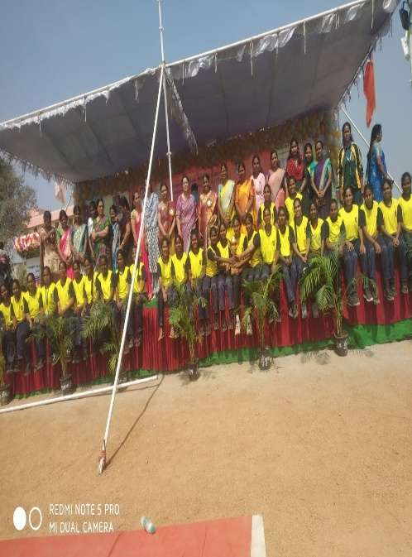 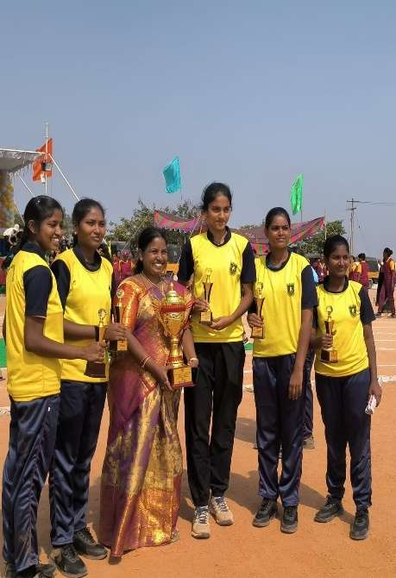

Our students have won the 1st Prize in Volley Ball competition in 7th RDC Sports meet conducted at TSWRD &PGC W, Budvel.

** OFFICE OF THE PRINCIPAL**

**TELANGANA SOCIAL WELFARE RESIDENTIAL DEGREE & PG**

**COLLEGE FOR WOMEN IBRAHIMPATNAM**

**AT ANKUSHAPUR**

**College Code: 61527 OU College Code : 2814**

**VIBRATIONS**

06.02.2024

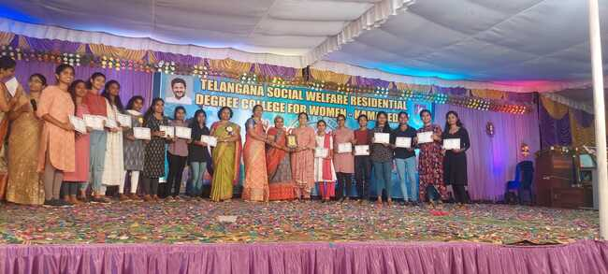

Our students have participated in the VIBRATIONS programme conducted by TSWRIES at TSWRDCW,Kamareddy in the month of February 2024.

Our students have won the following prizes

Group dance- 1st Prize

Spell Bee-2nd Prize

Student Presentation-3rd Prize

** OFFICE OF THE PRINCIPAL**

**TELANGANA SOCIAL WELFARE RESIDENTIAL DEGREE & PG**

**COLLEGE FOR WOMEN IBRAHIMPATNAM**

**AT ANKUSHAPUR**

**College Code: 61527 OU College Code : 2814**

**AWARENESS PROGRAM ON CYBER CRIMES AND CYBER STALKING**

05 FEBRUARY 2024

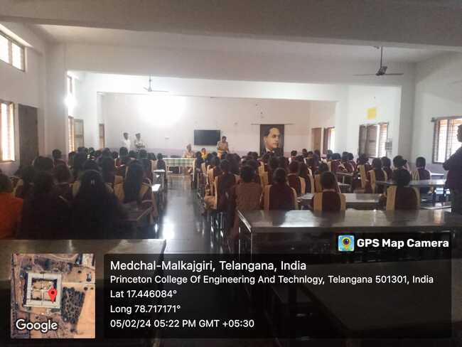

An awareness program on Cyber Crimes and Cyber Stalking was organised by Inspector Govardhan Giri and his team @Ghatkesar Police station at TSWRDCW, IBRAHIMPATNAM on 05/02/2024.

** OFFICE OF THE PRINCIPAL**

**TELANGANA SOCIAL WELFARE RESIDENTIAL DEGREE & PG**

**COLLEGE FOR WOMEN IBRAHIMPATNAM**

**AT ANKUSHAPUR**

**College Code: 61527 OU College Code : 2814**

**HEARTFULNESS PROGRAM**

08 FEBRUARY 2024

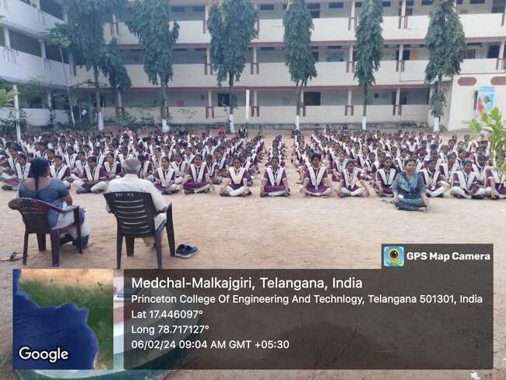

**“Calmness of mind is one of the beautiful jewels of wisdom”**

**Yoga and meditation is a daily activity performed in the college after the Prayer regularly. The session was conducted in the presence of KNP Rao sir,from Heartfulness Foundation,Principal Dr.H.Radhika,Vice Principal G.Soujanya and all the faculty.**

** OFFICE OF THE PRINCIPAL**

**TELANGANA SOCIAL WELFARE RESIDENTIAL DEGREE & PG**

**COLLEGE FOR WOMEN IBRAHIMPATNAM**

**AT ANKUSHAPUR**

**College Code: 61527 OU College Code : 2814**

**ప్రకృతి - పాట - వ్యక్తిత్వవికాసం కార్యశాల**

13 FEBRUARY 2024

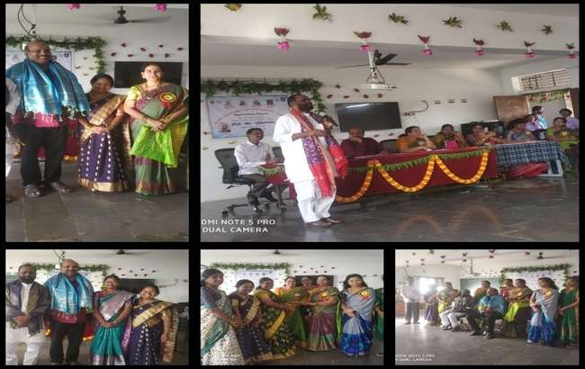

తెలంగాణ సాంఘీక సంక్షేమ మహిళా డిగ్రీ మరియు పీజి ఇబ్రహీంపట్నం కళాశాలలో 13.02.2024 మంగళవారం ఒకరోజు తెలుగు జాతీయ కార్యశాల నిర్వచించారు ఇందులో ప్రధాన వక్తలుగా డాక్టర్ జయరాజ్ గారు ప్రకృతి- పాట అను అంశం మీద ప్రసంగించారు. డాక్టర్ ప్రత్యూష సుబ్బారావు గారు విద్యార్థుల వ్యక్తిత్వ వికాసం మీద ప్రసంగించారు. విద్యార్థులు సాధించాల్సిన విజయాలు సమాజంపై గల బాధ్యతను వారు ఈ సందర్భంగా గుర్తు చేశారు. ఈ కార్యశాలలో ఇరు రాష్టాల విద్యార్థులు పీజి కళాశాల విద్యార్థులు అధ్యాపకులు పాల్గొన్నారు. ఈ కార్యాశాలలో పాల్గొన్న రీజినల్ కో ఆర్డినటర్ నాగ కళ్యాణి మేడం సాహిత్య విషయాల పట్ల తనకు అభిమానం ఉందన్న విషయాన్ని తెలియజేశారు. ఈ కార్యశాల విధ్యార్ధులకు అధ్యాపకులకు ఎంతో ఉపయోగంగా ఉందన్నారు కళాశాల ప్రిన్సిపాల్ డాక్టర్ హెచ్ రాధిక గారు కళాశాల సాదించిన విజయాలను పేర్కొన్నారు. కళాశాల ప్రాంగణంలో ఉన్న బుద్వెల్ కళాశాల ప్రిన్సిపాల్ ఎం వెంకటేశ్వర్లు గారు, మహేంద్ర హిల్స్ కళాశాల ప్రిన్సిపాల్ విజయలక్షిి గారు తెలుగు విభాగం డాక్టర్ పద్మ డాక్టర్ దాసోజు పద్మావతి కళాశాలలో ఉన్న అధ్యాపక బృందం పాల్గొన్నారు.

** OFFICE OF THE PRINCIPAL**

**TELANGANA SOCIAL WELFARE RESIDENTIAL DEGREE & PG**

**COLLEGE FOR WOMEN IBRAHIMPATNAM**

**AT ANKUSHAPUR**

**College Code: 61527 OU College Code : 2814**

**అంతర్జాతీయ మాతృభాషా దినోత్సవం**

21 FEBRUARY 2024

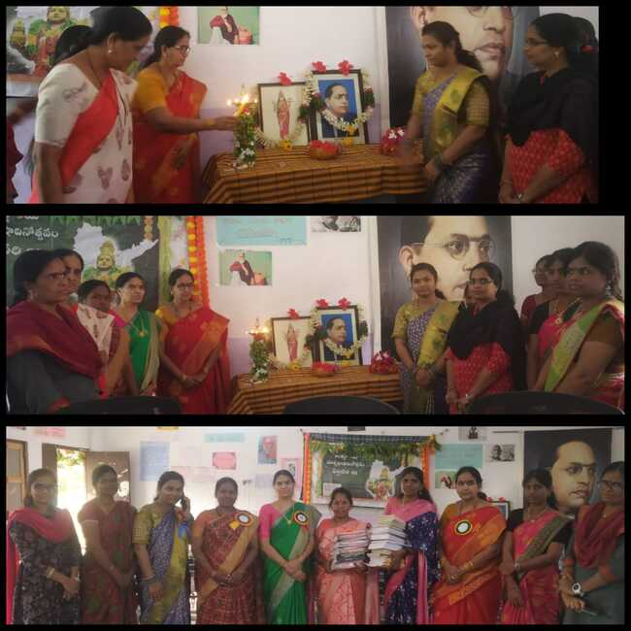

మాతృభాషను రక్షించుకోవాలి

ప్రపంచంలో ఏ దేశమైనా వారి మాతృభాషను రక్షించు కోవాలని కవయిత్రీ డాక్టర్ కొండపల్లి నీహారిణి అన్నారు. అంకు షాపూర్ లోని తెలంగాణ సాంఘిక సంక్షేమ గురుకుల మహిళ డిగ్రీ కళాశాలలో బుధవారం నిర్వహించిన అంతర్జాతీయ భాషా దిన్సో వానికి ముఖ్యఅతిథిగా హాజరయ్యారు. ఈ సందర్భంగా ఆమె మాట్లాడుతూ భావాలు, అభిప్రాయాలను వెలిబుచ్చడానికి మాతృభాషను మించిన జ్ఞానం ఏ భాషలో లభించదన్నారు. కార్యక్రమంలో డాక్టర్ రాధిక, డాక్టర్ పద్మావతి, పద్మమ్మ, శ్రీదేవి, కళాశాల అధ్యాపకులు, విద్యార్థులు పాల్గొన్నారు

** OFFICE OF THE PRINCIPAL**

**TELANGANA SOCIAL WELFARE RESIDENTIAL DEGREE & PG**

**COLLEGE FOR WOMEN IBRAHIMPATNAM**

**AT ANKUSHAPUR**

**College Code: 61527 OU College Code : 2814**

**IMPACT PROGRAM**

19 FEBRUARY 2024

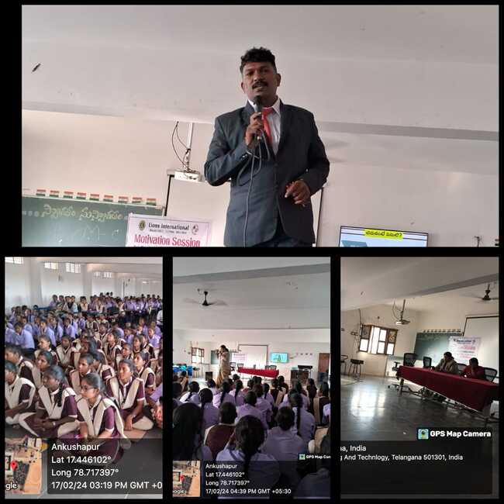

An impact Programme was conducted by Chakradhar sir and Vijaya mam,from Lions Club to create awareness on MENTAL WELLBEING and stress management for students.

** OFFICE OF THE PRINCIPAL**

**TELANGANA SOCIAL WELFARE RESIDENTIAL DEGREE & PG**

**COLLEGE FOR WOMEN IBRAHIMPATNAM**

**AT ANKUSHAPUR**

**College Code: 61527 OU College Code : 2814**

**అంతర్జాతీయ మాతృభాషా దినోత్సవం**

**21.02.2024**

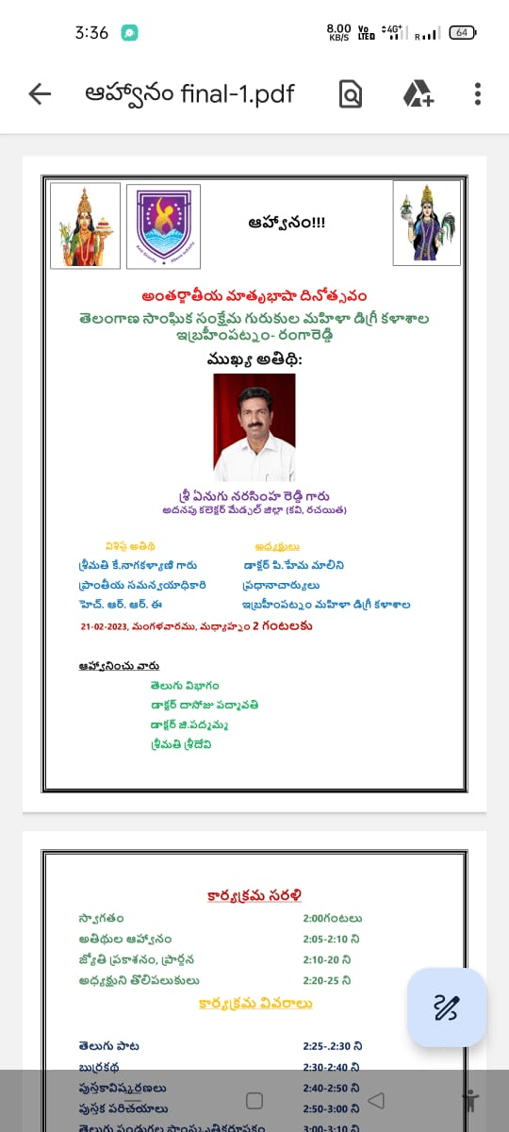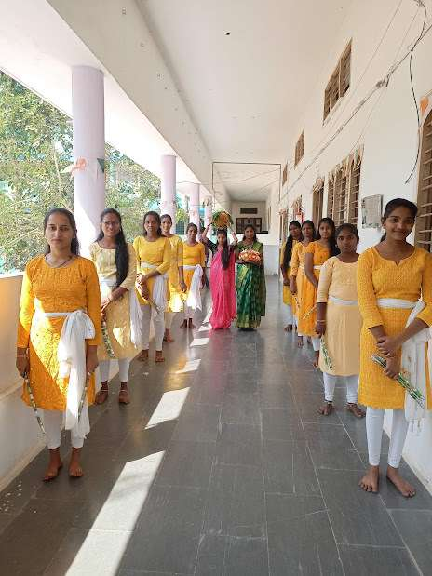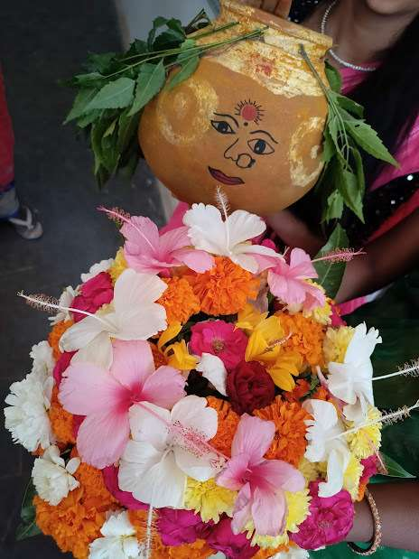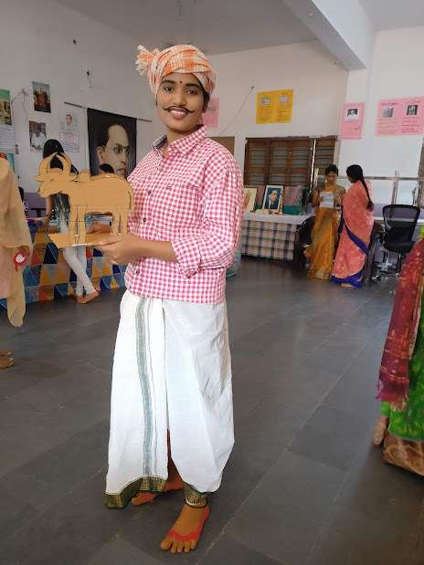

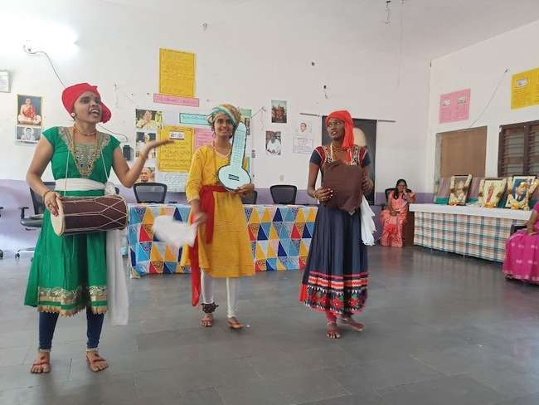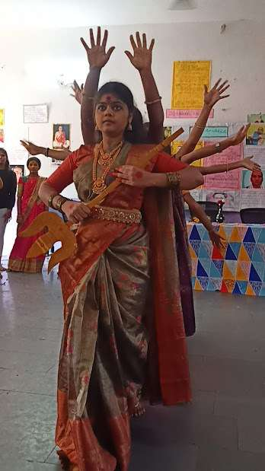

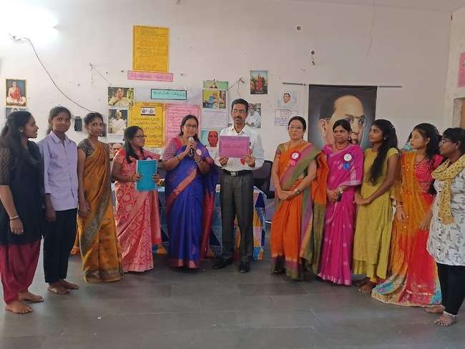

** OFFICE OF THE PRINCIPAL**

**TELANGANA SOCIAL WELFARE RESIDENTIAL DEGREE & PG**

**COLLEGE FOR WOMEN IBRAHIMPATNAM**

**AT ANKUSHAPUR**

**College Code: 61527 OU College Code : 2814**

**PSYCHOLOGY PROJECT**

22 FEBRUARY 2024

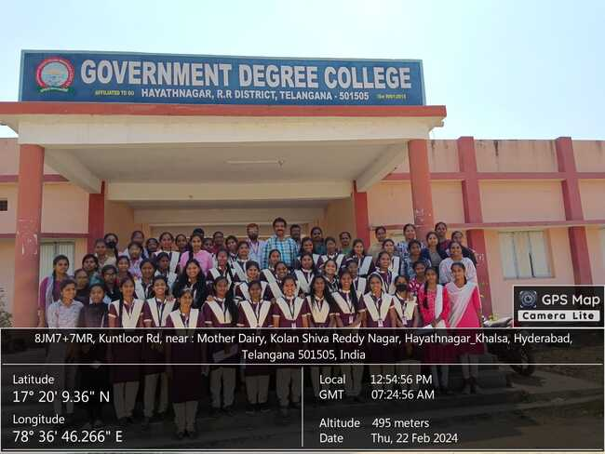

Students of BA III year from Department of Psychology went to Government Degree College, Hayathnagar to conduct a practical survey related to Psychology Project.

** OFFICE OF THE PRINCIPAL**

**TELANGANA SOCIAL WELFARE RESIDENTIAL DEGREE & PG**

**COLLEGE FOR WOMEN IBRAHIMPATNAM**

**AT ANKUSHAPUR**

**College Code: 61527 OU College Code : 2814**

**SPORTS ACHIEVEMENTS**

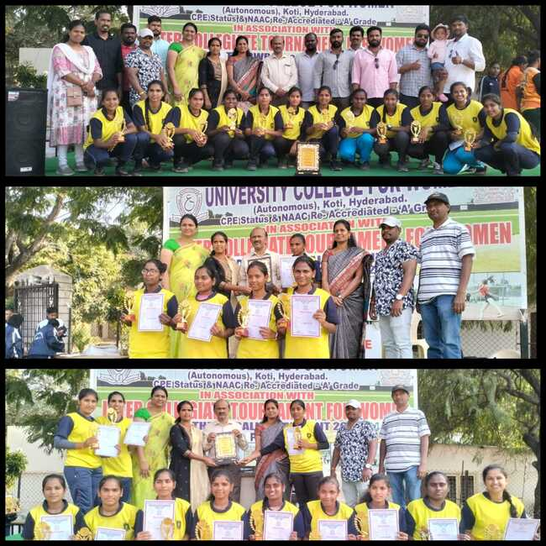

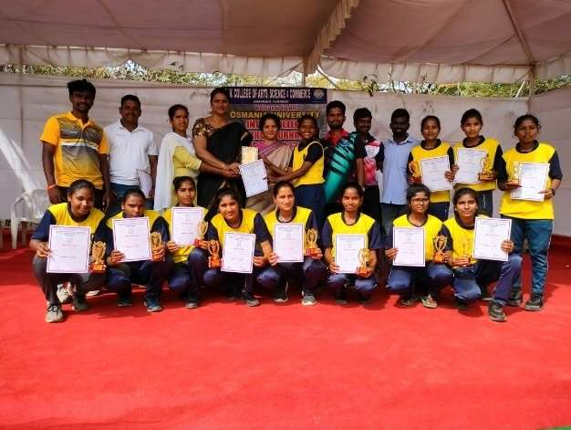 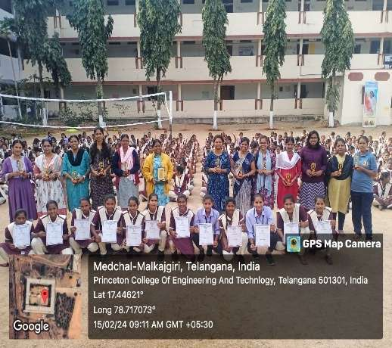

** OFFICE OF THE PRINCIPAL**

**TELANGANA SOCIAL WELFARE RESIDENTIAL DEGREE & PG**

**COLLEGE FOR WOMEN IBRAHIMPATNAM**

**AT ANKUSHAPUR**

**College Code: 61527 OU College Code : 2814**

Inter-college Tournament was held at University College For Women, Koti.

Our students have won the following Prizes.

Kabaddi- 1st Prize

Tennikoit- 1st Prize

Kho-Kho- 3rd Prize



** OFFICE OF THE PRINCIPAL**

**TELANGANA SOCIAL WELFARE RESIDENTIAL DEGREE & PG**

**COLLEGE FOR WOMEN IBRAHIMPATNAM**

**AT ANKUSHAPUR**

**College Code: 61527 OU College Code : 2814**

**HEARTFULNESS PROGRAM**

28 FEBRUARY 2024

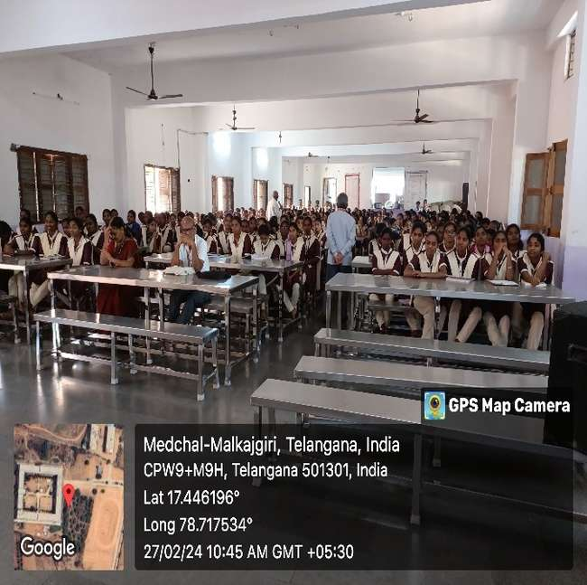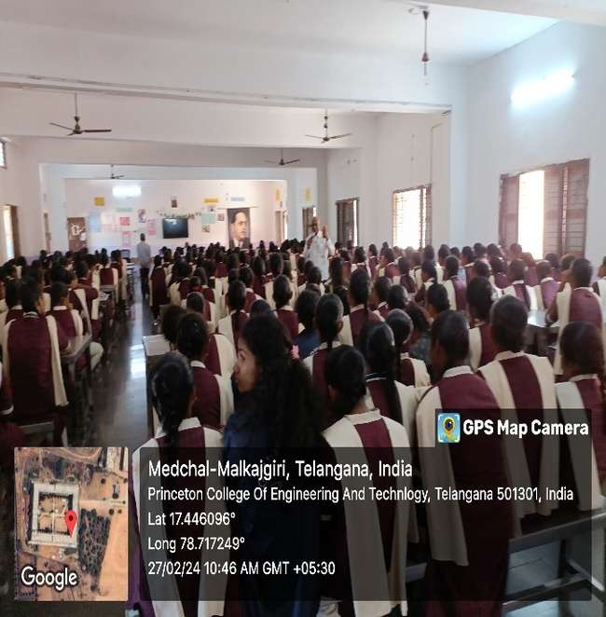

Heartfulness programme and orientation to the students on Yoga and Meditation

** OFFICE OF THE PRINCIPAL**

**TELANGANA SOCIAL WELFARE RESIDENTIAL DEGREE & PG**

**COLLEGE FOR WOMEN IBRAHIMPATNAM**

**AT ANKUSHAPUR**

**College Code: 61527 OU College Code : 2814**

**MENTAL WELLBEING SESSION TO FACULTY**

28 FEBRUARY 2024

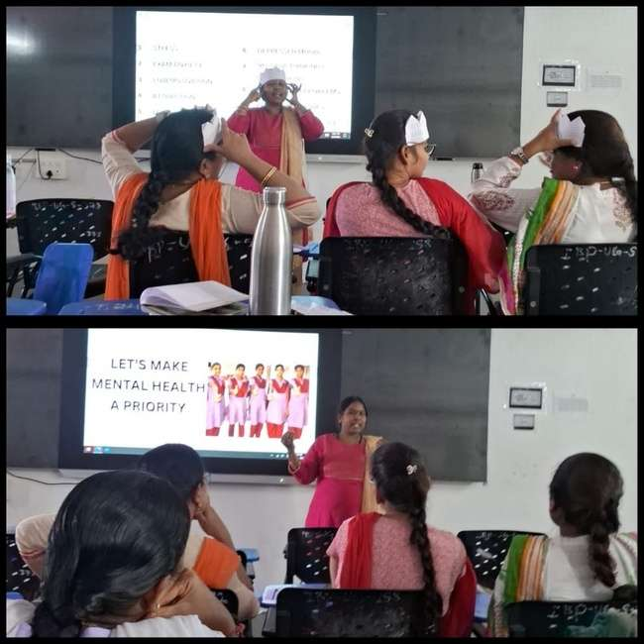

A motivational session has been conducted to all the principals of TSWRDCs to improve the mental health and that was being shared among the Faculty by performing various activities.

** OFFICE OF THE PRINCIPAL**

**TELANGANA SOCIAL WELFARE RESIDENTIAL DEGREE & PG**

**COLLEGE FOR WOMEN IBRAHIMPATNAM**

**AT ANKUSHAPUR**

**College Code: 61527 OU College Code : 2814**

**MENTAL HEALTH AWARENESS SESSION**

28 FEBRUARY 2024

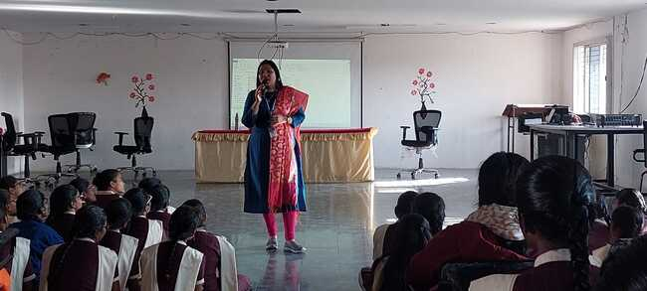 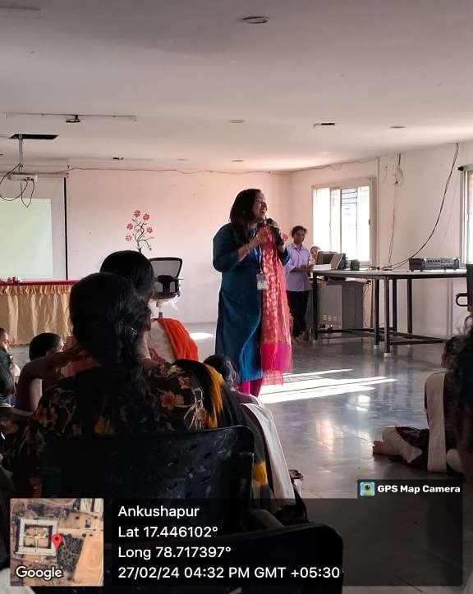

A motivation session has been conducted by Aditya Birla Foundation team on Mental health awareness has been organized in TSWRDCW, Mahendrahills campus.

** OFFICE OF THE PRINCIPAL**

**TELANGANA SOCIAL WELFARE RESIDENTIAL DEGREE & PG**

**COLLEGE FOR WOMEN IBRAHIMPATNAM**

**AT ANKUSHAPUR**

**College Code: 61527 OU College Code : 2814**

COWE

29.02.2024

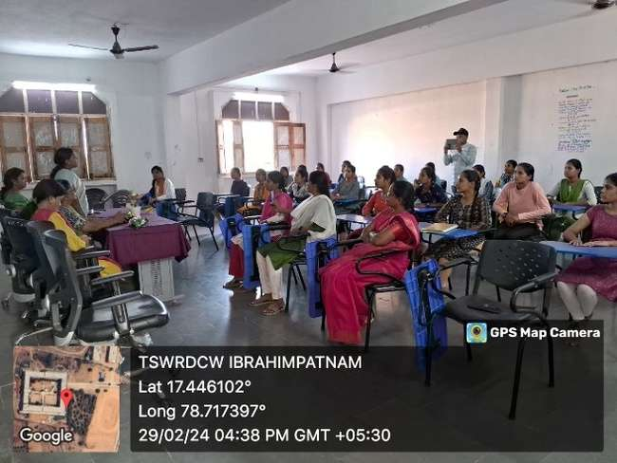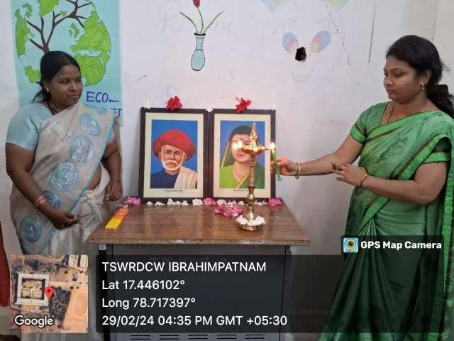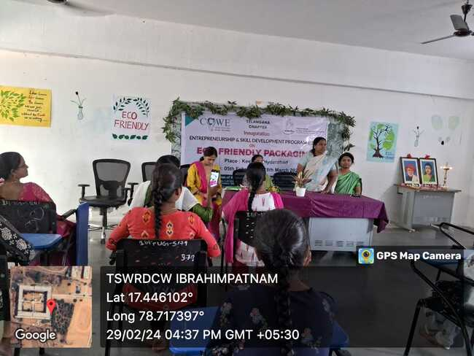

The Confederation of Women Entrepreneurs has initiated has taken an initiative to empower the students on utilisation on waste management.They have selected students of the scheduled tribe community and trained the students on different activities.

** OFFICE OF THE PRINCIPAL**

**TELANGANA SOCIAL WELFARE RESIDENTIAL DEGREE & PG**

**COLLEGE FOR WOMEN IBRAHIMPATNAM**

**AT ANKUSHAPUR**

**College Code: 61527 OU College Code : 2814**

INAUGURAL OF TAILORING TRAINING CENTER

01.03.2024

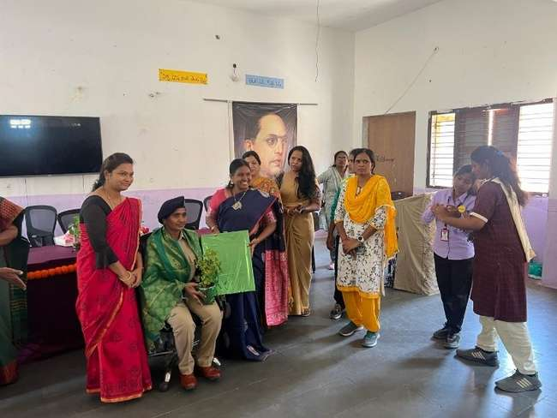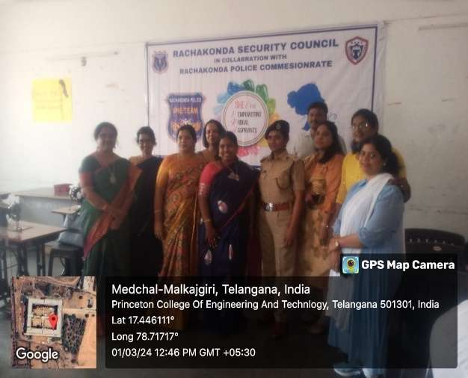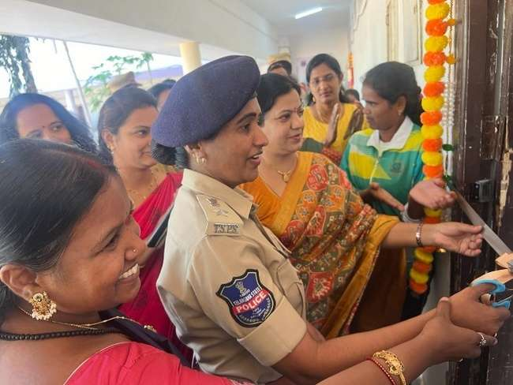

Rachakonda Cyber Security Council, under the Commissionreate of Rachakonda has started the tailoring training center in our college as a part of Womens day celebration week . Our students were being given training on tailoring course for a period of 45 days.

** OFFICE OF THE PRINCIPAL**

**TELANGANA SOCIAL WELFARE RESIDENTIAL DEGREE & PG**

**COLLEGE FOR WOMEN IBRAHIMPATNAM**

**AT ANKUSHAPUR**

**College Code: 61527 OU College Code : 2814**

UGADI CELEBRaTIONS

08.03.2024

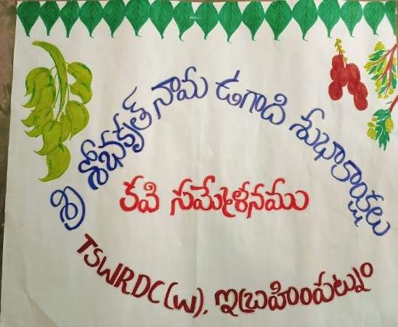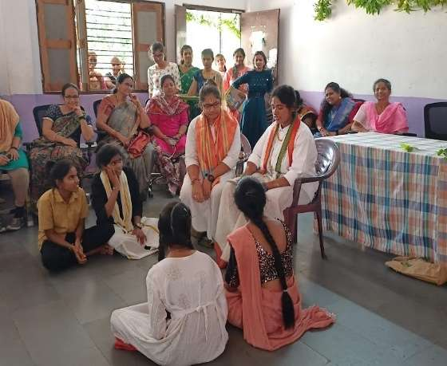

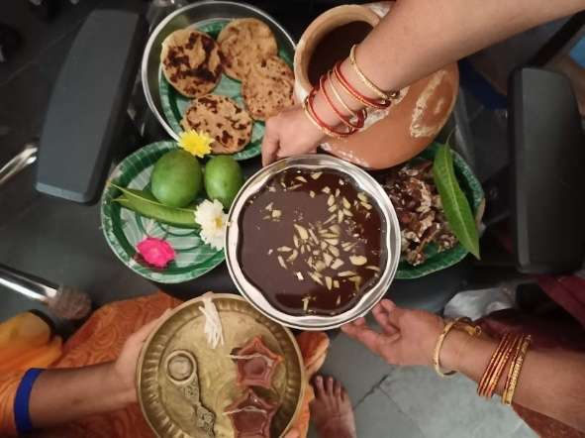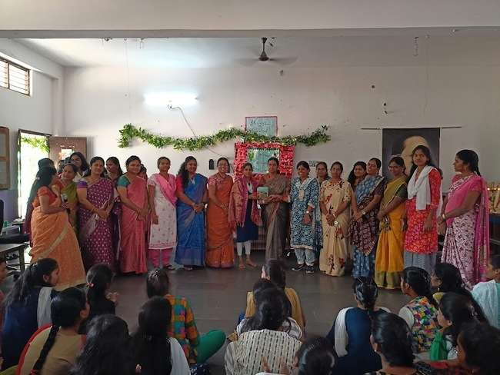

“UGADI”, meant to be beginning of a new age, This festival is celebrated on Chaitra Maasam welcoming the new blossoms .Our students have enacted a play on the eve of Ugadi stating its importance and enlightening the students by providing information on our rich culture and Heritage.

** OFFICE OF THE PRINCIPAL**

**TELANGANA SOCIAL WELFARE RESIDENTIAL DEGREE & PG**

**COLLEGE FOR WOMEN IBRAHIMPATNAM**

**AT ANKUSHAPUR**

**College Code: 61527 OU College Code : 2814**

WORLD WATER DAY

22.03.2024

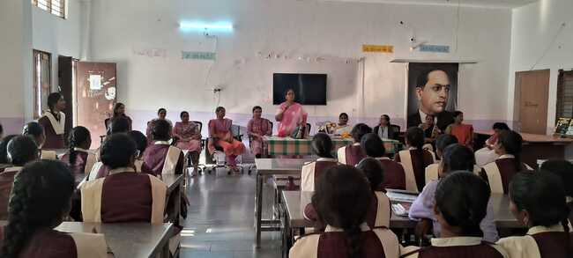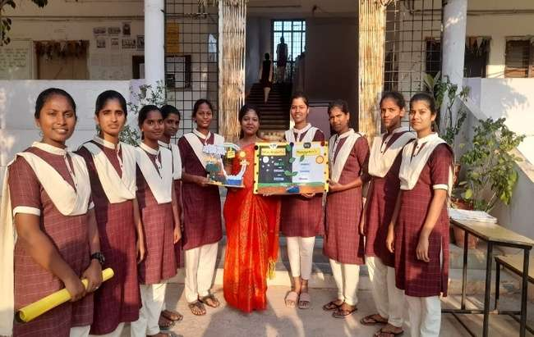

World Water is observed on 22nd march every year to spread awareness among the people on Conservation o fwater and effective utilisation of water.The Department of Geography has organized an awareness session fot the students on world water day.



** OFFICE OF THE PRINCIPAL**

**TELANGANA SOCIAL WELFARE RESIDENTIAL DEGREE & PG**

**COLLEGE FOR WOMEN IBRAHIMPATNAM**

**AT ANKUSHAPUR**

**College Code: 61527 OU College Code : 2814**

BABU JAGJEEVAN RAM JAYANTHI

05.04.2024

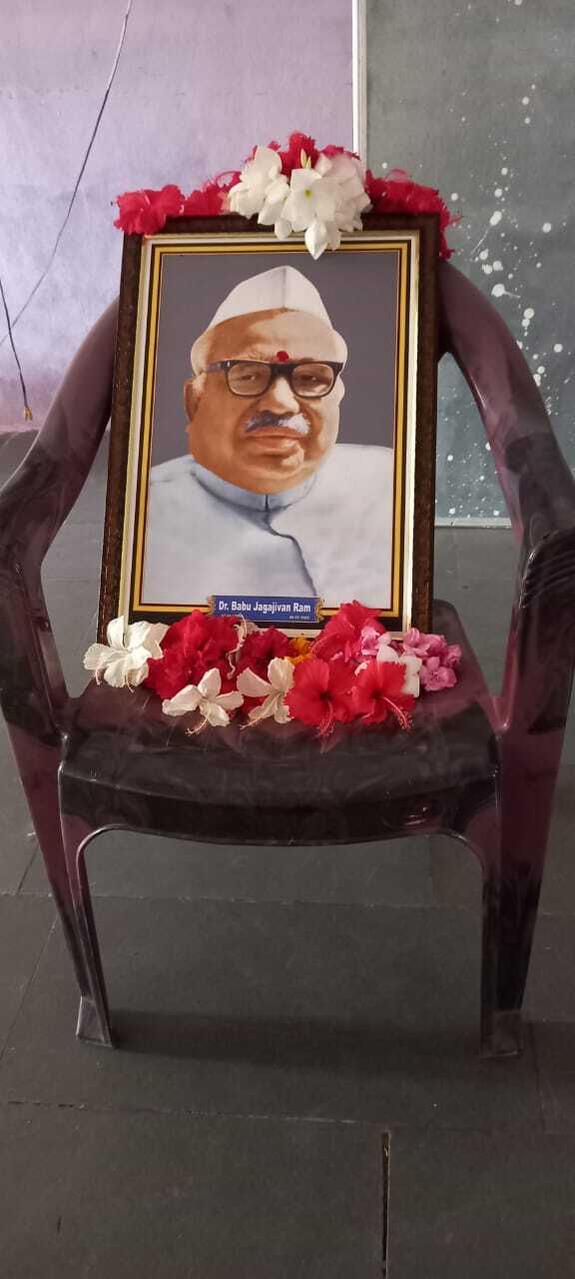 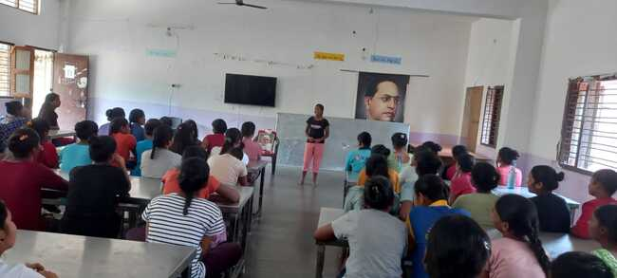

Babu Jagjeevan Jayanthi will be celebrated on 5th April every year. Babu Jagjivan Ram began his public life as a student activist and freedom fighter. At the age of 28, he became a legislator in 1936, as a nominated member of the Bihar Legislative Council.



** OFFICE OF THE PRINCIPAL**

**TELANGANA SOCIAL WELFARE RESIDENTIAL DEGREE & PG**

**COLLEGE FOR WOMEN IBRAHIMPATNAM**

**AT ANKUSHAPUR**

**College Code: 61527 OU College Code : 2814**

FAREWELL CELEBRATIONS

16.04.2024

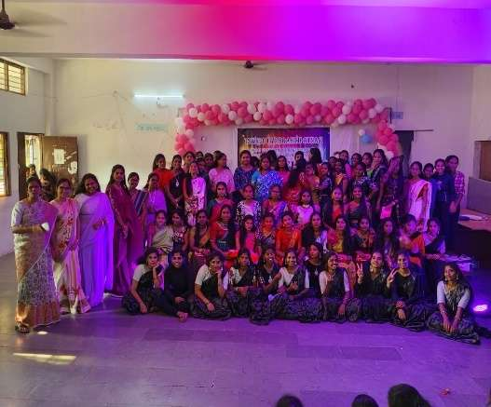 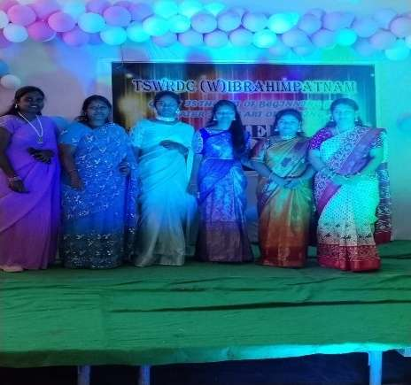

Farewell, a new beginning to another year of exploring greater experiences and future prospects.



** OFFICE OF THE PRINCIPAL**

**TELANGANA SOCIAL WELFARE RESIDENTIAL DEGREE & PG**

**COLLEGE FOR WOMEN IBRAHIMPATNAM**

**AT ANKUSHAPUR**

**College Code: 61527 OU College Code : 2814**

JYOTHIRAO PHULE jayanTHI

07.04.2024

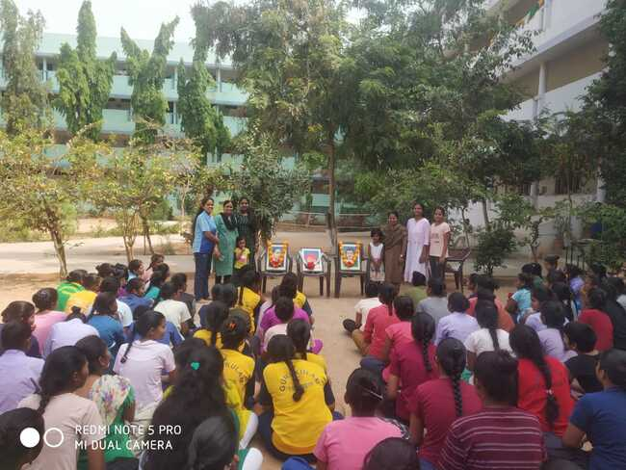

Jyothirao Phule, a renowned social activist, a social reformer and the person behind providing compulsory education to students.remembering him on his birth anniversary.



** OFFICE OF THE PRINCIPAL**

**TELANGANA SOCIAL WELFARE RESIDENTIAL DEGREE & PG**

**COLLEGE FOR WOMEN IBRAHIMPATNAM**

**AT ANKUSHAPUR**

**College Code: 61527 OU College Code : 2814**

AMBEDKAR JAYANTHI

13.04.2024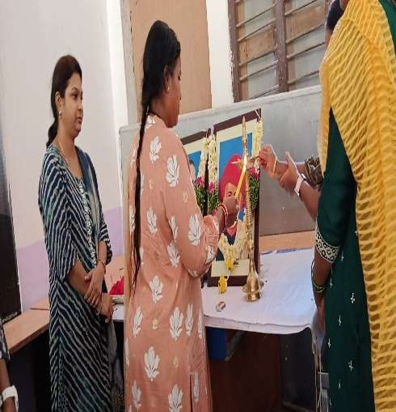 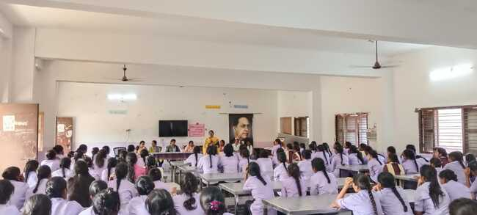

Dr. B. R. Ambedkar, the father of Indian Constitution and the chairman of the drafting Committee is well known famous personality towards encouraging women education, Providing equal status to all the sections of the society.remembering him on his birth anniversary, a program was organized in the college.



** OFFICE OF THE PRINCIPAL**

**TELANGANA SOCIAL WELFARE RESIDENTIAL DEGREE & PG**

**COLLEGE FOR WOMEN IBRAHIMPATNAM**

**AT ANKUSHAPUR**

**College Code: 61527 OU College Code : 2814**

English day

22 april 2024

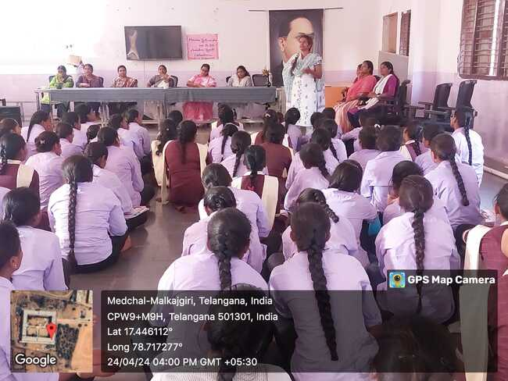

English language day is celebrated in the remembrance of William Shakespeare, a renowned poet, dramatist, and novel writer. His Poetry may be of old age but the poems are even more significant till now.

