**OFFICE OF THE PRINCIPAL**

**TELANGANA SOCIAL WELFARE RESIDENTIAL DEGREE**

**& PG COLLEGE FOR WOMEN IBRAHIMPATNAM**

**AT ANKUSHAPUR**

**College Code: 61527 OU College Code : 2814**

Criteria 4

Metric no.4.1.1

4.1.1:The institution has adequate infrastructure and other facilities for,

* Teaching -learning,viz.,classrooms,computer
* ICT– enabled facilities such as Smart class and projector

Infrastructure facilities

1.Classrooms

2.Computer lab

3.ICT facilities

4.Cultural activities

5.Sportroom

6.Yoga

7.Fire exitinguishers and RO Plant

8.Wellness centre

**OFFICE OF THE PRINCIPAL**

**TELANGANA SOCIAL WELFARE RESIDENTIAL DEGREE**

**& PG COLLEGE FOR WOMEN IBRAHIMPATNAM**

**AT ANKUSHAPUR**

**College Code: 61527 OU College Code : 2814**

1.PRINCIPAL CHAMBER

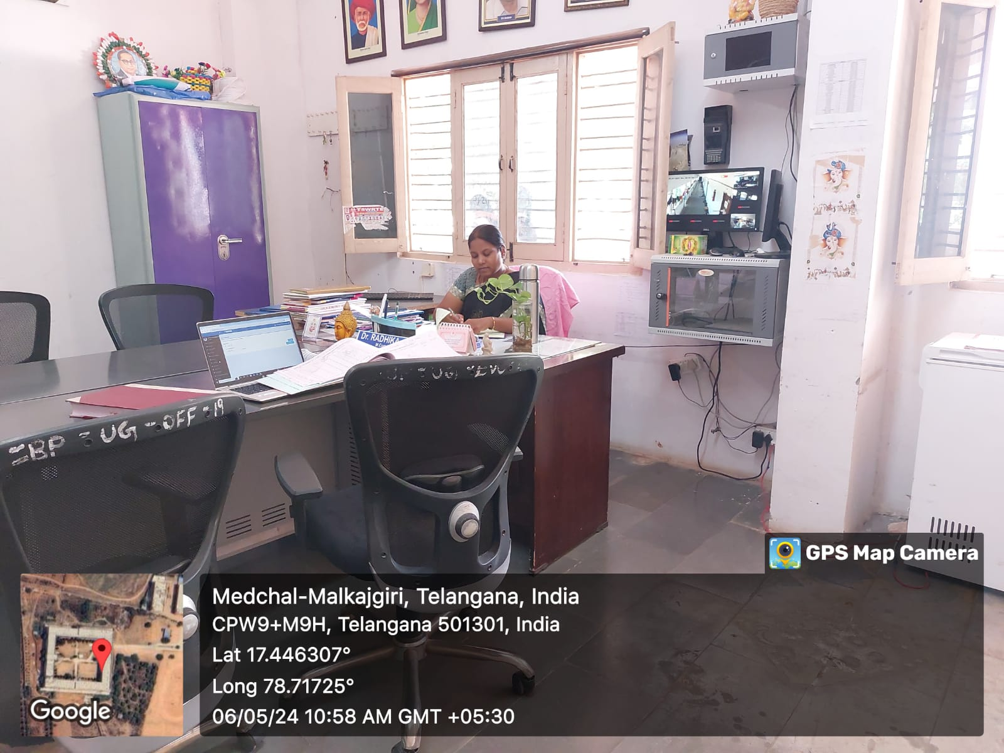

**OFFICE OF THE PRINCIPAL**

**TELANGANA SOCIAL WELFARE RESIDENTIAL DEGREE**

**& PG COLLEGE FOR WOMEN IBRAHIMPATNAM**

**AT ANKUSHAPUR**

**College Code: 61527 OU College Code : 2814**

**3.STAFF ROOM**

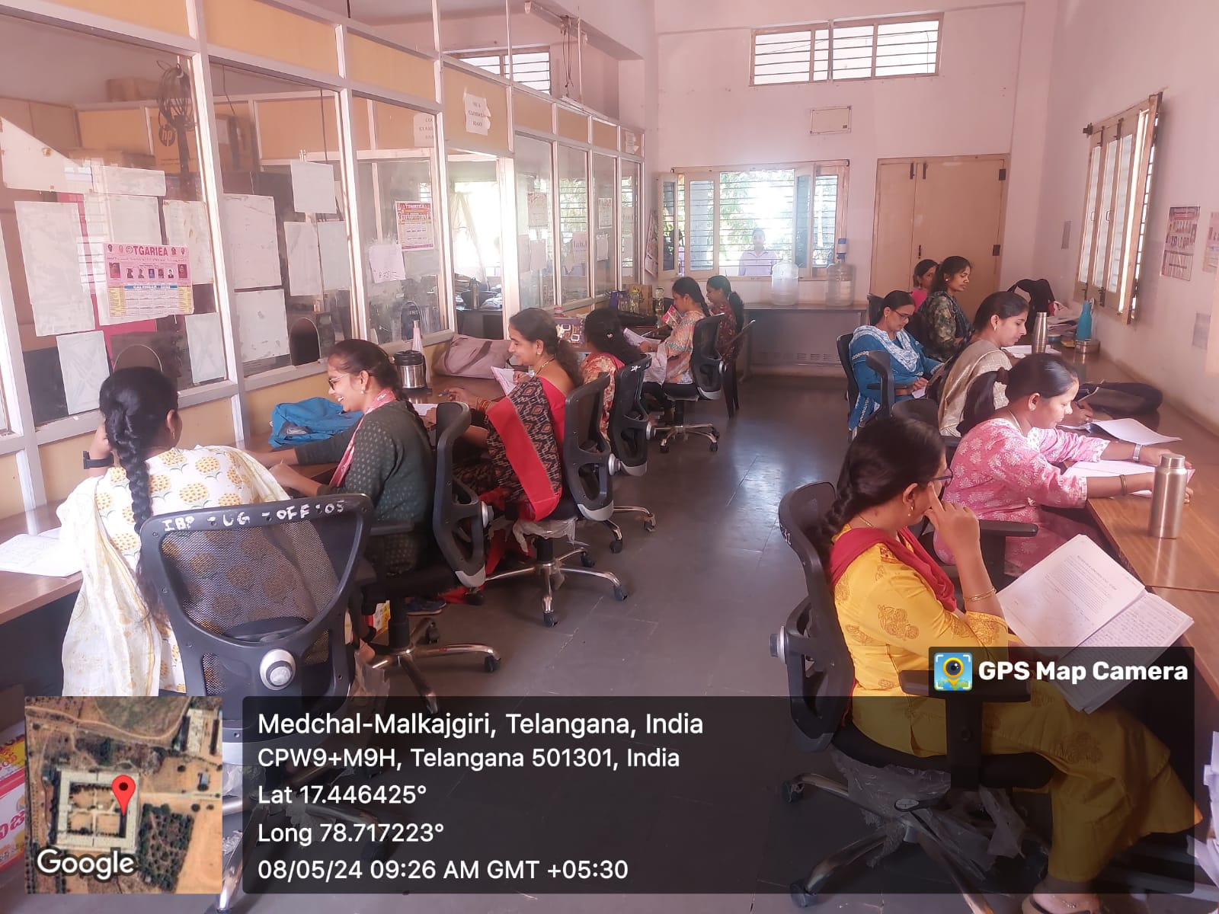

**OFFICE OF THE PRINCIPAL**

**TELANGANA SOCIAL WELFARE RESIDENTIAL DEGREE**

**& PG COLLEGE FOR WOMEN IBRAHIMPATNAM**

**AT ANKUSHAPUR**

**College Code: 61527 OU College Code : 2814**

**2.CLASSROOMS**

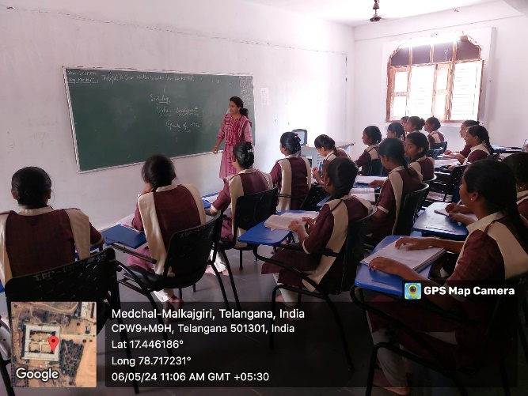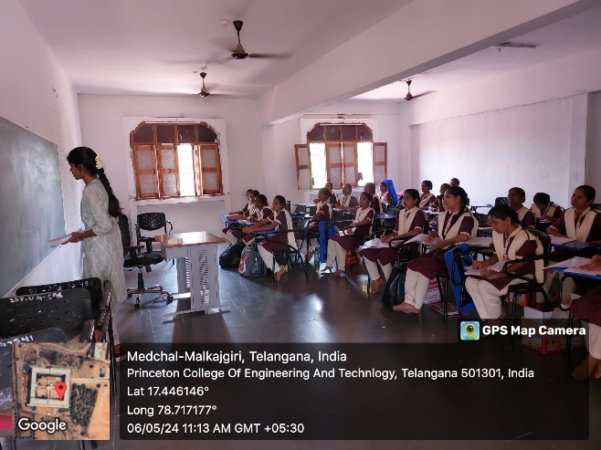

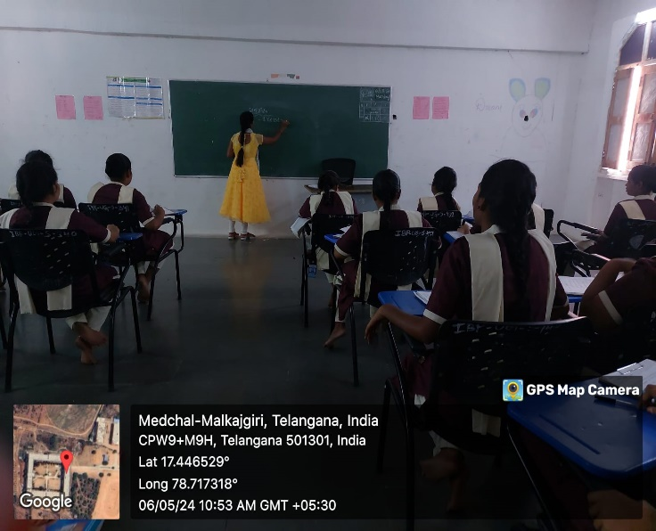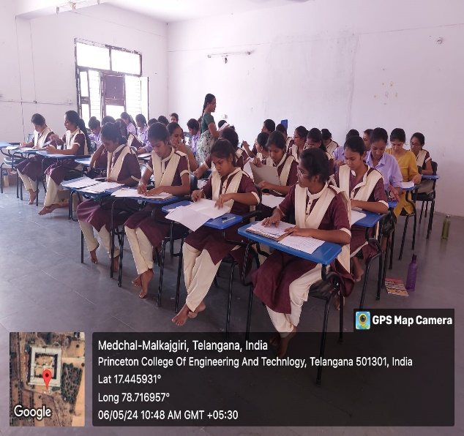

**OFFICE OF THE PRINCIPAL**

**TELANGANA SOCIAL WELFARE RESIDENTIAL DEGREE**

**& PG COLLEGE FOR WOMEN IBRAHIMPATNAM**

**AT ANKUSHAPUR**

**College Code: 61527 OU College Code : 2814**

COMPUTER LAB

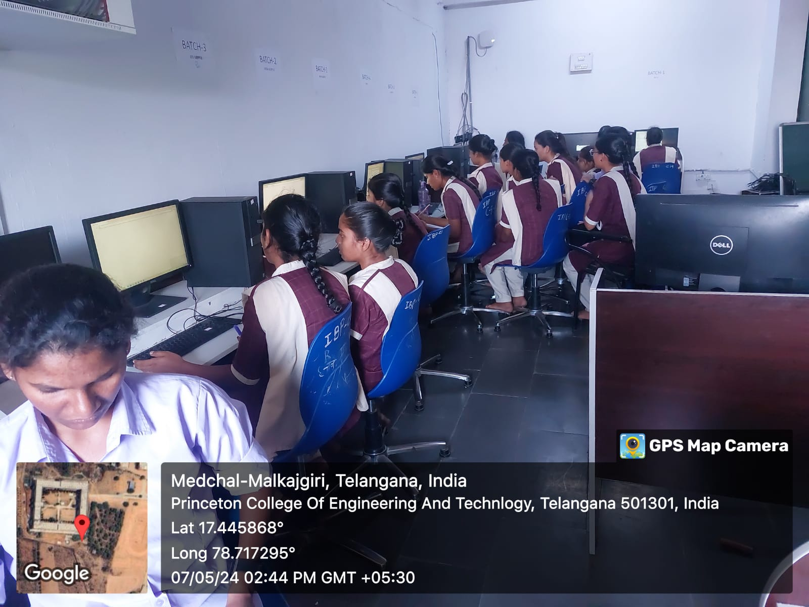

**OFFICE OF THE PRINCIPAL**

**TELANGANA SOCIAL WELFARE RESIDENTIAL DEGREE**

**& PG COLLEGE FOR WOMEN IBRAHIMPATNAM**

**AT ANKUSHAPUR**

**College Code: 61527 OU College Code : 2814**

ICT FACILITIES

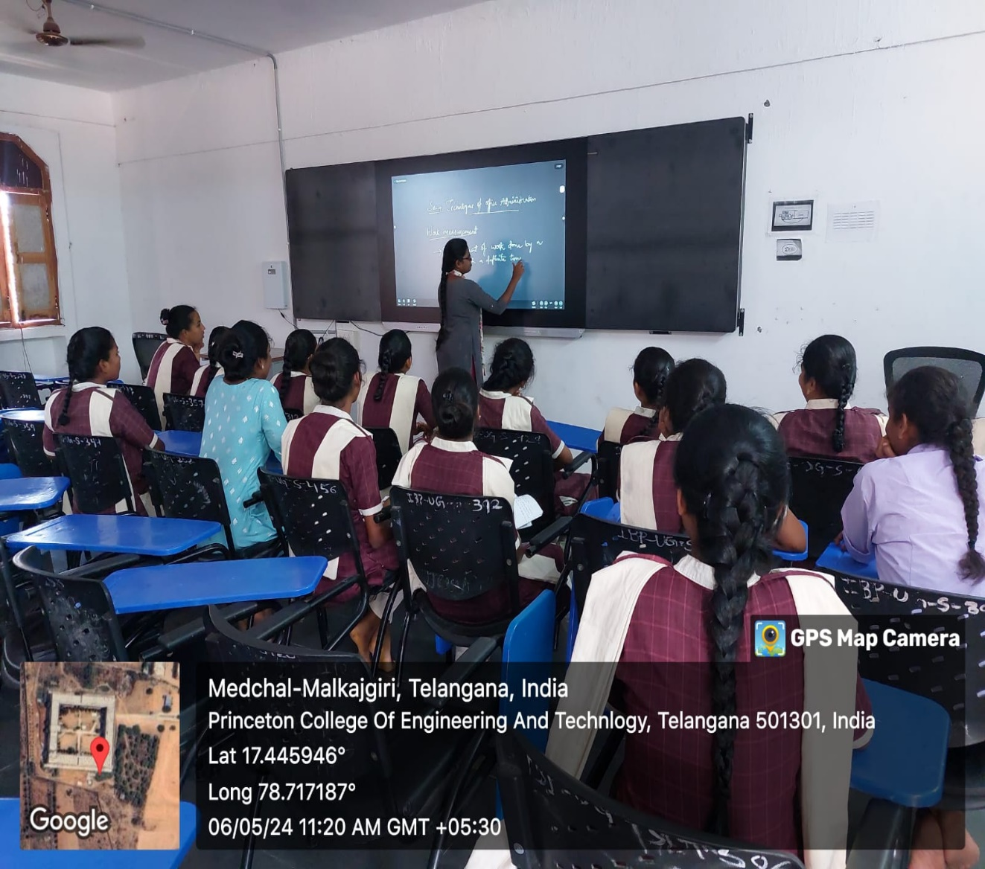

**OFFICE OF THE PRINCIPAL**

**TELANGANA SOCIAL WELFARE RESIDENTIAL DEGREE**

**& PG COLLEGE FOR WOMEN IBRAHIMPATNAM**

**AT ANKUSHAPUR**

**College Code: 61527 OU College Code : 2814**

**CULTURAL ACTIVITIES**

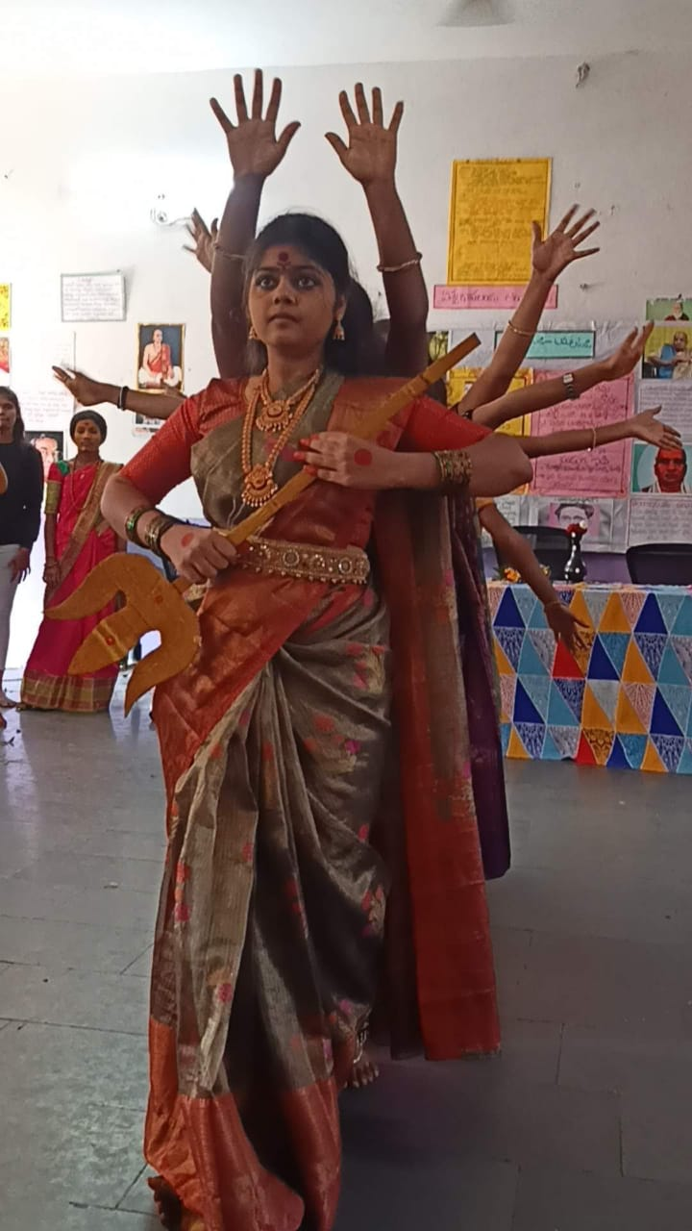

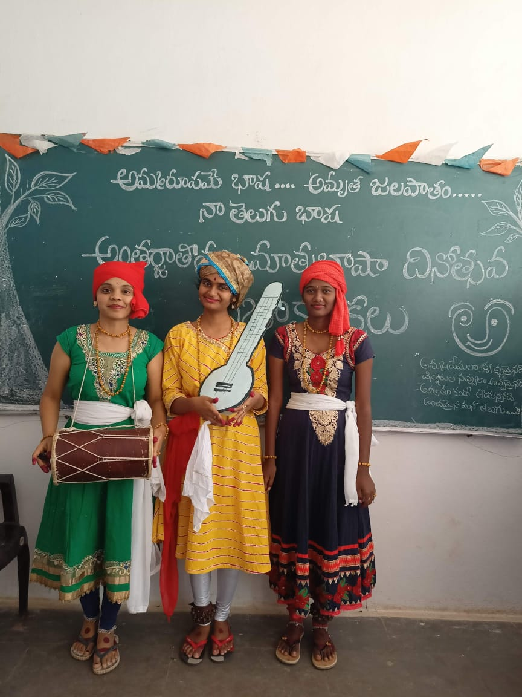

**OFFICE OF THE PRINCIPAL**

**TELANGANA SOCIAL WELFARE RESIDENTIAL DEGREE**

**& PG COLLEGE FOR WOMEN IBRAHIMPATNAM**

**AT ANKUSHAPUR**

**College Code: 61527 OU College Code : 2814**

**8.SPORTS AND GAMES**

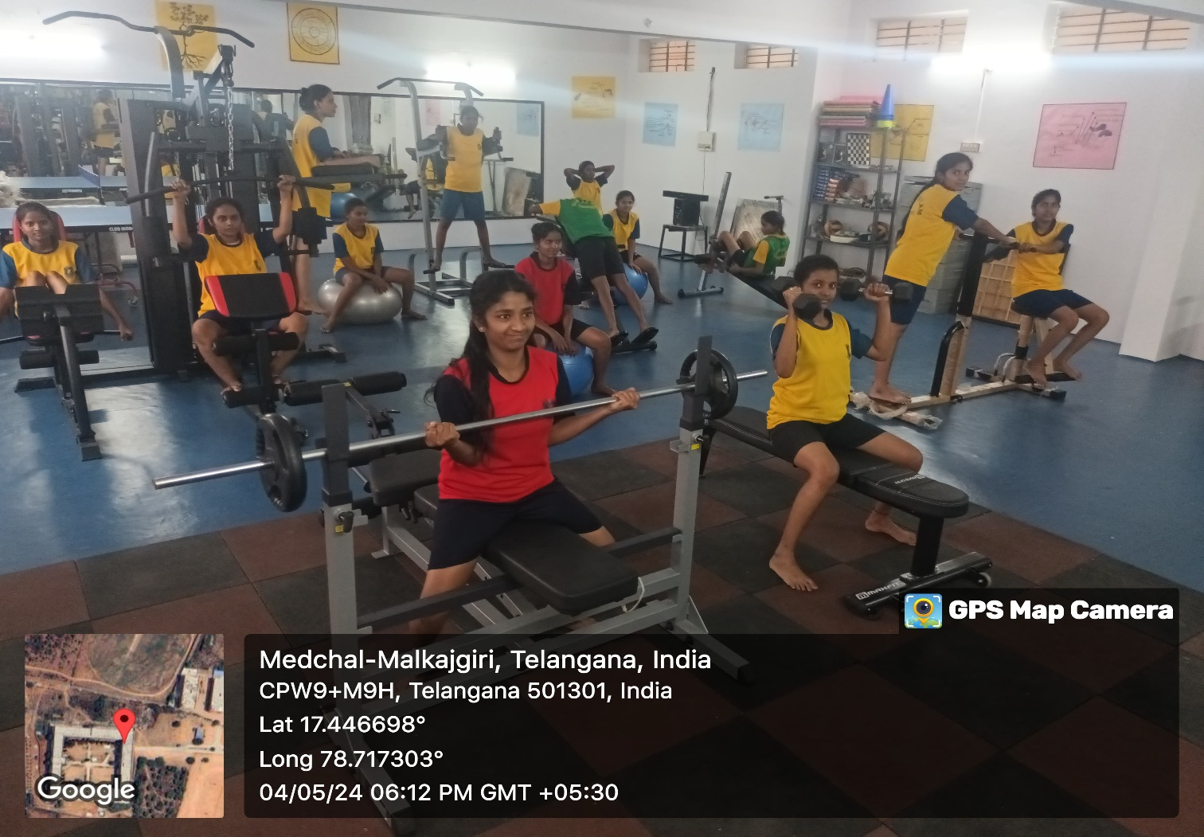

**GAMES**

**INDOOR GAMES AND YOGA**

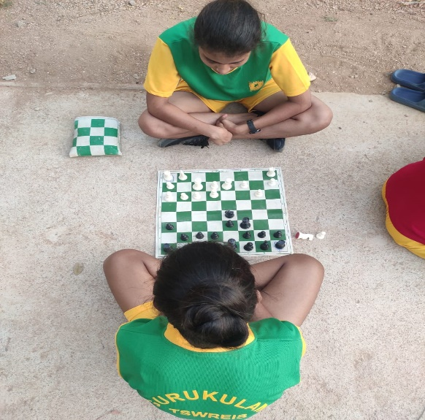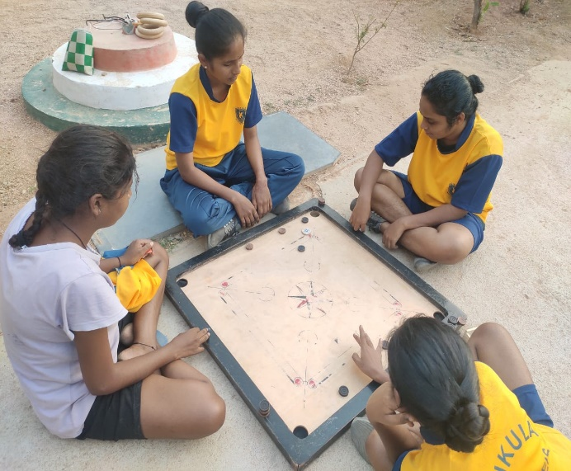

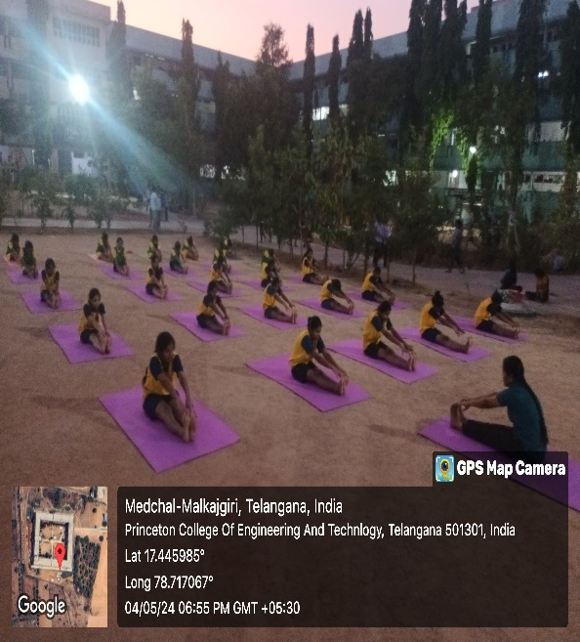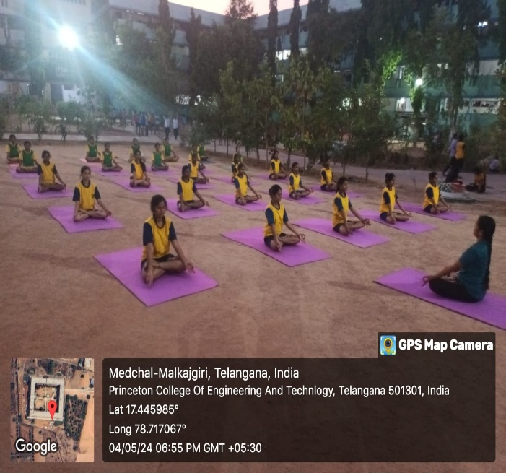

**OFFICE OF THE PRINCIPAL**

**TELANGANA SOCIAL WELFARE RESIDENTIAL DEGREE**

**& PG COLLEGE FOR WOMEN IBRAHIMPATNAM**

**AT ANKUSHAPUR**

**College Code: 61527 OU College Code : 2814**

**FIRE EXTINGUISHER AND RO PLANT**

**GROUND FLOOR**

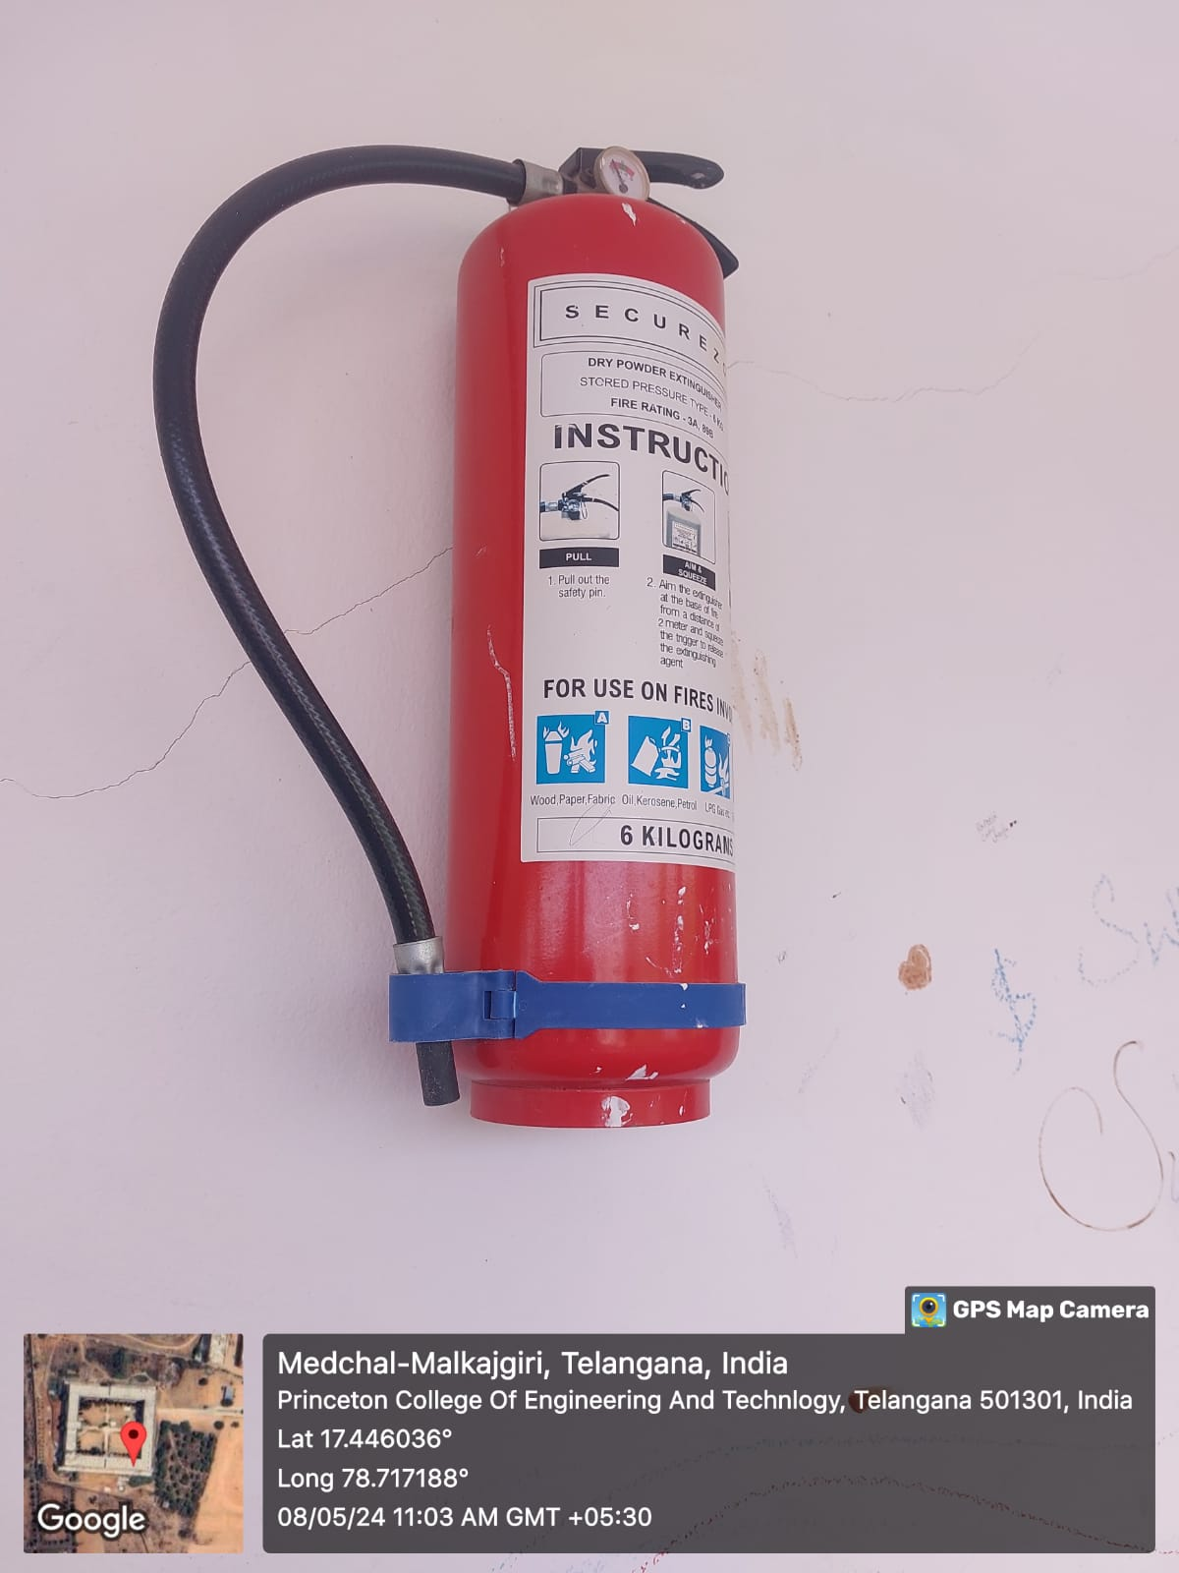

FIRST FLOOR

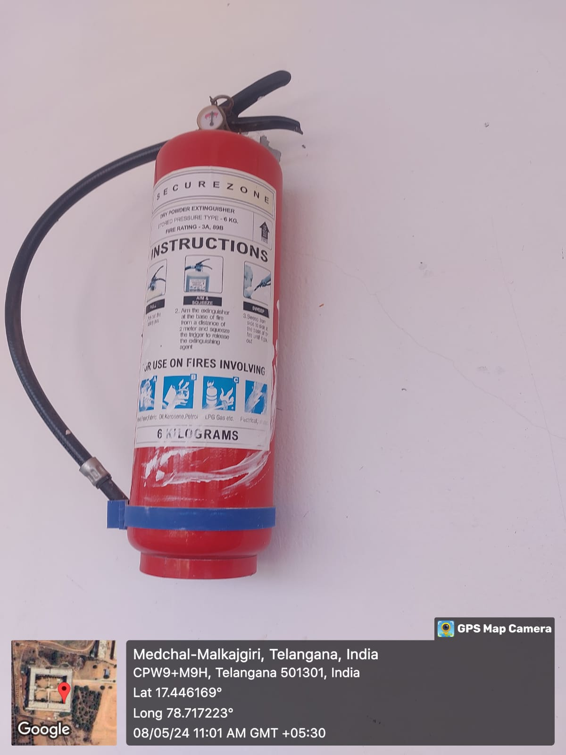

SECOND FLOOR

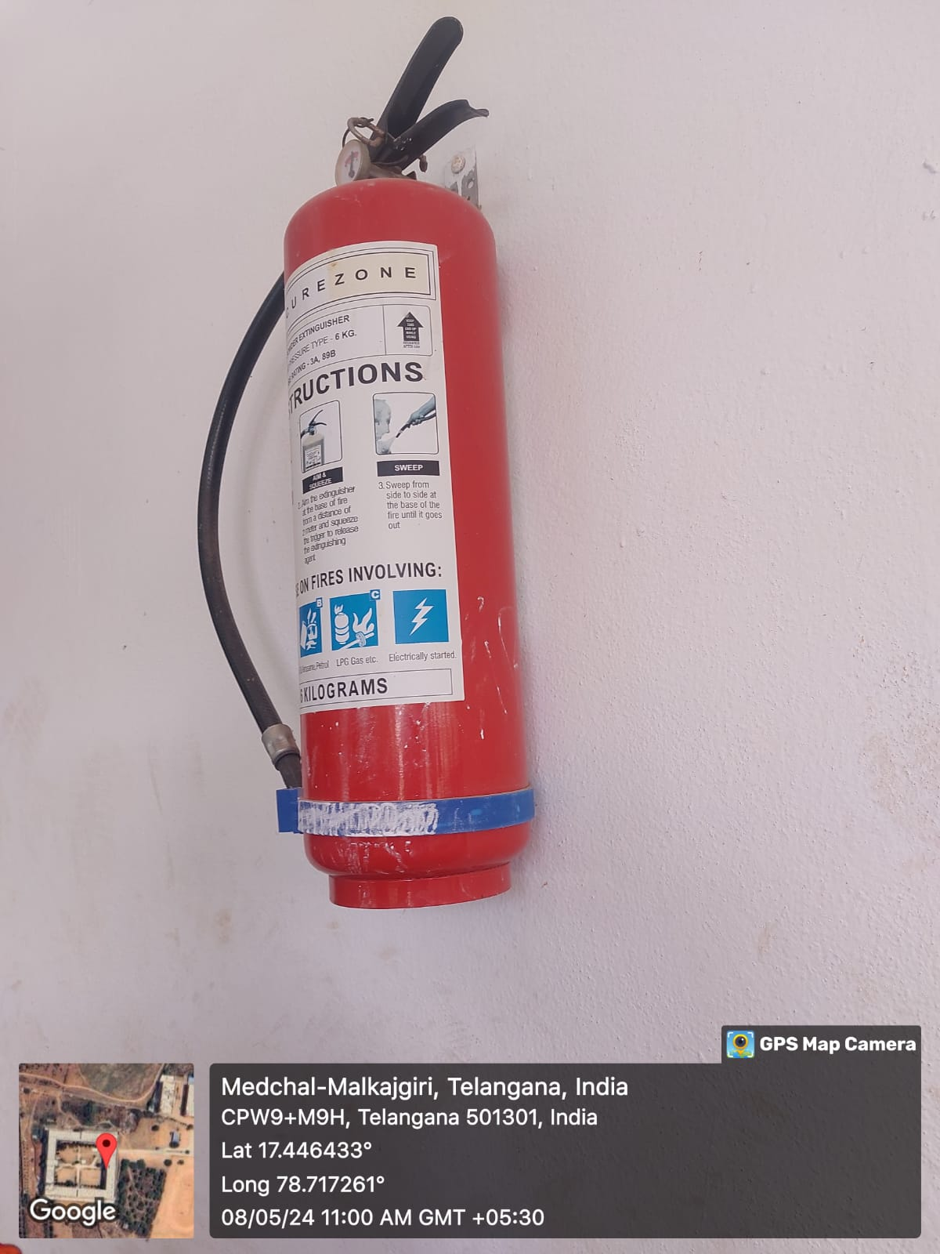

THIRD FLOOR

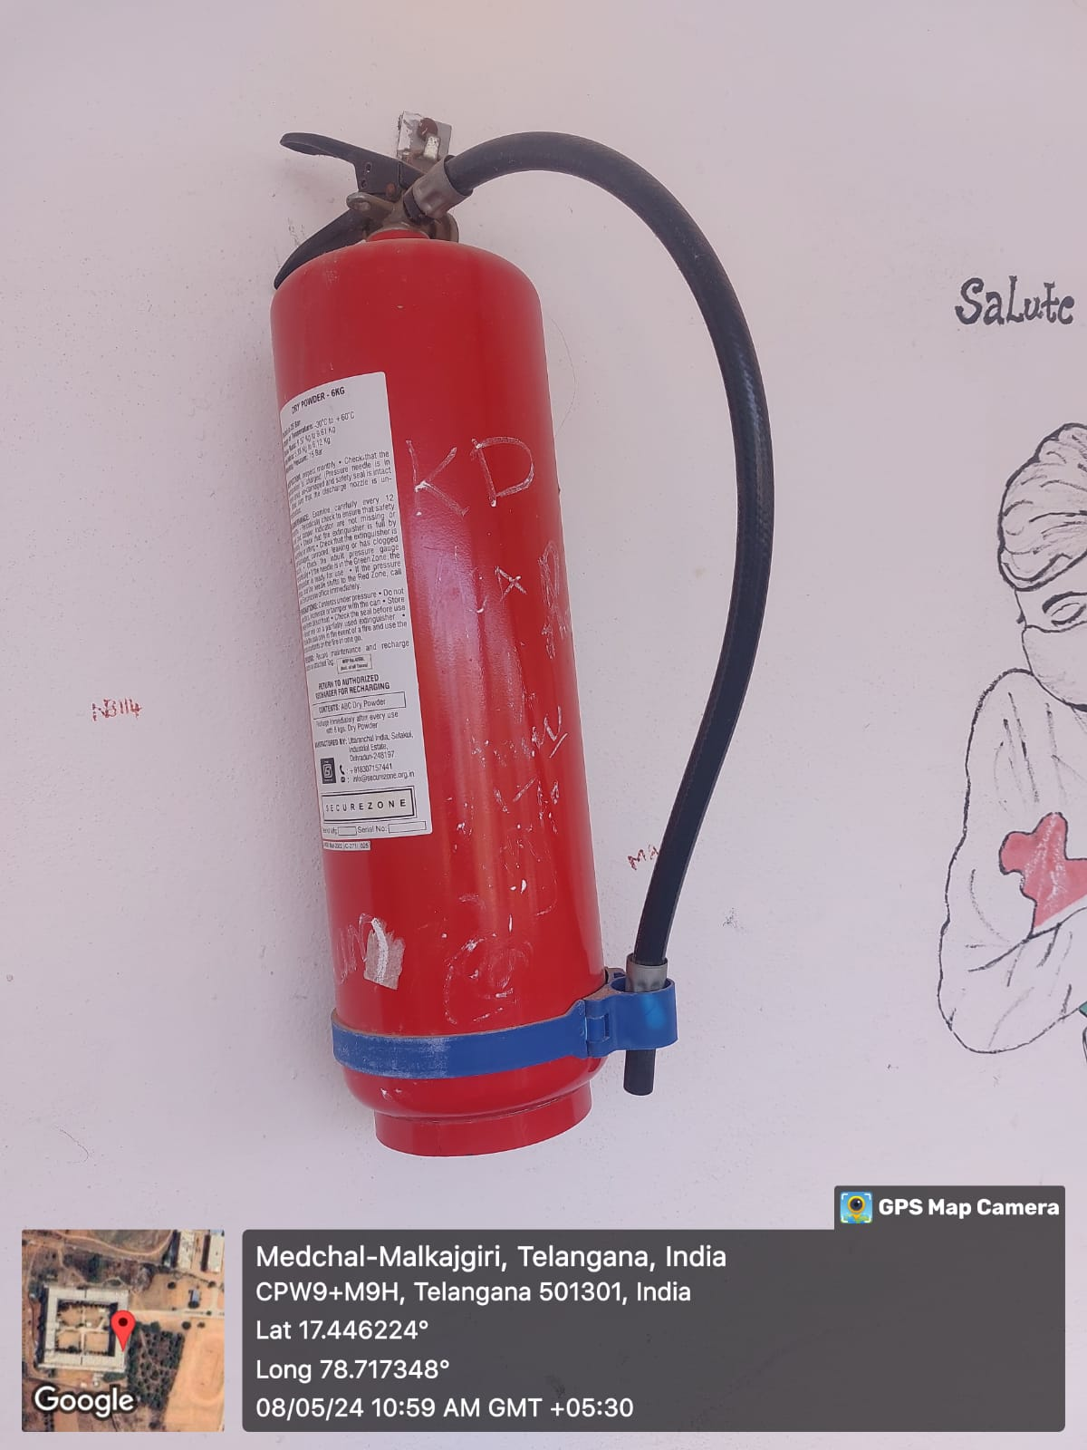

RO PLANT

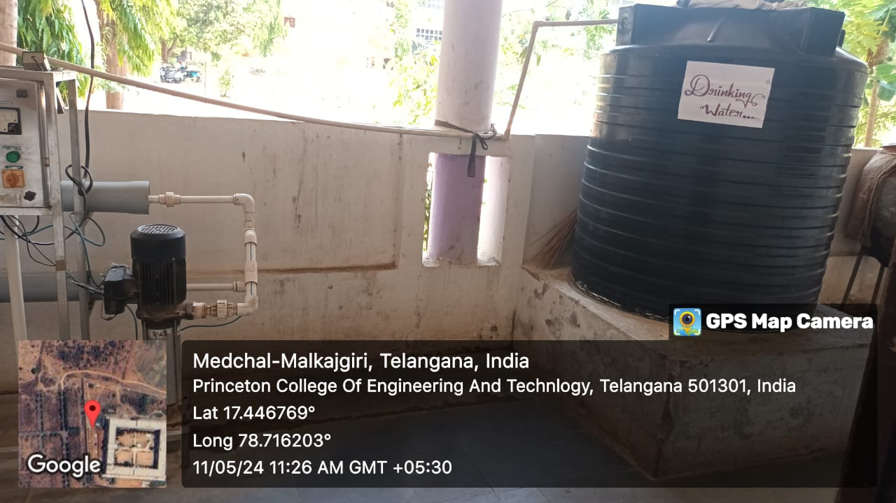

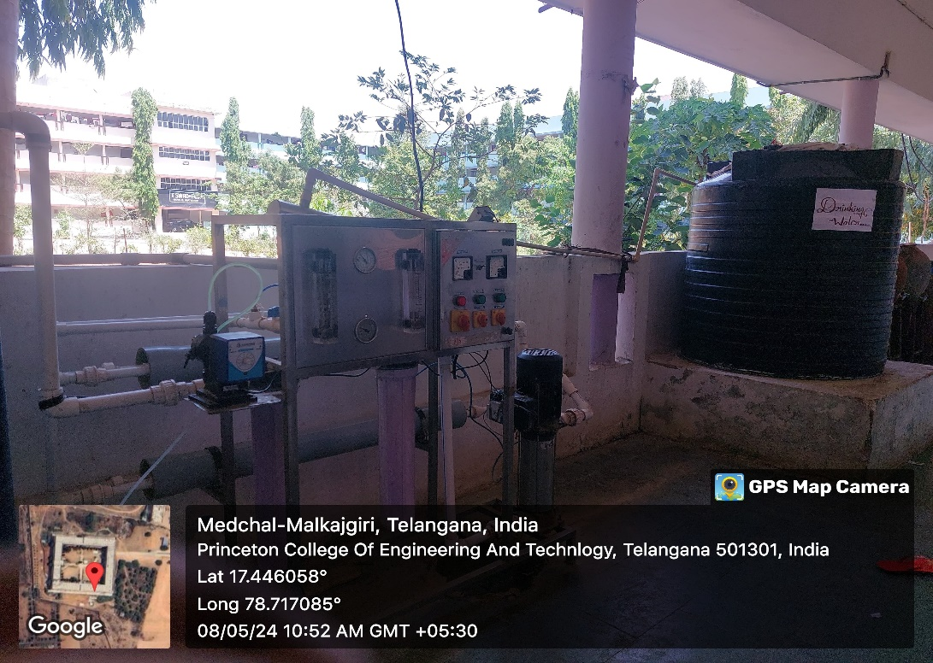

**OFFICE OF THE PRINCIPAL**

**TELANGANA SOCIAL WELFARE RESIDENTIAL DEGREE**

**& PG COLLEGE FOR WOMEN IBRAHIMPATNAM**

**AT ANKUSHAPUR**

**College Code: 61527**

**Wellness centre: OU College Code : 2814**

