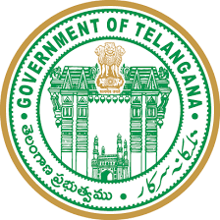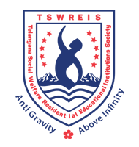0

**OFFICE OF THE PRINCIPAL**

**TELANGANA SOCIAL WELFARE RESIDENTIAL DEGREE**

**& PG COLLEGE FOR WOMEN IBRAHIMPATNAM**

**AT ANKUSHAPUR**

**College Code: 61527 OU College Code : 2814**

**Criteria-5**

**Metric No. 5.3.1**

Number of awards/medals for outstanding performance in sports/ cultural activities at University / state/ national / international level (award for a team event should be counted as one) during the last five years

|  |  |  |  |  |  |
| --- | --- | --- | --- | --- | --- |
| **YEAR** | **NAME OF THE AWARD/MEDAL** | **TEAM/INDIVIDUAL** | **UNIVERSITY/STATE/**  **NATIONAL/INTERNATIONAL** | **SPORTS/**  **GAMES** | **NAME OF THE**  **STUDENT & GROUP AND YEAR** |
| 2024 | First place in Gold medal | Team | RDC State meet | Volleyball | CH.Lavanya BA II YEAR  Bindhu BA I YEAR  Gayathri BA I YEAR  Maina BA I YEAR  B.Sravani BA III YEAR  Navya BA I YEAR |
| 2024 | Gold medal | Team | Inter college tournment in Osmania | Kabaddi | O.Prasanaa Jyothi BA III YEAR  Rajitha BA III YEAR  Nandhika II Year  Swarna II YEAR  Bindhu II YEAR  Shirisha I YEAR  Madhumathi I YEAR  Akhila I YEAR  Akhila I year  Abhinaya I YEAR  Swetha I YEAR  Manasa I YEAR |
| 2024 | Gold medal | Team | Inter college tournment in Osmania university | Tenny koit | Gayathri-BA III YEAR  Sravani-BA III YEAR  Akhila – I YEAR  Krishnaveni- I YEAR |
| 2024 | Bronze | Team | Inter college tornment in Osmania University | KHO-KHO | Gayathri -BA III YEAR  Manasa-BA III YEAR  Swarna-BA-II YEAR  Bindhu-BA-II YEAR  Sona-BA-II YEAR  Deepthi-BA-II YEAR Madhumathi-BA-I YEAR  Swetha-I YEAR  Saloni-I YEAR  Jaaru bhai-I YEAR  Sweety-I YEAR |
| 2024 | Silver-2 | Individual | Intern college tournments in  Osmania University | Athletics-100 Metres  Athletics-200 Meters | Mayavathi-BA II YEAR |
| 2024 | Silver-2 | Individual | RDC State level sports meet | Athletiics-200 mtrs  400 mtrs | Mayavathi-BA II YEAR |
| 2023 | Participation | Team | South zone inter university in chennai | Kabaddi | O.Prasanna |
| 2023 | Participation | Team | 51st Senior women Telangana state level hand ball championship | Handball | P.Pravalika |
| 2023 | Participation | Team | 51st Senior women Telangana state level hand ball championship | Handball | B.Srilatha |
| 2023 | Senior state meet |  |  |  |  |
| 2022 | Gold medal | Individual | Inter college athletic tournments for women | Athletic | P.Pravalika |
| 2022 | Bronze | Individual | Inter college atletic tournment for women | High jump | N.Jyoshna |
| 2022 | Gold | Individual | Inter college athletics for women | Athletics | Mayavathi |
| 2022 | Silver | Individual | Inter college athletics for women | Athletics | Mayavathi |
| 2022 | Silver | Individual | Inter college athletic tournments for women college | Athletics | Mayavathi |
| 2021 | Gold | Individual | State level 1500 meters | Athletic | A.Manasa |
| 2021 | Bronze | Individual | State level 4*100 Relay | Athletic | K.Manisha |
| 2021 | Participation | Individual | South zone national | Athletics | D.Bhagya laxmi |
| 2021 | Participation | Individual | 36TH National Junior athletics junior in assam | Athletics | D.Bhagya laxmi |
| 2021 | Gold | Individual | 81st All india inter university women athletics championship | Athletics | D. Bhgayalaxmi |
| 2020 | Bronze | Individual | State level | Karate | B.Sandhya |
| 2020 | Silver | Individual | State level | Karate | B.Sandhya |
| 2020 | Bronze | Individual | State level | Ball bat menton | K.Srikavya |
| 2020 | Participation | Individual | All India inter university | Yoga | D.Mounika |
| 2019 | Gold | Individual | Wrestling | Yoga | D.Swetha |

**7th RDC STATE MEET VOLLEY BALL CHAMPIONSHIP**

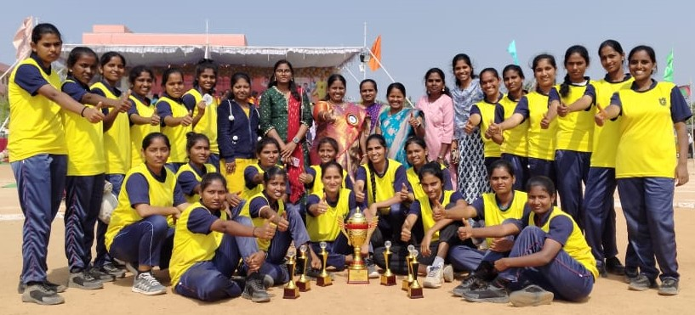

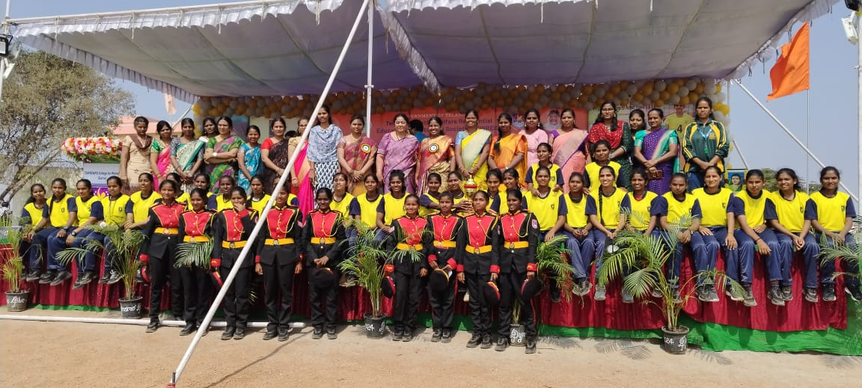

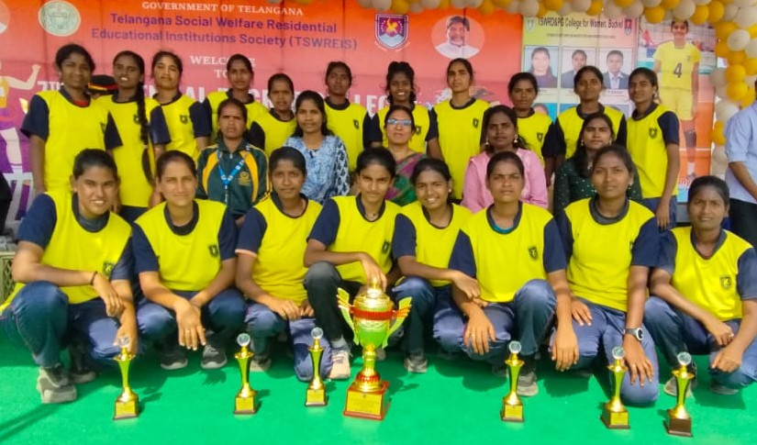

KABADDI INTER COLLEGE TOURNMENT IN OSMANIA UNIVERSITY

Our college students got first place in this tournament

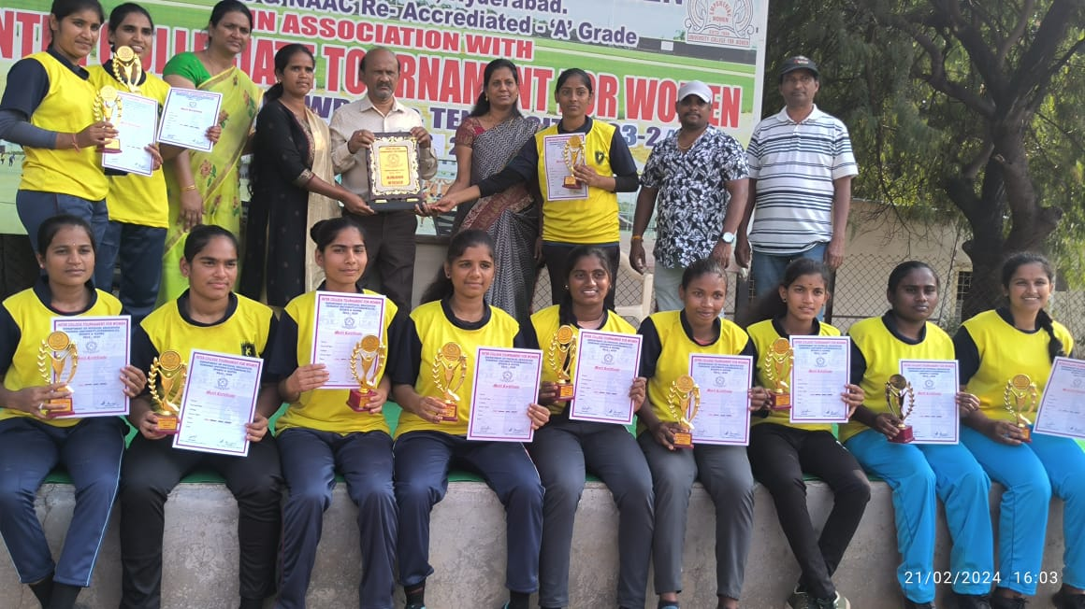

Osmania INETER COLLEGE TOURNMENTS KHO-KHO 3RD PLACE

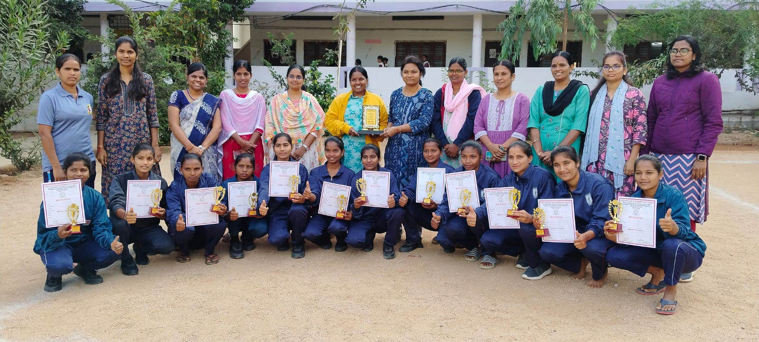

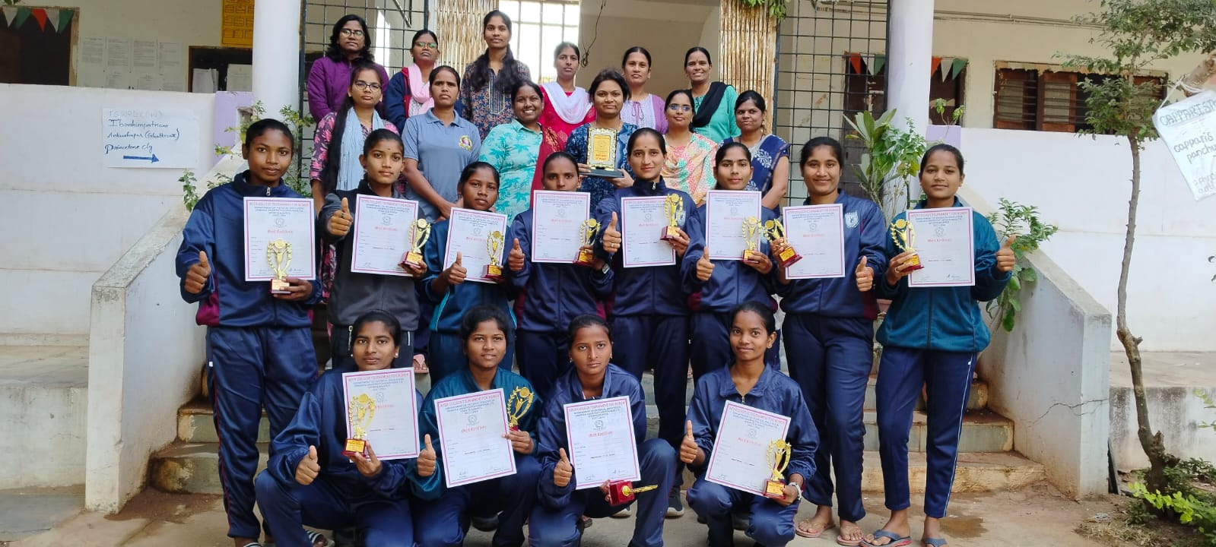

TSWRDCW IBRAHIMATNAM COLLEGE GROUND 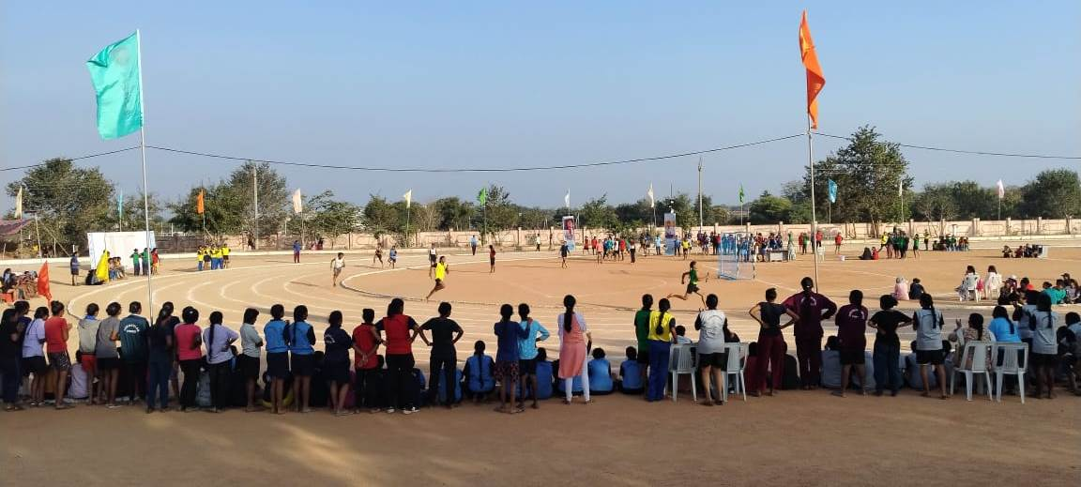

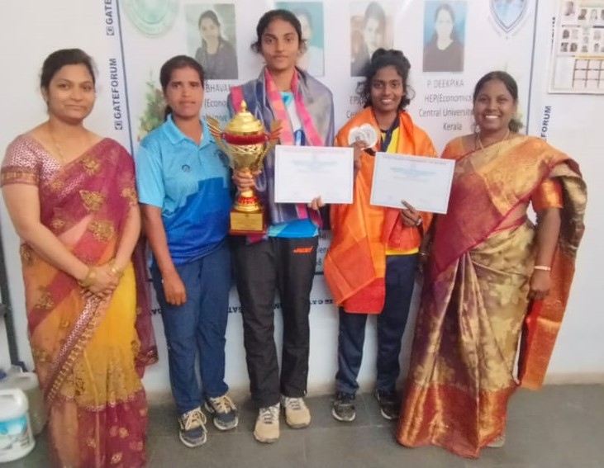

Indian volleyball player CH.Lavanya and National Athletic Mayavathi

Atletics Campionship Mayavathi 32 Nationals

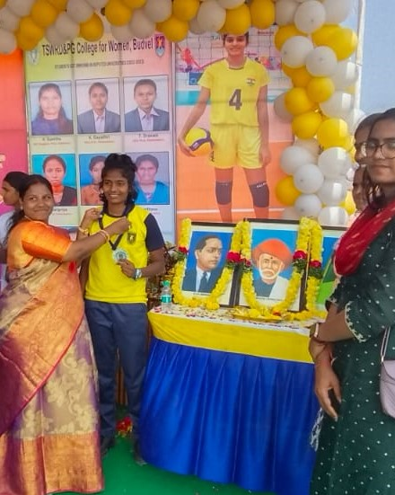\

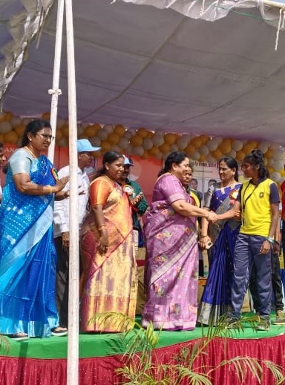

**7th RDC Sports meet Mayavathi she got 2nd place in 400mtrs athletics**

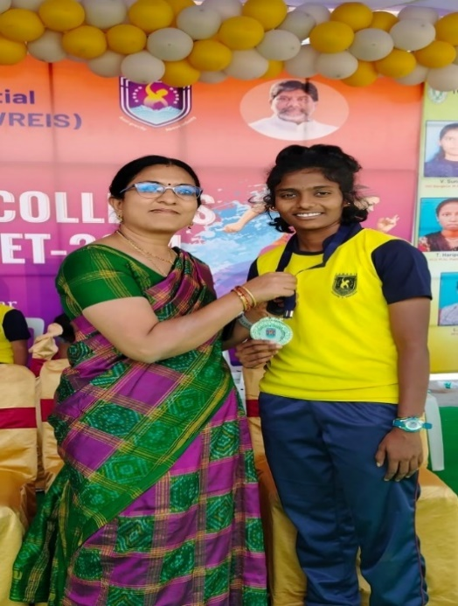

**TUG OF WAR**

South zone Tug of war selected students of TSWRDC(W) Ibrahimpatnam

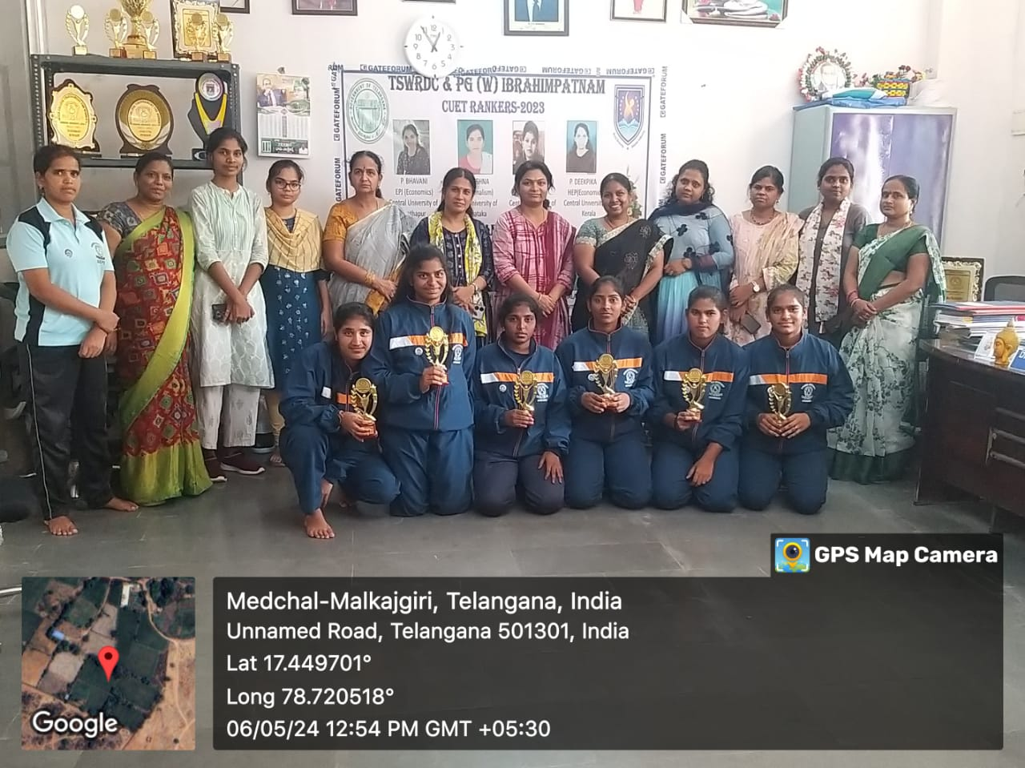

**Tennikoit**

Our students participated in Osmania University Inter College Tournament in This tournament Our students got First place

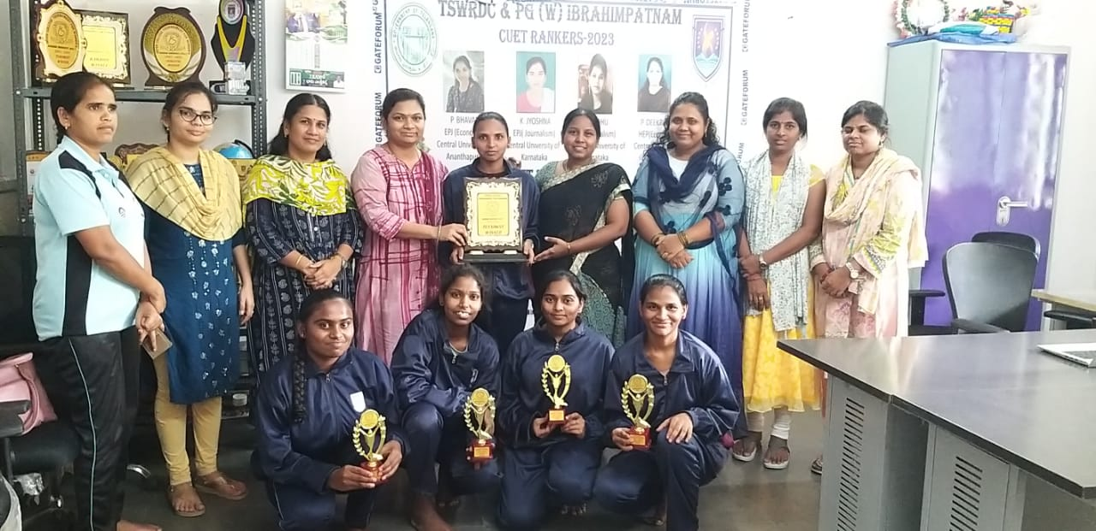

TSWRDC(W) Ibrahimpatnam - Gym Activities

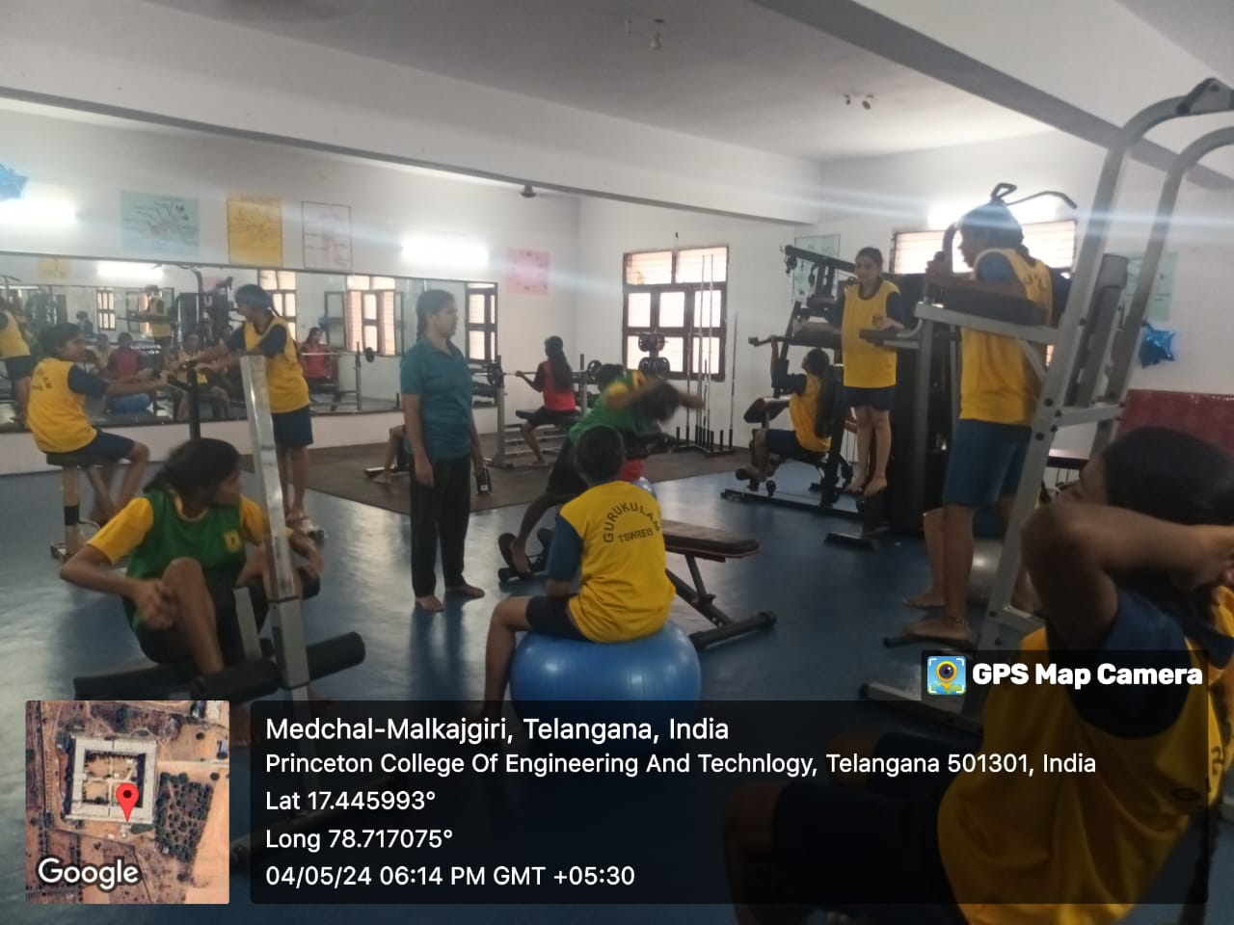 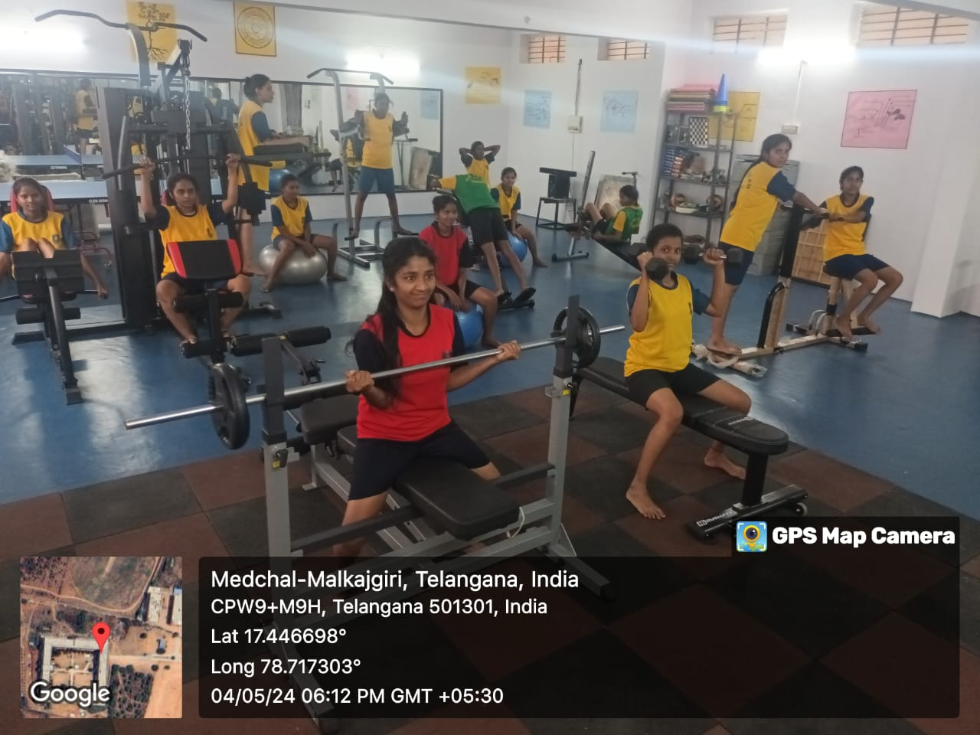

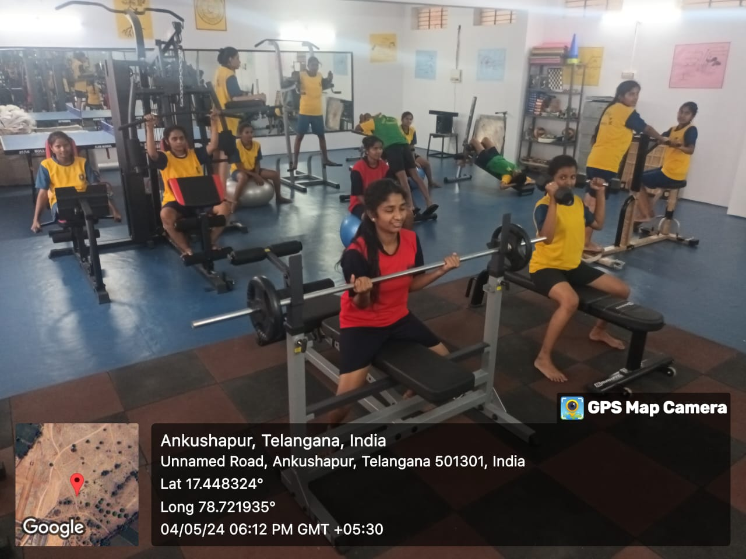

**Yoga and Meditation Activities**

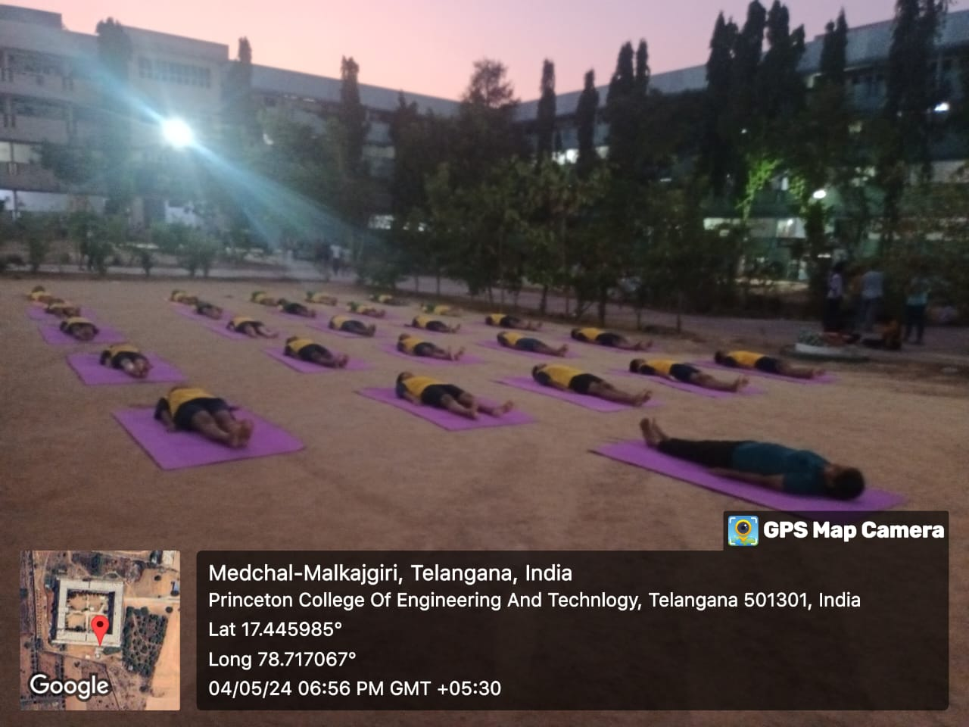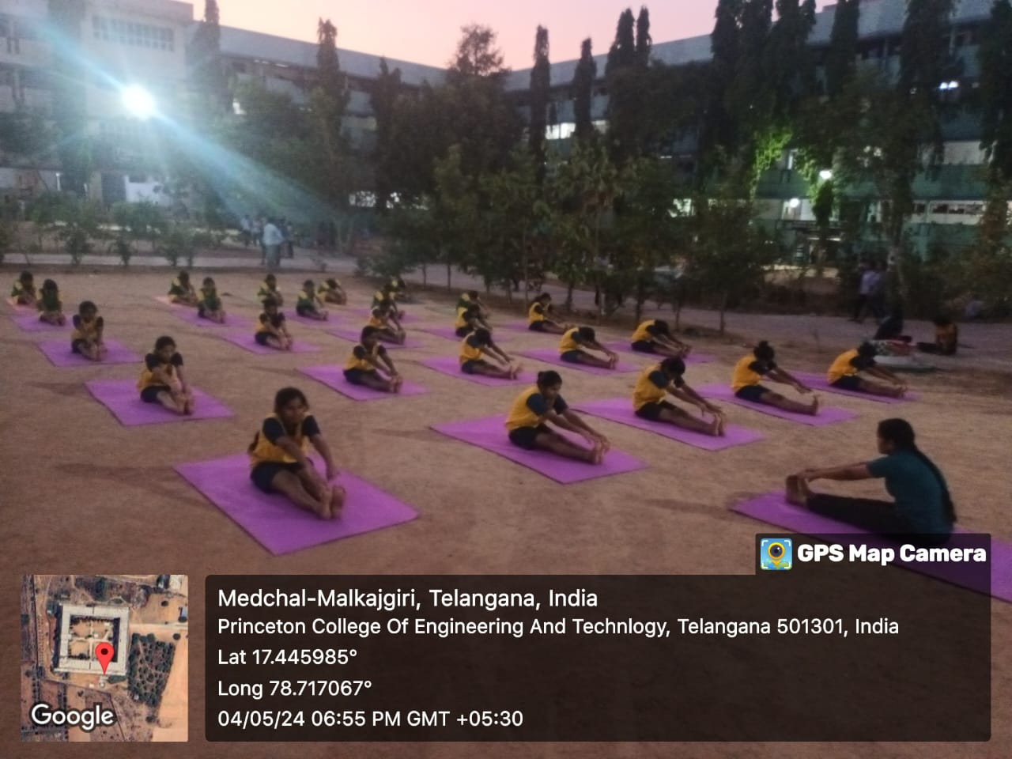

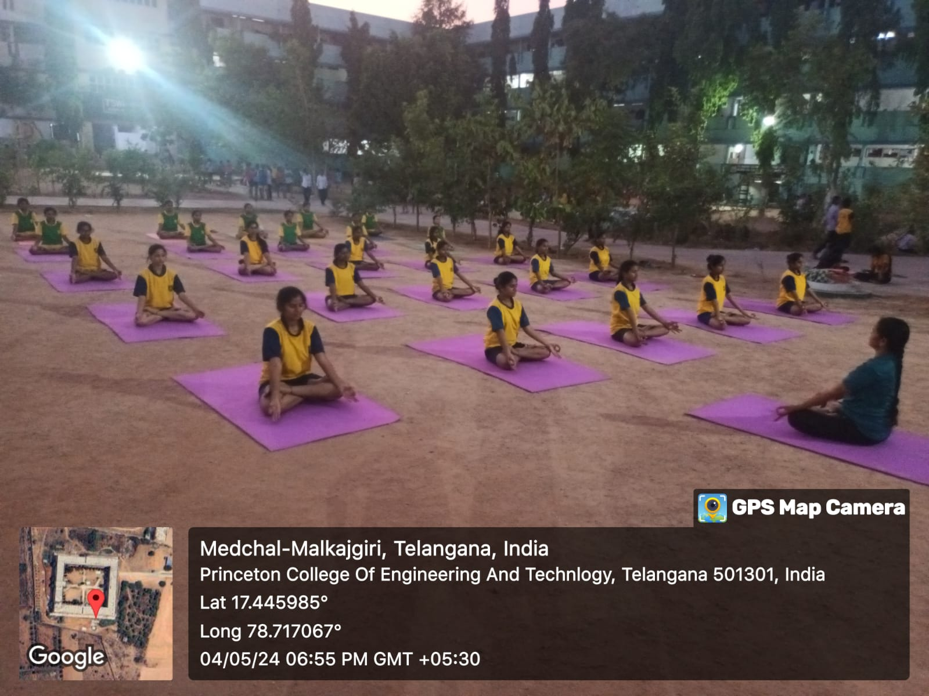

**TSWRDC(W) Ibrahimpatnam**

**Ground Activities**

**Kabaddi**

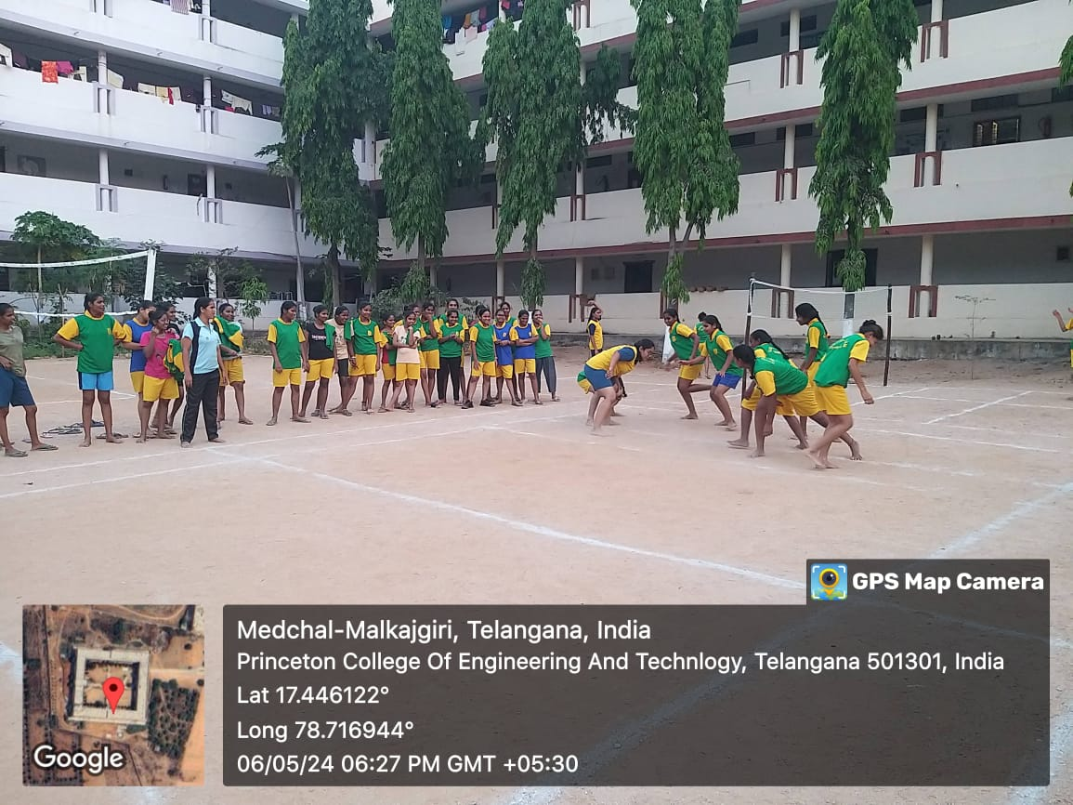

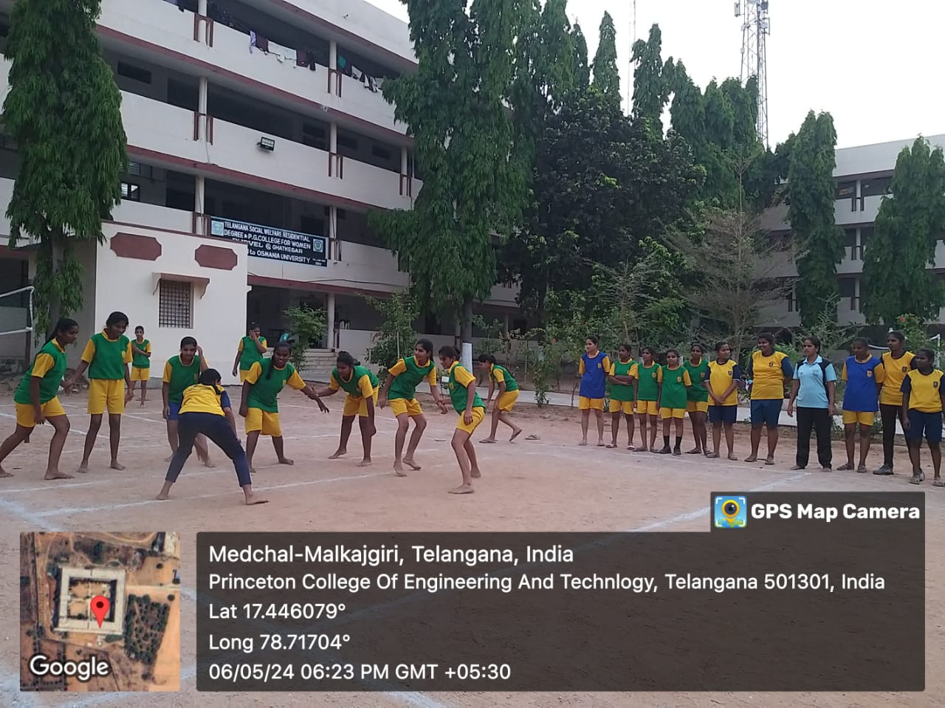

**Tennikoit**

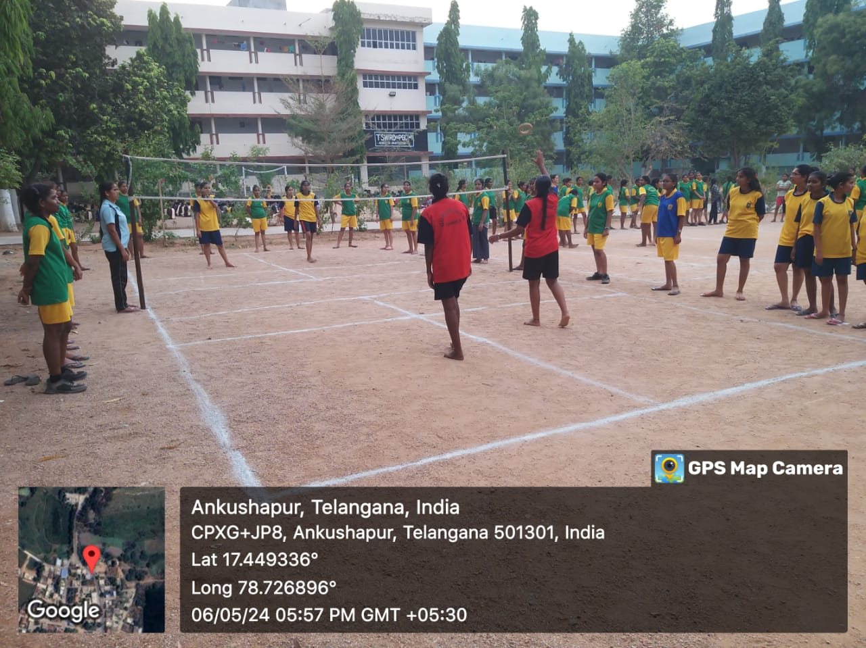

**Shuttle**

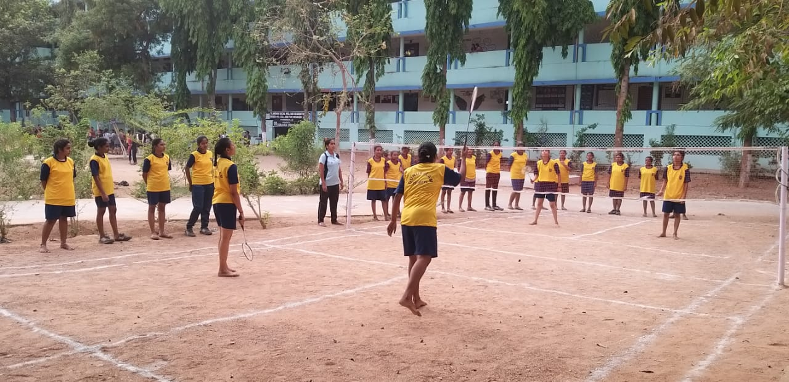

**VOLLEYBALL**

