  **TELANGANA SOCIAL WELFARE RESIDENTIAL DEGREE**

**& PG COLLEGE FOR WOMEN IBRAHIMPATNAM-501301**

**(Affiliated to Osmania University)**

**E-mail:prl-rdc-ibpm-swrs@telangana.gov.in**

**Website:** [**http://rdcwibrahimpatnam.tswreis.ac.in/**](http://rdcwibrahimpatnam.tswreis.ac.in/)

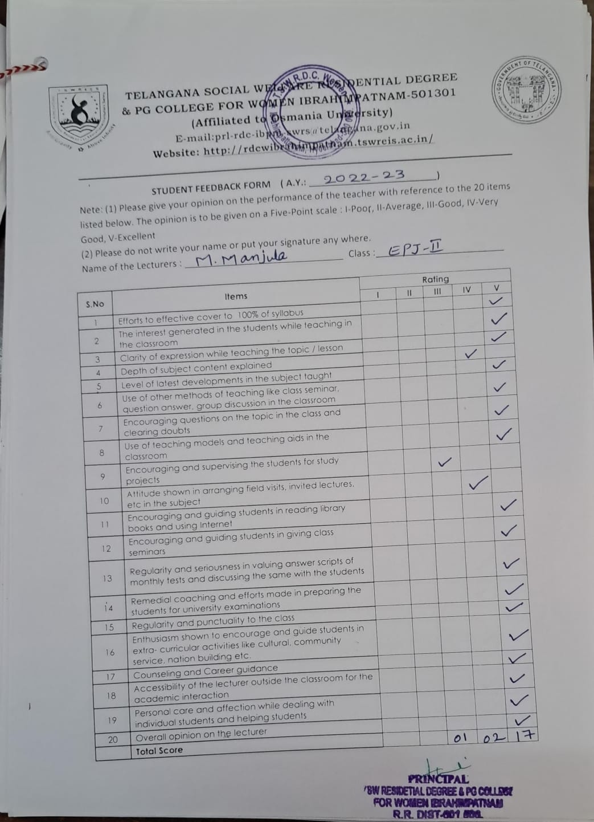

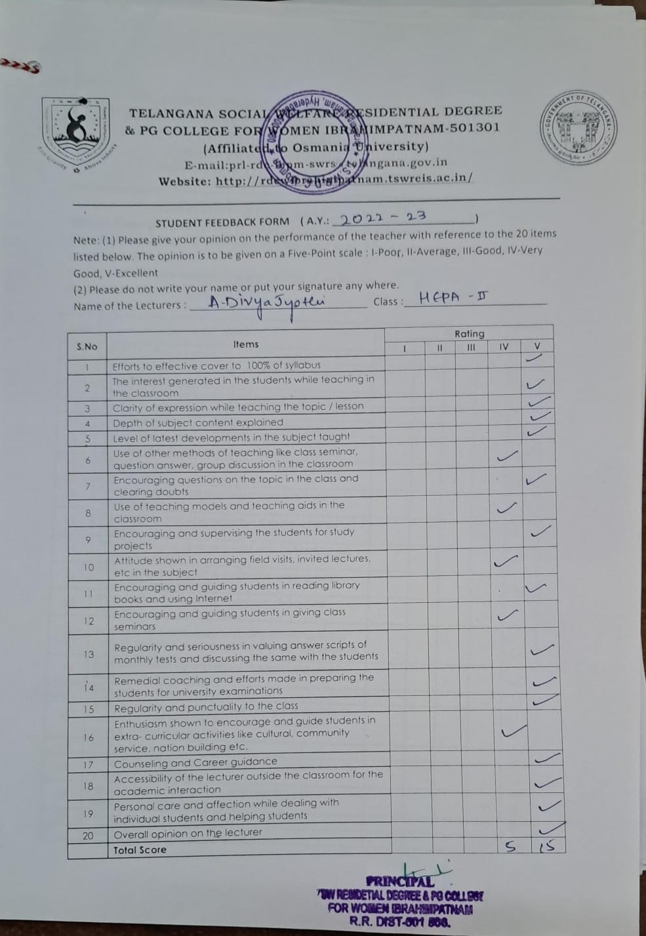

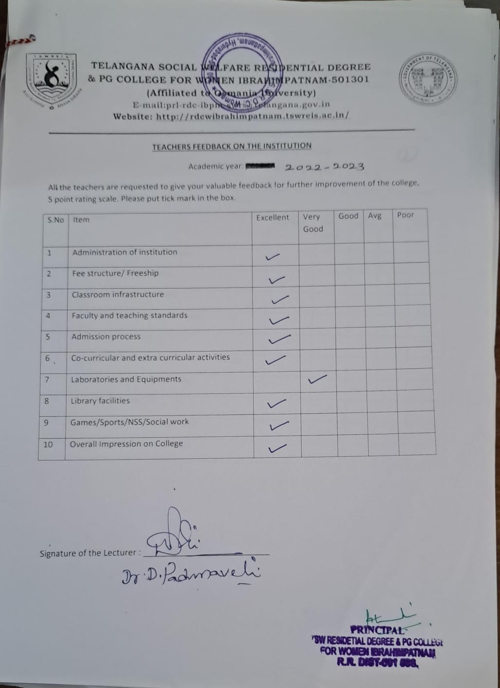

 **TELANGANA SOCIAL WELFARE RESIDENTIAL DEGREE**

**& PG COLLEGE FOR WOMEN IBRAHIMPATNAM-501301**

**(Affiliated to Osmania University)**

**E-mail:prl-rdc-ibpm-swrs@telangana.gov.in**

**Website:** [**http://rdcwibrahimpatnam.tswreis.ac.in/**](http://rdcwibrahimpatnam.tswreis.ac.in/)

**PROCEEDINGS** **OF** **INTERNAL QUALITY ASSURANCE CELL**

**AcademicYear2021-22**

The institution works persistently to maintain the calibre of its academic program, curriculum, and other elements. The most crucial component in maintaining and improving the institute's quality in all respects is gathering input from all stakeholders. The Internal Quality Assurance Cell (IQAC)gathers and evaluates comments from all parties involved in this process, including faculty and students, once a year. Feedback from faculty and students is collected during the academic year 2021 to 2022. Below is an analysis of the feedback received from the different stakeholders in the year 2021 to 2022.

|  |  |
| --- | --- |
| **Feedback Analysis** | **Action Taken** |
| **Teachers Feedback**  Feedback on the curriculum from faculty members is obtained, and it is discovered that replies range from Excellent to Very good and Strongly agree to Agree. No significant comments are identified. The curriculum is deemed to be effective in bridging the gap between academic and industry domains and appropriate for the associated courses. | Faculty members are provided with appropriate access to reference books and related materials. Teachers are encouraged by the institution to attend and participate in curriculum design. |
| **Students Feedback**  Based on the students' questionnaire, an analysis of their comments has been conducted, and the results range from Excellent to Average. Students noticed that in addition to using appropriate remedial teaching methods,100% of the syllabus is covered clearly and with relevant teaching techniques, encouraging students to ask questions and get their doubts answered. | Project work, field works is also encouraged, and peer learning and collaborative learning are promoted with appropriate personal care. Individual counselling is also provided. |
| **Parents feedback**  Majority of the parents were satisfied with infrastructure, learning and environment in the college. A few suggested improvements in facilities | The college is continuing to address the needs of the students so that their parents are also satisfied with the facilities and teaching learning environment in the college. |

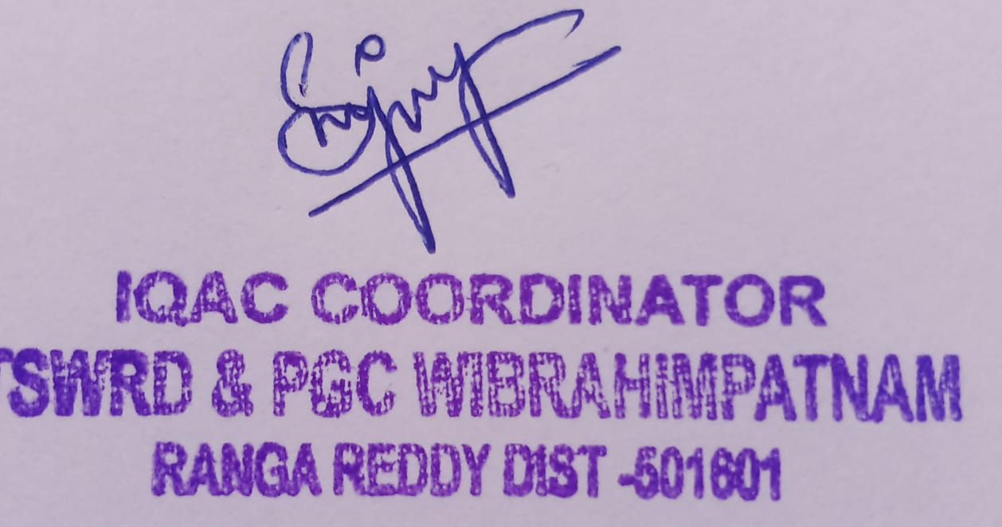 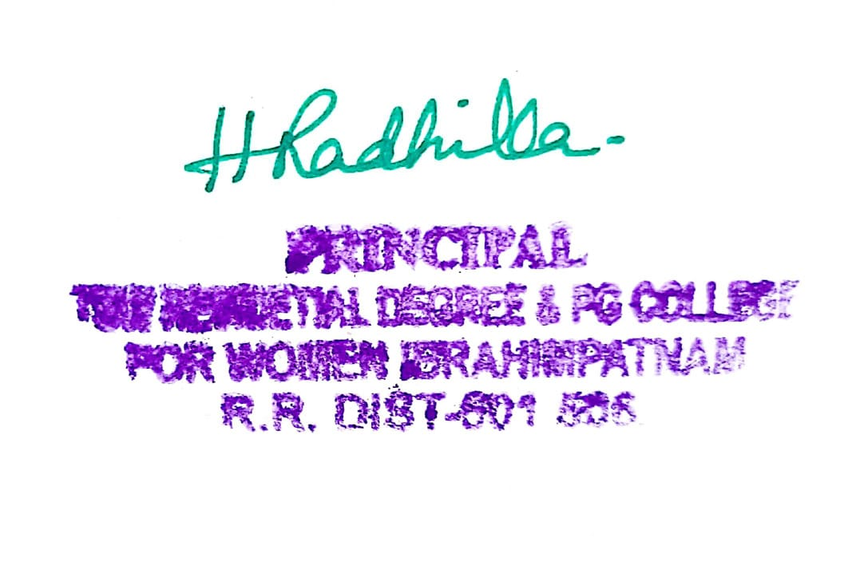

**IQAC Coordinator PRINCIPAL**

** TELANGANA SOCIAL WELFARE RESIDENTIAL DEGREE**

**& PG COLLEGE FOR WOMEN IBRAHIMPATNAM-501301**

**(Affiliated to Osmania University)**

**E-mail:prl-rdc-ibpm-swrs@telangana.gov.in**

**Website:** [**http://rdcwibrahimpatnam.tswreis.ac.in/**](http://rdcwibrahimpatnam.tswreis.ac.in/)

**PROCEEDINGS OF INTERNALQUALITY ASSURANCE CELL AcademicYear2022-2023**

The institution works persistently to maintain the calibre of its academic program, curriculum, and other elements. The most crucial component in maintaining and improving the institutions quality in all respects is gathering feedback from all stakeholders. The Internal Quality Assurance Cell (IQAC) collects and evaluates comments from all parties involved in this process, including faculty, students, and alumni, once a year. Feedback from faculty and students is collected during the academic year 2022-2023. Below is an analysis of the feedback received from different stakeholders in the year 2022–2023.

|  |  |
| --- | --- |
| **Feedback Analysis** | **Action Taken** |
| **Teachers Feedback**  Request to provide more ICT tools for better teaching and organize FDPs Modifications in the syllabus of certain departments is suggested | FDPs organized on Teaching Learning Methodology. To improve the ICT facilities A request letter is submitted to the University Academic Audit Cell for syllabus modifications. |
| **Students Feedback**  More reference books and competitive exam preparation material in the library and Requested for Sports and Gymnasium. | Post Graduate entrance material and competitive exam books are provided in the library. Gymnasium is established |
| **Parents Feedback**  Majority of the parents were satisfied with infrastructure, learning and environment in the college. A few suggested improvements in facilities. | The college is continuing to address the requirements of the students so that their parents are also satisfied with the faculty and teaching learning environment within the college. |
| **Alumni Feedback**  Alumni Feedback has been received from the members who are working in various fields. It is observed that their responses are ranging from Excellent too Good. The institution has received good response in terms of course, student teacher relationship, college campus, educational resources, college administration. | Teachers are in continuous interaction with Alumni and guide them in their career. At the same time, alumni are requested to motivate the students whenever they visit the campus. |

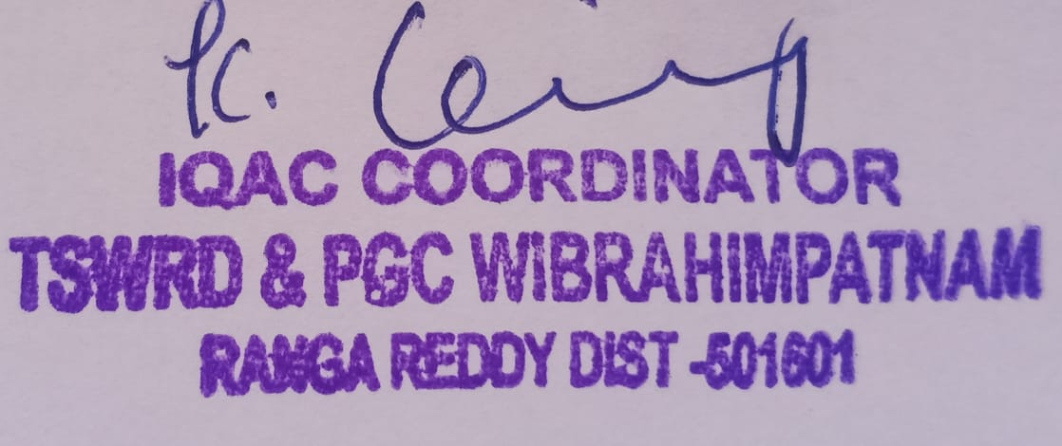 

IQAC Coordinator PRINCIPAL

