
TELANGANA SOCIAL WELFARE RESIDENTIAL DEGREE
& PG COLLEGE FOR WOMEN IBRAHIMPATNAM-501301
(Affiliated to Osmania University)
E-mail:prl-rdc-ibpm-swrs@telangana.gov.in
Website: http://rdcwibrahimpatnam.tswreis.ac.in/

Students Feedback on Teachers
A.Y.: 2018-2019

In order to know the students feedback on Teachers, the college has a standard practice of collecting feedback from students at the end of every academic year. A pre designed feedback sheet is given to the students consisting of 20 questions on various parameters relating to the Teachers. The students are required to give the ranking ranging from I to V. The ranks are assigned as:
S.NO | Rank | Score (Weight)
01 | Poor | +1
02 | Average | +2
03 | Good | +3
04 | Very Good | +4
05 | V-Excellent | +5
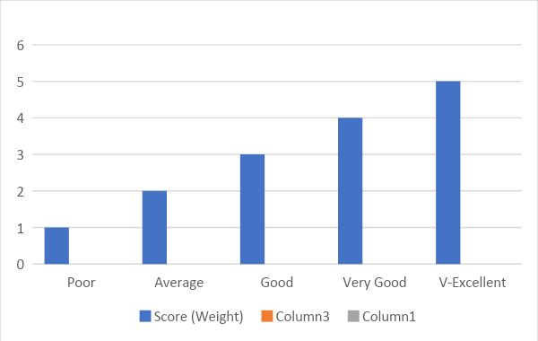
S.NO | Name Of The Lecturer | Subject | Q.1 | Q.2 | Q.3 | Q.4 | Q.5 | Q.6 | Q.7 | Q.8 | Q.9 | Q.10 | Q.11 | Q.12 | Q.13 | Q.14 | Q.15 | Q.16 | Q.17 | Q.18 | Q.19 | Q.20 | Total | Remarks
1 | S.Padma | Telugu | 4 | 5 | 3 | 3 | 4 | 3 | 3 | 2 | 3 | 3 | 4 | 4 | 4 | 3 | 4 | 3 | 4 | 4 | 4 | 3 | 70 | Very Good
p2 | K.Nagalatha | English | 4 | 4 | 3 | 3 | 3 | 3 | 4 | 2 | 3 | 2 | 3 | 3 | 4 | 4 | 4 | 3 | 4 | 4 | 4 | 3 | 67 | Very Good
3 | B.Radhika | History | 4 | 3 | 3 | 2 | 2 | 3 | 4 | 3 | 3 | 2 | 3 | 3 | 4 | 3 | 4 | 2 | 3 | 4 | 3 | 3 | 61 | Very Good
4 | S.Mumtaz | Economics | 5 | 4 | 4 | 4 | 4 | 4 | 3 | 3 | 3 | 4 | 4 | 4 | 4 | 4 | 4 | 4 | 4 | 4 | 4 | 4 | 78 | Very Good
5 | Shabana Begum | Political Science | 4 | 4 | 3 | 2 | 3 | 3 | 3 | 2 | 3 | 2 | 4 | 3 | 4 | 3 | 3 | 3 | 3 | 3 | 3 | 3 | 61 | Very Good
6 | N.Vichitra | Public Administration | 3 | 4 | 3 | 3 | 3 | 2 | 3 | 3 | 4 | 3 | 3 | 3 | 2 | 3 | 3 | 3 | 2 | 3 | 3 | 3 | 59 | Good
7 | P.Annapurna | Economics | 5 | 4 | 5 | 4 | 5 | 4 | 5 | 4 | 5 | 5 | 5 | 4 | 5 | 4 | 4 | 5 | 4 | 5 | 5 | 5 | 92 | Excellent
8 | A.Rekha | Political Science | 3 | 3 | 4 | 3 | 3 | 4 | 3 | 3 | 3 | 3 | 4 | 3 | 3 | 4 | 3 | 3 | 3 | 3 | 4 | 3 | 65 | Very Good
9 | D.Vignaneshwari | Economics | 5 | 4 | 4 | 4 | 5 | 4 | 4 | 3 | 3 | 3 | 5 | 4 | 5 | 5 | 5 | 5 | 4 | 5 | 5 | 5 | 87 | Excellent
10 | S.Deeparani | Telugu | 4 | 4 | 5 | 4 | 4 | 3 | 4 | 3 | 4 | 2 | 4 | 4 | 4 | 4 | 4 | 4 | 4 | 4 | 4 | 4 | 77 | Very Good
11 | Ch.Mounika | Jounalism | 5 | 5 | 4 | 5 | 4 | 3 | 4 | 5 | 5 | 4 | 5 | 5 | 4 | 5 | 5 | 5 | 5 | 5 | 5 | 5 | 93 | Excellent
12 | M.Venkateshwarlu | Telugu | 4 | 5 | 4 | 5 | 4 | 4 | 5 | 3 | 3 | 3 | 4 | 5 | 4 | 4 | 5 | 4 | 5 | 5 | 5 | 5 | 86 | Excellent
13 | Sneha Patil | History | 4 | 4 | 3 | 4 | 4 | 3 | 4 | 4 | 3 | 2 | 4 | 3 | 4 | 4 | 4 | 4 | 4 | 4 | 4 | 4 | 74 | Very Good
14 | T.Alekhya | Geography | 4 | 4 | 3 | 4 | 3 | 4 | 3 | 3 | 3 | 4 | 3 | 2 | 3 | 3 | 3 | 3 | 3 | 3 | 3 | 3 | 64 | Very Good

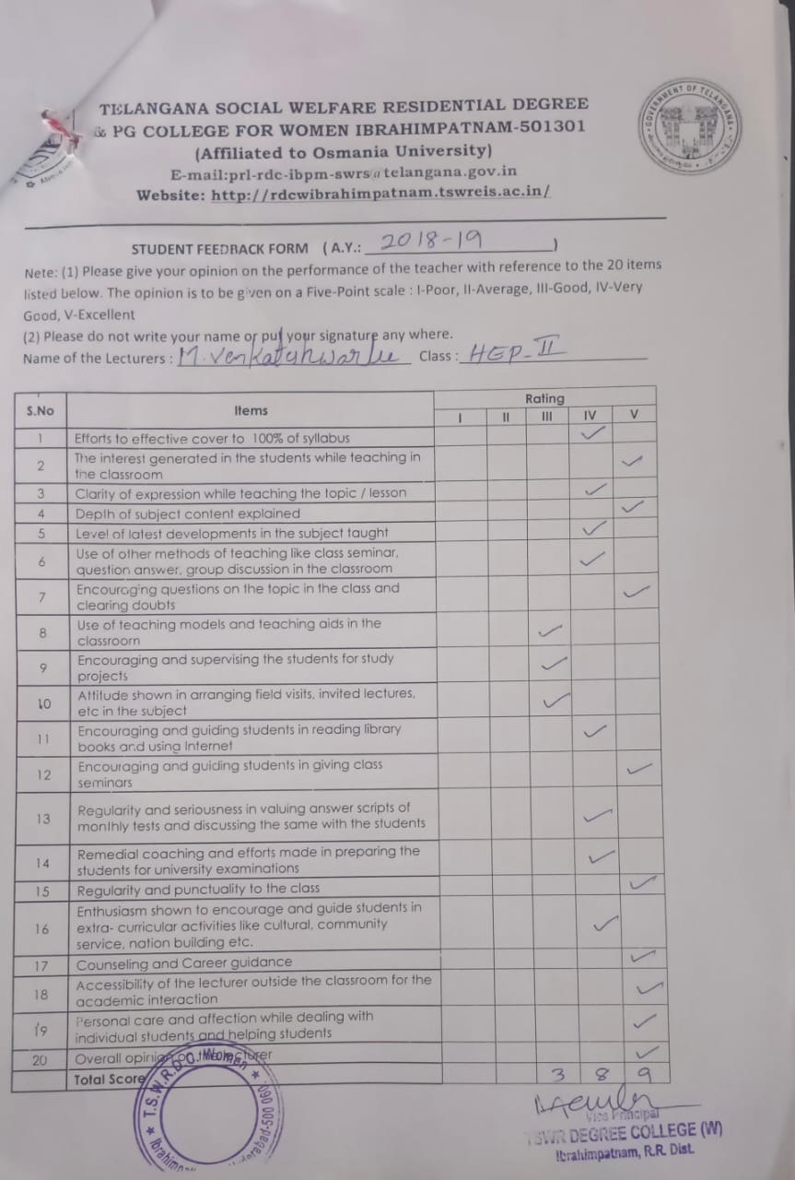
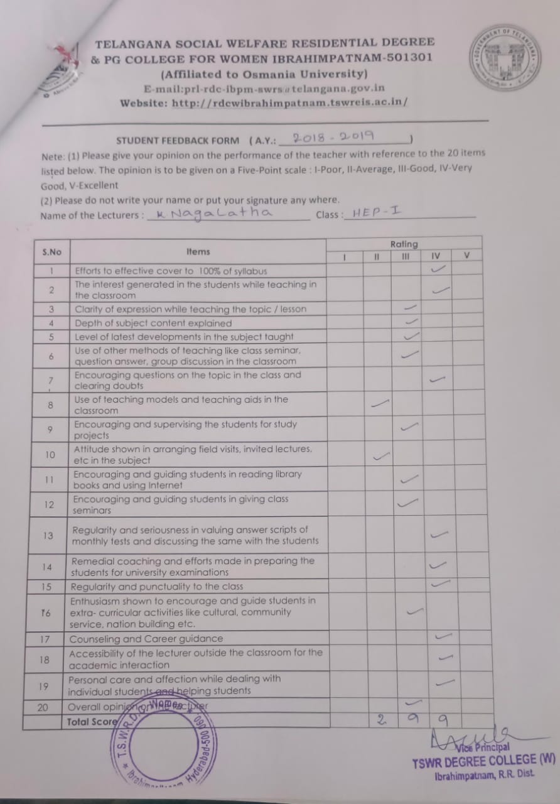

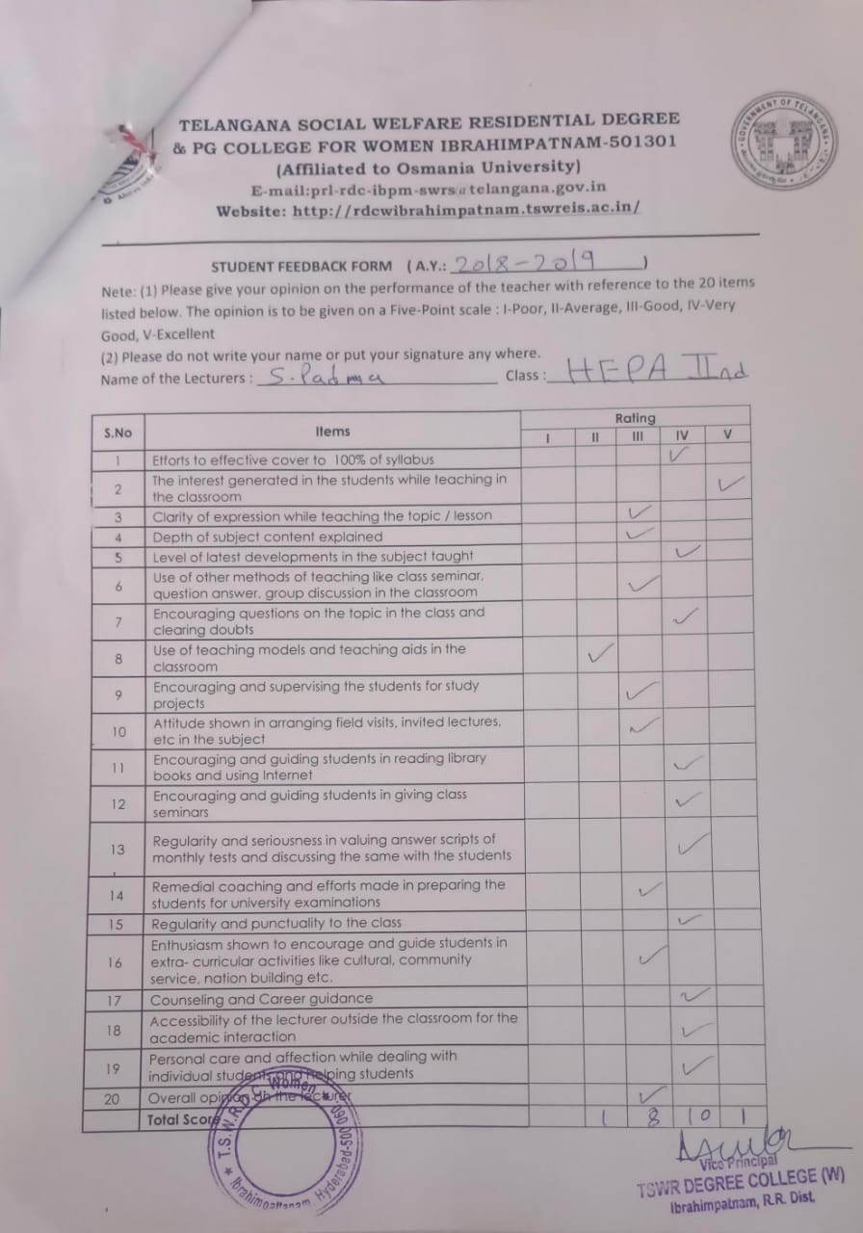

TELANGANA SOCIAL WELFARE RESIDENTIAL DEGREE
& PG COLLEGE FOR WOMEN IBRAHIMPATNAM-501301
(Affiliated to Osmania University)
E-mail:prl-rdc-ibpm-swrs@telangana.gov.in
Website: http://rdcwibrahimpatnam.tswreis.ac.in/

Students Feedback on Teachers
A.Y.: 2018-2019

Report :
- 0-20M -Poor,
21-40M-Average
41-60M- Good
61-80M – Very Good
81-100M- Excellent
- Based on the Feedback of the students 4 Lecturers scored Excellent score, 9 Lecturers scored Very Good Score & 1 Lecturer scored Good Score.

TELANGANA SOCIAL WELFARE RESIDENTIAL DEGREE
& PG COLLEGE FOR WOMEN IBRAHIMPATNAM-501301
(Affiliated to Osmania University)
E-mail:prl-rdc-ibpm-swrs@telangana.gov.in
Website: http://rdcwibrahimpatnam.tswreis.ac.in/

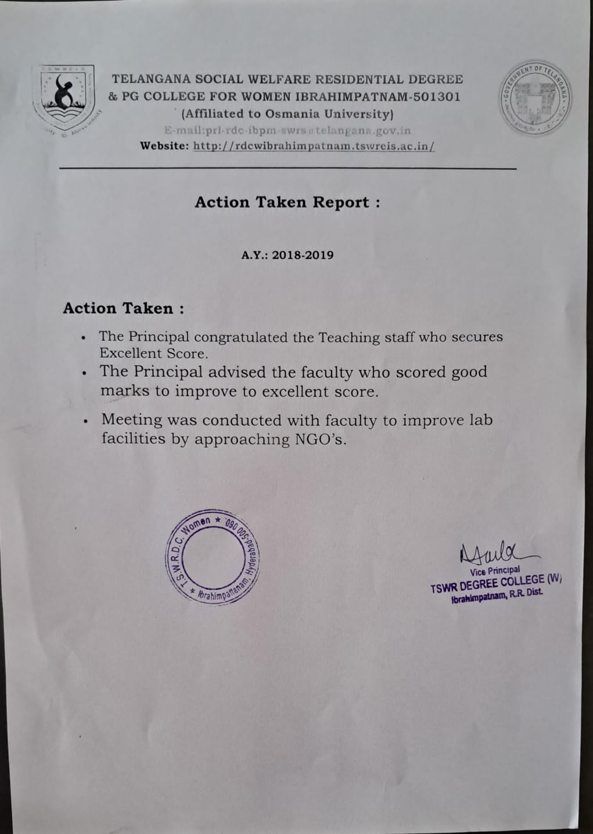
TELANGANA SOCIAL WELFARE RESIDENTIAL DEGREE
& PG COLLEGE FOR WOMEN IBRAHIMPATNAM-501301
(Affiliated to Osmania University)
E-mail:prl-rdc-ibpm-swrs@telangana.gov.in
Website: http://rdcwibrahimpatnam.tswreis.ac.in/

Teachers Feedback
A.Y.: 2018-2019

S.No | Item | Excellent | Very Good | Good | Average | Poor | Total
1 | Q.1 | 3 | 2 | 5 | 0 | 0 | 10
2 | Q.2 | 10 | 0 | 0 | 0 | 0 | 10
3 | Q.3 | 0 | 0 | 5 | 5 | 0 | 10
4 | Q.4 | 0 | 6 | 4 | 0 | 0 | 10
5 | Q.5 | 1 | 7 | 2 | 0 | 0 | 10
6 | Q.6 | 0 | 1 | 6 | 3 | 0 | 10
7 | Q.7 | 0 | 0 | 1 | 2 | 7 | 10
8 | Q.8 | 0 | 0 | 3 | 4 | 3 | 10
9 | Q.9 | 0 | 0 | 6 | 4 | 0 | 10
10 | Q.10 | 0 | 0 | 6 | 4 | 0 | 10
 |  | 14 | 16 | 38 | 22 | 10 | 100
Note : The Numbers indicate the total number of Stakeholders voted for particular question.
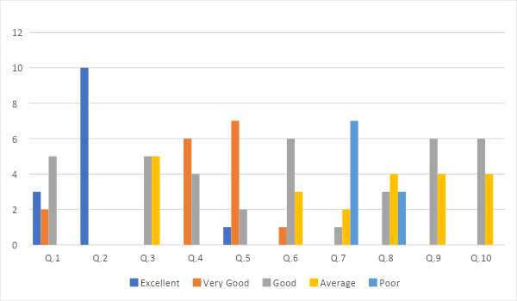
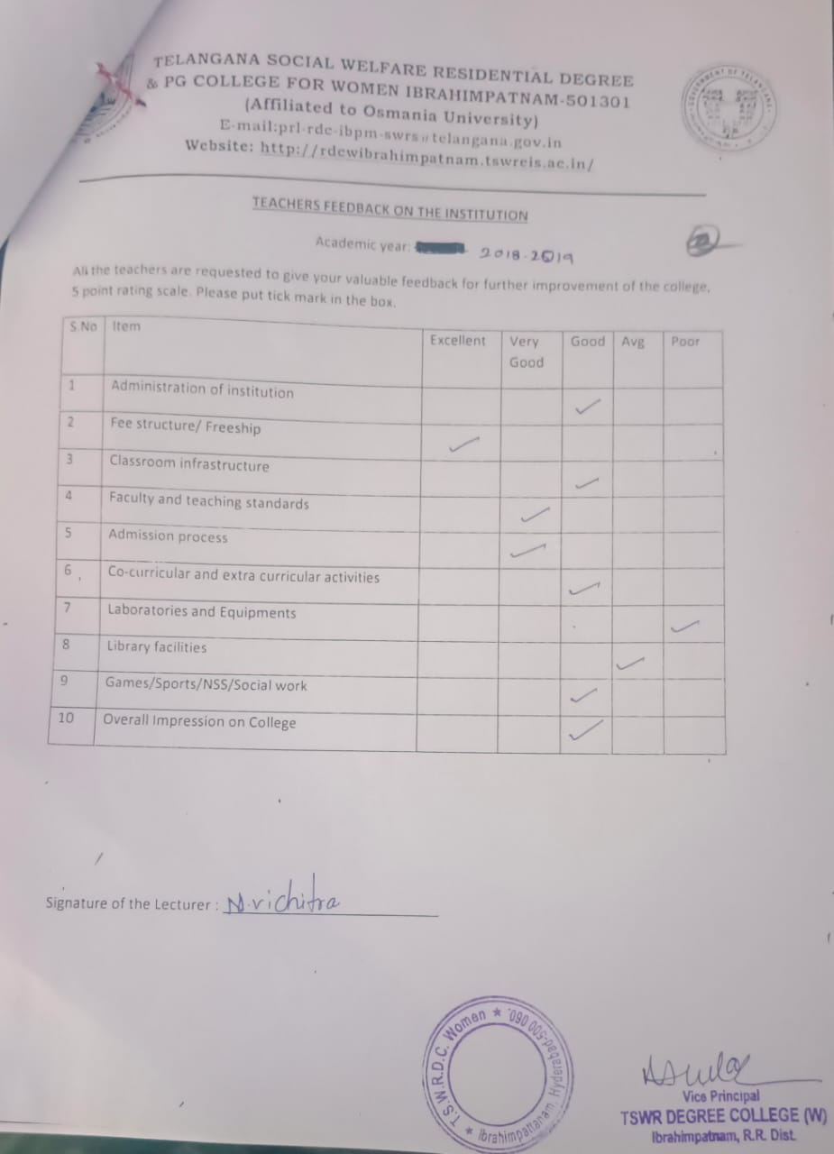

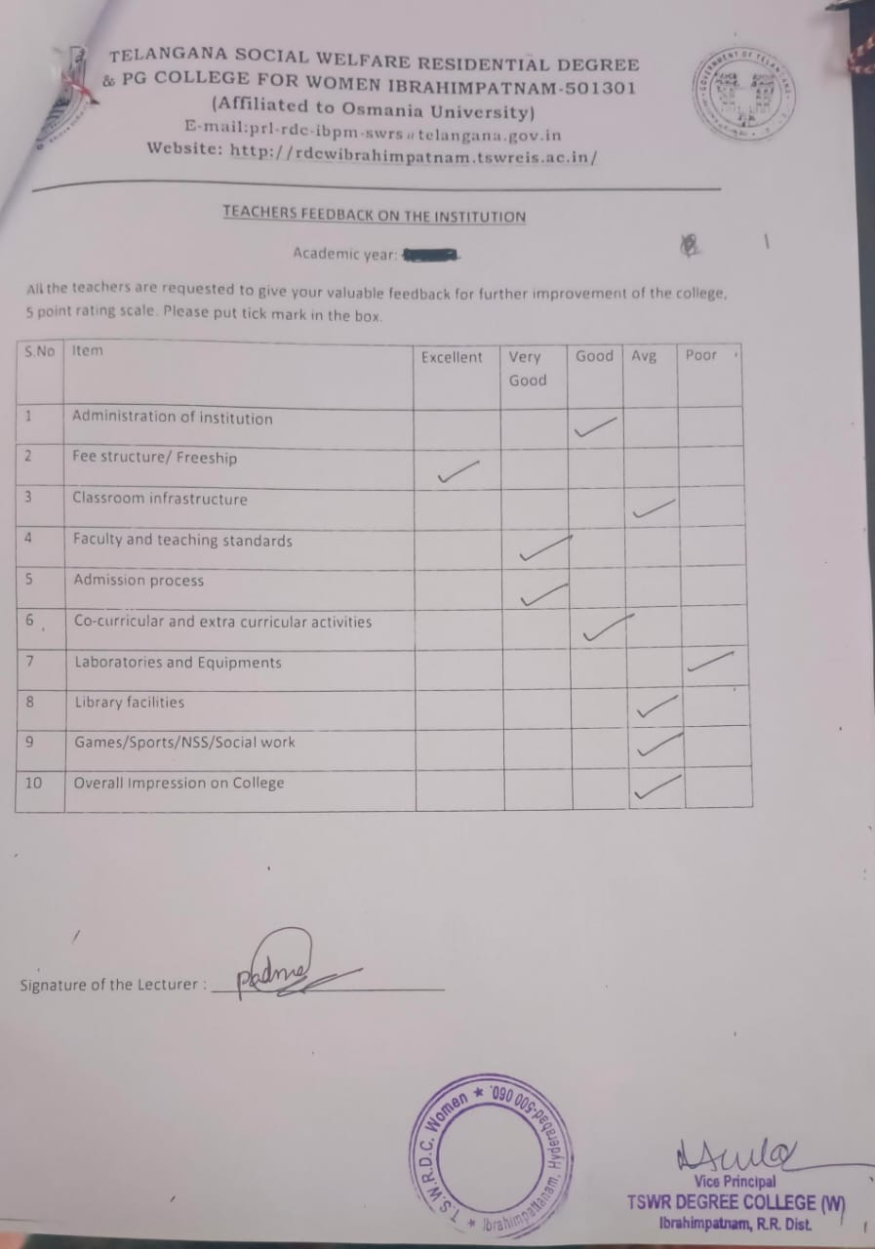

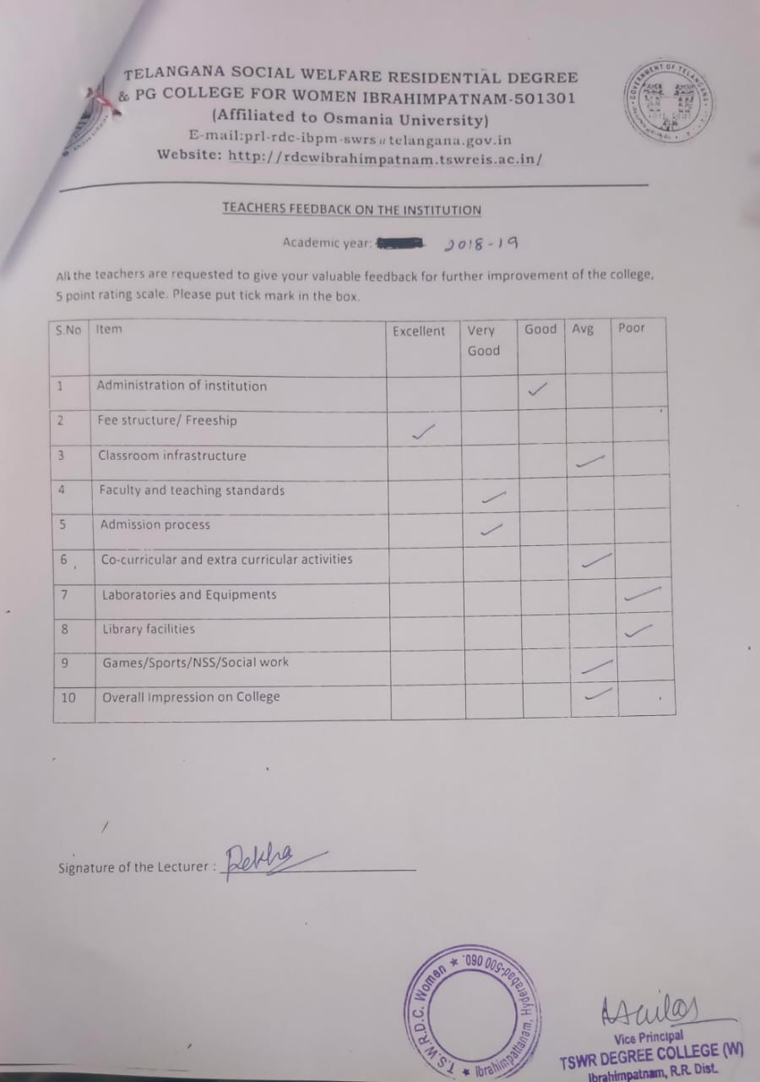

TELANGANA SOCIAL WELFARE RESIDENTIAL DEGREE
& PG COLLEGE FOR WOMEN IBRAHIMPATNAM-501301
(Affiliated to Osmania University)
E-mail:prl-rdc-ibpm-swrs@telangana.gov.in
Website: http://rdcwibrahimpatnam.tswreis.ac.in/

Parents Feedback
A.Y.: 2018-2019

S.No | Item | Excellent | Very Good | Good | Average | Poor | Total
1 | Q.1 | 0 | 1 | 5 | 4 | 0 | 10
2 | Q.2 | 0 | 2 | 8 | 0 | 0 | 10
3 | Q.3 | 0 | 1 | 5 | 4 | 0 | 10
4 | Q.4 | 0 | 2 | 7 | 1 | 0 | 10
5 | Q.5 | 0 | 1 | 4 | 5 | 0 | 10
6 | Q.6 | 0 | 1 | 4 | 5 | 0 | 10
7 | Q.7 | 0 | 1 | 5 | 4 | 0 | 10
Note : The Numbers indicate the total number of Stakeholders voted for particular question.

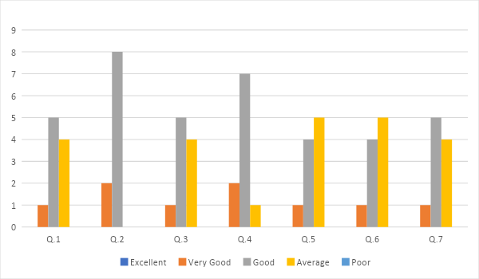

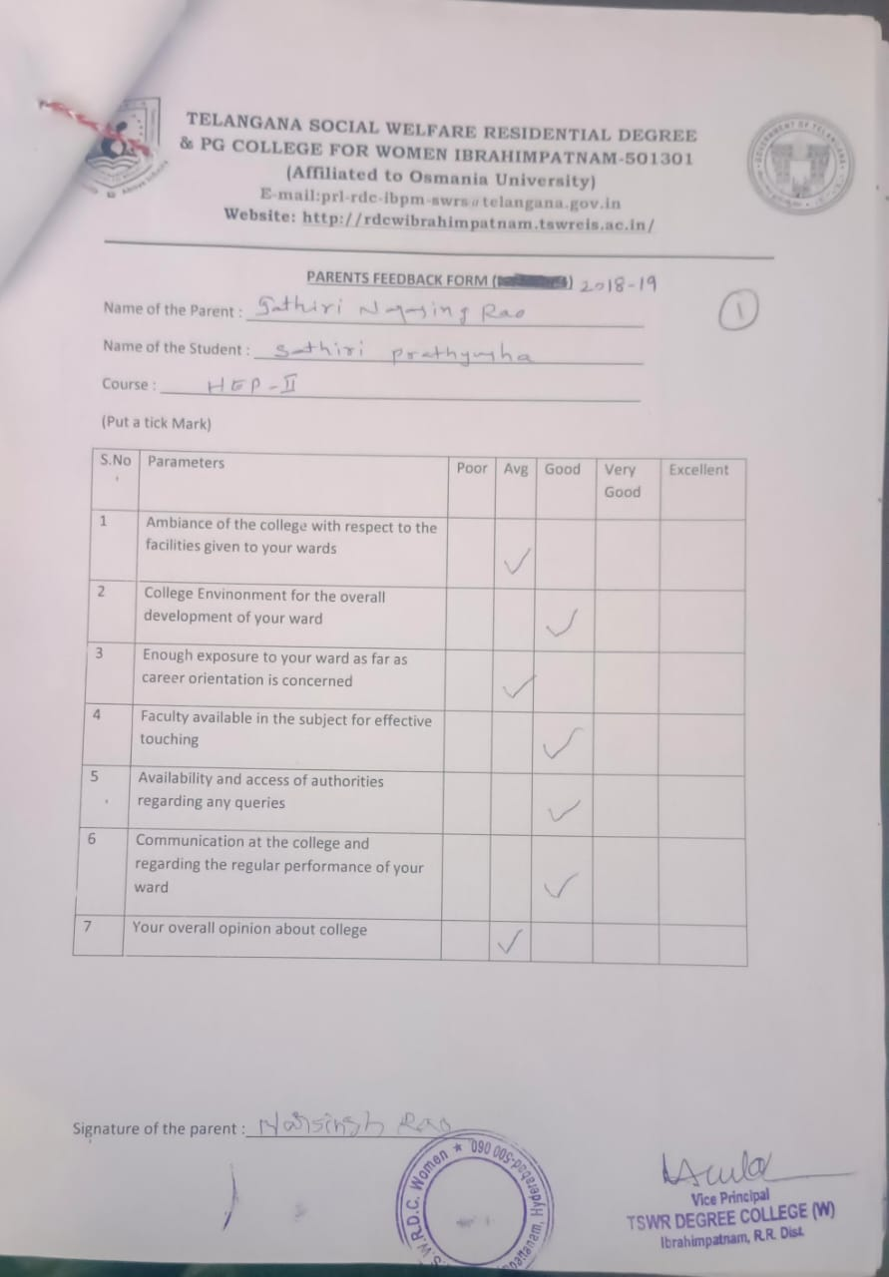

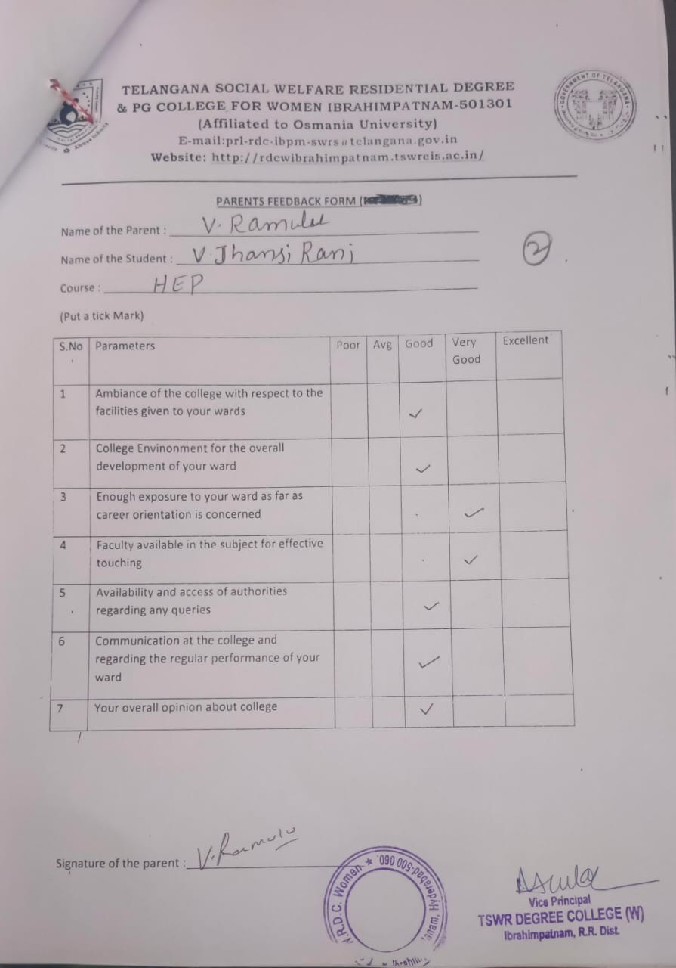

TELANGANA SOCIAL WELFARE RESIDENTIAL DEGREE
& PG COLLEGE FOR WOMEN IBRAHIMPATNAM-501301
(Affiliated to Osmania University)
E-mail:prl-rdc-ibpm-swrs@telangana.gov.in
Website: http://rdcwibrahimpatnam.tswreis.ac.in/

Students Feedback on Teachers
A.Y.: 2019-2020

In order to know the students feedback on Teachers, the college has a standard practice of collecting feedback from students at the end of every academic year. A pre designed feedback sheet is given to the students consisting of 20 questions on various parameters relating to the Teachers. The students are required to give the ranking ranging from I to V. The ranks are assigned as:
S.NO | Rank | Score (Weight)
01 | Poor | +1
02 | Average | +2
03 | Good | +3
04 | Very Good | +4
05 | V-Excellent | +5

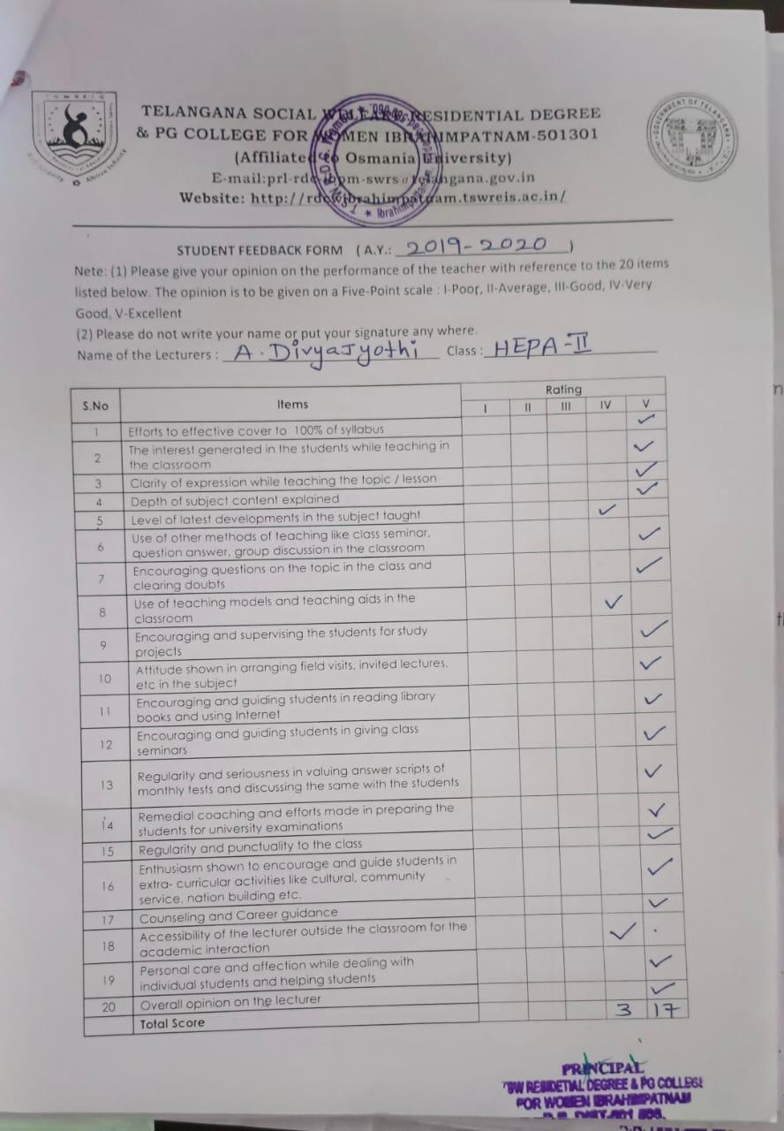

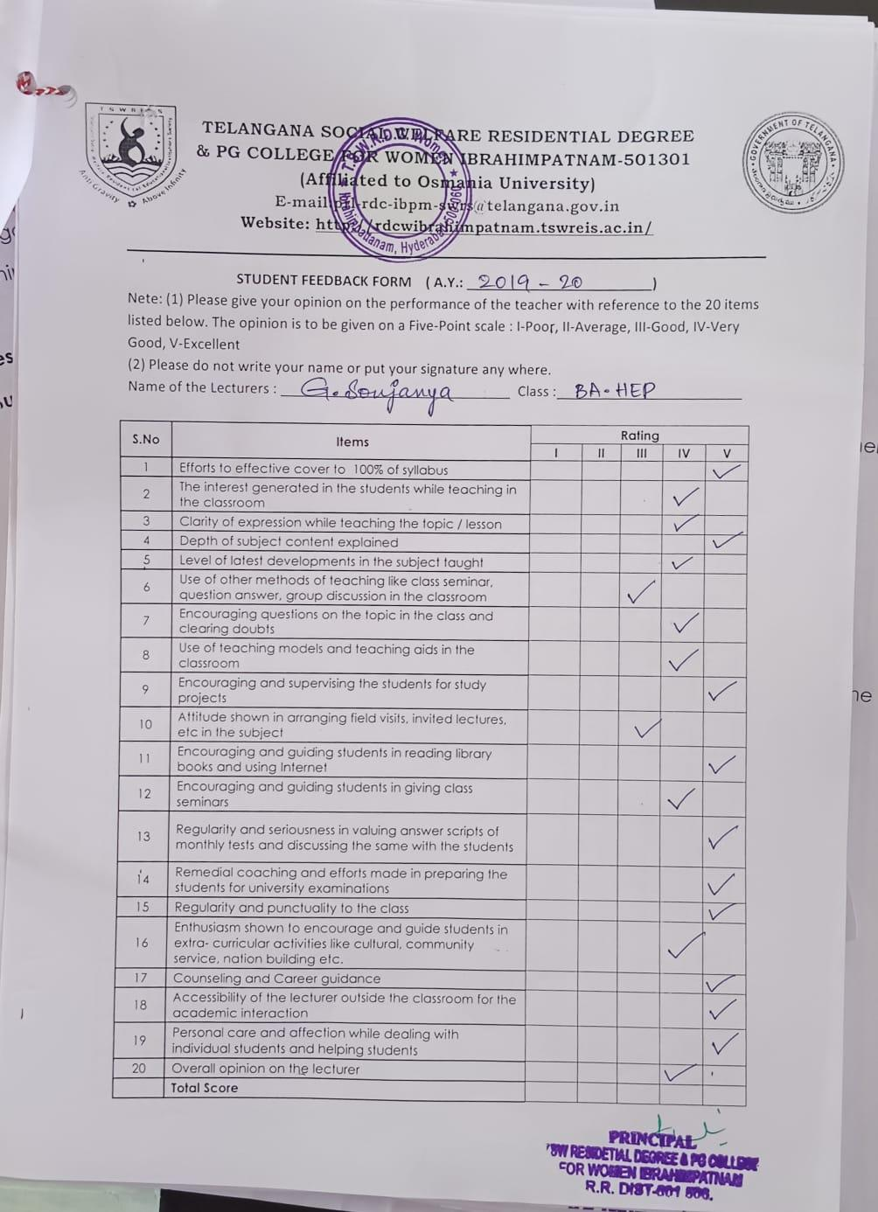

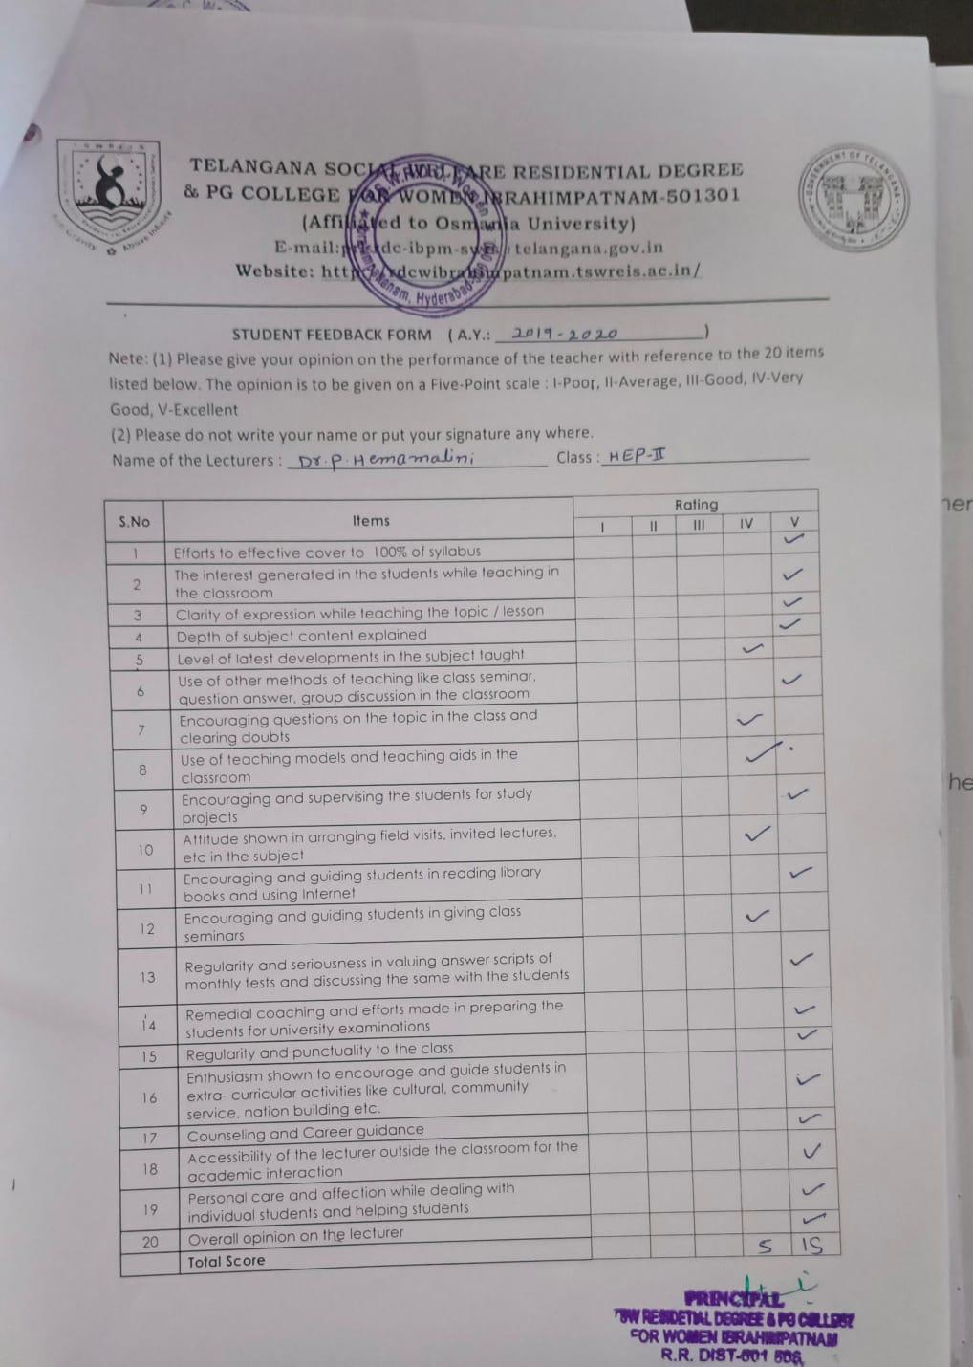

S.NO | Name Of The Lecturer | Subject | Q.1 | Q.2 | Q.3 | Q.4 | Q.5 | Q.6 | Q.7 | Q.8 | Q.9 | Q.10 | Q.11 | Q.12 | Q.13 | Q.14 | Q.15 | Q.16 | Q.17 | Q.18 | Q.19 | Q.20 | Total | Remarks
1 | R.Rekha | Economics | 5 | 4 | 4 | 4 | 4 | 4 | 4 | 3 | 2 | 4 | 3 | 4 | 5 | 4 | 5 | 4 | 4 | 4 | 5 | 5 | 81 | Excellent
2 | A.Divya Jyothi | Public Administration | 5 | 5 | 5 | 5 | 4 | 5 | 5 | 4 | 5 | 5 | 5 | 5 | 5 | 5 | 5 | 5 | 5 | 4 | 5 | 5 | 97 | Excellent
3 | P.Varalaxmi | History | 5 | 4 | 4 | 4 | 4 | 4 | 5 | 3 | 3 | 3 | 4 | 4 | 5 | 4 | 5 | 4 | 4 | 4 | 4 | 4 | 81 | Excellent
4 | Dr.P.Hemamalini | Economics | 5 | 5 | 5 | 5 | 4 | 5 | 4 | 4 | 5 | 4 | 5 | 4 | 5 | 5 | 5 | 5 | 5 | 5 | 5 | 5 | 95 | Excellent
5 | Dr.G.PAdmamma | Telugu | 5 | 4 | 5 | 5 | 4 | 3 | 5 | 3 | 5 | 4 | 4 | 5 | 5 | 4 | 5 | 4 | 4 | 5 | 4 | 4 | 86 | Excellent
6 | G.Soujanya | Sociology | 5 | 4 | 4 | 5 | 4 | 3 | 4 | 4 | 5 | 3 | 5 | 4 | 5 | 5 | 5 | 4 | 5 | 5 | 5 | 4 | 85 | Excellent
7 | M.Manjula | English | 5 | 4 | 5 | 4 | 5 | 5 | 5 | 4 | 5 | 3 | 4 | 5 | 5 | 4 | 5 | 3 | 5 | 5 | 5 | 5 | 90 | Excellent
8 | T.Vijaya Lakshmi | English | 4 | 4 | 4 | 4 | 3 | 4 | 4 | 3 | 4 | 4 | 5 | 5 | 4 | 4 | 5 | 4 | 4 | 4 | 4 | 4 | 81 | Excellent
9 | K.Vijaya | Political Science | 5 | 4 | 5 | 5 | 3 | 3 | 4 | 3 | 4 | 2 | 4 | 4 | 5 | 4 | 5 | 5 | 4 | 4 | 4 | 4 | 81 | Excellent
10 | M.Neeraja | Economics | 5 | 4 | 5 | 4 | 4 | 4 | 5 | 5 | 3 | 3 | 5 | 5 | 5 | 4 | 5 | 4 | 4 | 5 | 5 | 4 | 88 | Excellent
11 | R.Rajitha | History | 5 | 3 | 3 | 3 | 2 | 4 | 4 | 2 | 2 | 2 | 4 | 4 | 4 | 4 | 4 | 4 | 3 | 5 | 5 | 3 | 69 | Very Good
12 | K.Jhansi | Geography | 5 | 4 | 4 | 4 | 3 | 2 | 4 | 2 | 4 | 2 | 4 | 4 | 4 | 4 | 5 | 4 | 4 | 4 | 5 | 3 | 74 | Good
13 | M.Srivani | Telugu | 4 | 4 | 5 | 4 | 3 | 4 | 4 | 4 | 2 | 2 | 4 | 4 | 4 | 4 | 4 | 4 | 3 | 3 | 4 | 3 | 72 | Good
14 | M.Sujatha | English | 3 | 4 | 4 | 4 | 4 | 3 | 4 | 4 | 4 | 3 | 3 | 4 | 3 | 4 | 4 | 3 | 3 | 3 | 3 | 3 | 70 | Good

TELANGANA SOCIAL WELFARE RESIDENTIAL DEGREE
& PG COLLEGE FOR WOMEN IBRAHIMPATNAM-501301
(Affiliated to Osmania University)
E-mail:prl-rdc-ibpm-swrs@telangana.gov.in
Website: http://rdcwibrahimpatnam.tswreis.ac.in/

Students Feedback on Teachers
A.Y.: 2019-2020

Report :
- 0-20M -Poor,
21-40M-Average
41-60M- Good
61-80M – Very Good
81-100M- Excellent
- Based on the Feedback of the students 3 Lecturers scored Good Score, 11 Lecturers scored Excellent score.

TELANGANA SOCIAL WELFARE RESIDENTIAL DEGREE
& PG COLLEGE FOR WOMEN IBRAHIMPATNAM-501301
(Affiliated to Osmania University)
E-mail:prl-rdc-ibpm-swrs@telangana.gov.in
Website: http://rdcwibrahimpatnam.tswreis.ac.in/

Action Taken Report :
A.Y.: 2019-2020

Action Taken :
- The Principal congratulated the Teaching staff who secures Excellent Score.
- The Principal advised the faculty who scored good marks to improve to excellent score.

TELANGANA SOCIAL WELFARE RESIDENTIAL DEGREE
& PG COLLEGE FOR WOMEN IBRAHIMPATNAM-501301
(Affiliated to Osmania University)
E-mail:prl-rdc-ibpm-swrs@telangana.gov.in
Website: http://rdcwibrahimpatnam.tswreis.ac.in/

Teachers Feedback
A.Y.: 2019-2020

S.No | Item | Excellent | Very Good | Good | Average | Poor | Total
1 | Q.1 | 6 | 3 | 0 | 1 | 0 | 10
2 | Q.2 | 9 | 1 | 0 | 0 | 0 | 10
3 | Q.3 | 0 | 0 | 5 | 5 | 0 | 10
4 | Q.4 | 4 | 6 | 0 | 0 | 0 | 10
5 | Q.5 | 4 | 5 | 1 | 0 | 0 | 10
6 | Q.6 | 1 | 1 | 7 | 1 | 0 | 10
7 | Q.7 | 0 | 0 | 2 | 4 | 4 | 10
8 | Q.8 | 1 | 0 | 3 | 6 | 0 | 10
9 | Q.9 | 1 | 1 | 2 | 6 | 0 | 10
10 | Q.10 | 1 | 1 | 5 | 3 | 0 | 10
 |  | 27 | 18 | 25 | 26 | 4 | 100
Note : The Numbers indicate the total number of Stakeholders voted for particular question.

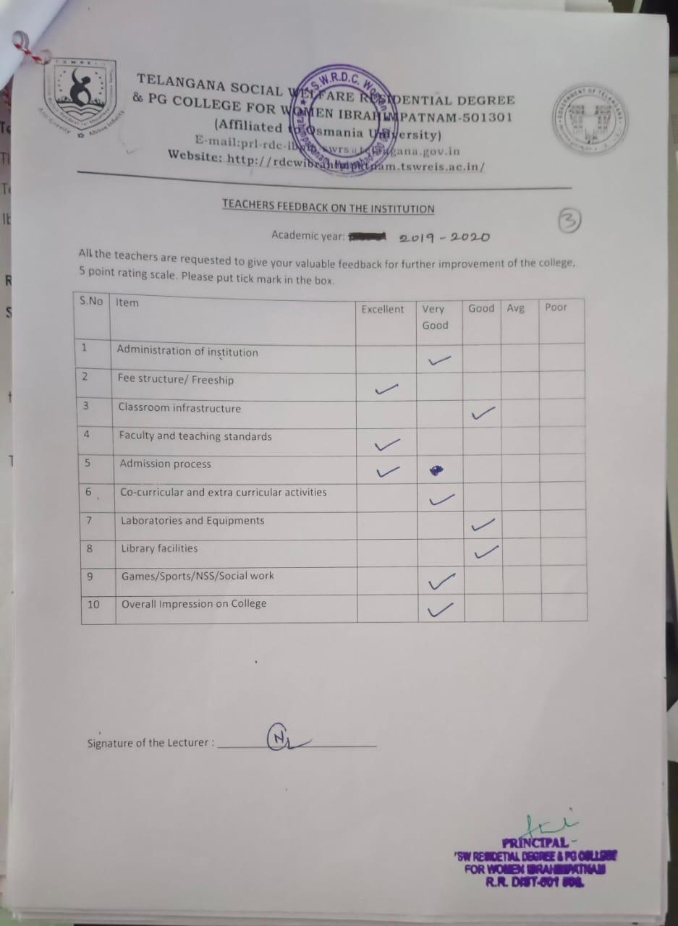
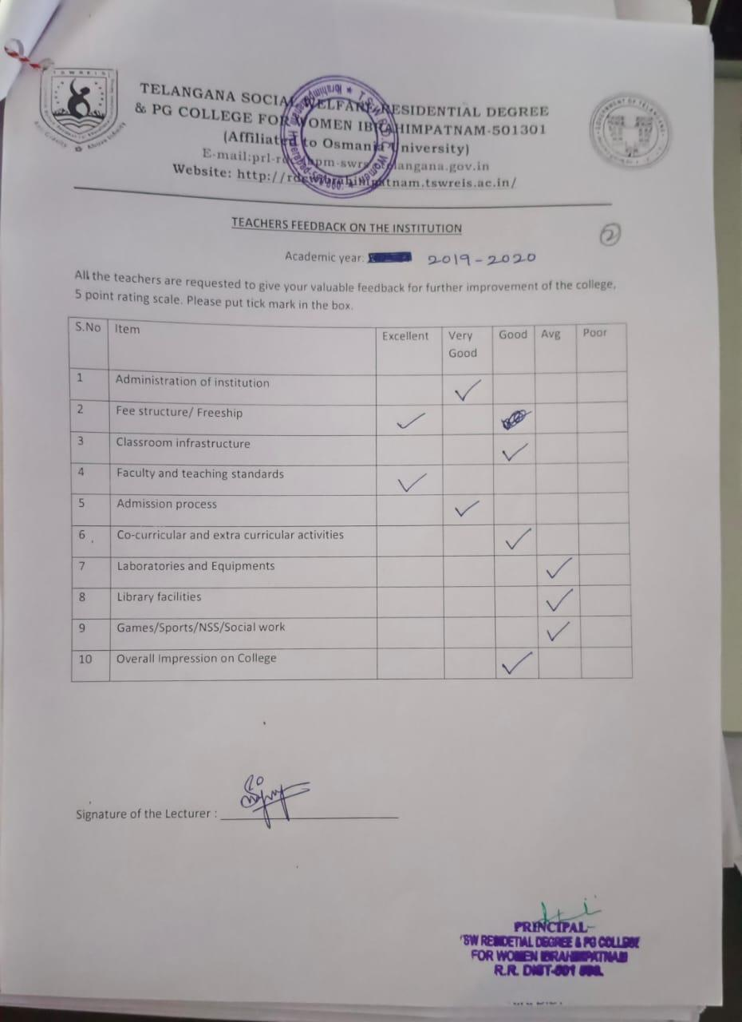

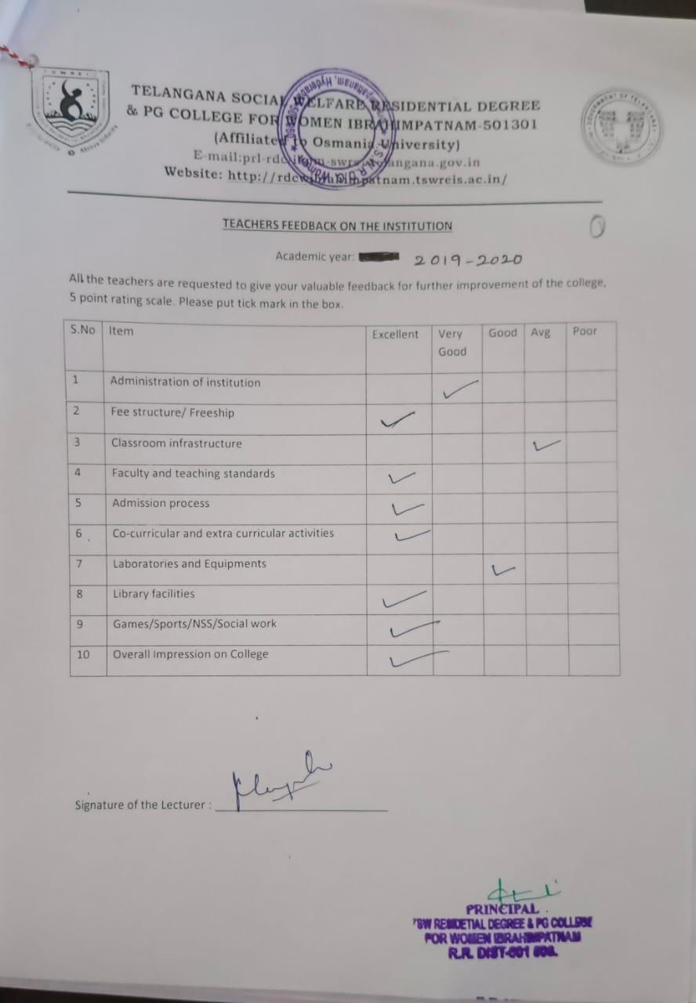

TELANGANA SOCIAL WELFARE RESIDENTIAL DEGREE
& PG COLLEGE FOR WOMEN IBRAHIMPATNAM-501301
(Affiliated to Osmania University)
E-mail:prl-rdc-ibpm-swrs@telangana.gov.in
Website: http://rdcwibrahimpatnam.tswreis.ac.in/

Parents Feedback
A.Y.: 2019-2020

S.No | Item | Excellent | Very Good | Good | Average | Poor | Total
1 | Q.1 | 1 | 4 | 5 | 0 | 0 | 10
2 | Q.2 | 5 | 5 | 0 | 0 | 0 | 10
3 | Q.3 | 1 | 3 | 6 | 0 | 0 | 10
4 | Q.4 | 4 | 6 | 0 | 0 | 0 | 10
5 | Q.5 | 3 | 6 | 1 | 0 | 0 | 10
6 | Q.6 | 2 | 7 | 1 | 0 | 0 | 10
7 | Q.7 | 3 | 5 | 2 | 0 | 0 | 10
Note : The Numbers indicate the total number of Stakeholders voted for particular question.

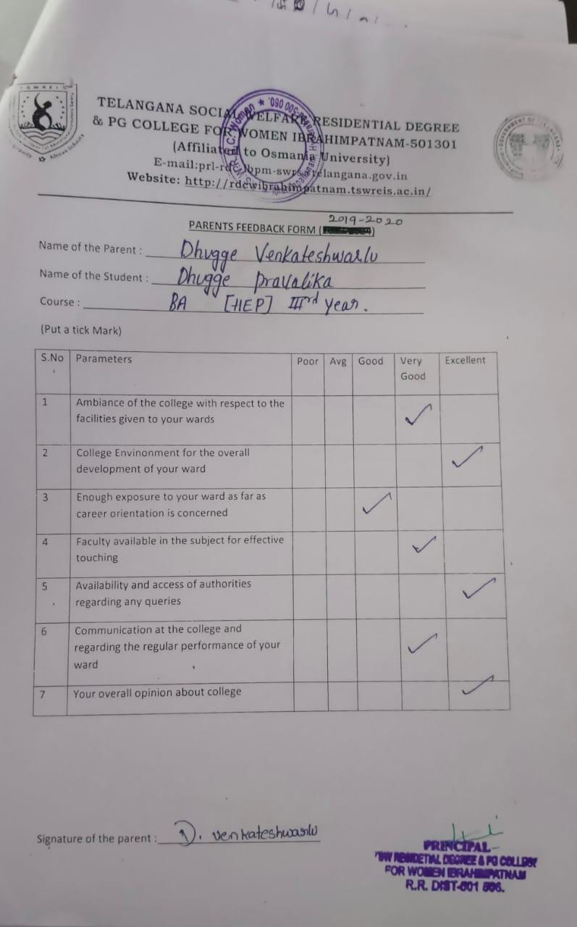
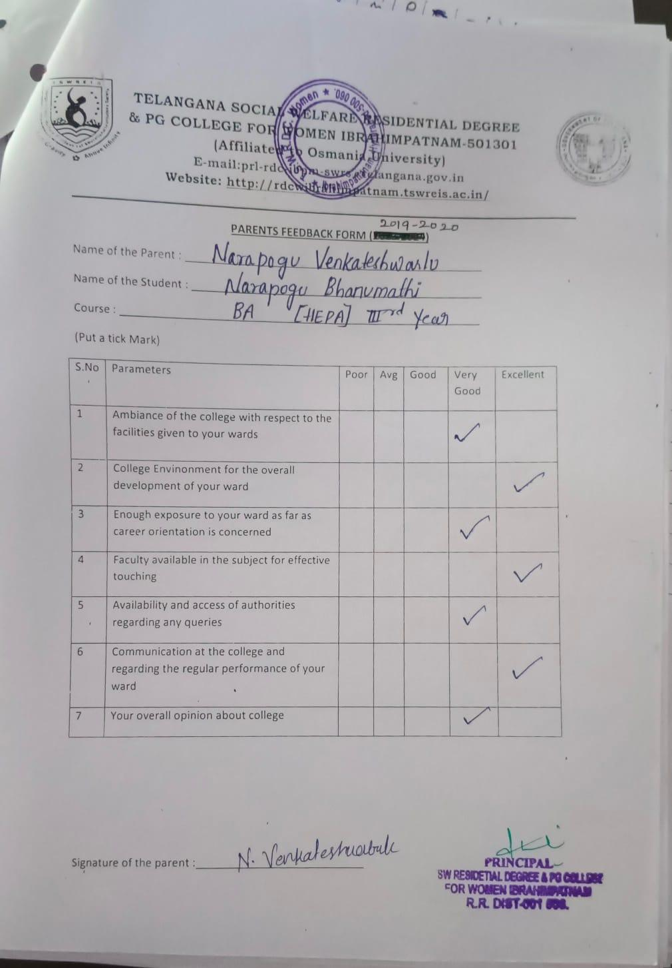

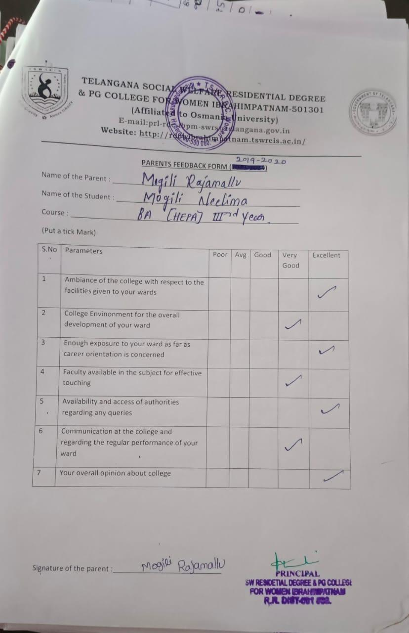

TELANGANA SOCIAL WELFARE RESIDENTIAL DEGREE
& PG COLLEGE FOR WOMEN IBRAHIMPATNAM-501301
(Affiliated to Osmania University)
E-mail:prl-rdc-ibpm-swrs@telangana.gov.in
Website: http://rdcwibrahimpatnam.tswreis.ac.in/

Students Feedback on Teachers
A.Y.: 2020-2021

In order to know the students feedback on Teachers, the college has a standard practice of collecting feedback from students at the end of every academic year. A pre designed feedback sheet is given to the students consisting of 20 questions on various parameters relating to the Teachers. The students are required to give the ranking ranging from I to V. The ranks are assigned as:
S.NO | Rank | Score (Weight)
01 | Poor | +1
02 | Average | +2
03 | Good | +3
04 | Very Good | +4
05 | V-Excellent | +5

S.NO | Name Of The Lecturer | Subject | Q.1 | Q.2 | Q.3 | Q.4 | Q.5 | Q.6 | Q.7 | Q.8 | Q.9 | Q.10 | Q.11 | Q.12 | Q.13 | Q.14 | Q.15 | Q.16 | Q.17 | Q.18 | Q.19 | Q.20 | Total | Remarks
1 | R.Rekha | Economics | 5 | 4 | 5 | 4 | 5 | 4 | 5 | 4 | 5 | 4 | 5 | 5 | 5 | 4 | 5 | 5 | 5 | 5 | 5 | 5 | 94 | Excellent
2 | A.Divya Jyothi | Public Administration | 5 | 4 | 4 | 5 | 4 | 5 | 5 | 5 | 5 | 4 | 5 | 5 | 5 | 5 | 5 | 4 | 4 | 5 | 5 | 5 | 94 | Excellent
3 | P.Varalaxmi | History | 5 | 5 | 5 | 5 | 5 | 5 | 5 | 4 | 4 | 5 | 5 | 5 | 4 | 4 | 5 | 5 | 4 | 4 | 5 | 5 | 94 | Excellent
4 | Dr.P.Hemamalini | Economics | 5 | 5 | 4 | 4 | 4 | 4 | 4 | 4 | 4 | 5 | 5 | 4 | 4 | 5 | 5 | 4 | 5 | 5 | 5 | 5 | 90 | Excellent
5 | Dr.G.PAdmamma | Telugu | 5 | 5 | 5 | 5 | 4 | 5 | 5 | 5 | 4 | 5 | 5 | 5 | 4 | 5 | 5 | 5 | 5 | 5 | 5 | 5 | 97 | Excellent
6 | G.Soujanya | Sociology | 5 | 5 | 4 | 5 | 4 | 4 | 4 | 4 | 4 | 4 | 5 | 5 | 5 | 5 | 5 | 5 | 4 | 5 | 5 | 5 | 92 | Excellent
7 | M.Manjula | English | 5 | 4 | 5 | 4 | 5 | 4 | 5 | 4 | 5 | 4 | 5 | 5 | 5 | 5 | 5 | 4 | 4 | 4 | 4 | 4 | 90 | Excellent
8 | T.Vijaya Lakshmi | English | 5 | 4 | 5 | 5 | 5 | 5 | 5 | 5 | 5 | 4 | 5 | 5 | 5 | 5 | 5 | 5 | 4 | 4 | 4 | 5 | 94 | Excellent
9 | K.Vijaya | Political Science | 4 | 5 | 4 | 4 | 4 | 5 | 5 | 4 | 5 | 4 | 5 | 4 | 5 | 4 | 5 | 5 | 4 | 5 | 5 | 5 | 91 | Excellent
10 | M.Neeraja | Economics | 4 | 5 | 5 | 4 | 4 | 5 | 5 | 4 | 5 | 4 | 5 | 4 | 4 | 4 | 5 | 5 | 4 | 4 | 5 | 5 | 90 | Excellent
11 | Dr.Padmavathi | Telugu | 5 | 5 | 5 | 5 | 5 | 4 | 5 | 5 | 5 | 4 | 5 | 5 | 5 | 5 | 5 | 5 | 5 | 5 | 5 | 5 | 98 | Excellent
12 | M.Sujatha | English | 5 | 5 | 5 | 5 | 5 | 5 | 5 | 4 | 5 | 5 | 5 | 5 | 5 | 5 | 5 | 5 | 5 | 4 | 5 | 5 | 98 | Excellent
13 | Alekhya | Geography | 4 | 3 | 4 | 3 | 4 | 3 | 3 | 4 | 4 | 4 | 4 | 4 | 4 | 4 | 4 | 4 | 4 | 4 | 4 | 4 | 76 | Good
14 | Dr.Asha | Psychology | 4 | 5 | 4 | 5 | 5 | 4 | 5 | 4 | 5 | 4 | 4 | 5 | 4 | 5 | 5 | 5 | 4 | 5 | 5 | 5 | 93 | Excellent
15 | M.Vishnu Priya | Journalism | 5 | 4 | 4 | 4 | 5 | 4 | 5 | 5 | 4 | 5 | 4 | 5 | 5 | 5 | 4 | 4 | 4 | 4 | 4 | 4 | 88 | Excellent
16 | Baby | Public Administration | 3 | 4 | 3 | 4 | 4 | 3 | 4 | 4 | 4 | 4 | 4 | 4 | 4 | 4 | 4 | 3 | 4 | 4 | 4 | 4 | 76 | Good
17 | Srilatha | History | 4 | 5 | 5 | 4 | 4 | 4 | 3 | 4 | 4 | 4 | 4 | 4 | 4 | 4 | 4 | 3 | 4 | 4 | 4 | 4 | 80 | Good
18 | T.Lalitha | Political Science | 5 | 4 | 4 | 4 | 5 | 4 | 4 | 5 | 4 | 4 | 4 | 4 | 4 | 4 | 4 | 4 |  | 4 | 4 | 4 | 79 | Good
19 | Dr.B.Kranthikumari | English | 5 | 4 | 5 | 4 | 4 | 4 | 5 | 5 | 4 | 5 | 5 | 5
20 | Dr.Elezebeth | English | 5 | 4 | 5 | 4 | 4 | 4 | 5 | 5 | 4 | 5 | 5 | 5

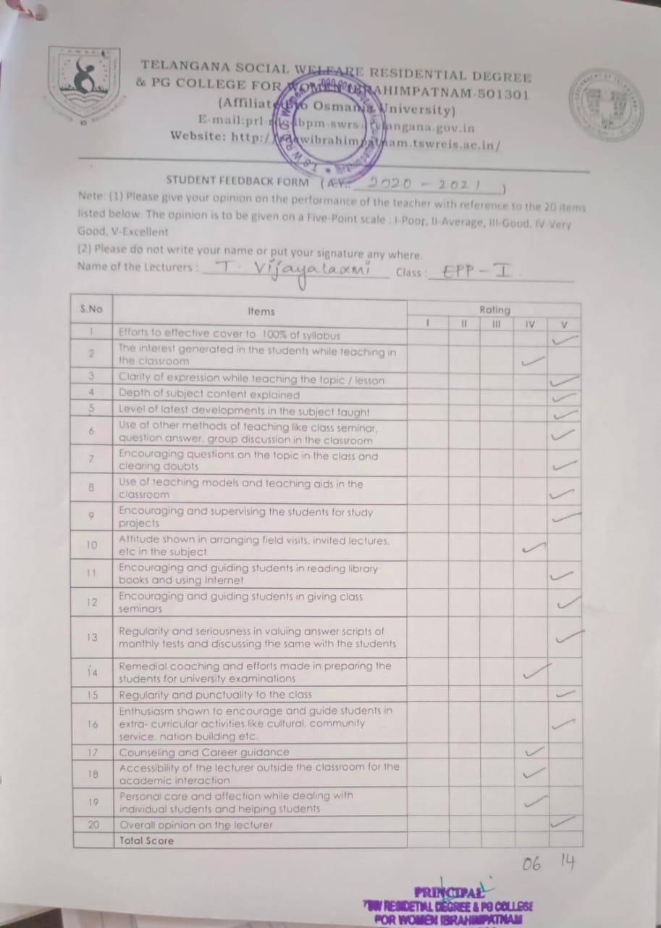

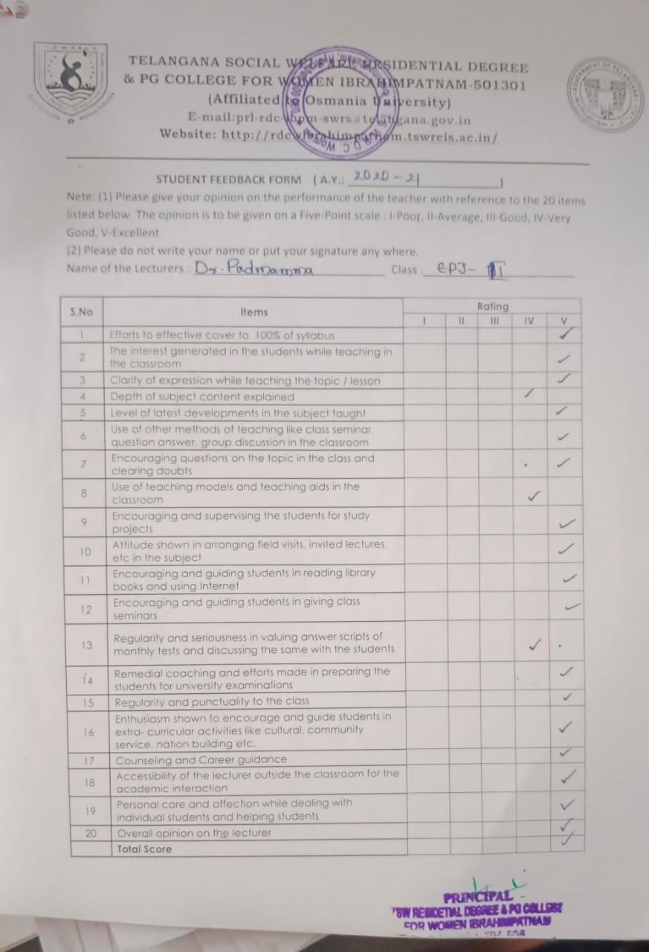

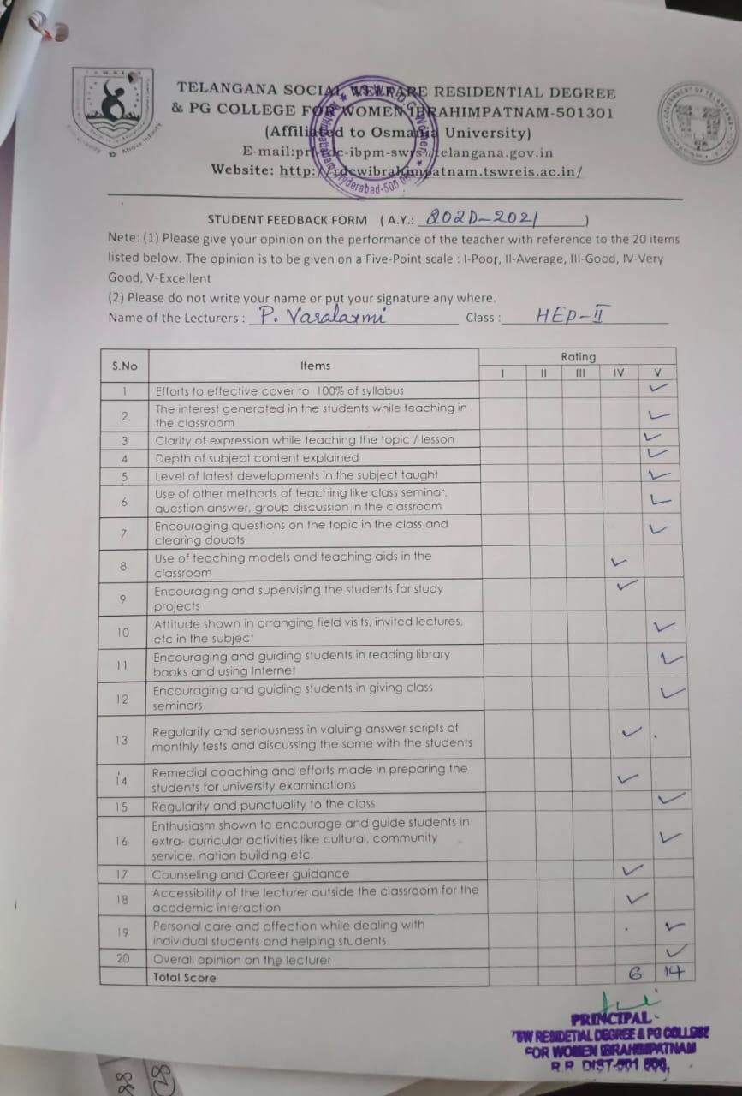

TELANGANA SOCIAL WELFARE RESIDENTIAL DEGREE
& PG COLLEGE FOR WOMEN IBRAHIMPATNAM-501301
(Affiliated to Osmania University)
E-mail:prl-rdc-ibpm-swrs@telangana.gov.in
Website: http://rdcwibrahimpatnam.tswreis.ac.in/

Students Feedback on Teachers
A.Y.: 2020-2021

Report :
- 0-20M -Poor,
21-40M-Average
41-60M- Good
61-80M – Very Good
81-100M- Excellent
- Based on the Feedback of the students 5 Lecturers scored Very Good Score, 15 Lecturers scored Excellent score.

TELANGANA SOCIAL WELFARE RESIDENTIAL DEGREE
& PG COLLEGE FOR WOMEN IBRAHIMPATNAM-501301
(Affiliated to Osmania University)
E-mail:prl-rdc-ibpm-swrs@telangana.gov.in
Website: http://rdcwibrahimpatnam.tswreis.ac.in/

Action Taken Report :

A.Y.: 2020-2021

Action Taken :
- The Principal congratulated the Teaching staff who secures Excellent Score.
- The Principal advised the faculty who scored very good marks to improve to excellent score.

TELANGANA SOCIAL WELFARE RESIDENTIAL DEGREE
& PG COLLEGE FOR WOMEN IBRAHIMPATNAM-501301
(Affiliated to Osmania University)
E-mail:prl-rdc-ibpm-swrs@telangana.gov.in
Website: http://rdcwibrahimpatnam.tswreis.ac.in/

Teachers Feedback
A.Y.: 2020-2021

S.No | Item | Excellent | Very Good | Good | Average | Poor | Total
1 | Q.1 | 5 | 5 | 0 | 0 | 0 | 10
2 | Q.2 | 8 | 2 | 0 | 0 | 0 | 10
3 | Q.3 | 2 | 8 | 0 | 0 | 0 | 10
4 | Q.4 | 8 | 2 | 0 | 0 | 0 | 10
5 | Q.5 | 5 | 4 | 1 | 0 | 0 | 10
6 | Q.6 | 6 | 3 | 1 | 0 | 0 | 10
7 | Q.7 | 0 | 2 | 5 | 3 | 0 | 10
8 | Q.8 | 2 | 1 | 6 | 1 | 0 | 10
9 | Q.9 | 3 | 5 | 2 | 0 | 0 | 10
10 | Q.10 | 3 | 6 | 1 | 0 | 0 | 10
 |  | 42 | 38 | 16 | 4 | 0 | 100
Note : The Numbers indicate the total number of Stakeholders voted for particular question.

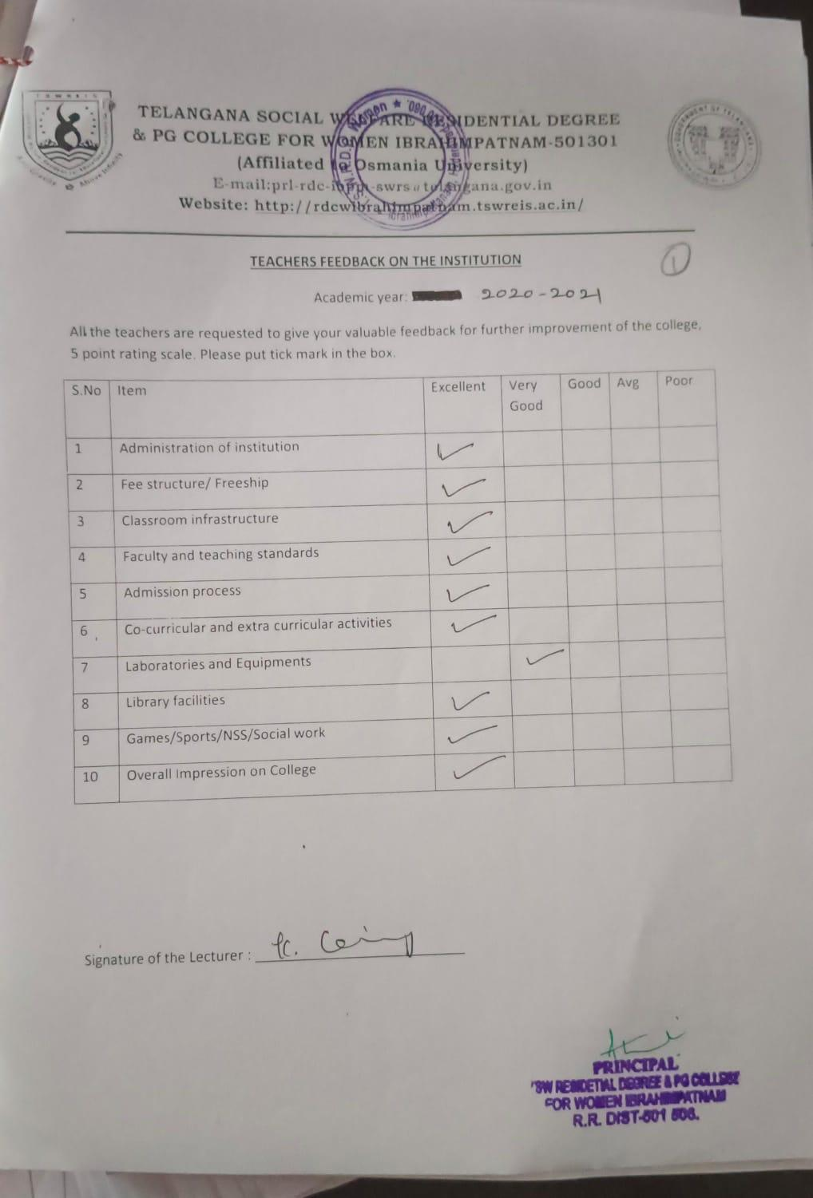

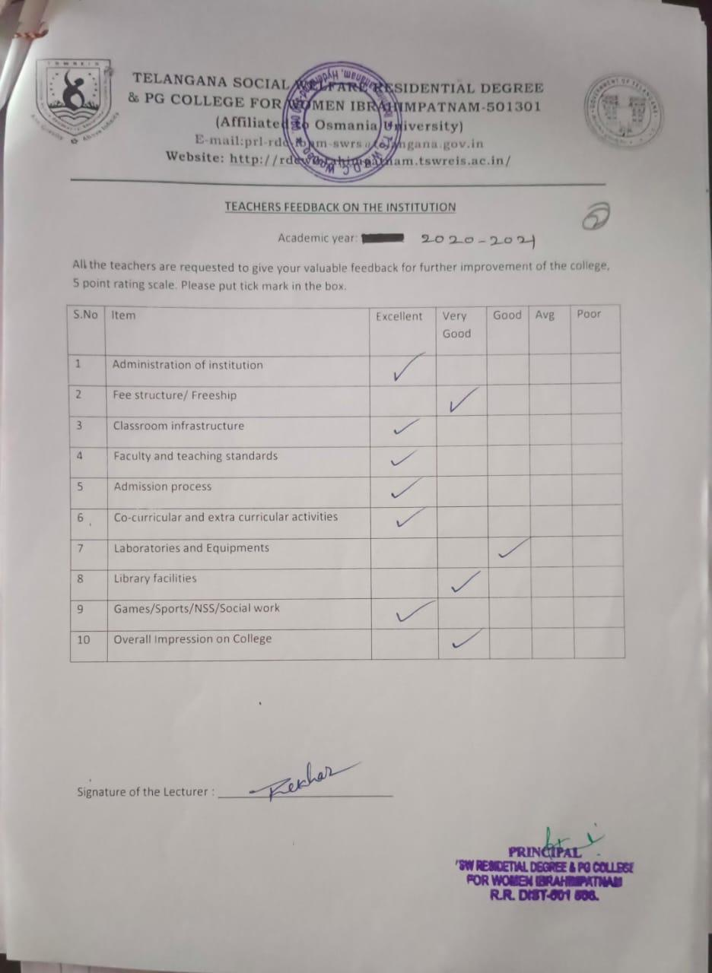

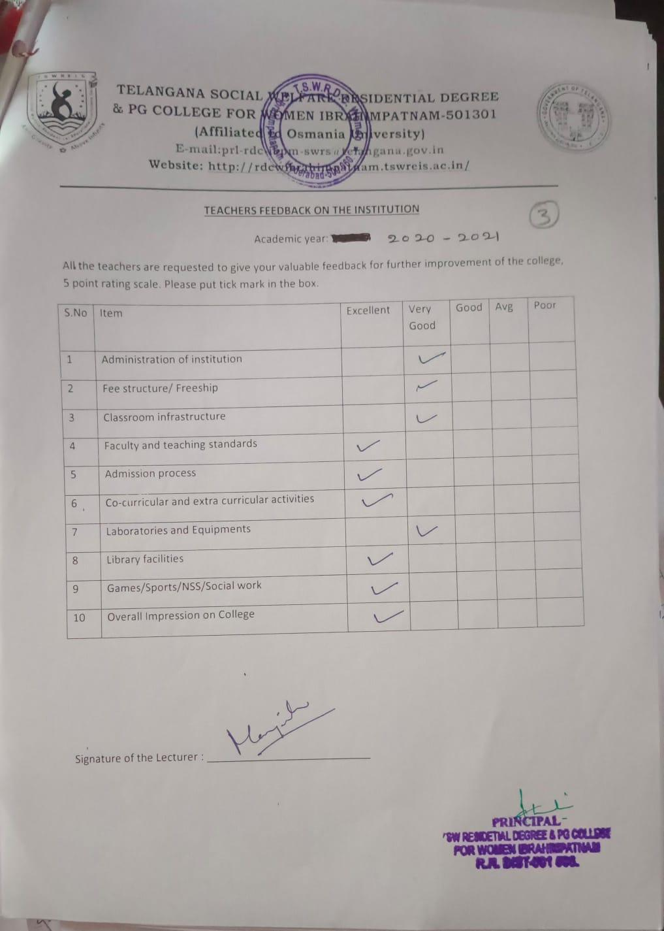

TELANGANA SOCIAL WELFARE RESIDENTIAL DEGREE
& PG COLLEGE FOR WOMEN IBRAHIMPATNAM-501301
(Affiliated to Osmania University)
E-mail:prl-rdc-ibpm-swrs@telangana.gov.in
Website: http://rdcwibrahimpatnam.tswreis.ac.in/

Parents Feedback
A.Y.: 2020-2021

S.No | Item | Excellent | Very Good | Good | Average | Poor | Total
1 | Q.1 | 2 | 6 | 2 | 0 | 0 | 10
2 | Q.2 | 3 | 4 | 3 | 0 | 0 | 10
3 | Q.3 | 3 | 6 | 0 | 1 | 0 | 10
4 | Q.4 | 6 | 3 | 1 | 0 | 0 | 10
5 | Q.5 | 4 | 4 | 2 | 0 | 0 | 10
6 | Q.6 | 4 | 4 | 2 | 0 | 0 | 10
7 | Q.7 | 5 | 3 | 2 | 0 | 0 | 10
Note : The Numbers indicate the total number of Stakeholders voted for particular question.

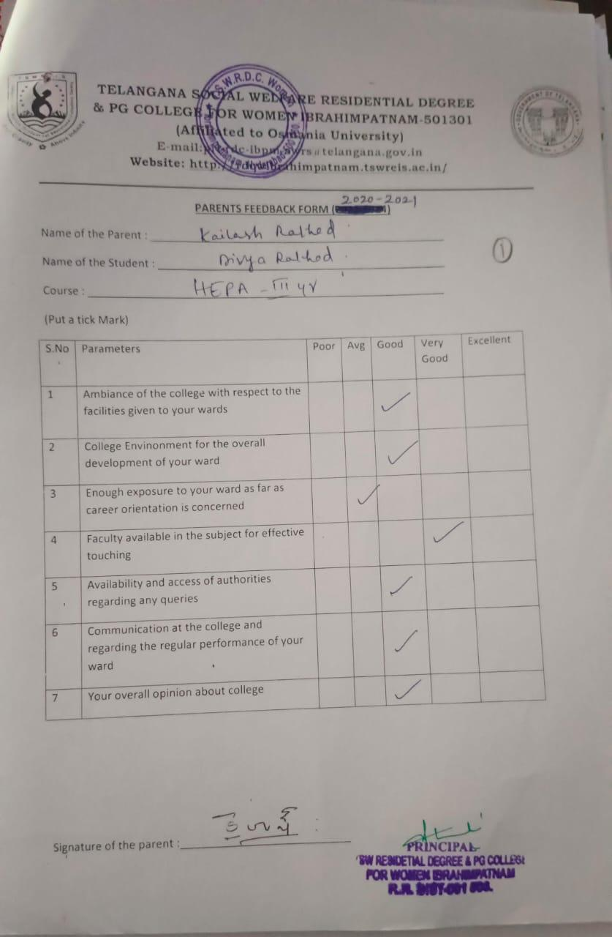

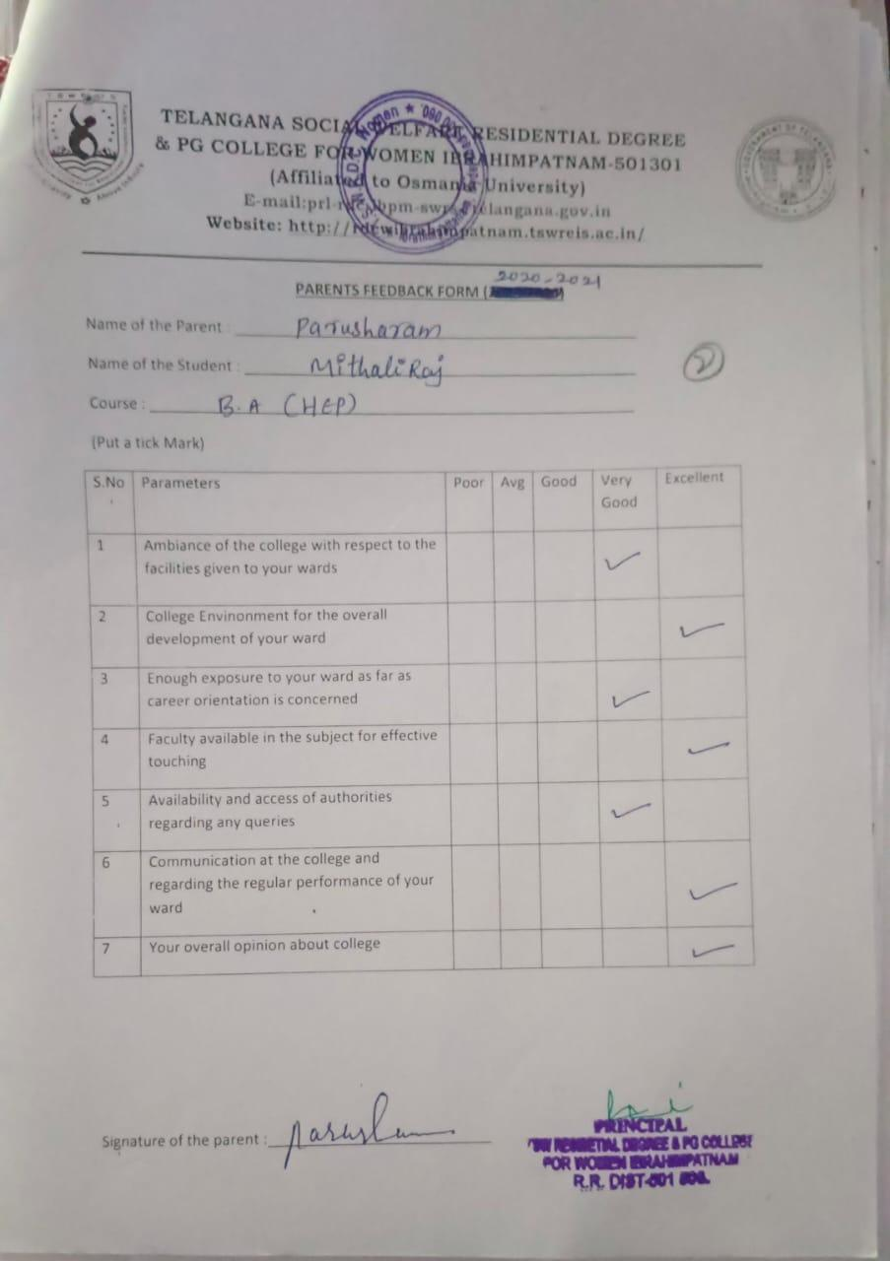

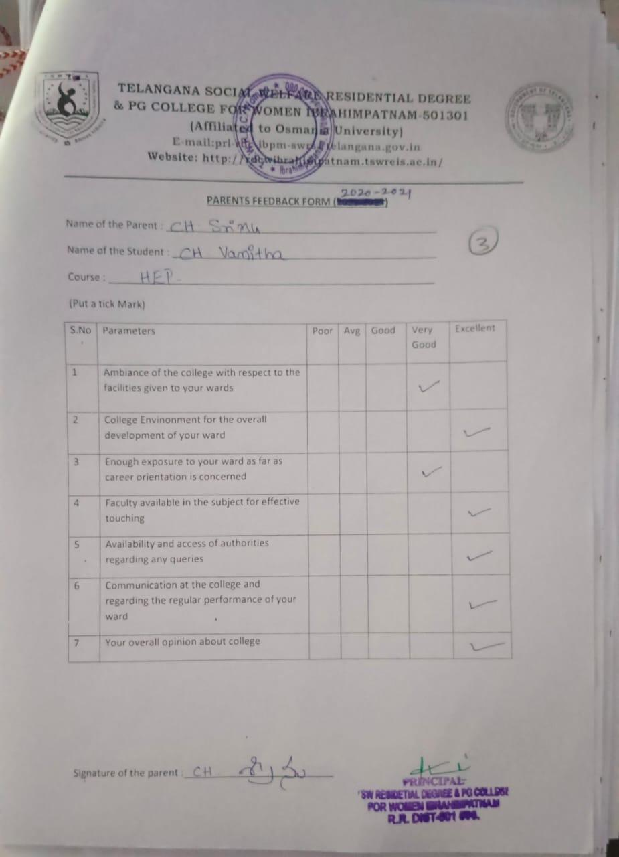

TELANGANA SOCIAL WELFARE RESIDENTIAL DEGREE
& PG COLLEGE FOR WOMEN IBRAHIMPATNAM-501301
(Affiliated to Osmania University)
E-mail:prl-rdc-ibpm-swrs@telangana.gov.in
Website: http://rdcwibrahimpatnam.tswreis.ac.in/

Students Feedback on Teachers
A.Y.: 2021-22

In order to know the students feedback on Teachers, the college has a standard practice of collecting feedback from students at the end of every academic year. A pre designed feedback sheet is given to the students consisting of 20 questions on various parameters relating to the Teachers. The students are required to give the ranking ranging from I to V. The ranks are assigned as:
S.NO | Rank | Score (Weight)
01 | Poor | +1
02 | Average | +2
03 | Good | +3
04 | Very Good | +4
05 | V-Excellent | +5

S.NO | Name Of The Lecturer | Subject | Q.1 | Q.2 | Q.3 | Q.4 | Q.5 | Q.6 | Q.7 | Q.8 | Q.9 | Q.10 | Q.11 | Q.12 | Q.13 | Q.14 | Q.15 | Q.16 | Q.17 | Q.18 | Q.19 | Q.20 | Total | Remarks
1 | R.Rekha | Economics | 4 | 5 | 4 | 5 | 4 | 5 | 4 | 5 | 5 | 4 | 4 | 5 | 5 | 4 | 5 | 4 | 4 | 5 | 4 | 5 | 90 | Excellent
2 | A.Divya Jyothi | Public Administration | 5 | 4 | 5 | 4 | 5 | 5 | 5 | 4 | 5 | 5 | 4 | 5 | 4 | 5 | 5 | 5 | 5 | 5 | 4 | 5 | 94 | Excellent
3 | P.Varalaxmi | History | 5 | 5 | 5 | 4 | 4 | 4 | 4 | 3 | 4 | 3 | 4 | 4 | 4 | 4 | 5 | 4 | 4 | 5 | 4 | 4 | 83 | Excellent
4 | Dr.P.Hemamalini | Economics | 5 | 5 | 5 | 5 | 5 | 5 | 4 | 5 | 5 | 5 | 5 | 5 | 5 | 5 | 5 | 5 | 4 | 5 | 5 | 5 | 98 | Excellent
5 | Dr.G.Padmamma | Telugu | 5 | 4 | 5 | 4 | 5 | 4 | 5 | 3 | 5 | 4 | 5 | 5 | 5 | 5 | 5 | 5 | 5 | 5 | 5 | 5 | 97 | Excellent
6 | G.Soujanya | Sociology | 5 | 5 | 4 | 5 | 4 | 4 | 5 | 3 | 4 | 4 | 5 | 5 | 4 | 5 | 5 | 5 | 5 | 4 | 5 | 4 | 90 | Excellent
7 | M.Manjula | English | 5 | 5 | 5 | 4 | 4 | 4 | 5 | 4 | 4 | 4 | 4 | 5 | 5 | 4 | 5 | 5 | 4 | 5 | 5 | 4 | 90 | Excellent
8 | T.Vijaya Lakshmi | English | 4 | 5 | 4 | 4 | 5 | 4 | 4 | 3 | 4 | 3 | 4 | 4 | 5 | 4 | 5 | 4 | 4 | 4 | 4 | 4 | 82 | Excellent
9 | K.Vijaya | Political Science | 5 | 5 | 5 | 4 | 4 | 5 | 5 | 3 | 4 | 4 | 5 | 4 | 5 | 5 | 5 | 5 | 5 | 5 | 5 | 5 | 93 | Excellent
10 | M.Neeraja | Economics | 5 | 5 | 5 | 5 | 4 | 4 | 5 | 4 | 4 | 4 | 5 | 5 | 5 | 5 | 5 | 5 | 5 | 5 | 5 | 5 | 95 | Excellent
11 | Dr.D.Padmavathi | Telugu | 5 | 5 | 5 | 5 | 5 | 5 | 5 | 5 | 5 | 5 | 5 | 5 | 5 | 5 | 5 | 5 | 4 | 4 | 5 | 5 | 98 | Excellent
12 | K.Ujwala | English | 5 | 5 | 4 | 5 | 4 | 4 | 4 | 4 | 4 | 4 | 5 | 5 | 4 | 4 | 5 | 4 | 4 | 4 | 5 | 5 | 93 | Excellent
13 | T.Lalitha | Political Science | 5 | 5 | 4 | 4 | 4 | 5 | 4 | 3 | 3 | 4 | 5 | 5 | 4 | 4 | 5 | 4 | 4 | 4 | 5 | 4 | 85 | Excellent
14 | Ch.Sridevi | Telugu | 5 | 4 | 4 | 4 | 4 | 4 | 5 | 5 | 4 | 4 | 5 | 4 | 5 | 5 | 4 | 4 | 4 | 4 | 4 | 4 | 86 | Excellent
15 | Y.Srilatha | History | 4 | 4 | 4 | 4 | 4 | 4 | 4 | 3 | 4 | 4 | 4 | 4 | 4 | 4 | 4 | 4 | 4 | 4 | 4 | 4 | 79 | Very Good
16 | Dr.Asha | Psychology | 5 | 4 | 4 | 5 | 4 | 5 | 5 | 5 | 4 | 5 | 5 | 4 | 4 | 4 | 4 | 4 | 4 | 4 | 4 | 4 | 87 | Excellent
17 | T.Alekhya | Geography | 4 | 4 | 3 | 4 | 4 | 4 | 4 | 4 | 4 | 4 | 4 | 4 | 4 | 3 | 4 | 4 | 4 | 4 | 4 | 4 | 78 | Very Good
18 | Dr.B.Kranthikumari | English | 5 | 4 | 5 | 4 | 4 | 4 | 5 | 5 | 4 | 5 | 5 | 5 | 5 | 5 | 4 | 4 | 4 | 4 | 4 | 5 | 90 | Excellent
19 | Dr.Elezebeth | English | 5 | 4 | 5 | 4 | 4 | 4 | 5 | 5 | 4 | 5 | 5 | 5 | 5 | 5 | 4 | 4 | 4 | 4 | 4 | 5 | 90 | Excellent

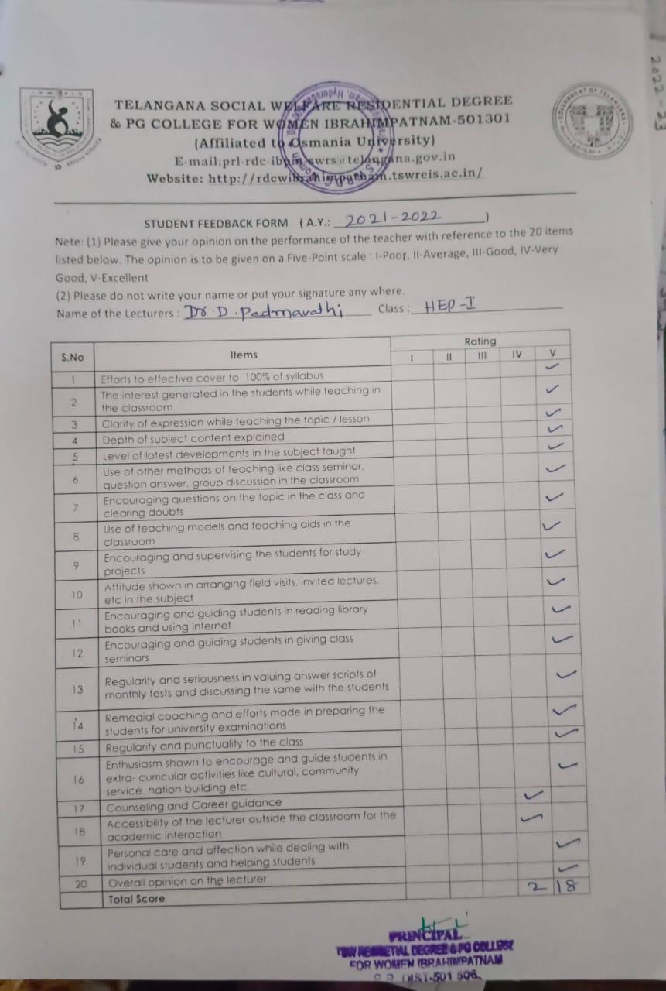

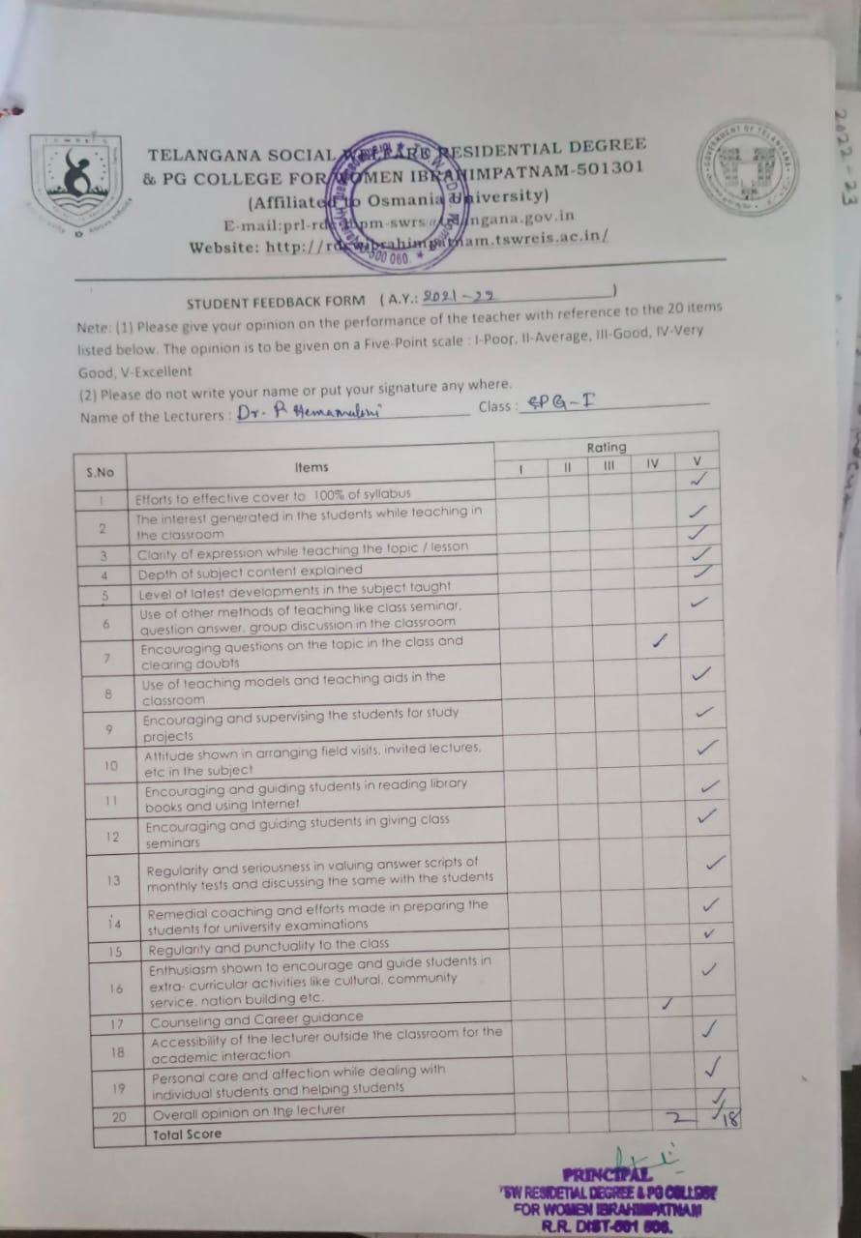

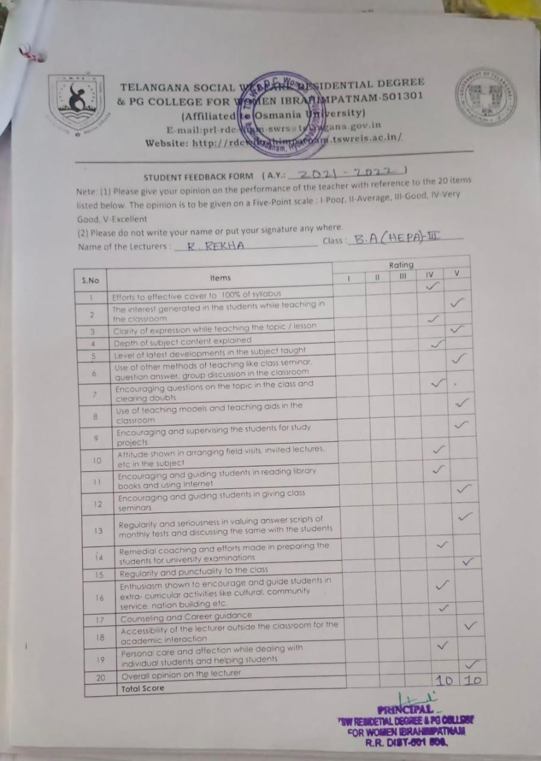

TELANGANA SOCIAL WELFARE RESIDENTIAL DEGREE
& PG COLLEGE FOR WOMEN IBRAHIMPATNAM-501301
(Affiliated to Osmania University)
E-mail:prl-rdc-ibpm-swrs@telangana.gov.in
Website: http://rdcwibrahimpatnam.tswreis.ac.in/

Students Feedback on Teachers
A.Y.: 2021-2022

Report :
- 0-20M -Poor,
21-40M-Average
41-60M- Good
61-80M – Very Good
81-100M- Excellent
- Based on the Feedback of the students 2 Lecturers scored Very Good Score, 17 Lecturers scored Excellent score.

TELANGANA SOCIAL WELFARE RESIDENTIAL DEGREE
& PG COLLEGE FOR WOMEN IBRAHIMPATNAM-501301
(Affiliated to Osmania University)
E-mail:prl-rdc-ibpm-swrs@telangana.gov.in
Website: http://rdcwibrahimpatnam.tswreis.ac.in/

Action Taken Report :

A.Y.: 2021-2022

Action Taken :
- The Principal congratulated the Teaching staff who secures Excellent Score.
- The Principal advised the faculty who scored very good marks to improve to excellent score.

TELANGANA SOCIAL WELFARE RESIDENTIAL DEGREE
& PG COLLEGE FOR WOMEN IBRAHIMPATNAM-501301
(Affiliated to Osmania University)
E-mail:prl-rdc-ibpm-swrs@telangana.gov.in
Website: http://rdcwibrahimpatnam.tswreis.ac.in/

Teachers Feedback
A.Y.: 2021-2022

S.No | Item | Excellent | Very Good | Good | Average | Poor | Total
1 | Q.1 | 4 | 6 | 0 | 0 | 0 | 10
2 | Q.2 | 8 | 2 | 0 | 0 | 0 | 10
3 | Q.3 | 4 | 6 | 0 | 0 | 0 | 10
4 | Q.4 | 8 | 2 | 0 | 0 | 0 | 10
5 | Q.5 | 5 | 5 | 0 | 0 | 0 | 10
6 | Q.6 | 8 | 2 | 0 | 0 | 0 | 10
7 | Q.7 | 0 | 1 | 9 | 0 | 0 | 10
8 | Q.8 | 1 | 6 | 3 | 0 | 0 | 10
9 | Q.9 | 3 | 6 | 1 | 0 | 0 | 10
10 | Q.10 | 6 | 4 | 0 | 0 | 0 | 10
 |  | 47 | 40 | 13 | 0 | 0 | 100
Note : The Numbers indicate the total number of Stakeholders voted for particular question.

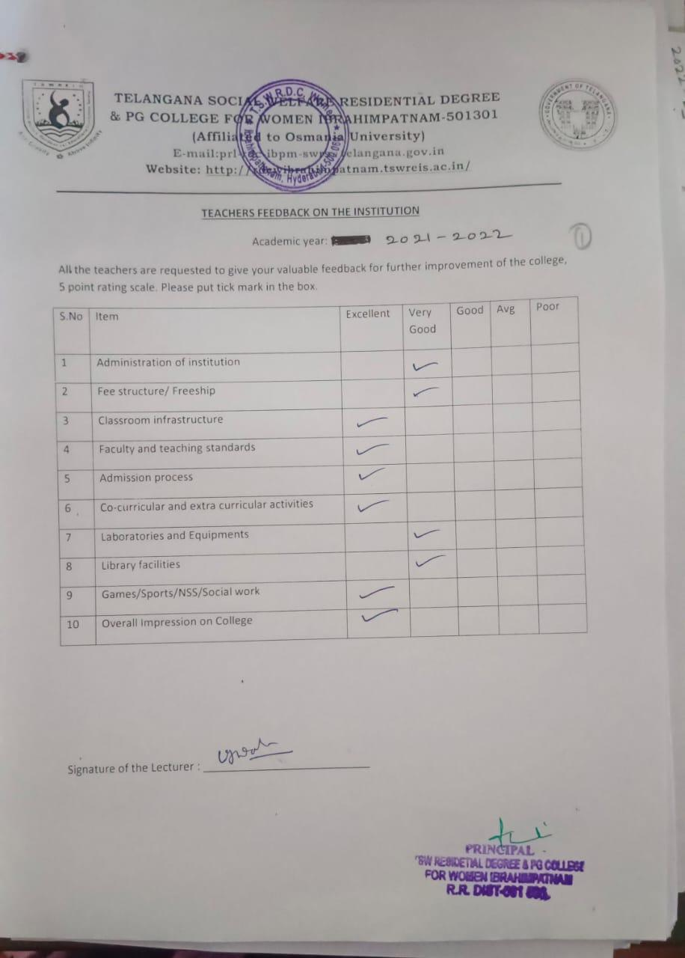

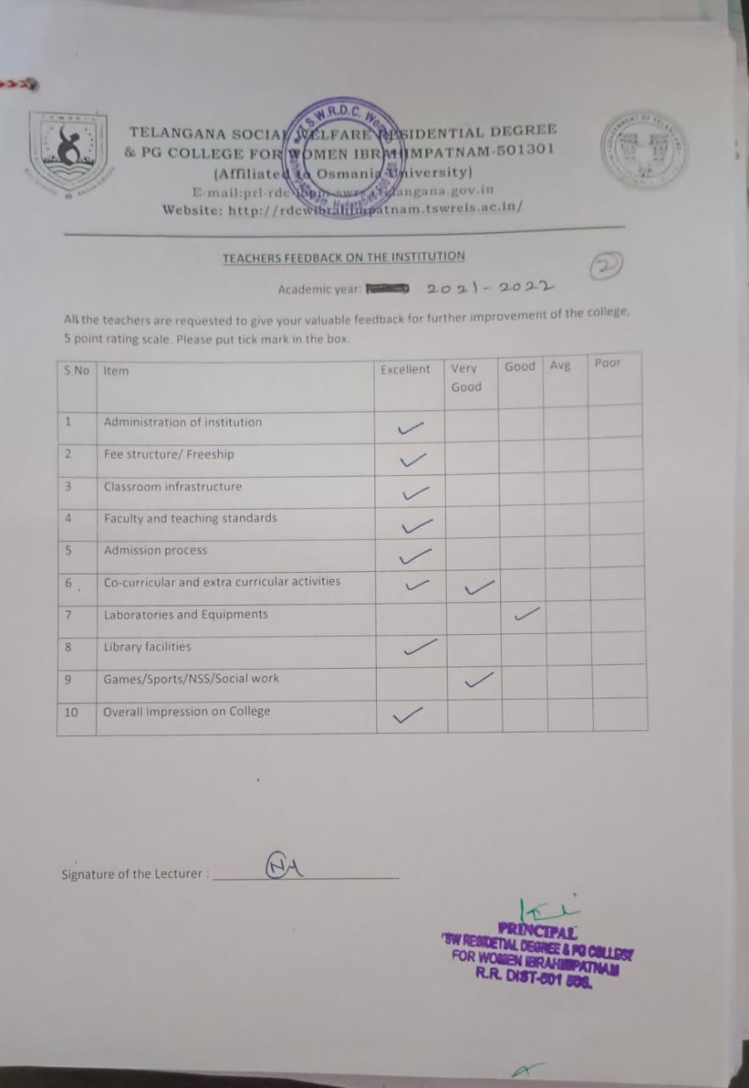

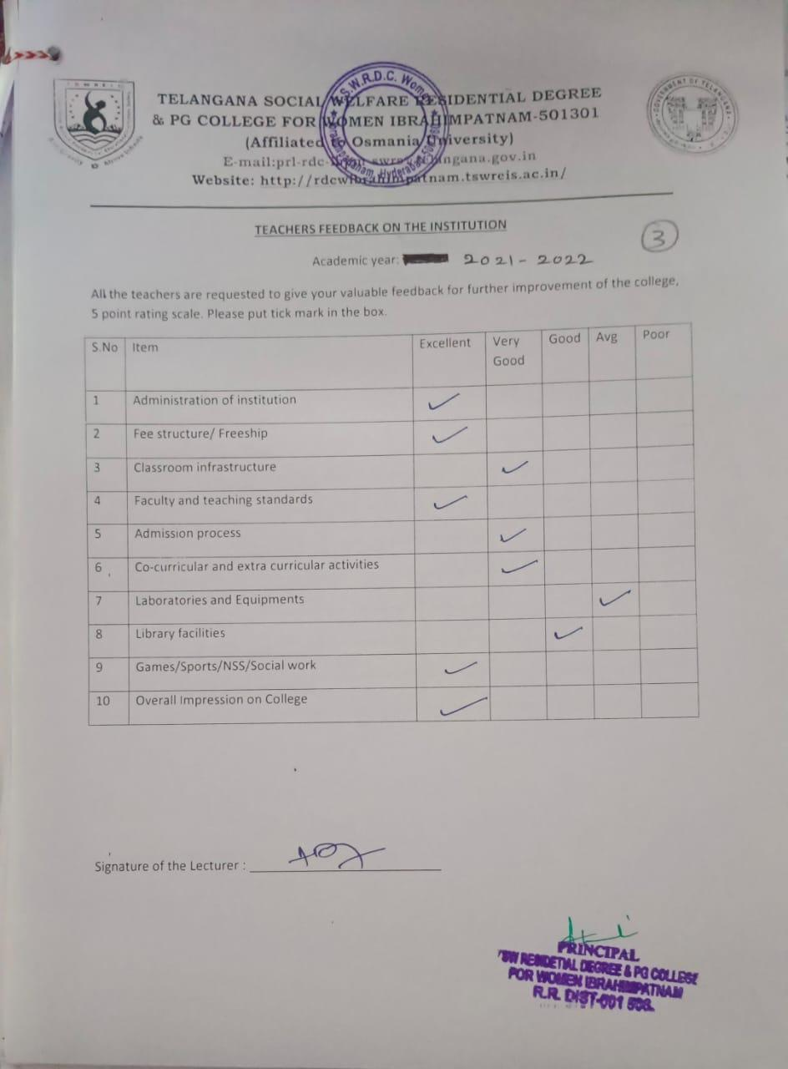

TELANGANA SOCIAL WELFARE RESIDENTIAL DEGREE
& PG COLLEGE FOR WOMEN IBRAHIMPATNAM-501301
(Affiliated to Osmania University)
E-mail:prl-rdc-ibpm-swrs@telangana.gov.in
Website: http://rdcwibrahimpatnam.tswreis.ac.in/

Parents Feedback
A.Y.: 2021-2022

S.No | Item | Excellent | Very Good | Good | Average | Poor | Total
1 | Q.1 | 1 | 7 | 2 | 0 | 0 | 10
2 | Q.2 | 9 | 1 | 0 | 0 | 0 | 10
3 | Q.3 | 2 | 8 | 0 | 0 | 0 | 10
4 | Q.4 | 8 | 2 | 0 | 0 | 0 | 10
5 | Q.5 | 4 | 5 | 1 | 0 | 0 | 10
6 | Q.6 | 4 | 6 | 0 | 0 | 0 | 10
7 | Q.7 | 4 | 6 | 0 | 0 | 0 | 10
Note : The Numbers indicate the total number of Stakeholders voted for particular question.

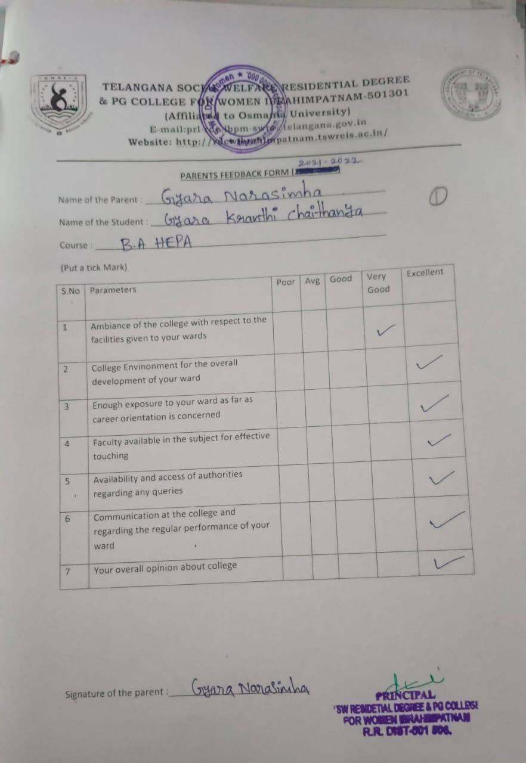

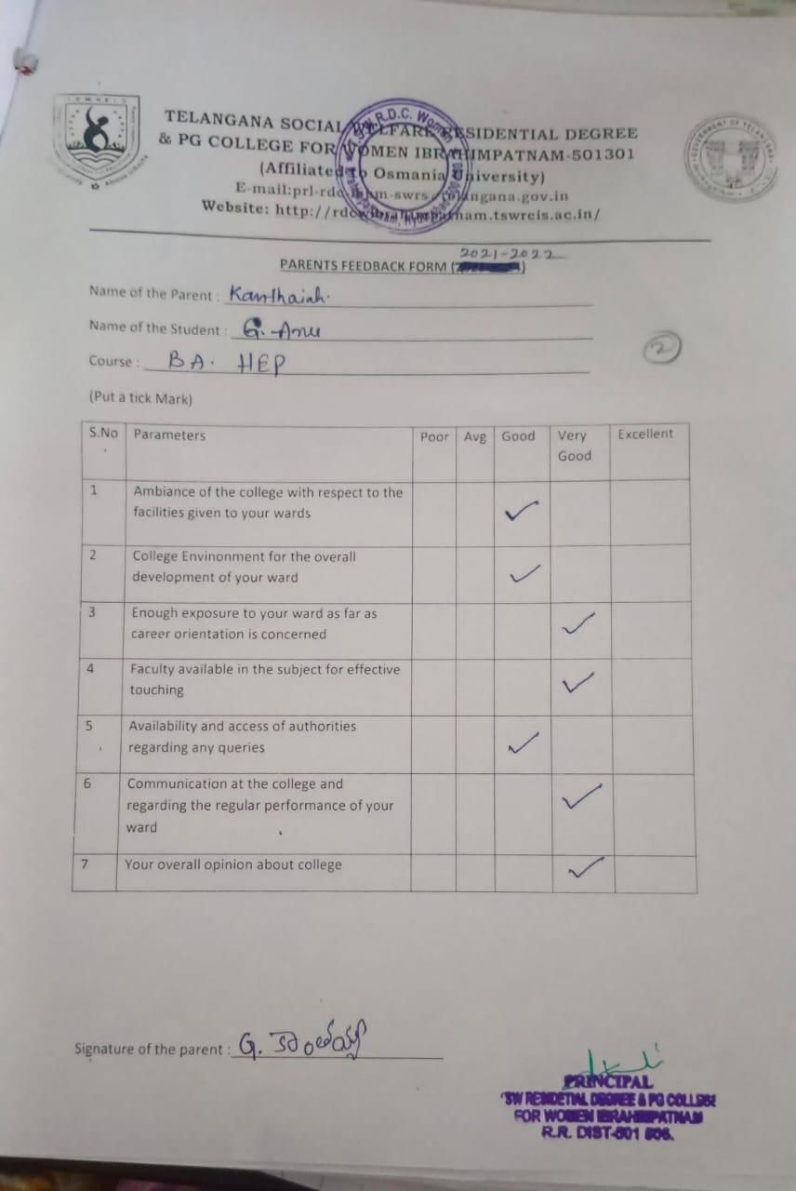

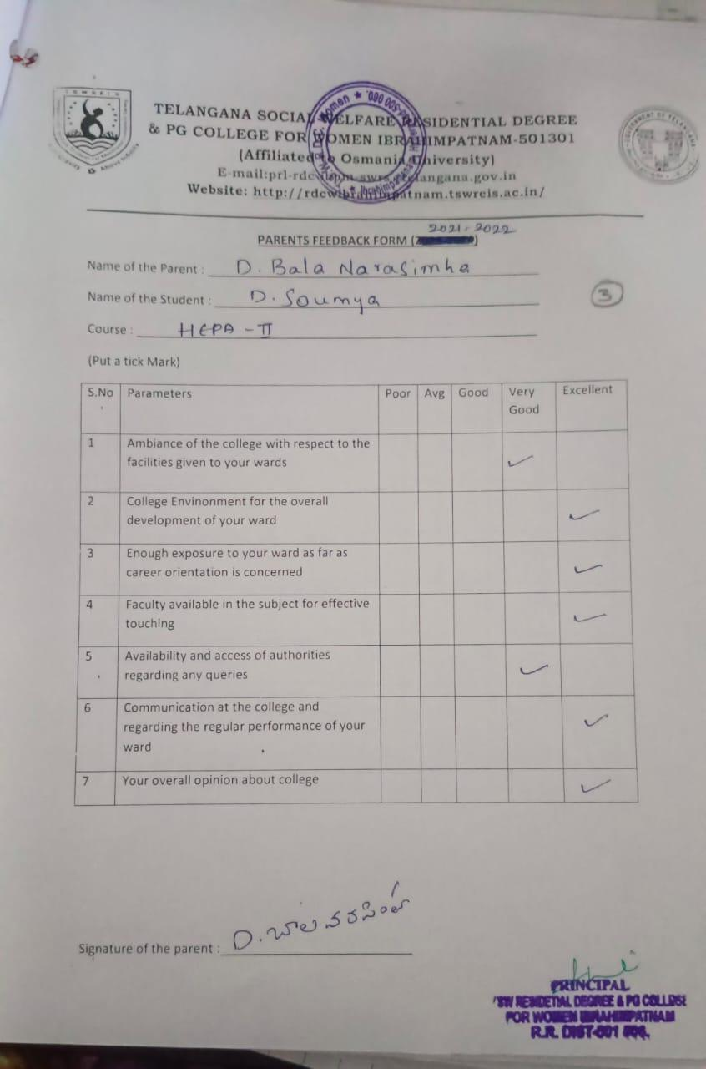

TELANGANA SOCIAL WELFARE RESIDENTIAL DEGREE
& PG COLLEGE FOR WOMEN IBRAHIMPATNAM-501301
(Affiliated to Osmania University)
E-mail:prl-rdc-ibpm-swrs@telangana.gov.in
Website: http://rdcwibrahimpatnam.tswreis.ac.in/

Alumni Feedback
A.Y.: 2021-2022
S.No | Item | Excellent | Very Good | Good | Average | Poor | Total
1 | Q.1 | 6 | 3 | 1 | 0 | 0 | 10
2 | Q.2 | 1 | 7 | 2 | 0 | 0 | 10
3 | Q.3 | 8 | 1 | 1 | 0 | 0 | 10
4 | Q.4 | 7 | 2 | 1 | 0 | 0 | 10
5 | Q.5 | 5 | 4 | 1 | 0 | 0 | 10
6 | Q.6 | 2 | 4 | 4 | 0 | 0 | 10
7 | Q.7 | 6 | 1 | 3 | 0 | 0 | 10
8 | Q.8 | 9 | 1 | 0 | 0 | 0 | 10
Note : The Numbers indicate the total number of Stakeholders voted for particular question.

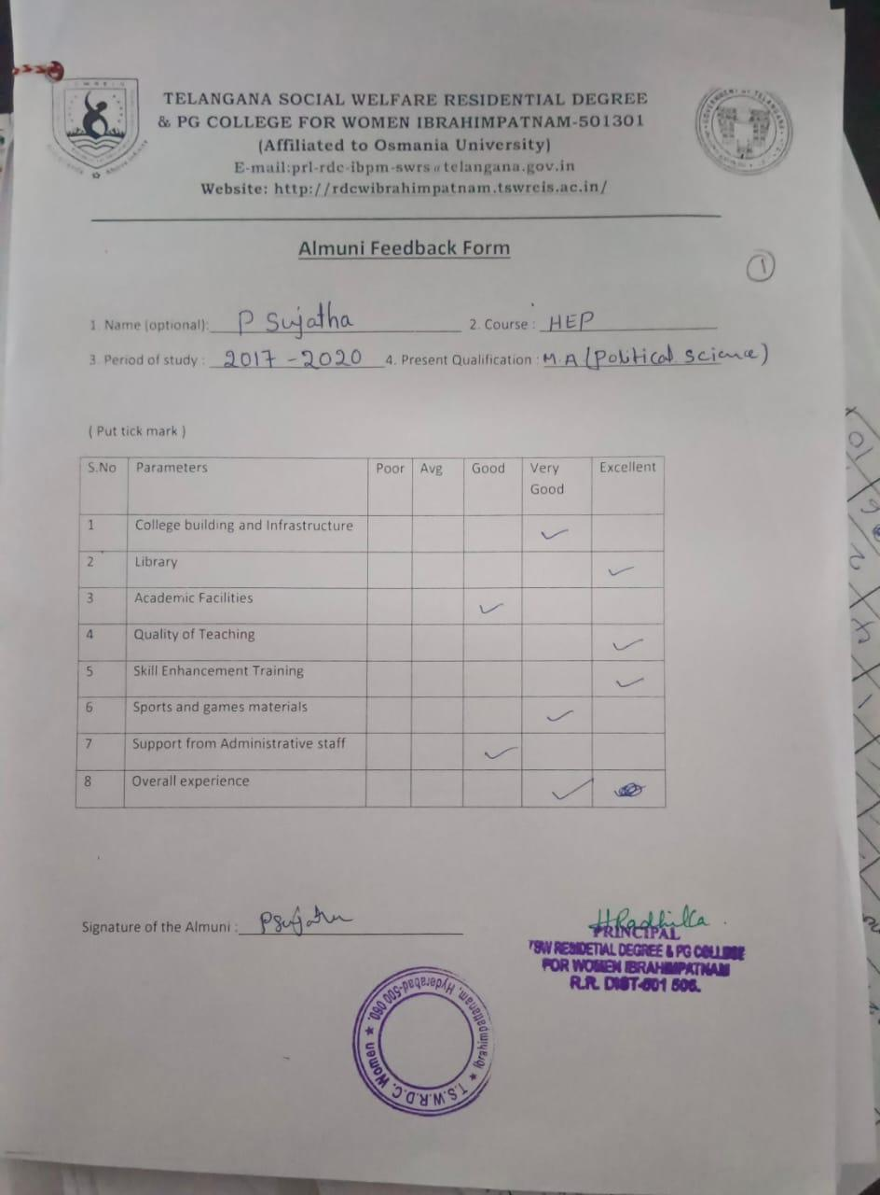

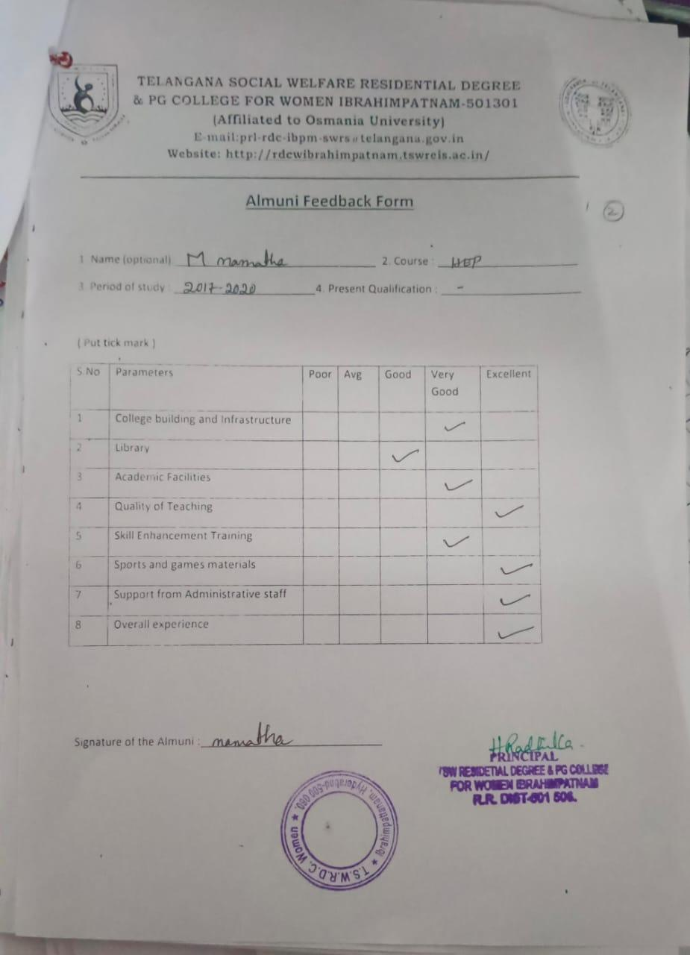

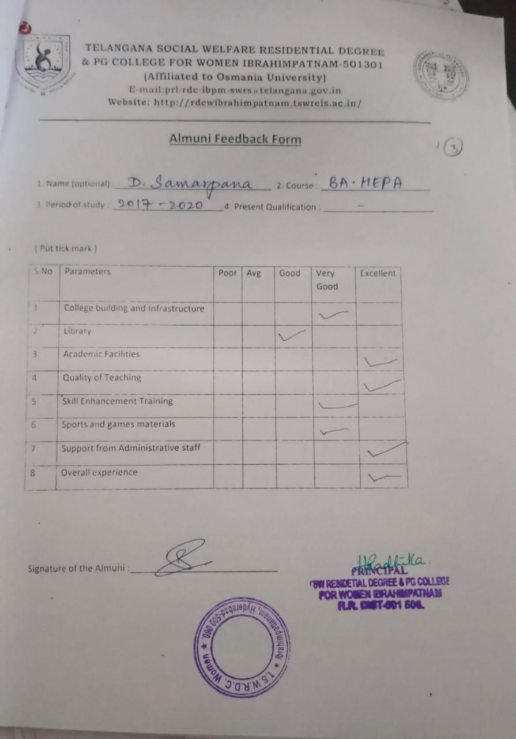

TELANGANA SOCIAL WELFARE RESIDENTIAL DEGREE
& PG COLLEGE FOR WOMEN IBRAHIMPATNAM-501301
(Affiliated to Osmania University)
E-mail:prl-rdc-ibpm-swrs@telangana.gov.in
Website: http://rdcwibrahimpatnam.tswreis.ac.in/

Students Feedback on Teachers
A.Y.: 2022-2023

In order to know the students feedback on Teachers, the college has a standard practice of collecting feedback from students at the end of every academic year. A pre designed feedback sheet is given to the students consisting of 20 questions on various parameters relating to the Teachers. The students are required to give the ranking ranging from I to V. The ranks are assigned as:
S.NO | Rank | Score (Weight)
01 | Poor | +1
02 | Average | +2
03 | Good | +3
04 | Very Good | +4
05 | V-Excellent | +5

S.NO | Name Of The Lecturer | Subject | Q.1 | Q.2 | Q.3 | Q.4 | Q.5 | Q.6 | Q.7 | Q.8 | Q.9 | Q.10 | Q.11 | Q.12 | Q.13 | Q.14 | Q.15 | Q.16 | Q.17 | Q.18 | Q.19 | Q.20 | Total | Remarks
1 | R.Rekha | Economics | 4 | 5 | 4 | 4 | 5 | 5 | 5 | 4 | 4 | 5 | 5 | 4 | 4 | 5 | 4 | 5 | 5 | 4 | 4 | 5 | 90 | Excellent
2 | A.Divya Jyothi | Public Administration | 5 | 5 | 5 | 5 | 5 | 4 | 5 | 4 | 5 | 4 | 5 | 4 | 5 | 5 | 5 | 4 | 5 | 5 | 5 | 5 | 95 | Excellent
3 | P.Varalaxmi | History | 5 | 5 | 5 | 5 | 4 | 5 | 5 | 5 | 4 | 5 | 5 | 4 | 5 | 5 | 5 | 5 | 5 | 4 | 5 | 4 | 95 | Excellent
4 | Dr.P.Hemamalini | Economics | 5 | 5 | 4 | 4 | 4 | 5 | 4 | 5 | 5 | 5 | 4 | 4 | 5 | 5 | 4 | 4 | 4 | 4 | 5 | 5 | 90 | Excellent
5 | Dr.G.Padmamma | Telugu | 5 | 4 | 4 | 4 | 5 | 5 | 5 | 4 | 4 | 5 | 4 | 5 | 5 | 5 | 4 | 4 | 4 | 5 | 5 | 5 | 91 | Excellent
6 | G.Soujanya | Sociology | 5 | 4 | 5 | 4 | 5 | 5 | 5 | 4 | 3 | 5 | 4 | 5 | 4 | 5 | 5 | 5 | 5 | 5 | 5 | 5 | 93 | Excellent
7 | M.Manjula | English | 5 | 5 | 5 | 4 | 5 | 5 | 5 | 5 | 3 | 4 | 5 | 5 | 5 | 5 | 5 | 5 | 5 | 5 | 5 | 5 | 96 | Excellent
8 | T.Vijaya Lakshmi | English | 5 | 4 | 5 | 5 | 4 | 4 | 5 | 4 | 4 | 4 | 5 | 5 | 5 | 4 | 5 | 5 | 5 | 5 | 4 | 5 | 92 | Excellent
9 | K.Vijaya | Political Science | 5 | 4 | 5 | 5 | 4 | 5 | 4 | 5 | 4 | 5 | 4 | 5 | 5 | 5 | 4 | 4 | 5 | 5 | 5 | 5 | 93 | Excellent
10 | M.Neeraja | Economics | 5 | 4 | 5 | 5 | 4 | 5 | 4 | 5 | 4 | 5 | 5 | 4 | 5 | 5 | 4 | 5 | 4 | 5 | 5 | 5 | 93 | Excellent
11 | Dr.D.Padmavathi | Telugu | 5 | 5 | 5 | 4 | 5 | 5 | 5 | 4 | 5 | 5 | 5 | 4 | 5 | 5 | 5 | 4 | 4 | 5 | 5 | 5 | 95 | Excellent
12 | K.Ujwala | English | 4 | 4 | 4 | 5 | 5 | 5 | 5 | 4 | 4 | 4 | 4 | 5 | 5 | 5 | 4 | 5 | 4 | 5 | 4 | 5 | 90 | Excellent
13 | T.Lalitha | Political Science | 5 | 4 | 5 | 5 | 4 | 5 | 5 | 4 | 4 | 5 | 4 | 4 | 5 | 5 | 5 | 4 | 4 | 4 | 5 | 4 | 90 | Excellent
14 | Ch.Sridevi | Telugu | 5 | 4 | 4 | 4 | 4 | 4 | 4 | 4 | 4 | 5 | 5 | 4 | 4 | 5 | 5 | 5 | 5 | 5 | 5 | 5 | 90 | Excellent
15 | D.Yamini | Political Science | 5 | 4 | 4 | 5 | 4 | 4 | 5 | 4 | 5 | 4 | 5 | 4 | 5 | 4 | 5 | 4 | 4 | 5 | 5 | 5 | 90 | Excellent
16 | V.Amani | Economics | 5 | 4 | 5 | 4 | 5 | 4 | 5 | 4 | 5 | 4 | 5 | 5 | 4 | 4 | 5 | 4 | 5 | 4 | 4 | 5 | 90 | Excellent
17 | K.Jyothi | Psychology | 5 | 4 | 5 | 5 | 4 | 4 | 4 | 5 | 4 | 5 | 4 | 5 | 5 | 4 | 5 | 4 | 5 | 4 | 5 | 4 | 90 | Excellent
18 | T.Srujana Deepthi | Geography | 4 | 4 | 3 | 3 | 4 | 4 | 3 | 3 | 4 | 3 | 4 | 3 | 3 | 4 | 3 | 3 | 3 | 3 | 4 | 5 | 70 | Very Good
19 | K.Madhavi | Public Administration | 5 | 4 | 4 | 5 | 4 | 5 | 5 | 4 | 4 | 4 | 5 | 5 | 5 | 4 | 5 | 5 | 5 | 5 | 4 | 5 | 92 | Excellent
20 | J.Prudhvi Rani | Journalism | 4 | 4 | 5 | 5 | 4 | 4 | 4 | 5 | 5 | 5 | 4 | 5 | 4 | 5 | 4 | 4 | 5 | 5 | 4 | 5 | 90 | Excellent
21 | Dr.B.Kranthikumari | English | 5 | 4 | 5 | 4 | 4 | 4 | 5 | 5 | 4 | 5 | 5 | 5 | 5 | 5 | 4 | 4 | 4 | 4 | 4 | 5 | 90 | Excellent
22 | Dr.Elezebeth | English | 5 | 4 | 5 | 4 | 4 | 4 | 5 | 5 | 4 | 5 | 5 | 5 | 5 | 5 | 4 | 4 | 4 | 4 | 4 | 5 | 90 | Excellent
23 | P.Neelavathi | English | 5 | 4 | 4 | 4 | 4 | 3 | 4 | 3 | 3 | 4 | 4 | 4 | 5 | 4 | 5 | 4 | 4 | 4 | 4 | 4 | 80 | Very Good
24 | D.Christhumani | English | 5 | 4 | 4 | 4 | 4 | 3 | 4 | 3 | 3 | 4 | 4 | 4 | 5 | 4 | 5 | 4 | 4 | 4 | 4 | 4 | 80 | Very Good

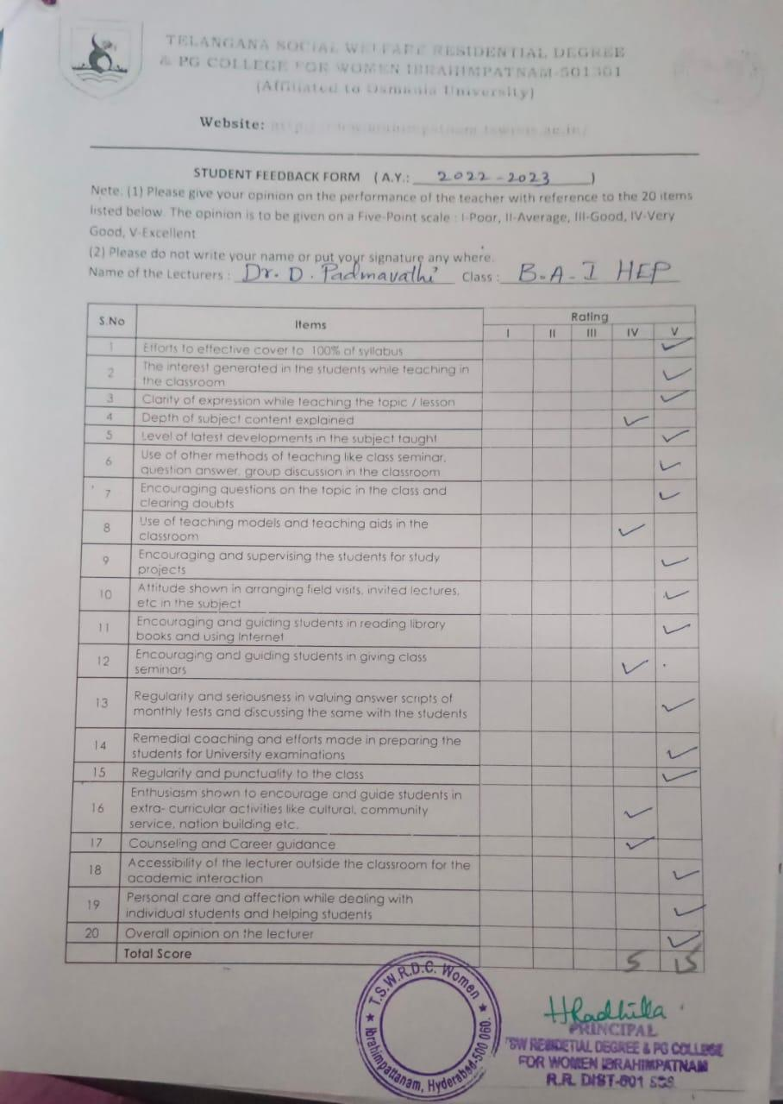

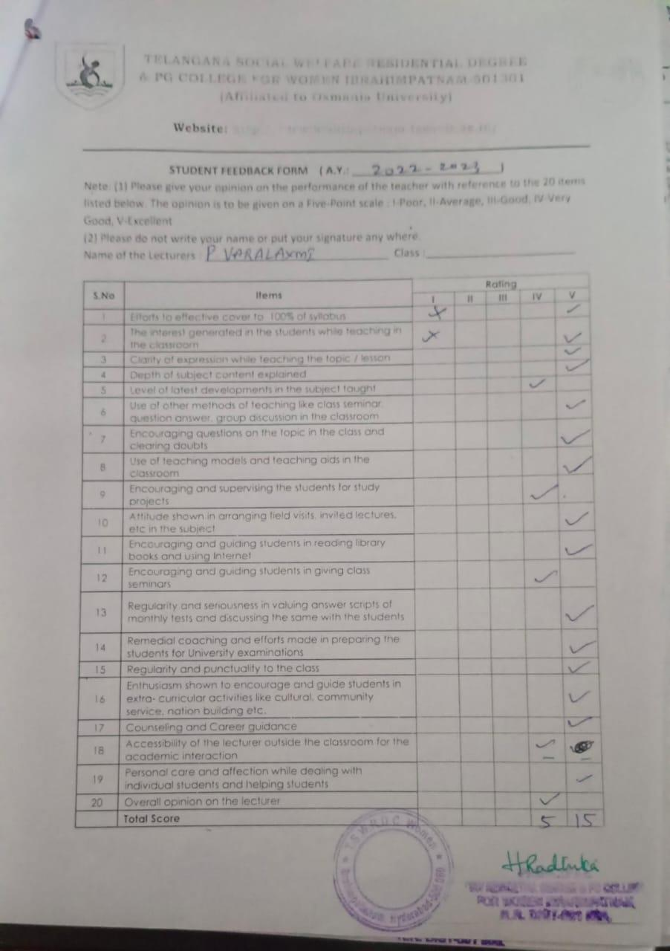

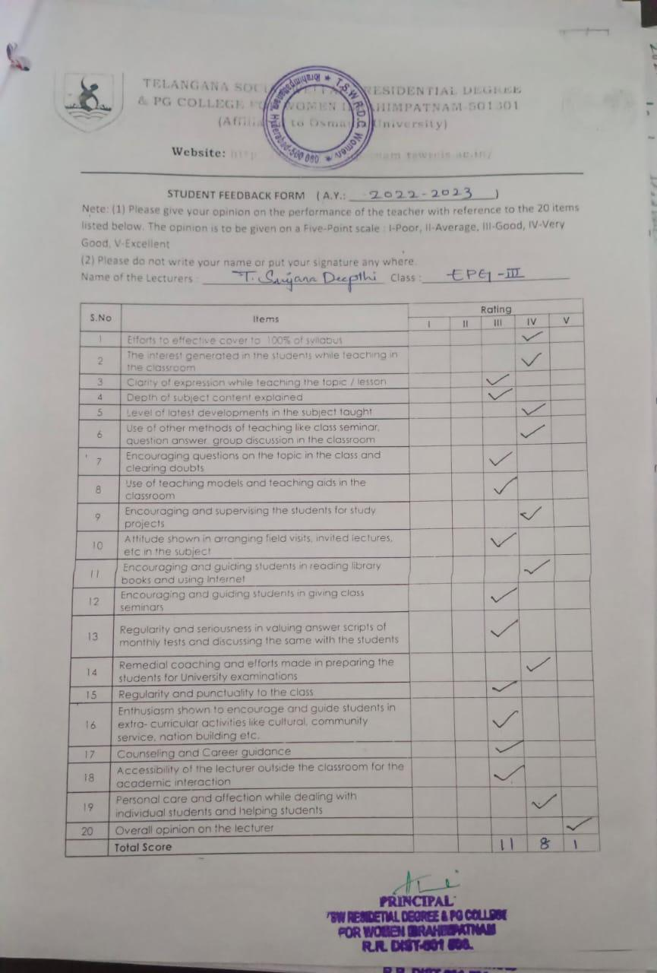

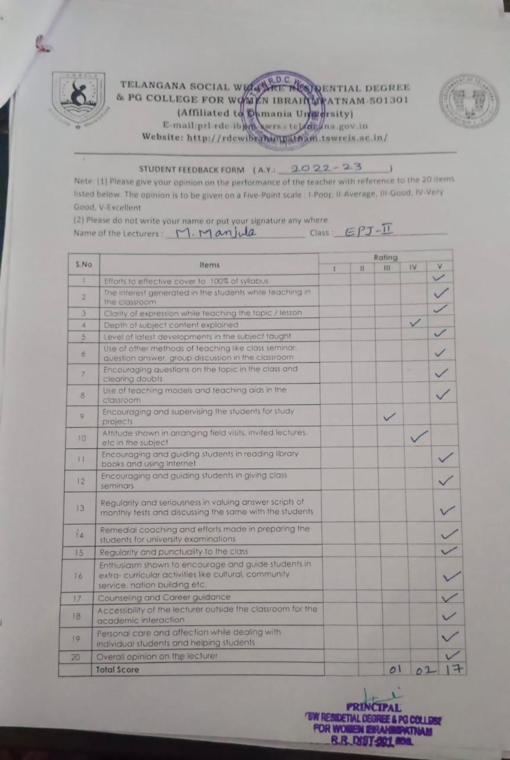

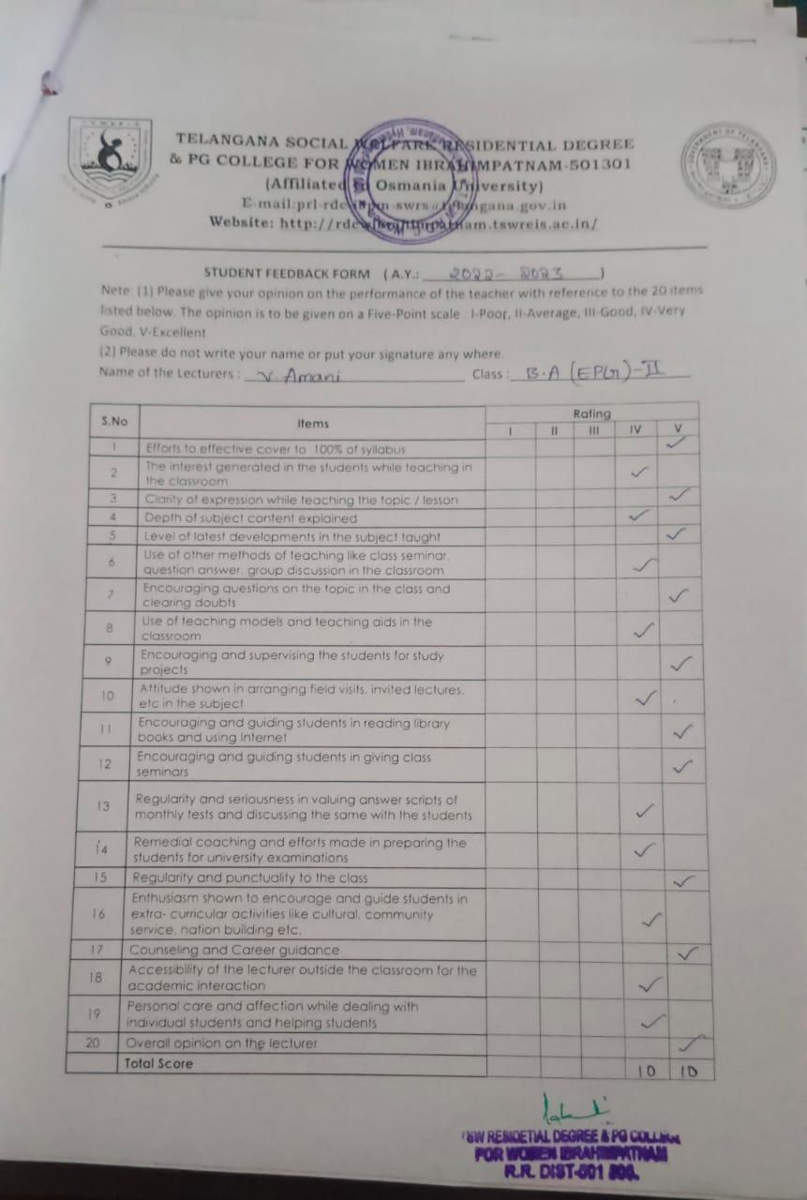

TELANGANA SOCIAL WELFARE RESIDENTIAL DEGREE
& PG COLLEGE FOR WOMEN IBRAHIMPATNAM-501301
(Affiliated to Osmania University)
E-mail:prl-rdc-ibpm-swrs@telangana.gov.in
Website: http://rdcwibrahimpatnam.tswreis.ac.in/

Students Feedback on Teachers
A.Y.: 2022-2023

Report :
- 0-20M -Poor,
21-40M-Average
41-60M- Good
61-80M – Very Good
81-100M- Excellent
- Based on the Feedback of the students 3 Lecturers scored Very Good Score, 21 Lecturers scored Excellent score.

TELANGANA SOCIAL WELFARE RESIDENTIAL DEGREE
& PG COLLEGE FOR WOMEN IBRAHIMPATNAM-501301
(Affiliated to Osmania University)
E-mail:prl-rdc-ibpm-swrs@telangana.gov.in
Website: http://rdcwibrahimpatnam.tswreis.ac.in/

Action Taken Report :

A.Y.: 2022-2023

Action Taken :
- The Principal congratulated the Teaching staff who secures Excellent Score.
- The Principal advised the faculty who scored very good marks to improve to excellent score.

TELANGANA SOCIAL WELFARE RESIDENTIAL DEGREE
& PG COLLEGE FOR WOMEN IBRAHIMPATNAM-501301
(Affiliated to Osmania University)
E-mail:prl-rdc-ibpm-swrs@telangana.gov.in
Website: http://rdcwibrahimpatnam.tswreis.ac.in/

Teachers Feedback
A.Y.: 2022-2023

S.No | Item | Excellent | Very Good | Good | Average | Poor | Total
1 | Q.1 | 7 | 2 | 1 | 0 | 0 | 10
2 | Q.2 | 10 | 0 | 0 | 0 | 0 | 10
3 | Q.3 | 2 | 8 | 0 | 0 | 0 | 10
4 | Q.4 | 5 | 5 | 0 | 0 | 0 | 10
5 | Q.5 | 4 | 6 | 0 | 0 | 0 | 10
6 | Q.6 | 8 | 2 | 0 | 0 | 0 | 10
7 | Q.7 | 0 | 2 | 7 | 1 | 0 | 10
8 | Q.8 | 2 | 7 | 1 | 0 | 0 | 10
9 | Q.9 | 4 | 6 | 0 | 0 | 0 | 10
10 | Q.10 | 4 | 6 | 0 | 0 | 0 | 10
 |  | 46 | 44 | 9 | 1 | 0 | 100
Note : The Numbers indicate the total number of Stakeholders voted for particular question.

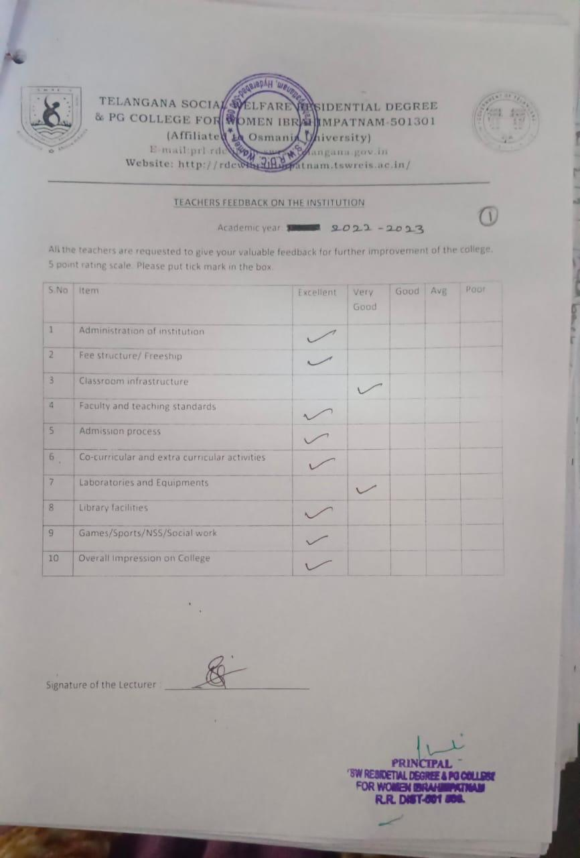

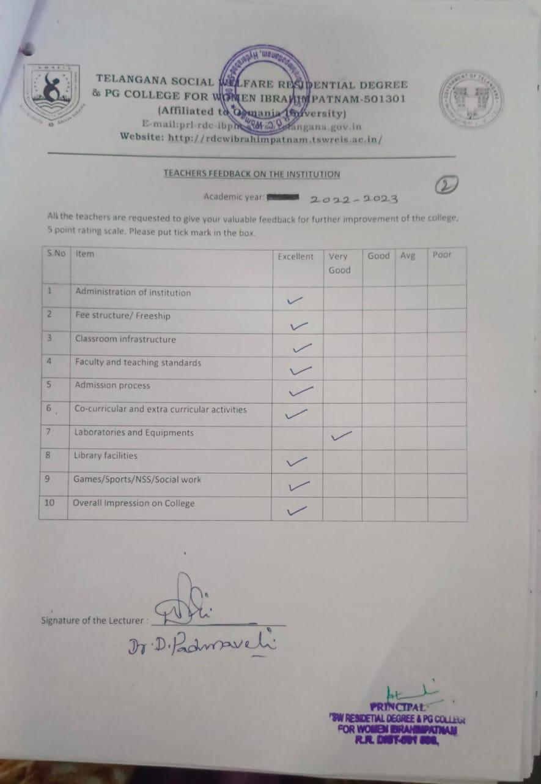

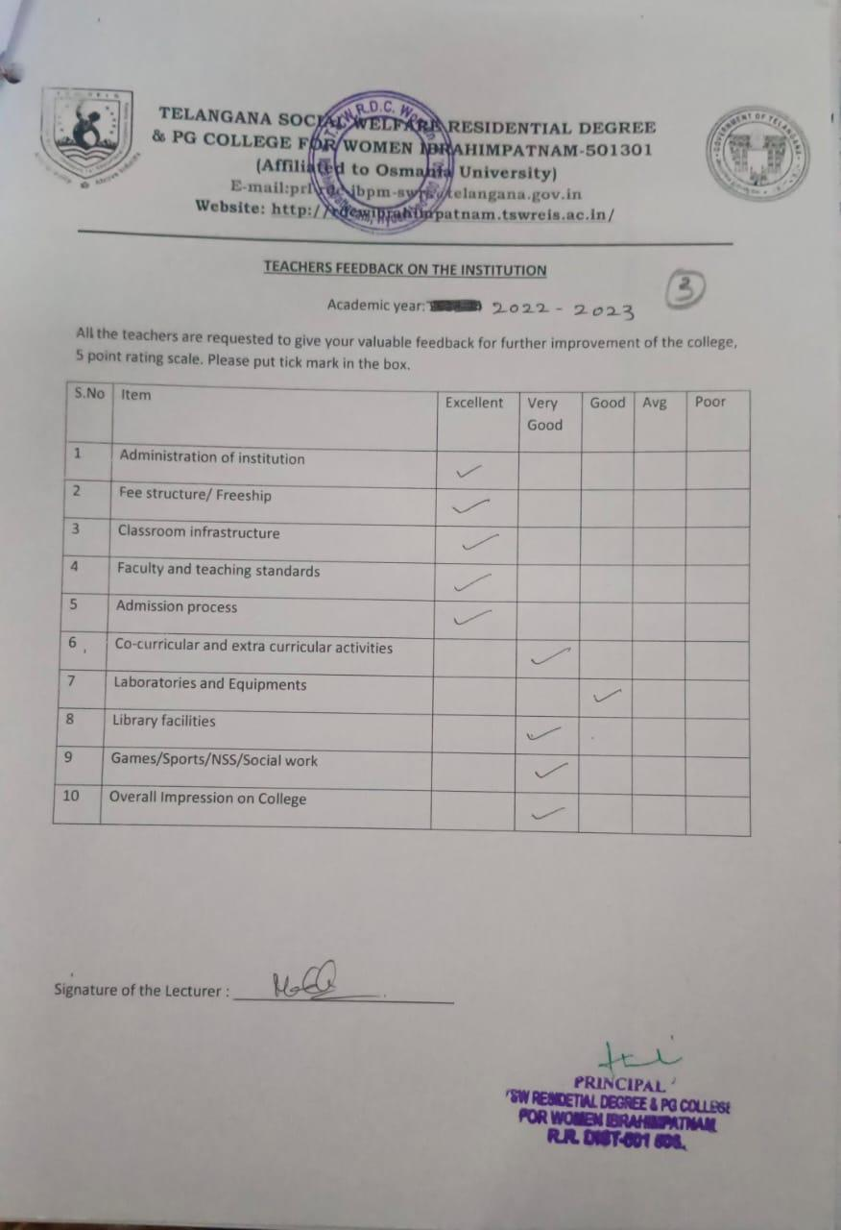

TELANGANA SOCIAL WELFARE RESIDENTIAL DEGREE
& PG COLLEGE FOR WOMEN IBRAHIMPATNAM-501301
(Affiliated to Osmania University)
E-mail:prl-rdc-ibpm-swrs@telangana.gov.in
Website: http://rdcwibrahimpatnam.tswreis.ac.in/

Parents Feedback
A.Y.: 2022-2023

S.No | Item | Excellent | Very Good | Good | Average | Poor | Total
1 | Q.1 | 2 | 8 | 0 | 0 | 0 | 10
2 | Q.2 | 7 | 3 | 0 | 0 | 0 | 10
3 | Q.3 | 3 | 7 | 0 | 0 | 0 | 10
4 | Q.4 | 7 | 3 | 0 | 0 | 0 | 10
5 | Q.5 | 4 | 6 | 0 | 0 | 0 | 10
6 | Q.6 | 4 | 6 | 0 | 0 | 0 | 10
7 | Q.7 | 6 | 4 | 0 | 0 | 0 | 10
Note : The Numbers indicate the total number of Stakeholders voted for particular question.

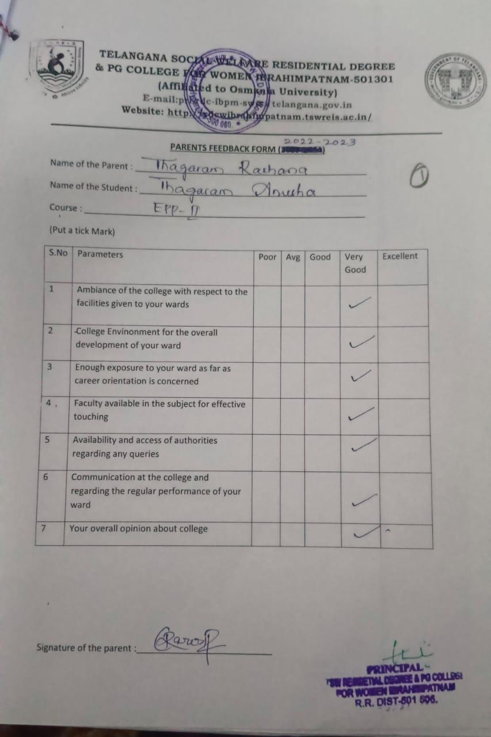

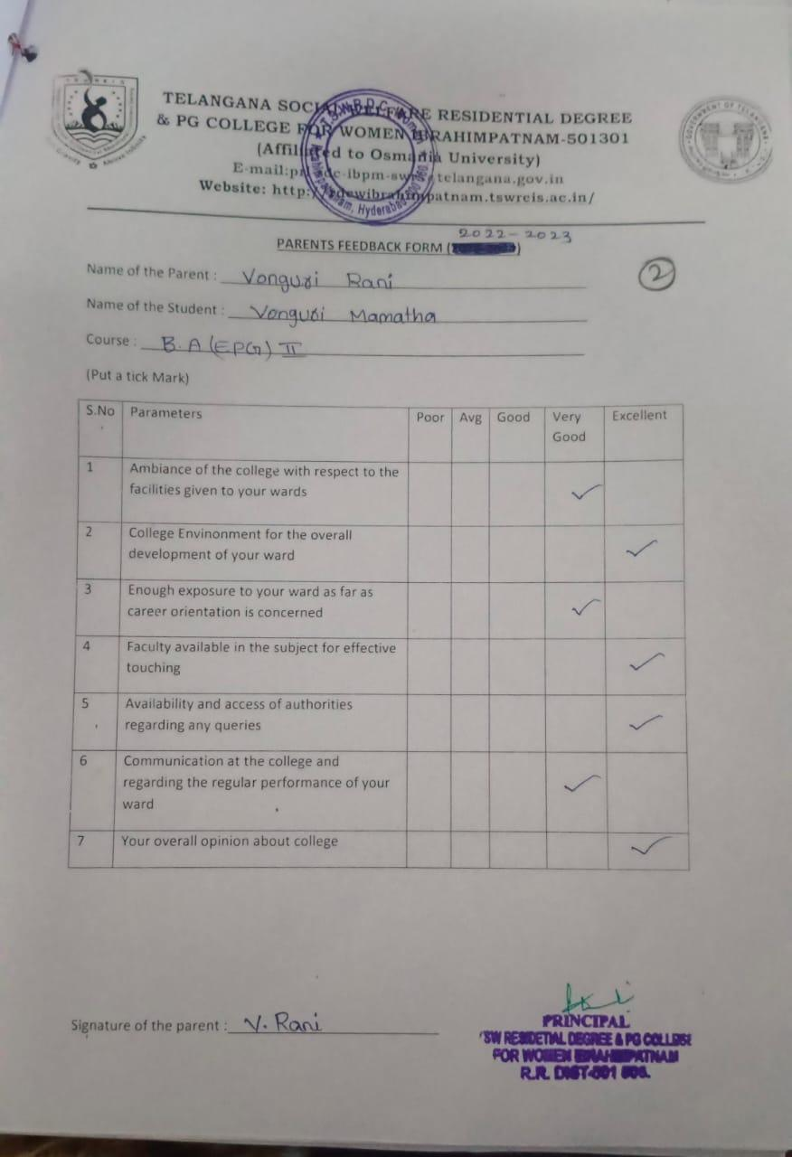

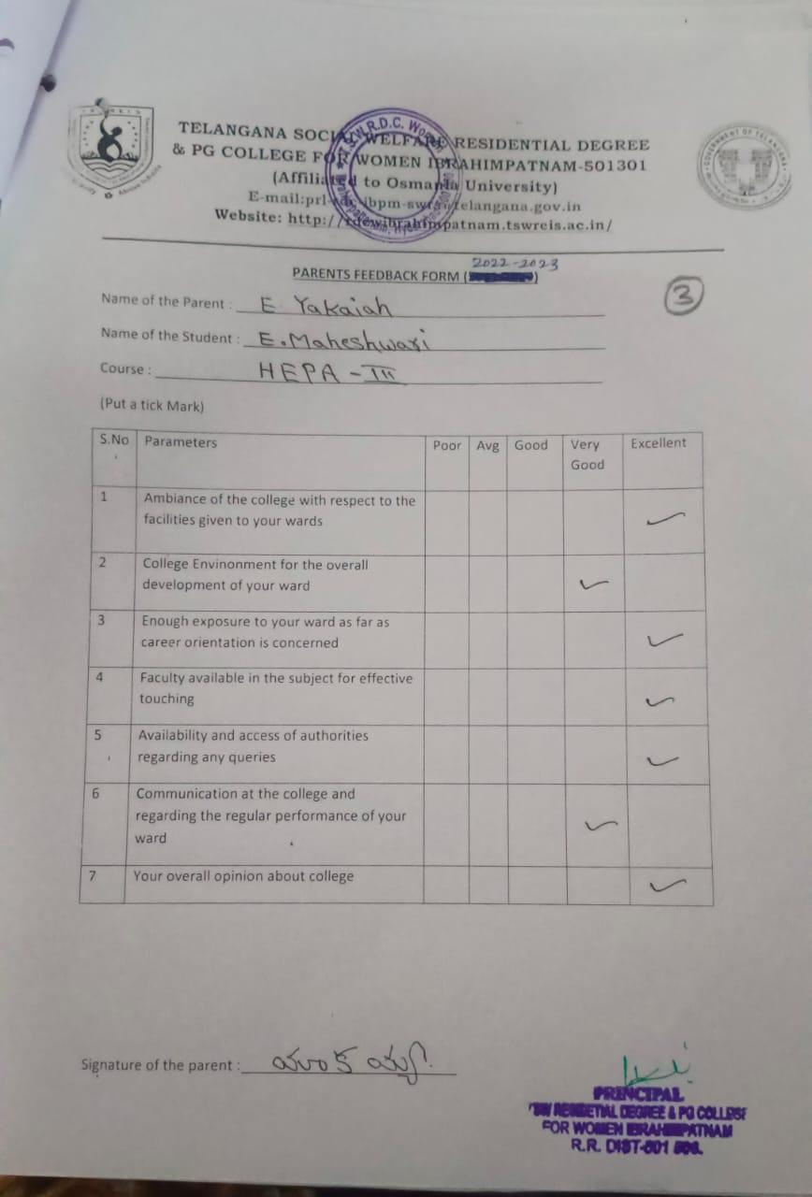

TELANGANA SOCIAL WELFARE RESIDENTIAL DEGREE
& PG COLLEGE FOR WOMEN IBRAHIMPATNAM-501301
(Affiliated to Osmania University)
E-mail:prl-rdc-ibpm-swrs@telangana.gov.in
Website: http://rdcwibrahimpatnam.tswreis.ac.in/

Alumni Feedback
A.Y.: 2022-2023

S.No | Item | Excellent | Very Good | Good | Average | Poor | Total
1 | Q.1 | 5 | 5 | 0 | 0 | 0 | 10
2 | Q.2 | 6 | 4 | 0 | 0 | 0 | 10
3 | Q.3 | 6 | 4 | 0 | 0 | 0 | 10
4 | Q.4 | 9 | 1 | 0 | 0 | 0 | 10
5 | Q.5 | 5 | 5 | 0 | 0 | 0 | 10
6 | Q.6 | 2 | 8 | 0 | 0 | 0 | 10
7 | Q.7 | 6 | 4 | 0 | 0 | 0 | 10
8 | Q.8 | 9 | 1 | 0 | 0 | 0 | 10
Note : The Numbers indicate the total number of Stakeholders voted for particular question.

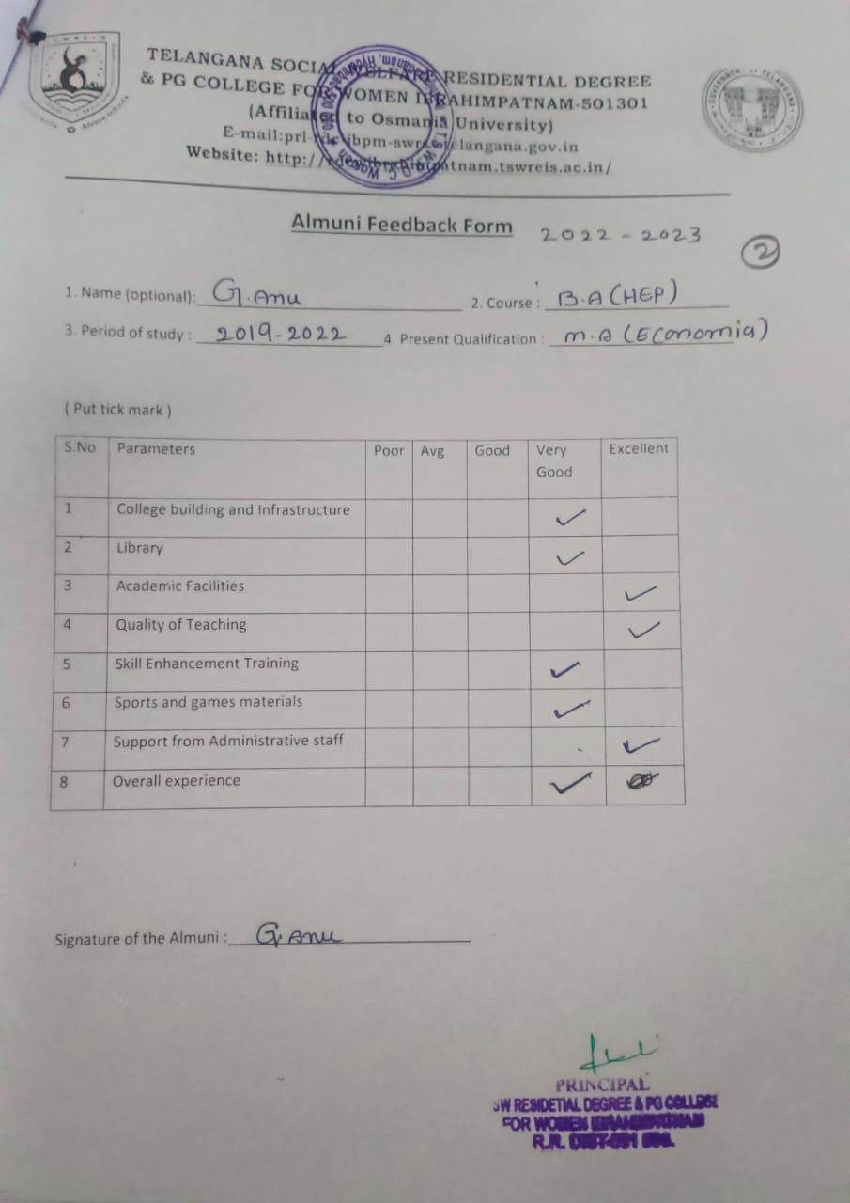

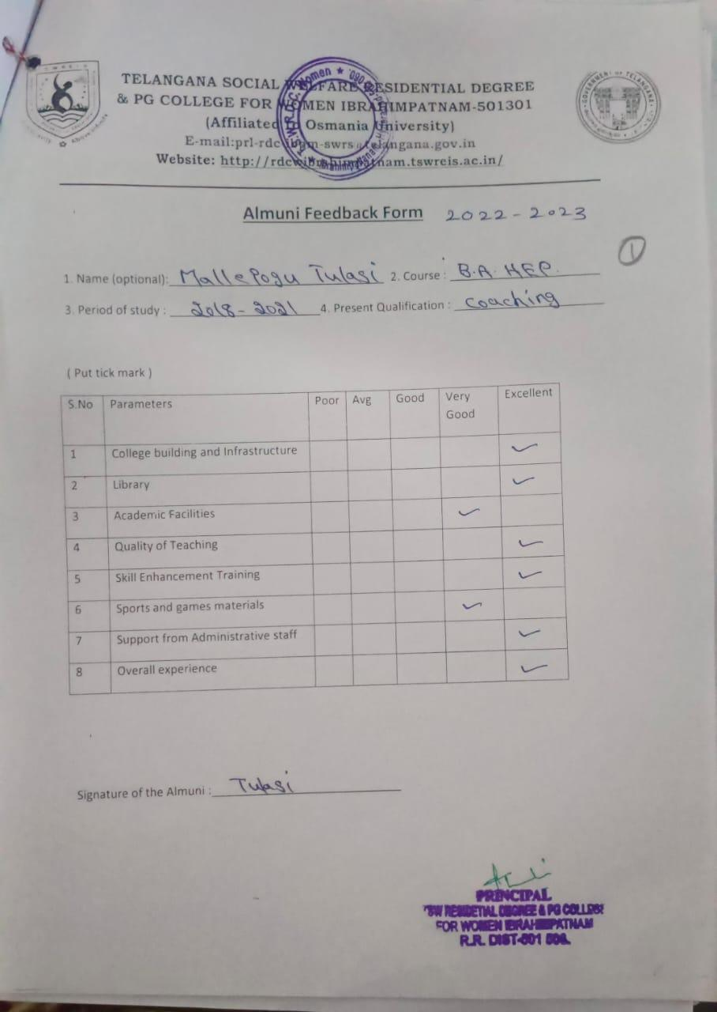

TELANGANA SOCIAL WELFARE RESIDENTIAL DEGREE
& PG COLLEGE FOR WOMEN IBRAHIMPATNAM-501301
(Affiliated to Osmania University)
E-mail:prl-rdc-ibpm-swrs@telangana.gov.in
Website: http://rdcwibrahimpatnam.tswreis.ac.in/

Students Feedback on Teachers
A.Y.: 2023-2024

In order to know the students feedback on Teachers, the college has a standard practice of collecting feedback from students at the end of every academic year. A pre designed feedback sheet is given to the students consisting of 20 questions on various parameters relating to the Teachers. The students are required to give the ranking ranging from I to V. The ranks are assigned as:
S.NO | Rank | Score (Weight)
01 | Poor | +1
02 | Average | +2
03 | Good | +3
04 | Very Good | +4
05 | V-Excellent | +5

S.NO | Name Of The Lecturer | Subject | Q.1 | Q.2 | Q.3 | Q.4 | Q.5 | Q.6 | Q.7 | Q.8 | Q.9 | Q.10 | Q.11 | Q.12 | Q.13 | Q.14 | Q.15 | Q.16 | Q.17 | Q.18 | Q.19 | Q.20 | Total | Remarks
1 | R.Rekha | Economics | 5 | 5 | 5 | 4 | 5 | 5 | 5 | 5 | 5 | 5 | 4 | 5 | 5 | 5 | 5 | 5 | 5 | 5 | 5 | 5 | 98 | Excellent
2 | A.Divya Jyothi | Public Administration | 5 | 5 | 5 | 5 | 5 | 5 | 4 | 5 | 5 | 4 | 5 | 5 | 5 | 5 | 5 | 5 | 5 | 5 | 5 | 5 | 98 | Excellent
3 | P.Varalaxmi | History | 5 | 5 | 5 | 5 | 4 | 5 | 5 | 5 | 5 | 5 | 5 | 5 | 5 | 4 | 5 | 5 | 5 | 5 | 5 | 5 | 98 | Excellent
4 | Dr.P.Hemamalini | Economics | 5 | 5 | 5 | 5 | 5 | 4 | 5 | 5 | 5 | 5 | 5 | 5 | 4 | 5 | 5 | 5 | 5 | 5 | 5 | 5 | 98 | Excellent
5 | Dr.G.Padmamma | Telugu | 5 | 5 | 5 | 5 | 5 | 5 | 5 | 5 | 5 | 5 | 5 | 5 | 4 | 5 | 5 | 5 | 4 | 5 | 5 | 5 | 98 | Excellent
6 | G.Soujanya | Sociology | 5 | 4 | 5 | 4 | 3 | 4 | 3 | 5 | 5 | 5 | 5 | 5 | 5 | 5 | 5 | 5 | 5 | 5 | 5 | 5 | 92 | Excellent
7 | M.Manjula | English | 5 | 5 | 5 | 5 | 5 | 5 | 5 | 4 | 5 | 5 | 5 | 5 | 5 | 4 | 5 | 5 | 5 | 5 | 5 | 5 | 98 | Excellent
8 | T.Vijaya Lakshmi | English | 5 | 5 | 5 | 5 | 5 | 5 | 5 | 4 | 5 | 5 | 5 | 5 | 4 | 5 | 5 | 5 | 5 | 5 | 5 | 5 | 98 | Excellent
9 | K.Vijaya | Political Science | 5 | 5 | 5 | 5 | 4 | 5 | 5 | 4 | 4 | 5 | 5 | 5 | 5 | 4 | 5 | 5 | 4 | 5 | 5 | 5 | 95 | Excellent
10 | M.Neeraja | Economics | 5 | 5 | 5 | 5 | 5 | 5 | 5 | 5 | 5 | 4 | 5 | 5 | 5 | 5 | 5 | 4 | 5 | 5 | 5 | 5 | 98 | Excellent
11 | Dr.D.Padmavathi | Telugu | 5 | 5 | 5 | 5 | 5 | 5 | 5 | 5 | 5 | 5 | 5 | 5 | 5 | 5 | 5 | 5 | 5 | 5 | 5 | 5 | 100 | Excellent
12 | K.Ujwala | English | 5 | 5 | 5 | 5 | 5 | 5 | 5 | 5 | 5 | 4 | 5 | 4 | 5 | 5 | 5 | 5 | 5 | 4 | 5 | 5 | 97 | Excellent
13 | T.Lalitha | Political Science | 5 | 5 | 5 | 5 | 5 | 5 | 5 | 5 | 5 | 4 | 5 | 4 | 5 | 5 | 5 | 5 | 5 | 4 | 5 | 5 | 97 | Excellent
14 | Ch.Sridevi | Telugu | 5 | 5 | 5 | 5 | 5 | 5 | 5 | 5 | 5 | 4 | 5 | 4 | 5 | 5 | 5 | 5 | 5 | 4 | 5 | 5 | 97 | Excellent
15 | V.Amani | Economics | 5 | 4 | 4 | 5 | 5 | 5 | 4 | 4 | 5 | 4 | 4 | 5 | 5 | 4 | 5 | 5 | 4 | 4 | 4 | 5 | 90 | Excellent
16 | K.Jyothi | Psychology | 3 | 4 | 3 | 3 | 4 | 3 | 4 | 3 | 3 | 5 | 4 | 4 | 3 | 3 | 3 | 4 | 3 | 3 | 4 | 4 | 70 | Excellent
17 | T.Srujana Deepthi | Geography | 5 | 4 | 4 | 4 | 4 | 4 | 3 | 4 | 4 | 5 | 4 | 4 | 4 | 5 | 5 | 5 | 5 | 5 | 5 | 5 | 88 | Excellent
18 | K.Madhavi | Public Administration | 5 | 4 | 5 | 4 | 4 | 4 | 5 | 5 | 4 | 5 | 5 | 5 | 5 | 5 | 4 | 4 | 4 | 4 | 4 | 5 | 90 | Excellent
19 | J.Prudhvi Rani | Journalism | 5 | 4 | 4 | 4 | 4 | 3 | 4 | 3 | 3 | 4 | 4 | 4 | 5 | 4 | 5 | 4 | 4 | 4 | 4 | 4 | 80 | Very Good
20 | Dr.B.Kranthikumari | English | 5 | 4 | 5 | 4 | 4 | 4 | 5 | 5 | 4 | 5 | 5 | 5 | 5 | 5 | 4 | 4 | 4 | 4 | 4 | 5 | 90 | Excellent
21 | Dr.Elezebeth | English | 5 | 4 | 5 | 4 | 4 | 4 | 5 | 5 | 4 | 5 | 5 | 5 | 5 | 5 | 4 | 4 | 4 | 4 | 4 | 5 | 90 | Excellent
22 | P.Neelavathi | English | 5 | 4 | 4 | 4 | 4 | 3 | 4 | 3 | 3 | 4 | 4 | 4 | 5 | 4 | 5 | 4 | 4 | 4 | 4 | 4 | 80 | Very Good
23 | D.Christhumani | English | 5 | 4 | 4 | 4 | 4 | 3 | 4 | 3 | 3 | 4 | 4 | 4 | 5 | 4 | 5 | 4 | 4 | 4 | 4 | 4 | 80 | Very Good

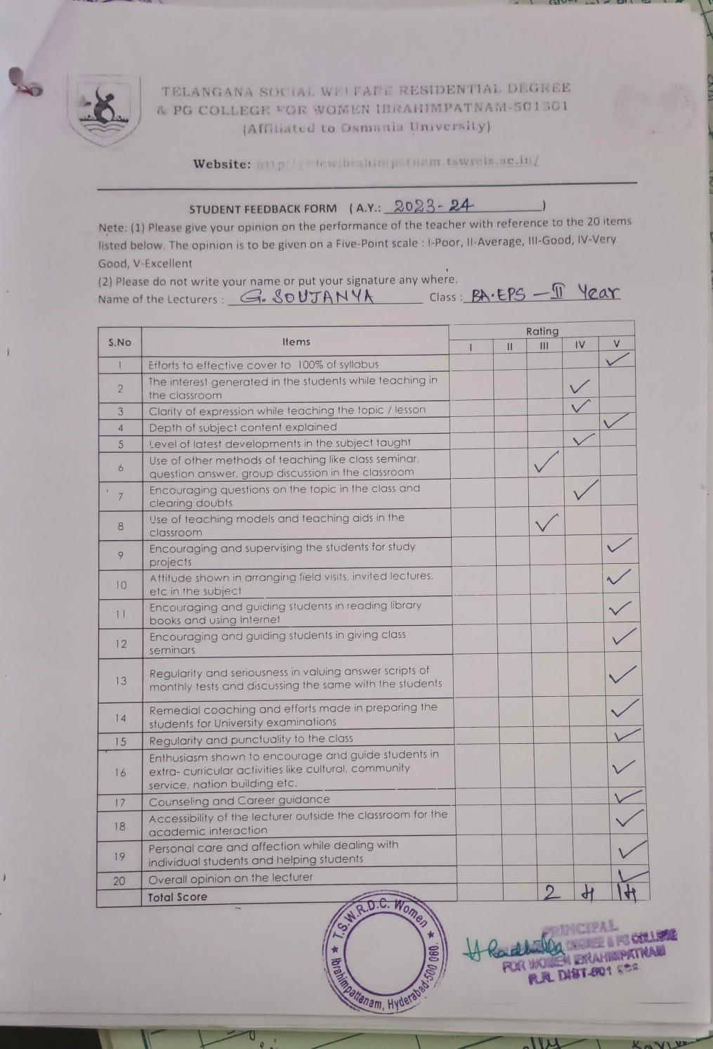

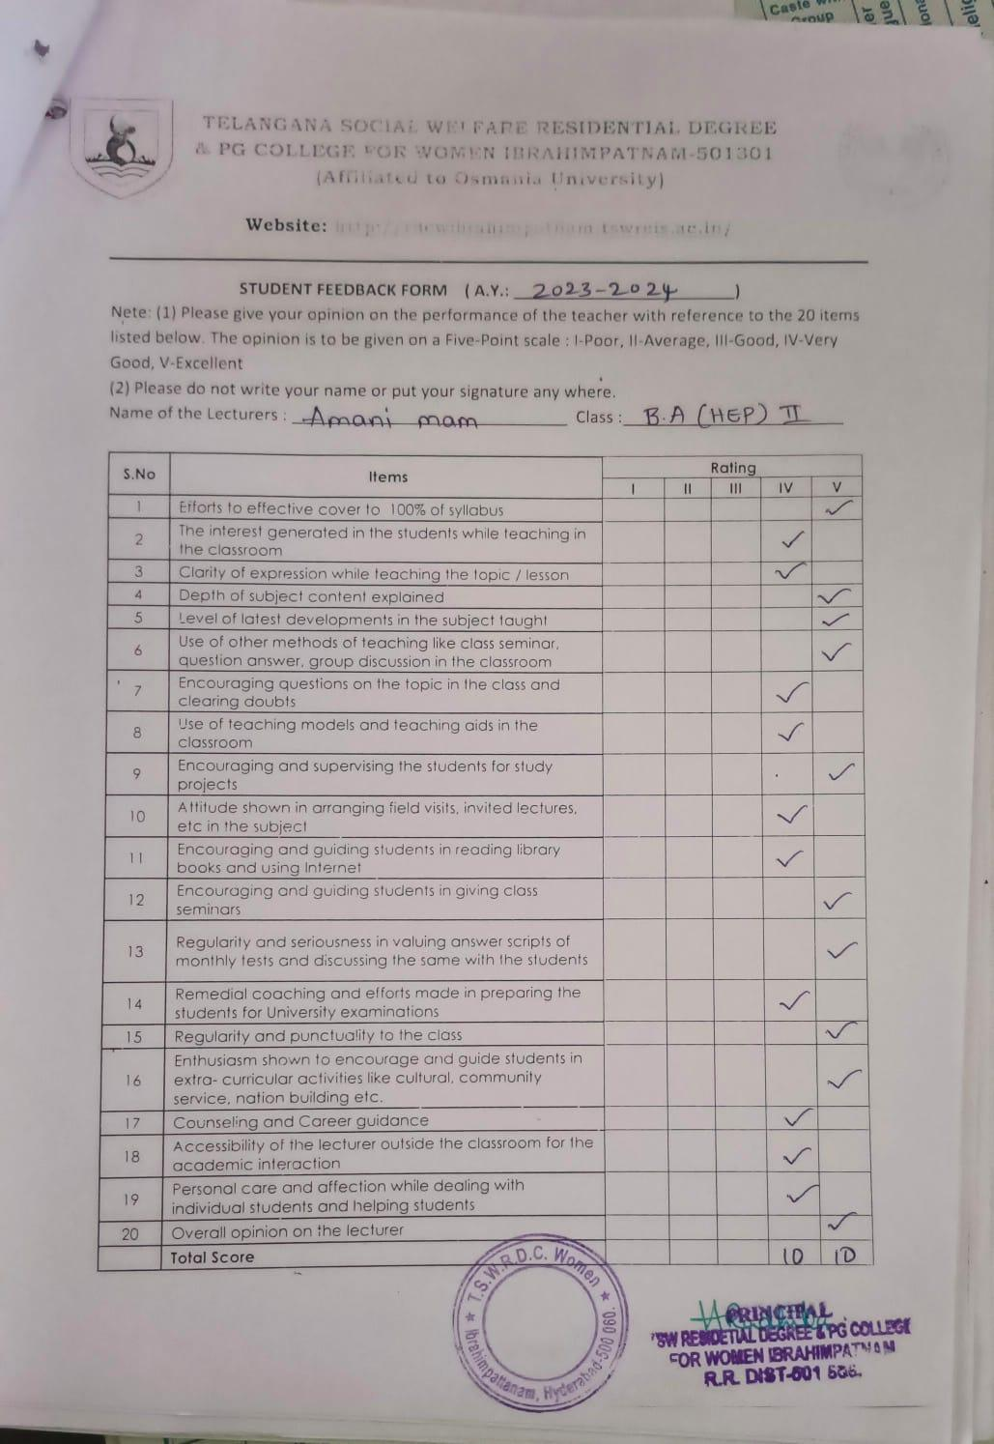

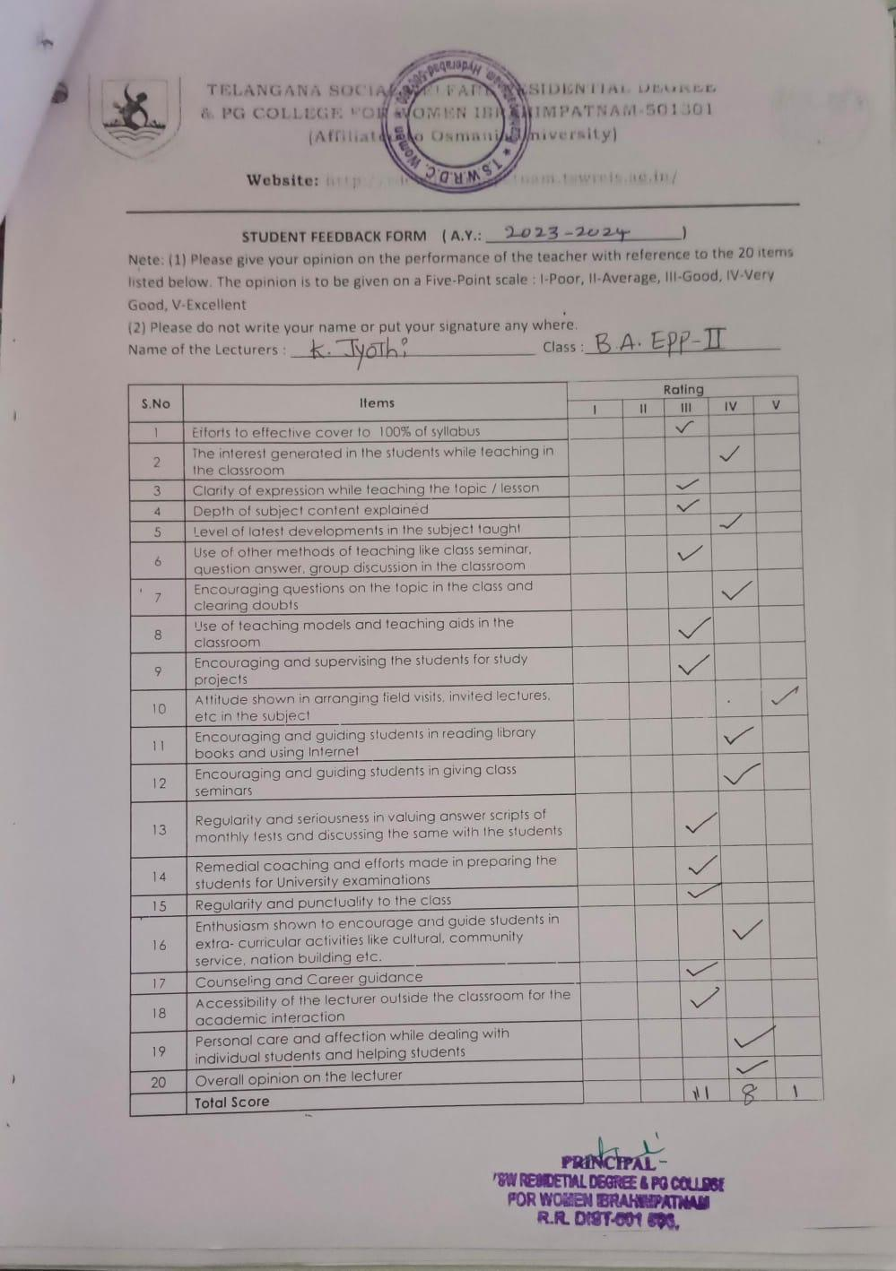

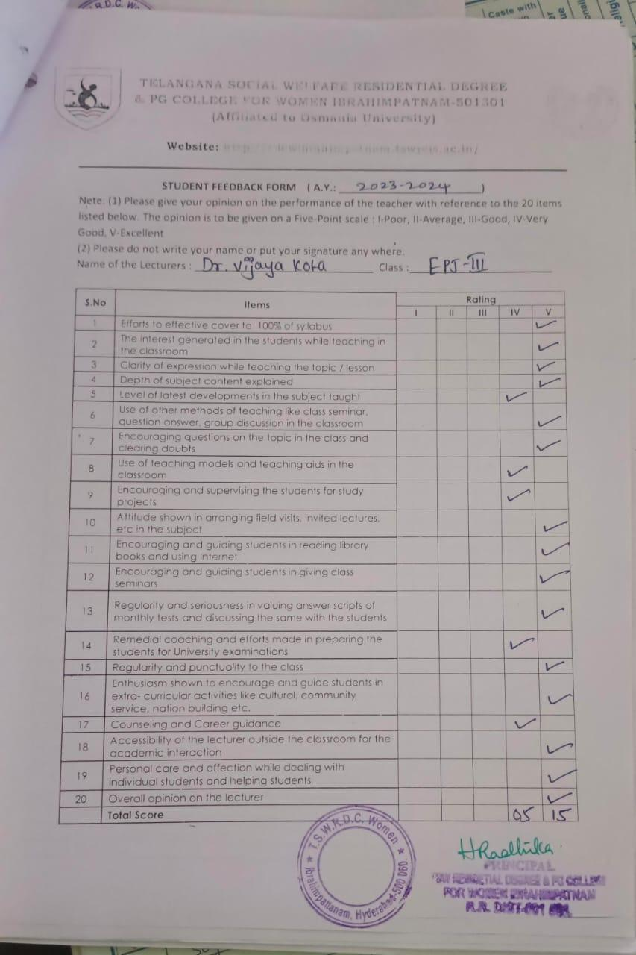

TELANGANA SOCIAL WELFARE RESIDENTIAL DEGREE
& PG COLLEGE FOR WOMEN IBRAHIMPATNAM-501301
(Affiliated to Osmania University)
E-mail:prl-rdc-ibpm-swrs@telangana.gov.in
Website: http://rdcwibrahimpatnam.tswreis.ac.in/

Students Feedback on Teachers
A.Y.: 2023-2024

Report :
- 0-20M -Poor,
21-40M-Average
41-60M- Good
61-80M – Very Good
81-100M- Excellent
- Based on the Feedback of the students 3 Lecturers scored Very Good Score, 20 Lecturers scored Excellent score.

TELANGANA SOCIAL WELFARE RESIDENTIAL DEGREE
& PG COLLEGE FOR WOMEN IBRAHIMPATNAM-501301
(Affiliated to Osmania University)
E-mail:prl-rdc-ibpm-swrs@telangana.gov.in
Website: http://rdcwibrahimpatnam.tswreis.ac.in/

Action Taken Report :

A.Y.: 2023-2024

Action Taken :
- The Principal congratulated the Teaching staff who secures Excellent Score.
- The Principal advised the faculty who scored very good marks to improve to excellent score.

TELANGANA SOCIAL WELFARE RESIDENTIAL DEGREE
& PG COLLEGE FOR WOMEN IBRAHIMPATNAM-501301
(Affiliated to Osmania University)
E-mail:prl-rdc-ibpm-swrs@telangana.gov.in
Website: http://rdcwibrahimpatnam.tswreis.ac.in/

Teachers Feedback
A.Y.: 2023-2024

S.No | Item | Excellent | Very Good | Good | Average | Poor | Total
1 | Q.1 | 6 | 4 | 1 | 0 | 0 | 10
2 | Q.2 | 7 | 3 | 0 | 0 | 0 | 10
3 | Q.3 | 5 | 1 | 4 | 0 | 0 | 10
4 | Q.4 | 8 | 2 | 0 | 0 | 0 | 10
5 | Q.5 | 6 | 4 | 0 | 0 | 0 | 10
6 | Q.6 | 7 | 3 | 0 | 0 | 0 | 10
7 | Q.7 | 1 | 5 | 2 | 2 | 0 | 10
8 | Q.8 | 3 | 6 | 1 | 0 | 0 | 10
9 | Q.9 | 9 | 1 | 0 | 0 | 0 | 10
10 | Q.10 | 5 | 4 | 1 | 0 | 0 | 10
 |  | 57 | 33 | 9 | 2 | 0 | 100
Note : The Numbers indicate the total number of Stakeholders voted for particular question.

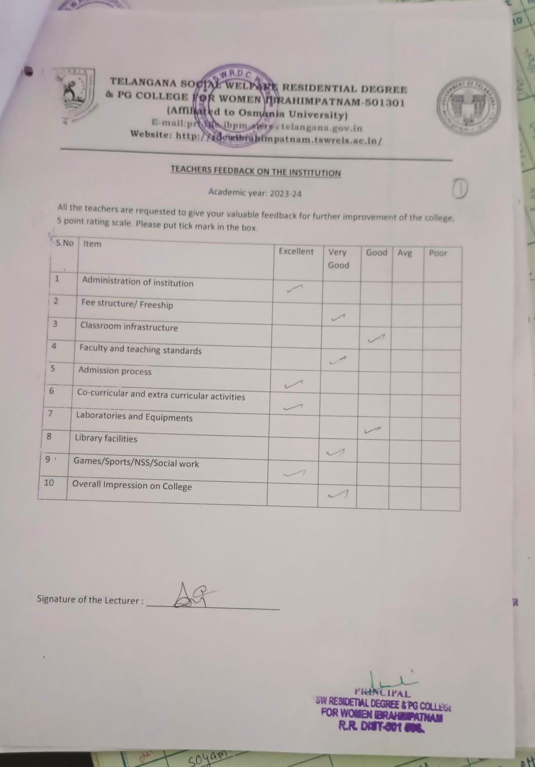

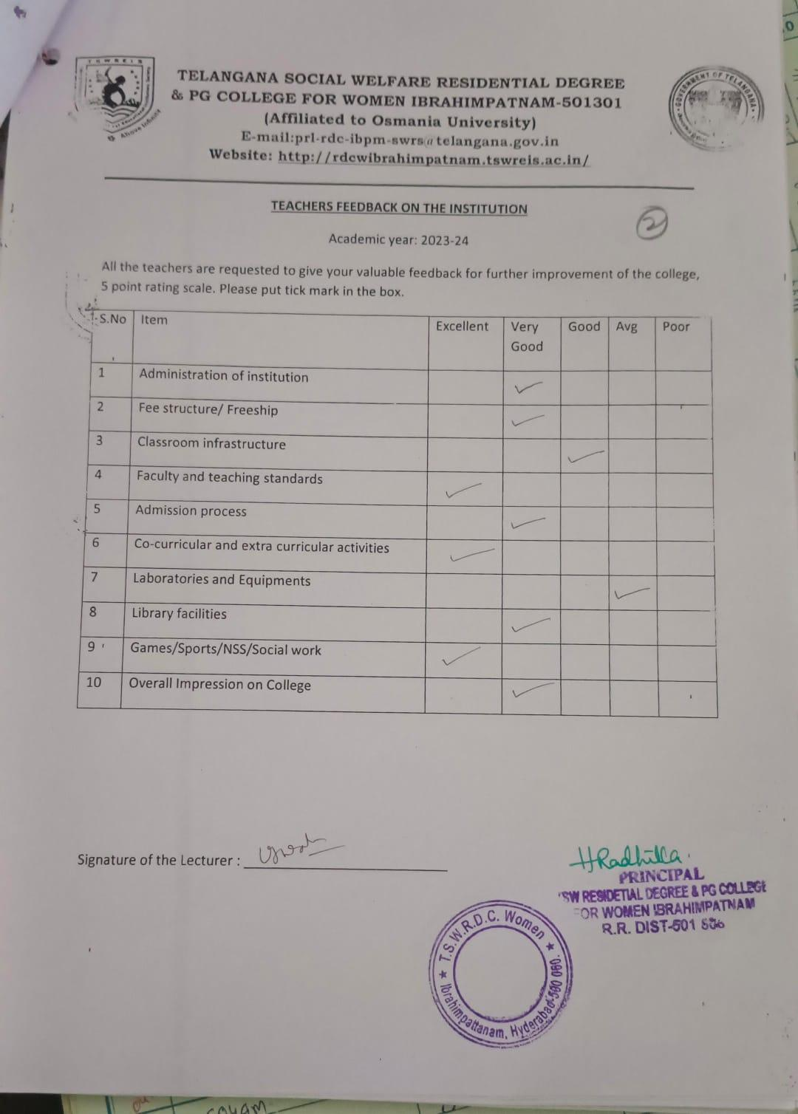

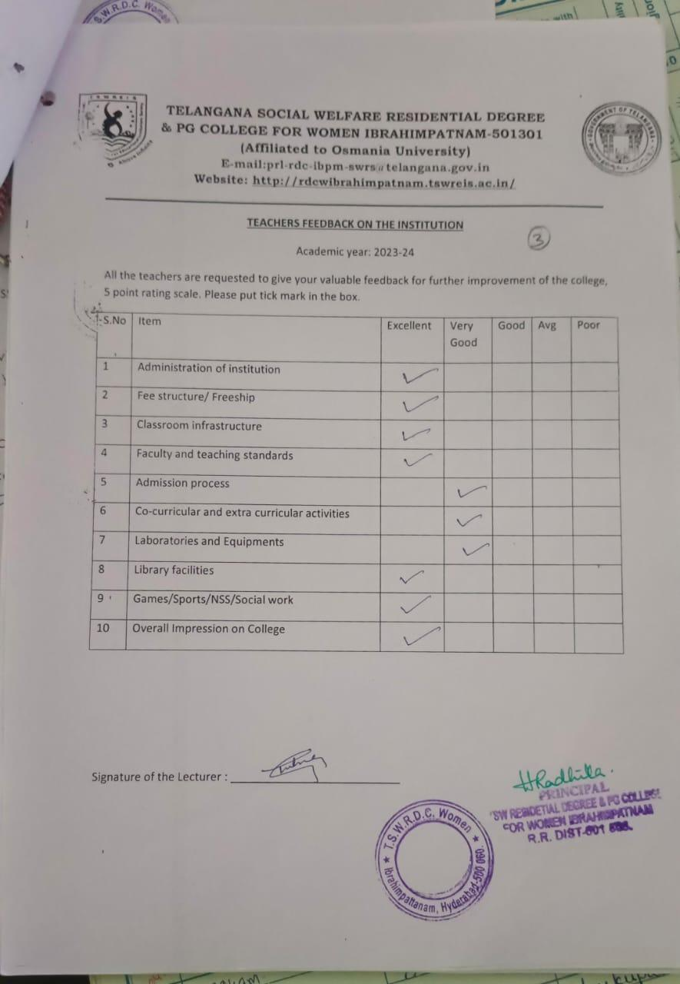

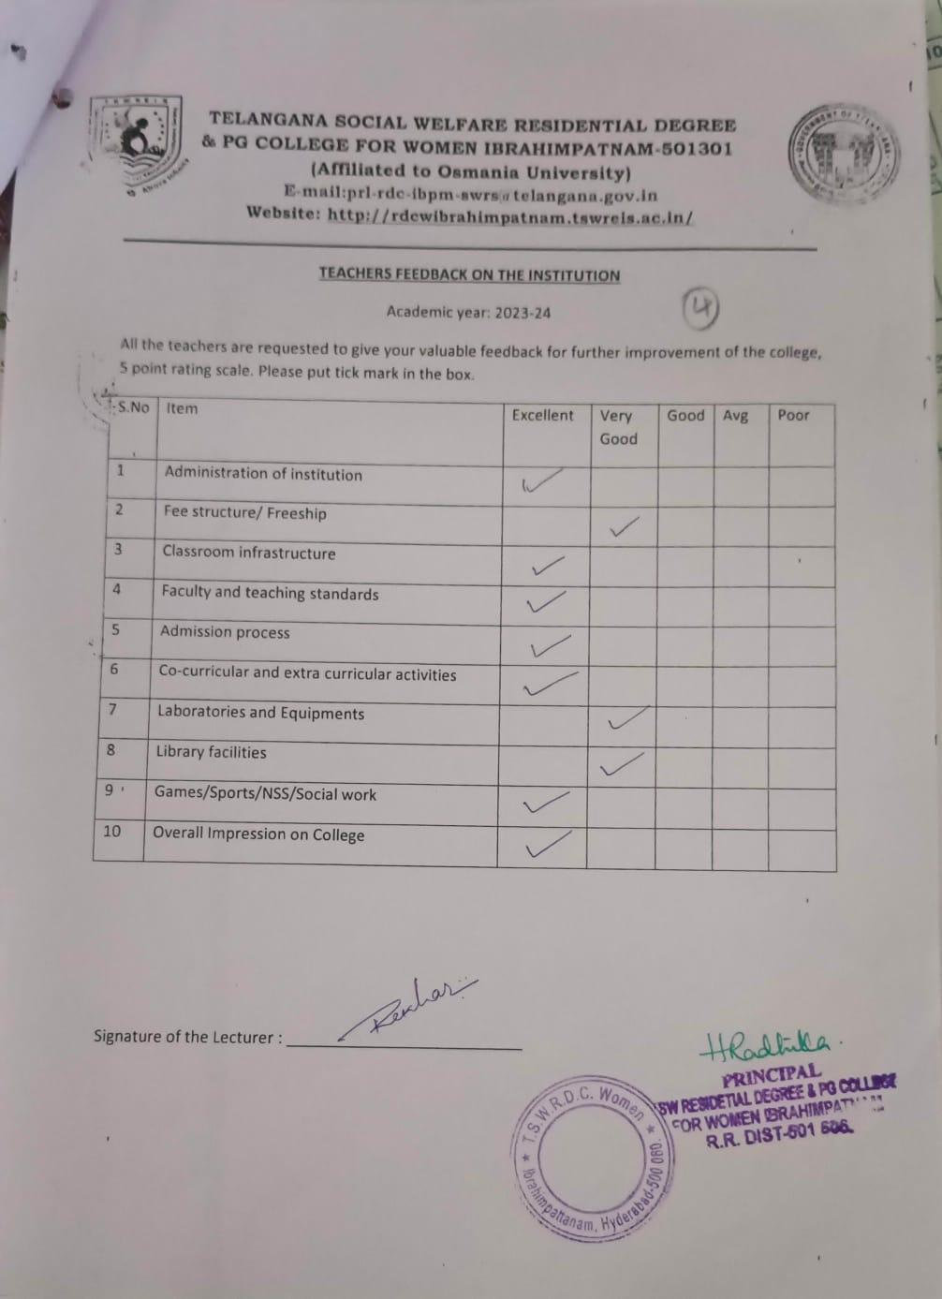

TELANGANA SOCIAL WELFARE RESIDENTIAL DEGREE
& PG COLLEGE FOR WOMEN IBRAHIMPATNAM-501301
(Affiliated to Osmania University)
E-mail:prl-rdc-ibpm-swrs@telangana.gov.in
Website: http://rdcwibrahimpatnam.tswreis.ac.in/

Parents Feedback
A.Y.: 2023-2024

S.No | Item | Excellent | Very Good | Good | Average | Poor | Total
1 | Q.1 | 6 | 4 | 0 | 0 | 0 | 10
2 | Q.2 | 8 | 2 | 0 | 0 | 0 | 10
3 | Q.3 | 7 | 2 | 1 | 0 | 0 | 10
4 | Q.4 | 9 | 1 | 0 | 0 | 0 | 10
5 | Q.5 | 7 | 3 | 0 | 0 | 0 | 10
6 | Q.6 | 9 | 1 | 0 | 0 | 0 | 10
7 | Q.7 | 8 | 2 | 0 | 0 | 0 | 10
Note : The Numbers indicate the total number of Stakeholders voted for particular question.

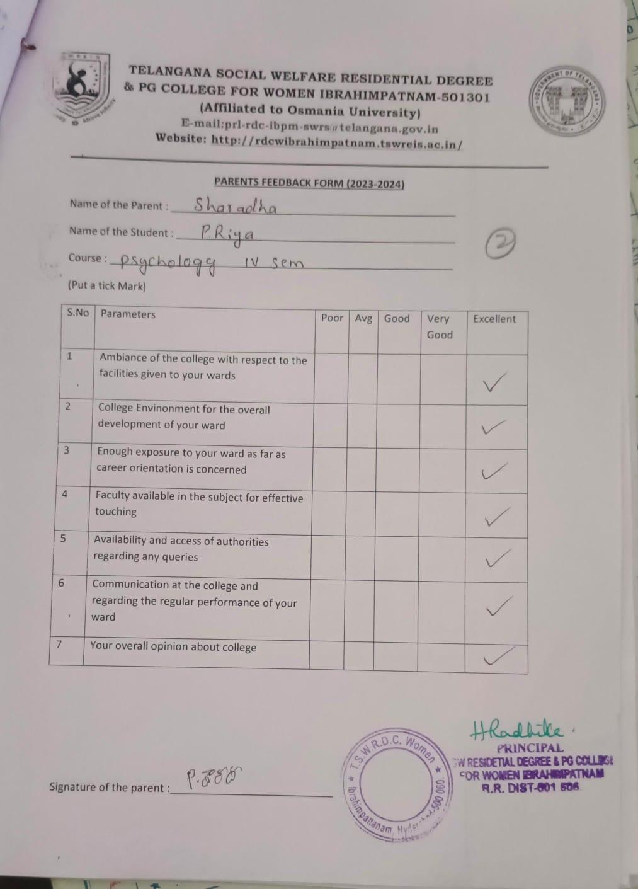

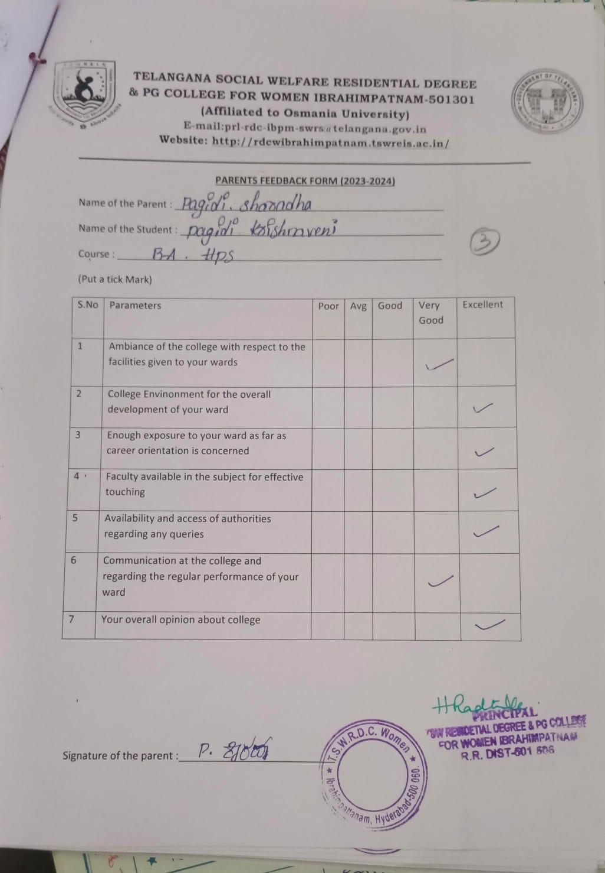

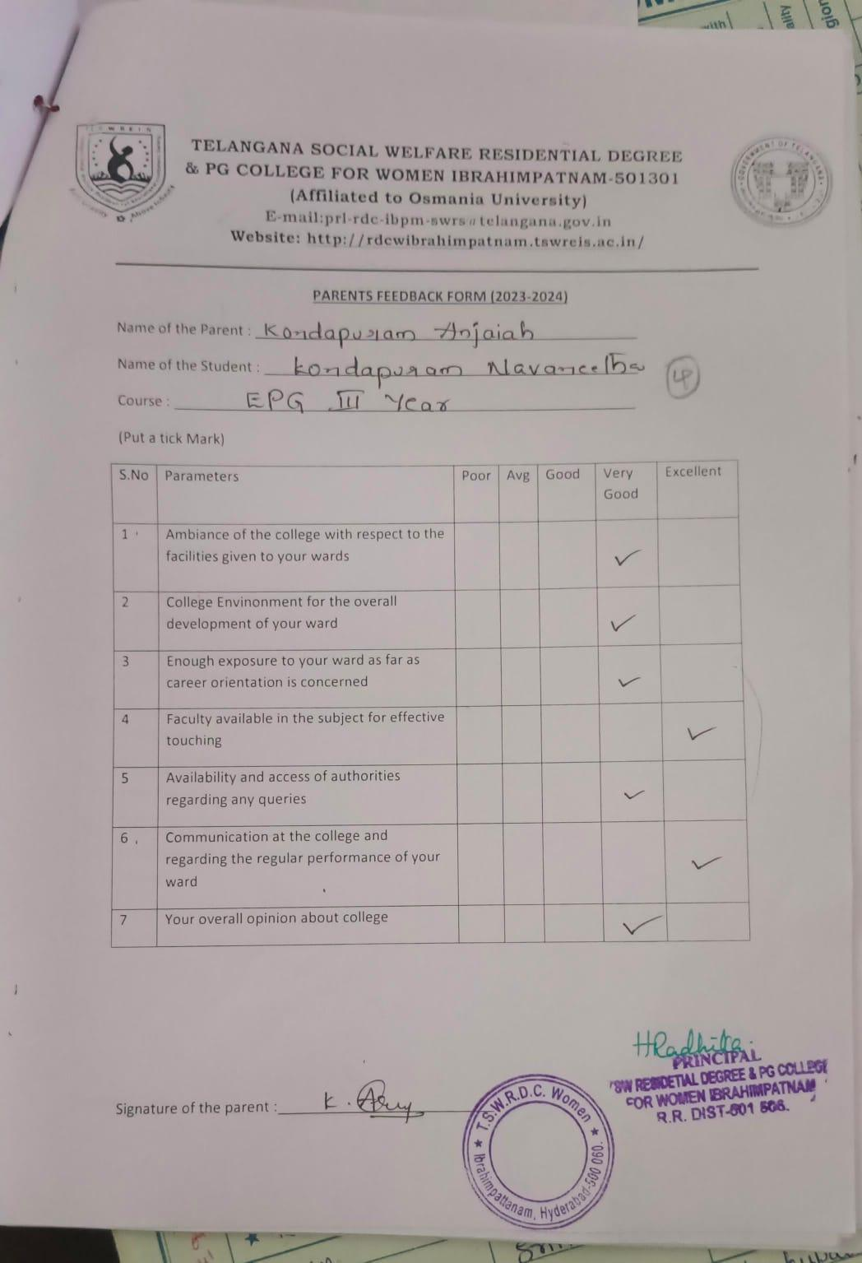

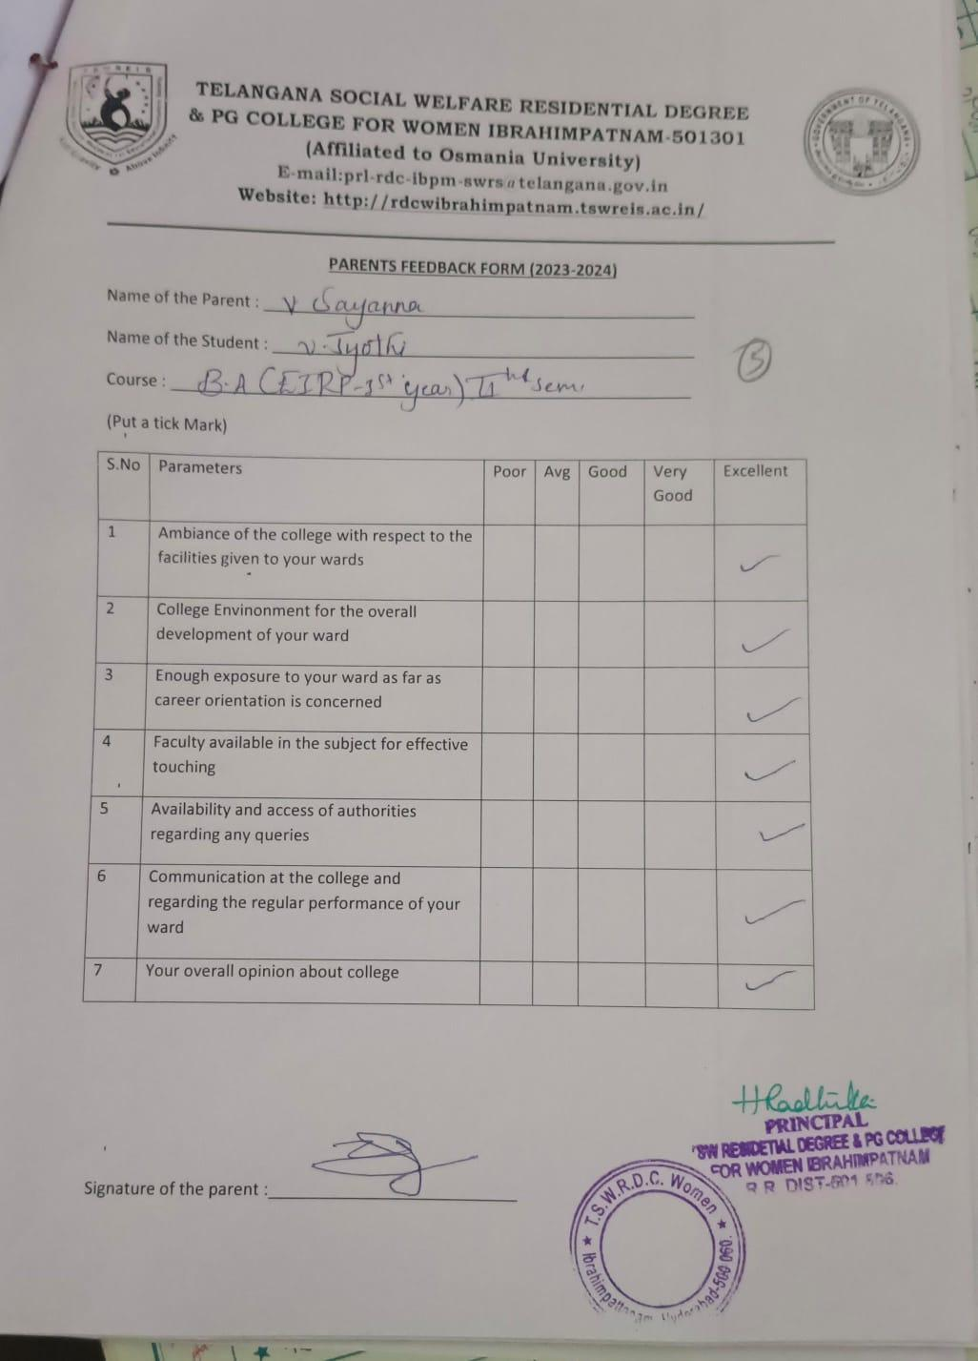

TELANGANA SOCIAL WELFARE RESIDENTIAL DEGREE
& PG COLLEGE FOR WOMEN IBRAHIMPATNAM-501301
(Affiliated to Osmania University)
E-mail:prl-rdc-ibpm-swrs@telangana.gov.in
Website: http://rdcwibrahimpatnam.tswreis.ac.in/

Alumni Feedback
A.Y.: 2023-2024
S.No | Item | Excellent | Very Good | Good | Average | Poor | Total
1 | Q.1 | 3 | 6 | 0 | 1 | 0 | 10
2 | Q.2 | 1 | 7 | 2 | 0 | 0 | 10
3 | Q.3 | 2 | 5 | 3 | 0 | 0 | 10
4 | Q.4 | 8 | 1 | 1 | 0 | 0 | 10
5 | Q.5 | 2 | 6 | 2 | 0 | 0 | 10
6 | Q.6 | 4 | 5 | 1 | 0 | 0 | 10
7 | Q.7 | 5 | 5 | 0 | 0 | 0 | 10
8 | Q.8 | 4 | 5 | 1 | 0 | 0 | 10
Note : The Numbers indicate the total number of Stakeholders voted for particular question.

