**TELANGANA SOCIAL WELFARE RESIDENTIAL DEGREE**

**& PG COLLEGE FOR WOMEN IBRAHIMPATNAM-501301**

**(Affiliated to Osmania University)**

**E-mail:prl-rdc-ibpm-swrs@telangana.gov.in**

**Website:** [**http://rdcwibrahimpatnam.tswreis.ac.in/**](http://rdcwibrahimpatnam.tswreis.ac.in/)

**Students Feedback on Teachers**

**A.Y.: 2022-2023**

In order to know the students feedback on Teachers, the college has a standard practice of collecting feedback from students at the end of every academic year. A pre designed feedback sheet is given to the students consisting of 20 questions on various parameters relating to the Teachers. The students are required to give the ranking ranging from I to V. The ranks are assigned as:

| **S.NO** | **Rank** | **Score (Weight)** |
| --- | --- | --- |
| 01 | Poor | +1 |
| 02 | Average | +2 |
| 03 | Good | +3 |
| 04 | Very Good | +4 |
| 05 | V-Excellent | +5 |

| **S.NO** | **Name Of The Lecturer** | **Subject** | **Q.1** | **Q.2** | **Q.3** | **Q.4** | **Q.5** | **Q.6** | **Q.7** | **Q.8** | **Q.9** | **Q.10** | **Q.11** | **Q.12** | **Q.13** | **Q.14** | **Q.15** | **Q.16** | **Q.17** | **Q.18** | **Q.19** | **Q.20** | **Total** | **Remarks** |
| --- | --- | --- | --- | --- | --- | --- | --- | --- | --- | --- | --- | --- | --- | --- | --- | --- | --- | --- | --- | --- | --- | --- | --- | --- |
| **1** | R.Rekha | Economics | 4 | 5 | 4 | 4 | 5 | 5 | 5 | 4 | 4 | 5 | 5 | 4 | 4 | 5 | 4 | 5 | 5 | 4 | 4 | 5 | 90 | Excellent |
| **2** | A.Divya Jyothi | Public Administration | 5 | 5 | 5 | 5 | 5 | 4 | 5 | 4 | 5 | 4 | 5 | 4 | 5 | 5 | 5 | 4 | 5 | 5 | 5 | 5 | 95 | Excellent |
| **3** | P.Varalaxmi | History | 5 | 5 | 5 | 5 | 4 | 5 | 5 | 5 | 4 | 5 | 5 | 4 | 5 | 5 | 5 | 5 | 5 | 4 | 5 | 4 | 95 | Excellent |
| **4** | Dr.P.Hemamalini | Economics | 5 | 5 | 4 | 4 | 4 | 5 | 4 | 5 | 5 | 5 | 4 | 4 | 5 | 5 | 4 | 4 | 4 | 4 | 5 | 5 | 90 | Excellent |
| **5** | Dr.G.Padmamma | Telugu | 5 | 4 | 4 | 4 | 5 | 5 | 5 | 4 | 4 | 5 | 4 | 5 | 5 | 5 | 4 | 4 | 4 | 5 | 5 | 5 | 91 | Excellent |
| **6** | G.Soujanya | Sociology | 5 | 4 | 5 | 4 | 5 | 5 | 5 | 4 | 3 | 5 | 4 | 5 | 4 | 5 | 5 | 5 | 5 | 5 | 5 | 5 | 93 | Excellent |
| **7** | M.Manjula | English | 5 | 5 | 5 | 4 | 5 | 5 | 5 | 5 | 3 | 4 | 5 | 5 | 5 | 5 | 5 | 5 | 5 | 5 | 5 | 5 | 96 | Excellent |
| **8** | T.Vijaya Lakshmi | English | 5 | 4 | 5 | 5 | 4 | 4 | 5 | 4 | 4 | 4 | 5 | 5 | 5 | 4 | 5 | 5 | 5 | 5 | 4 | 5 | 92 | Excellent |
| **9** | K.Vijaya | Political Science | 5 | 4 | 5 | 5 | 4 | 5 | 4 | 5 | 4 | 5 | 4 | 5 | 5 | 5 | 4 | 4 | 5 | 5 | 5 | 5 | 93 | Excellent |
| **10** | M.Neeraja | Economics | 5 | 4 | 5 | 5 | 4 | 5 | 4 | 5 | 4 | 5 | 5 | 4 | 5 | 5 | 4 | 5 | 4 | 5 | 5 | 5 | 93 | Excellent |
| **11** | Dr.D.Padmavathi | Telugu | 5 | 5 | 5 | 4 | 5 | 5 | 5 | 4 | 5 | 5 | 5 | 4 | 5 | 5 | 5 | 4 | 4 | 5 | 5 | 5 | 95 | Excellent |
| **12** | K.Ujwala | English | 4 | 4 | 4 | 5 | 5 | 5 | 5 | 4 | 4 | 4 | 4 | 5 | 5 | 5 | 4 | 5 | 4 | 5 | 4 | 5 | 90 | Excellent |
| **13** | T.Lalitha | Political Science | 5 | 4 | 5 | 5 | 4 | 5 | 5 | 4 | 4 | 5 | 4 | 4 | 5 | 5 | 5 | 4 | 4 | 4 | 5 | 4 | 90 | Excellent |
| **14** | Ch.Sridevi | Telugu | 5 | 4 | 4 | 4 | 4 | 4 | 4 | 4 | 4 | 5 | 5 | 4 | 4 | 5 | 5 | 5 | 5 | 5 | 5 | 5 | 90 | Excellent |
| **15** | D.Yamini | Political Science | 5 | 4 | 4 | 5 | 4 | 4 | 5 | 4 | 5 | 4 | 5 | 4 | 5 | 4 | 5 | 4 | 4 | 5 | 5 | 5 | 90 | Excellent |
| **16** | V.Amani | Economics | 5 | 4 | 5 | 4 | 5 | 4 | 5 | 4 | 5 | 4 | 5 | 5 | 4 | 4 | 5 | 4 | 5 | 4 | 4 | 5 | 90 | Excellent |
| **17** | K.Jyothi | Psychology | 5 | 4 | 5 | 5 | 4 | 4 | 4 | 5 | 4 | 5 | 4 | 5 | 5 | 4 | 5 | 4 | 5 | 4 | 5 | 4 | 90 | Excellent |
| **18** | T.Srujana Deepthi | Geography | 4 | 4 | 3 | 3 | 4 | 4 | 3 | 3 | 4 | 3 | 4 | 3 | 3 | 4 | 3 | 3 | 3 | 3 | 4 | 5 | 70 | Very Good |
| **19** | K.Madhavi | Public Administration | 5 | 4 | 4 | 5 | 4 | 5 | 5 | 4 | 4 | 4 | 5 | 5 | 5 | 4 | 5 | 5 | 5 | 5 | 4 | 5 | 92 | Excellent |
| **20** | J.Prudhvi Rani | Journalism | 4 | 4 | 5 | 5 | 4 | 4 | 4 | 5 | 5 | 5 | 4 | 5 | 4 | 5 | 4 | 4 | 5 | 5 | 4 | 5 | 90 | Excellent |
| **21** | Dr.B.Kranthikumari | English | 5 | 4 | 5 | 4 | 4 | 4 | 5 | 5 | 4 | 5 | 5 | 5 | 5 | 5 | 4 | 4 | 4 | 4 | 4 | 5 | 90 | Excellent |
| **22** | Dr.Elezebeth | English | 5 | 4 | 5 | 4 | 4 | 4 | 5 | 5 | 4 | 5 | 5 | 5 | 5 | 5 | 4 | 4 | 4 | 4 | 4 | 5 | 90 | Excellent |
| **23** | P.Neelavathi | English | 5 | 4 | 4 | 4 | 4 | 3 | 4 | 3 | 3 | 4 | 4 | 4 | 5 | 4 | 5 | 4 | 4 | 4 | 4 | 4 | 80 | Very Good |
| **24** | D.Christhumani | English | 5 | 4 | 4 | 4 | 4 | 3 | 4 | 3 | 3 | 4 | 4 | 4 | 5 | 4 | 5 | 4 | 4 | 4 | 4 | 4 | 80 | Very Good |

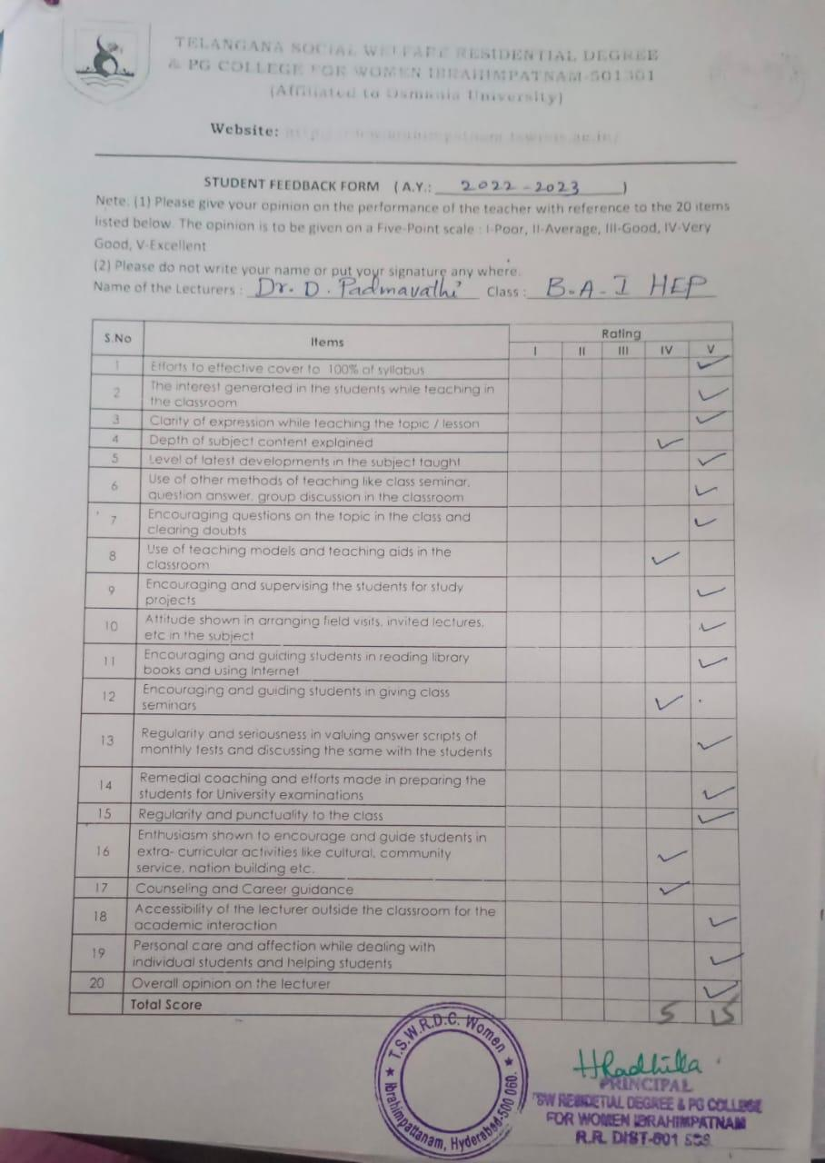

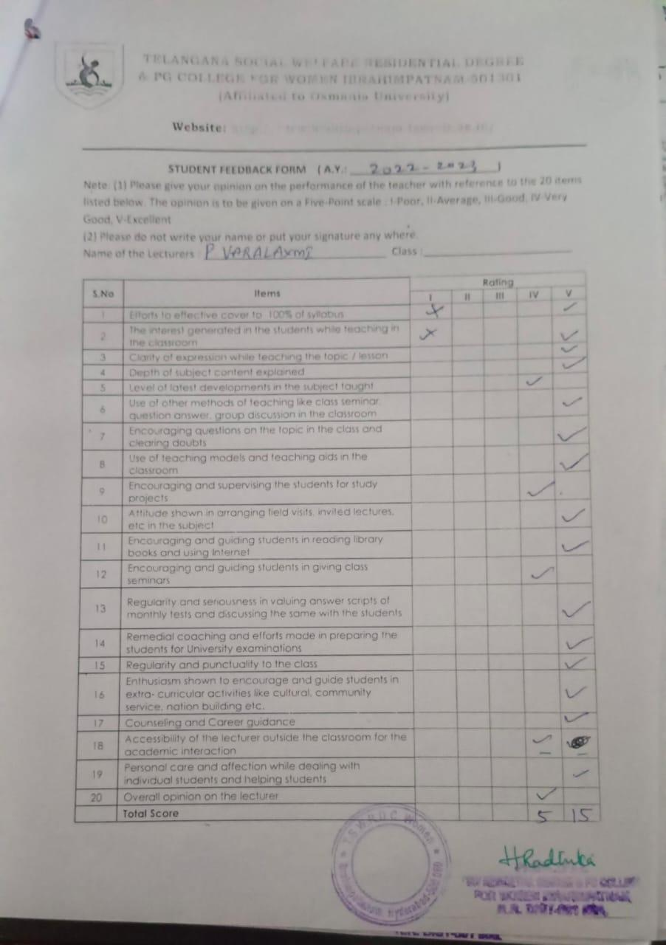

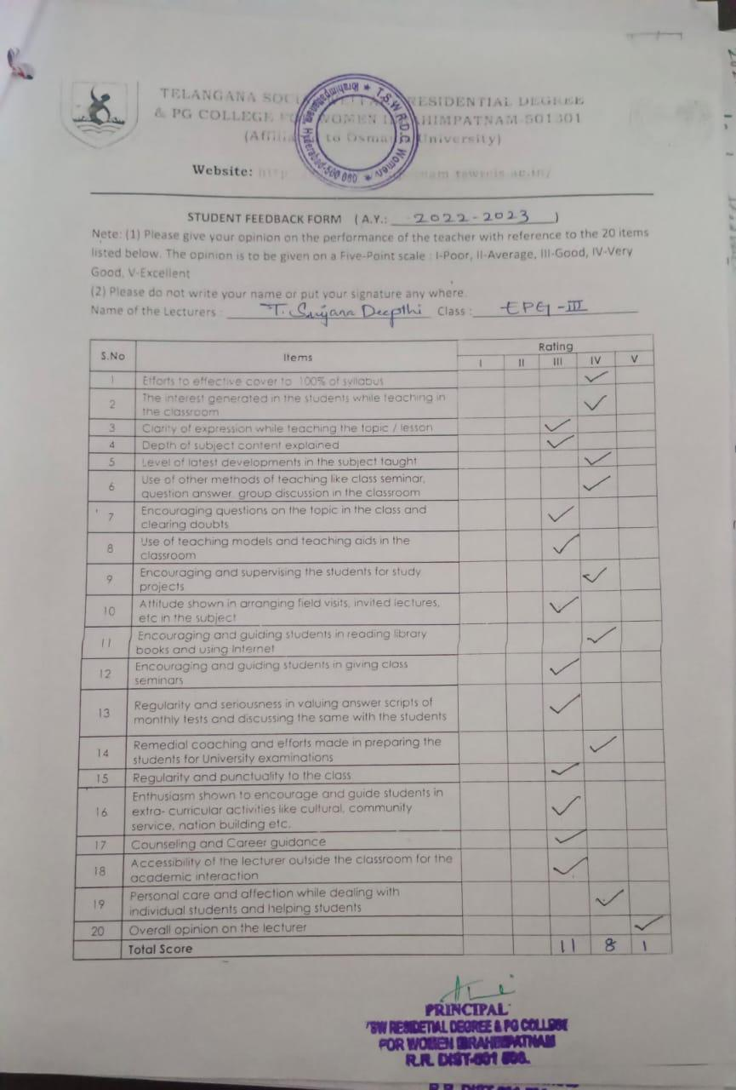

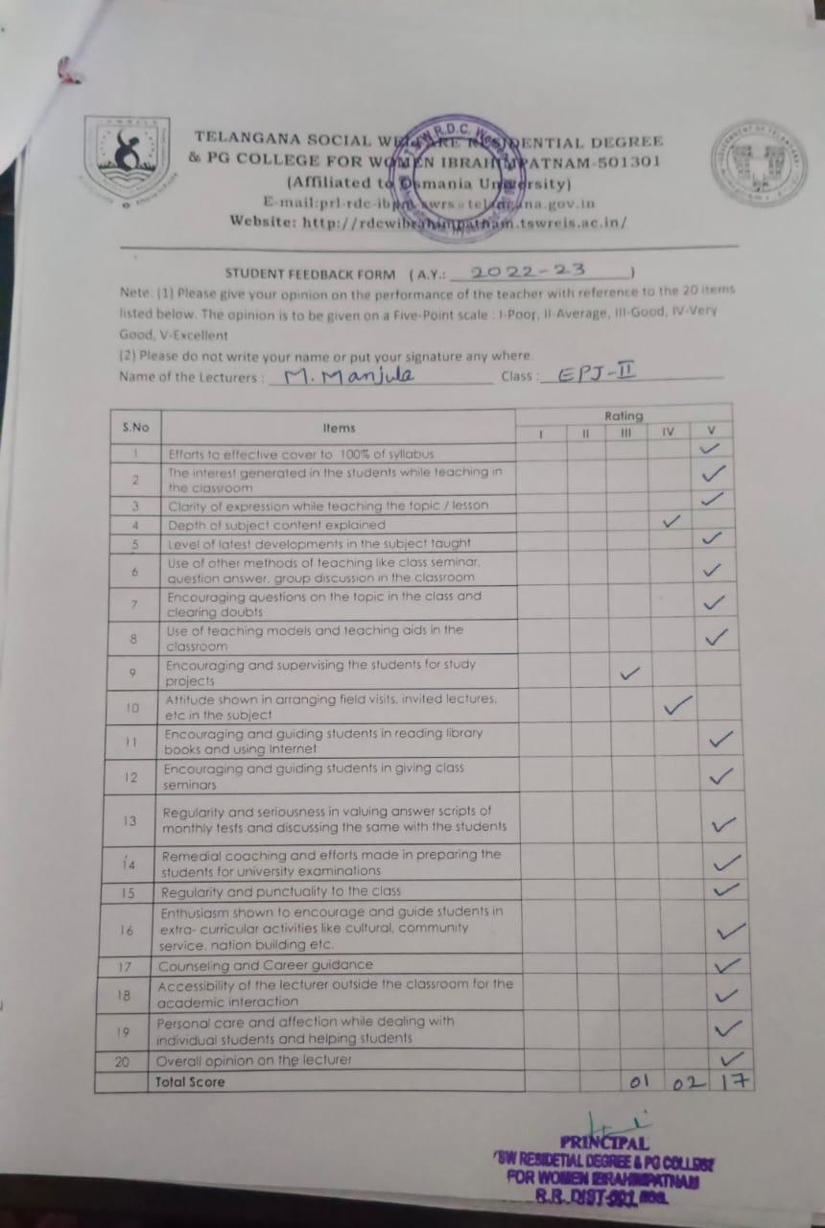

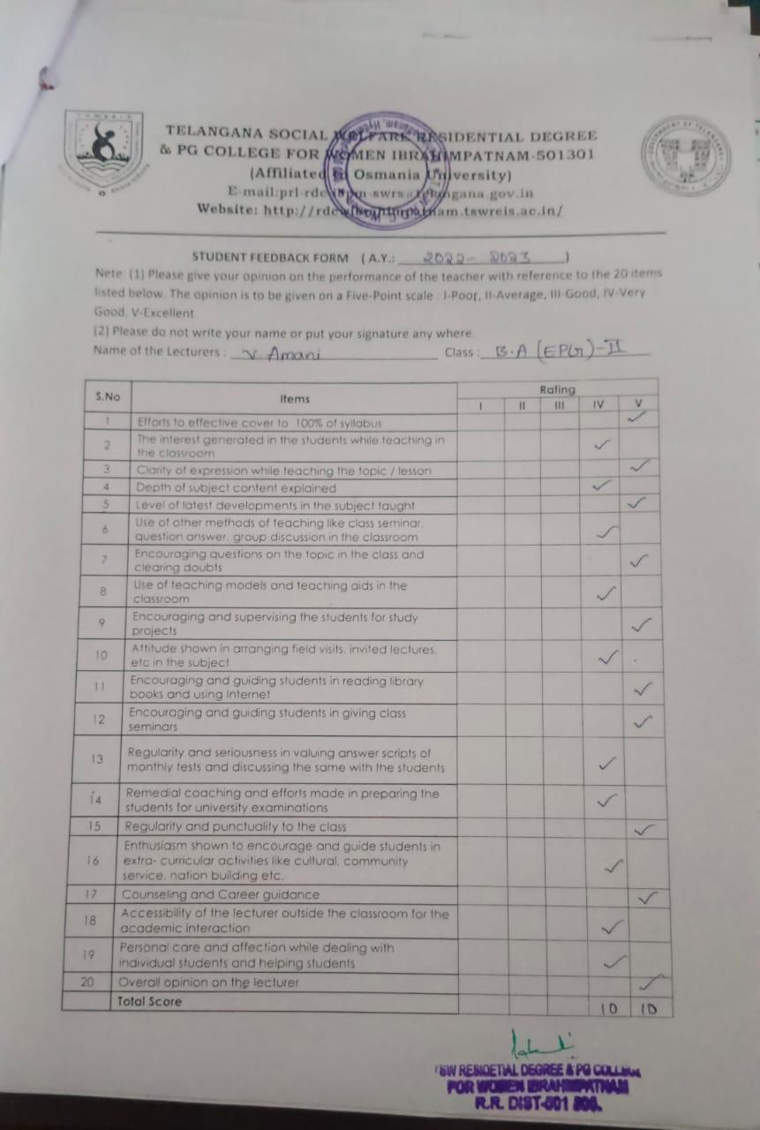

**TELANGANA SOCIAL WELFARE RESIDENTIAL DEGREE**

**& PG COLLEGE FOR WOMEN IBRAHIMPATNAM-501301**

**(Affiliated to Osmania University)**

**E-mail:prl-rdc-ibpm-swrs@telangana.gov.in**

**Website:** [**http://rdcwibrahimpatnam.tswreis.ac.in/**](http://rdcwibrahimpatnam.tswreis.ac.in/)

**Students Feedback on Teachers**

**A.Y.: 2022-2023**

Report :

1. 0-20M -Poor,

21-40M-Average

41-60M- Good

61-80M – Very Good

81-100M- Excellent

1. Based on the Feedback of the students 3 Lecturers scored Very Good Score, 21 Lecturers scored Excellent score.

**TELANGANA SOCIAL WELFARE RESIDENTIAL DEGREE**

**& PG COLLEGE FOR WOMEN IBRAHIMPATNAM-501301**

**(Affiliated to Osmania University)**

**E-mail:prl-rdc-ibpm-swrs@telangana.gov.in**

**Website:** [**http://rdcwibrahimpatnam.tswreis.ac.in/**](http://rdcwibrahimpatnam.tswreis.ac.in/)

**Teachers Feedback**

**A.Y.: 2022-2023**

| **S.No** | **Item** | **Excellent** | **Very Good** | **Good** | **Average** | **Poor** | **Total** |
| --- | --- | --- | --- | --- | --- | --- | --- |
| **1** | **Q.1** | 7 | 2 | 1 | 0 | 0 | 10 |
| **2** | **Q.2** | 10 | 0 | 0 | 0 | 0 | 10 |
| **3** | **Q.3** | 2 | 8 | 0 | 0 | 0 | 10 |
| **4** | **Q.4** | 5 | 5 | 0 | 0 | 0 | 10 |
| **5** | **Q.5** | 4 | 6 | 0 | 0 | 0 | 10 |
| **6** | **Q.6** | 8 | 2 | 0 | 0 | 0 | 10 |
| **7** | **Q.7** | 0 | 2 | 7 | 1 | 0 | 10 |
| **8** | **Q.8** | 2 | 7 | 1 | 0 | 0 | 10 |
| **9** | **Q.9** | 4 | 6 | 0 | 0 | 0 | 10 |
| **10** | **Q.10** | 4 | 6 | 0 | 0 | 0 | 10 |
|  |  | **46** | **44** | **9** | **1** | **0** | **100** |

Note : The Numbers indicate the total number of Stakeholders voted for particular question.

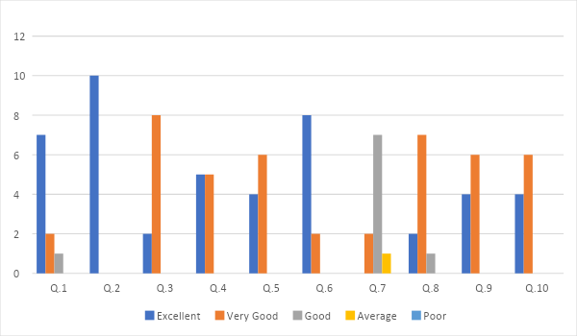

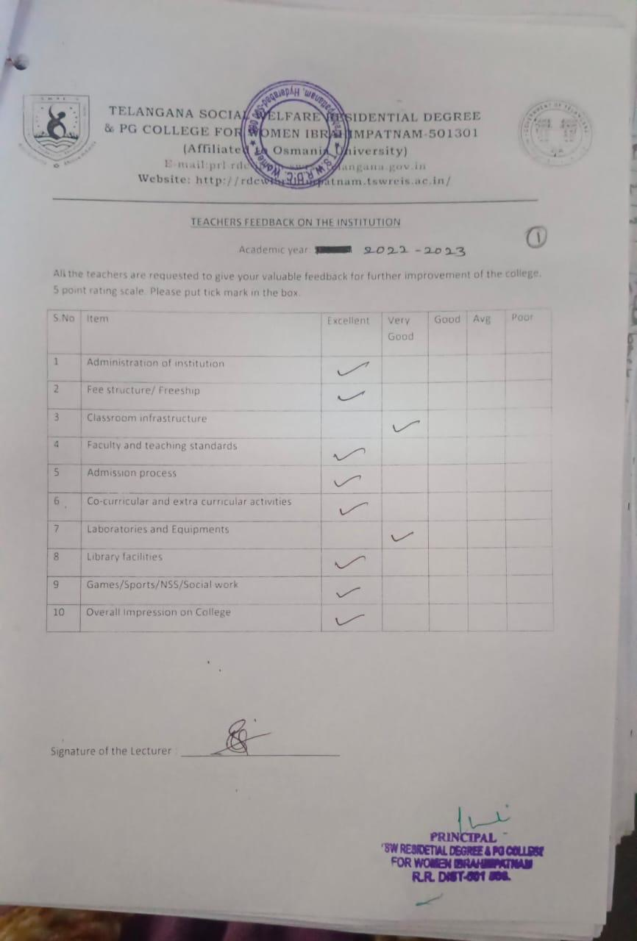

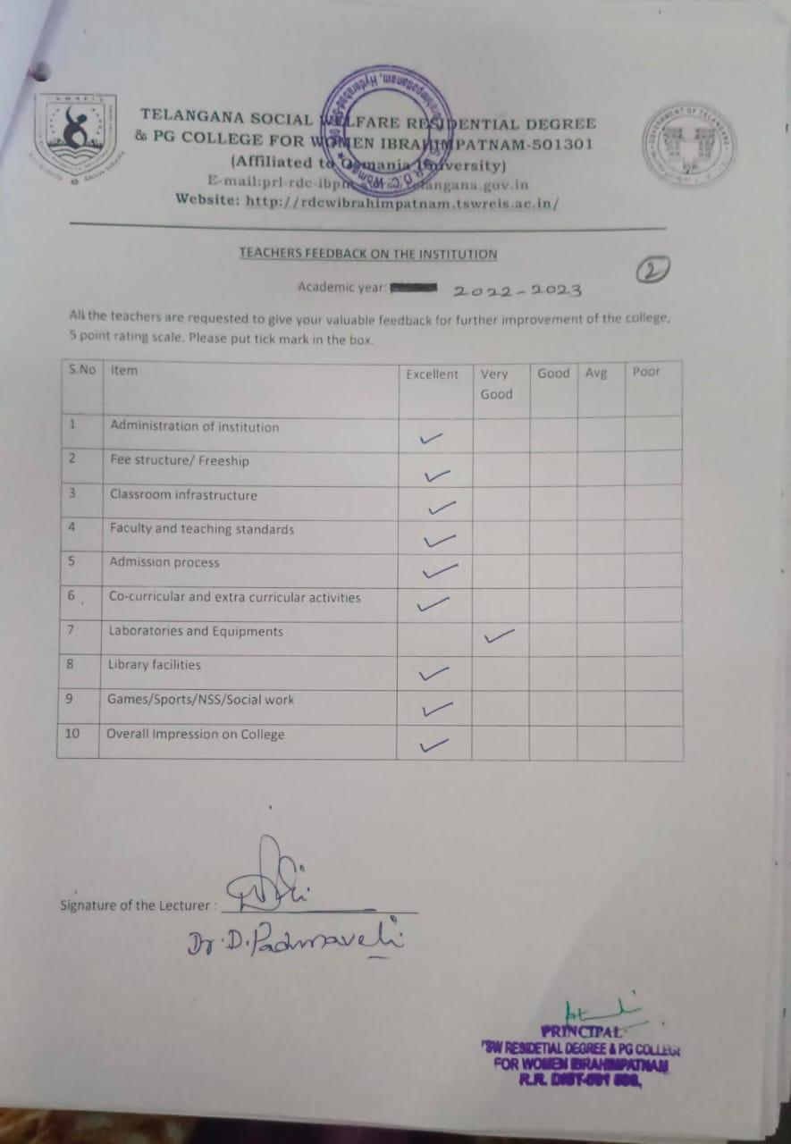

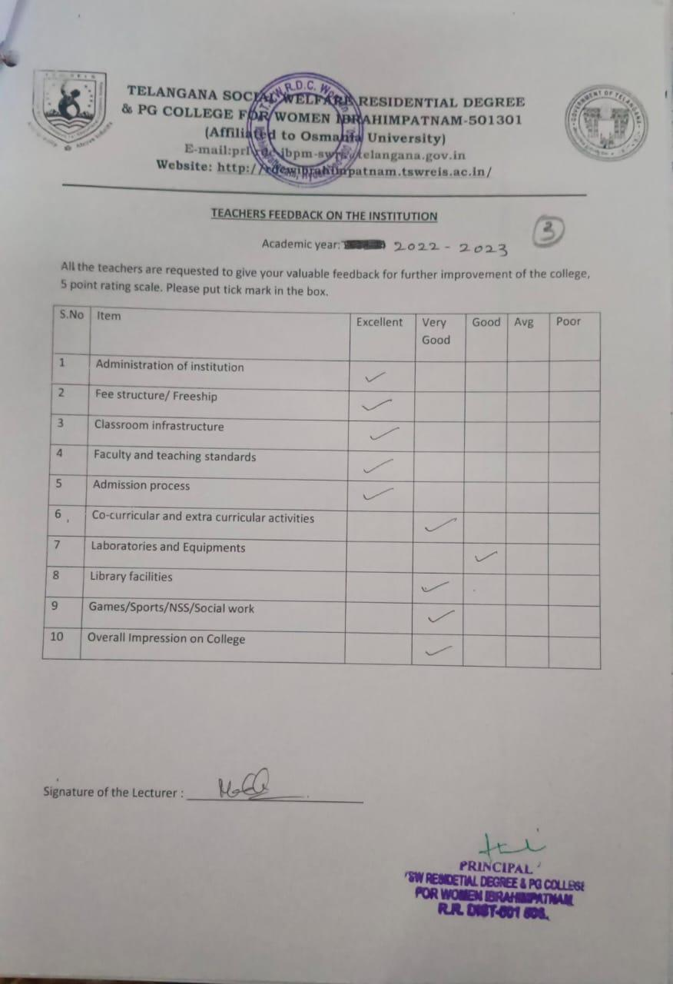

**TELANGANA SOCIAL WELFARE RESIDENTIAL DEGREE**

**& PG COLLEGE FOR WOMEN IBRAHIMPATNAM-501301**

**(Affiliated to Osmania University)**

**E-mail:prl-rdc-ibpm-swrs@telangana.gov.in**

**Website:** [**http://rdcwibrahimpatnam.tswreis.ac.in/**](http://rdcwibrahimpatnam.tswreis.ac.in/)

**Parents Feedback**

**A.Y.: 2022-2023**

| **S.No** | **Item** | **Excellent** | **Very Good** | **Good** | **Average** | **Poor** | **Total** |
| --- | --- | --- | --- | --- | --- | --- | --- |
| **1** | **Q.1** | 2 | 8 | 0 | 0 | 0 | 10 |
| **2** | **Q.2** | 7 | 3 | 0 | 0 | 0 | 10 |
| **3** | **Q.3** | 3 | 7 | 0 | 0 | 0 | 10 |
| **4** | **Q.4** | 7 | 3 | 0 | 0 | 0 | 10 |
| **5** | **Q.5** | 4 | 6 | 0 | 0 | 0 | 10 |
| **6** | **Q.6** | 4 | 6 | 0 | 0 | 0 | 10 |
| **7** | **Q.7** | 6 | 4 | 0 | 0 | 0 | 10 |

Note : The Numbers indicate the total number of Stakeholders voted for particular question.

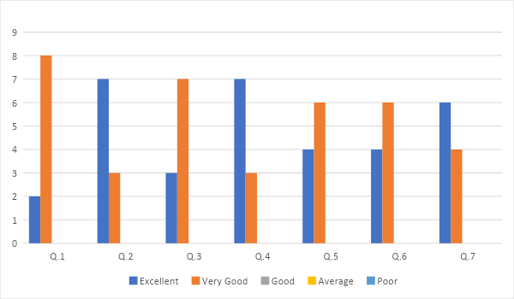

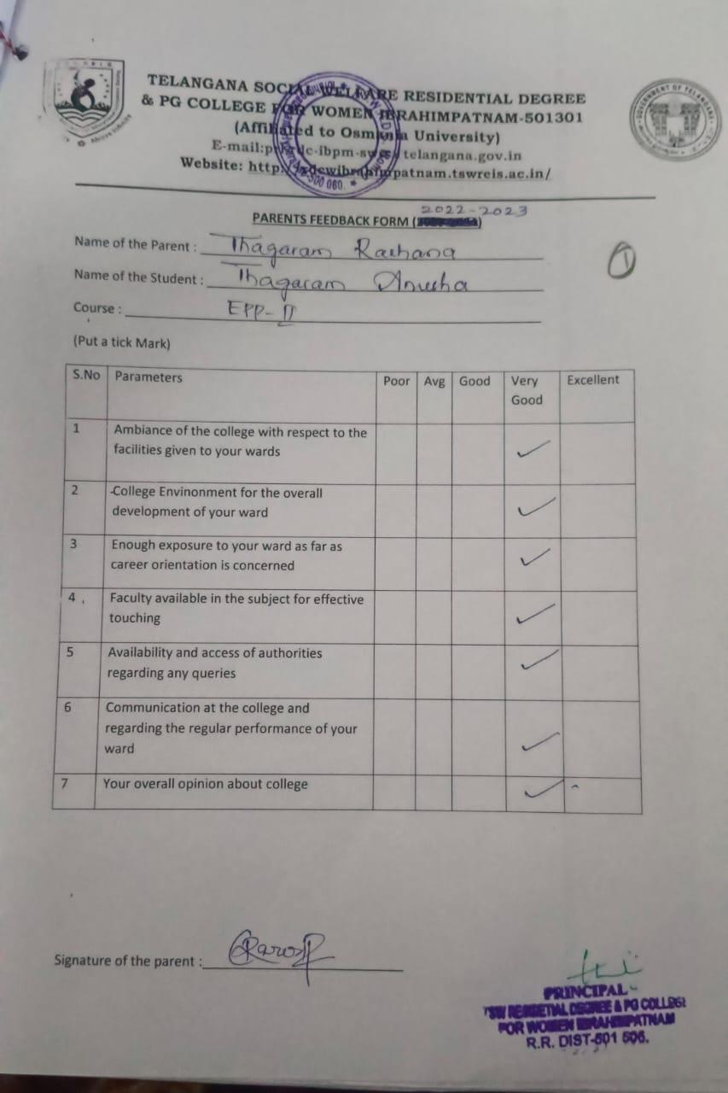

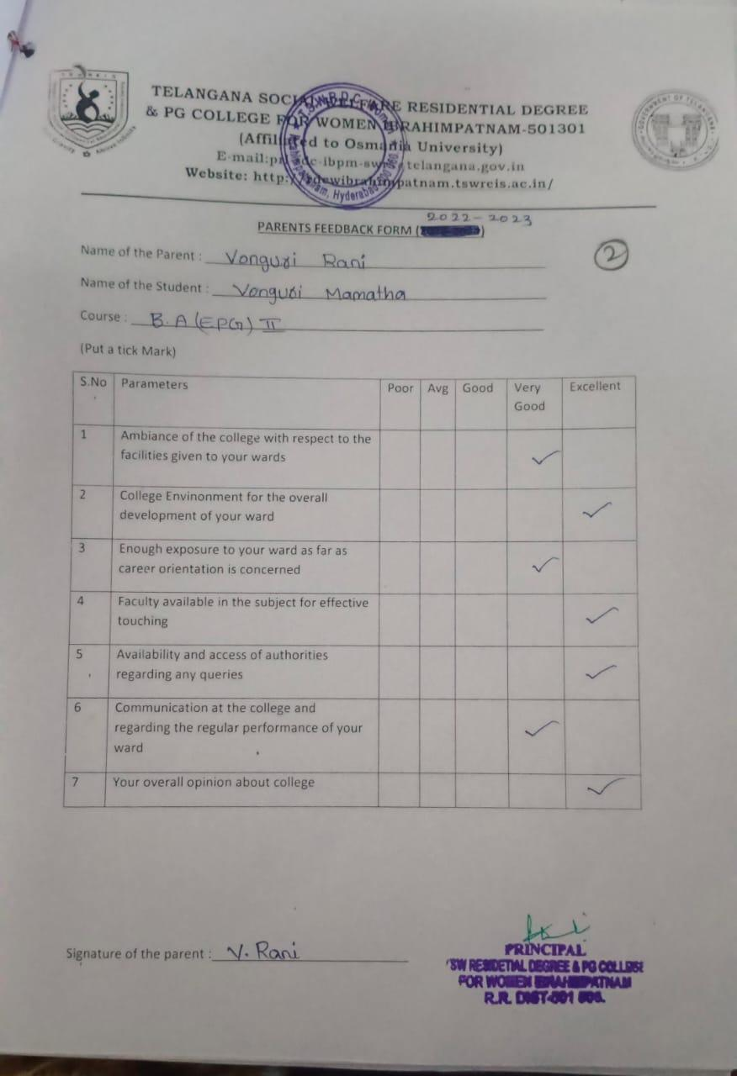

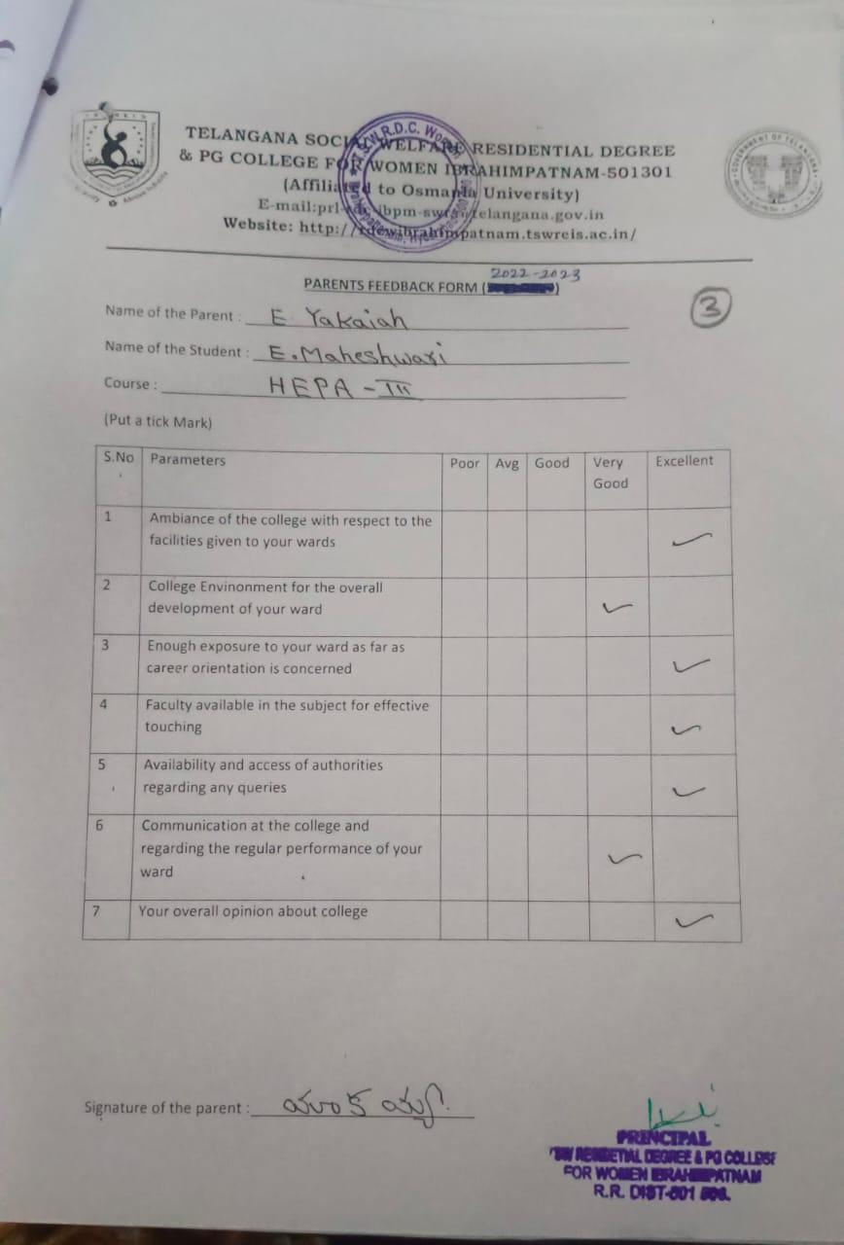

**TELANGANA SOCIAL WELFARE RESIDENTIAL DEGREE**

**& PG COLLEGE FOR WOMEN IBRAHIMPATNAM-501301**

**(Affiliated to Osmania University)**

**E-mail:prl-rdc-ibpm-swrs@telangana.gov.in**

**Website:** [**http://rdcwibrahimpatnam.tswreis.ac.in/**](http://rdcwibrahimpatnam.tswreis.ac.in/)

**Alumni Feedback**

**A.Y.: 2022-2023**

| **S.No** | **Item** | **Excellent** | **Very Good** | **Good** | **Average** | **Poor** | **Total** |
| --- | --- | --- | --- | --- | --- | --- | --- |
| **1** | **Q.1** | 5 | 5 | 0 | 0 | 0 | 10 |
| **2** | **Q.2** | 6 | 4 | 0 | 0 | 0 | 10 |
| **3** | **Q.3** | 6 | 4 | 0 | 0 | 0 | 10 |
| **4** | **Q.4** | 9 | 1 | 0 | 0 | 0 | 10 |
| **5** | **Q.5** | 5 | 5 | 0 | 0 | 0 | 10 |
| **6** | **Q.6** | 2 | 8 | 0 | 0 | 0 | 10 |
| **7** | **Q.7** | 6 | 4 | 0 | 0 | 0 | 10 |
| **8** | **Q.8** | 9 | 1 | 0 | 0 | 0 | 10 |

Note : The Numbers indicate the total number of Stakeholders voted for particular question.



