

**TELANGANA SOCIAL WELFARE RESIDENTIAL DEGREE**

**& PG COLLEGE FOR WOMEN IBRAHIMPATNAM-501301**

**(Affiliated to Osmania University)**

**E-mail:prl-rdc-ibpm-swrs@telangana.gov.in**

**Website:** [**http://rdcwibrahimpatnam.tswreis.ac.in/**](http://rdcwibrahimpatnam.tswreis.ac.in/)

**Students Feedback on Teachers**

**A.Y.: 2018-2019**

In order to know the students feedback on Teachers, the college has a standard practice of collecting feedback from students at the end of every academic year. A pre designed feedback sheet is given to the students consisting of 20 questions on various parameters relating to the Teachers. The students are required to give the ranking ranging from I to V. The ranks are assigned as:

| **S.NO** | **Rank** | **Score (Weight)** |
| --- | --- | --- |
| 01 | Poor | +1 |
| 02 | Average | +2 |
| 03 | Good | +3 |
| 04 | Very Good | +4 |
| 05 | V-Excellent | +5 |

| **S.NO** | **Name Of The Lecturer** | **Subject** | **Q.1** | **Q.2** | **Q.3** | **Q.4** | **Q.5** | **Q.6** | **Q.7** | **Q.8** | **Q.9** | **Q.10** | **Q.11** | **Q.12** | **Q.13** | **Q.14** | **Q.15** | **Q.16** | **Q.17** | **Q.18** | **Q.19** | **Q.20** | **Total** | **Remarks** |
| --- | --- | --- | --- | --- | --- | --- | --- | --- | --- | --- | --- | --- | --- | --- | --- | --- | --- | --- | --- | --- | --- | --- | --- | --- |
| **1** | S.Padma | Telugu | 4 | 5 | 3 | 3 | 4 | 3 | 3 | 2 | 3 | 3 | 4 | 4 | 4 | 3 | 4 | 3 | 4 | 4 | 4 | 3 | 70 | Very Good |
| **2** | K.Nagalatha | English | 4 | 4 | 3 | 3 | 3 | 3 | 4 | 2 | 3 | 2 | 3 | 3 | 4 | 4 | 4 | 3 | 4 | 4 | 4 | 3 | 67 | Very Good |
| **3** | B.Radhika | History | 4 | 3 | 3 | 2 | 2 | 3 | 4 | 3 | 3 | 2 | 3 | 3 | 4 | 3 | 4 | 2 | 3 | 4 | 3 | 3 | 61 | Very Good |
| **4** | S.Mumtaz | Economics | 5 | 4 | 4 | 4 | 4 | 4 | 3 | 3 | 3 | 4 | 4 | 4 | 4 | 4 | 4 | 4 | 4 | 4 | 4 | 4 | 78 | Very Good |
| **5** | Shabana Begum | Political Science | 4 | 4 | 3 | 2 | 3 | 3 | 3 | 2 | 3 | 2 | 4 | 3 | 4 | 3 | 3 | 3 | 3 | 3 | 3 | 3 | 61 | Very Good |
| **6** | N.Vichitra | Public Administration | 3 | 4 | 3 | 3 | 3 | 2 | 3 | 3 | 4 | 3 | 3 | 3 | 2 | 3 | 3 | 3 | 2 | 3 | 3 | 3 | 59 | Good |
| **7** | P.Annapurna | Economics | 5 | 4 | 5 | 4 | 5 | 4 | 5 | 4 | 5 | 5 | 5 | 4 | 5 | 4 | 4 | 5 | 4 | 5 | 5 | 5 | 92 | Excellent |
| **8** | A.Rekha | Political Science | 3 | 3 | 4 | 3 | 3 | 4 | 3 | 3 | 3 | 3 | 4 | 3 | 3 | 4 | 3 | 3 | 3 | 3 | 4 | 3 | 65 | Very Good |
| **9** | D.Vignaneshwari | Economics | 5 | 4 | 4 | 4 | 5 | 4 | 4 | 3 | 3 | 3 | 5 | 4 | 5 | 5 | 5 | 5 | 4 | 5 | 5 | 5 | 87 | Excellent |
| **10** | S.Deeparani | Telugu | 4 | 4 | 5 | 4 | 4 | 3 | 4 | 3 | 4 | 2 | 4 | 4 | 4 | 4 | 4 | 4 | 4 | 4 | 4 | 4 | 77 | Very Good |
| **11** | Ch.Mounika | Jounalism | 5 | 5 | 4 | 5 | 4 | 3 | 4 | 5 | 5 | 4 | 5 | 5 | 4 | 5 | 5 | 5 | 5 | 5 | 5 | 5 | 93 | Excellent |
| **12** | M.Venkateshwarlu | Telugu | 4 | 5 | 4 | 5 | 4 | 4 | 5 | 3 | 3 | 3 | 4 | 5 | 4 | 4 | 5 | 4 | 5 | 5 | 5 | 5 | 86 | Excellent |
| **13** | Sneha Patil | History | 4 | 4 | 3 | 4 | 4 | 3 | 4 | 4 | 3 | 2 | 4 | 3 | 4 | 4 | 4 | 4 | 4 | 4 | 4 | 4 | 74 | Very Good |
| **14** | T.Alekhya | Geography | 4 | 4 | 3 | 4 | 3 | 4 | 3 | 3 | 3 | 4 | 3 | 2 | 3 | 3 | 3 | 3 | 3 | 3 | 3 | 3 | 64 | Very Good |
|  |  |  |  |  |  |  |  |  |  |  |  |  |  |  |  |  |  |  |  |  |  |  |  |  |

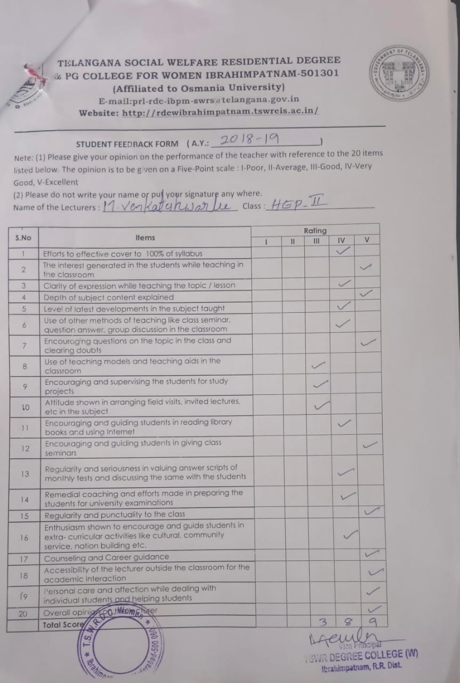

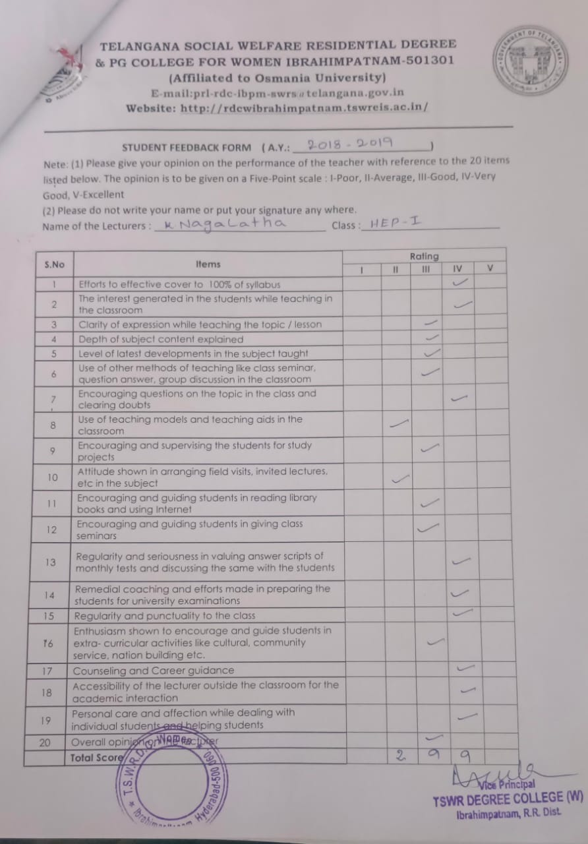

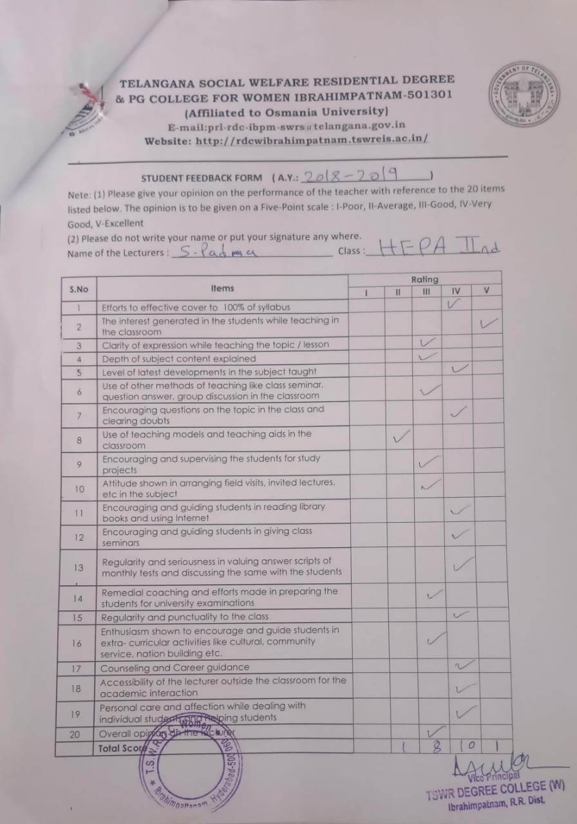

**TELANGANA SOCIAL WELFARE RESIDENTIAL DEGREE** 

**& PG COLLEGE FOR WOMEN IBRAHIMPATNAM-501301**

**(Affiliated to Osmania University)**

**E-mail:prl-rdc-ibpm-swrs@telangana.gov.in**

**Website:** [**http://rdcwibrahimpatnam.tswreis.ac.in/**](http://rdcwibrahimpatnam.tswreis.ac.in/)

**Students Feedback on Teachers**

**A.Y.: 2018-2019**

Report :

1. 0-20M -Poor,

21-40M-Average

41-60M- Good

61-80M – Very Good

81-100M- Excellent

1. Based on the Feedback of the students 4 Lecturers scored Excellent score, 9 Lecturers scored Very Good Score & 1 Lecturer scored Good Score.

**TELANGANA SOCIAL WELFARE RESIDENTIAL DEGREE**

**& PG COLLEGE FOR WOMEN IBRAHIMPATNAM-501301**

**(Affiliated to Osmania University)**

**E-mail:prl-rdc-ibpm-swrs@telangana.gov.in**

**Website:** [**http://rdcwibrahimpatnam.tswreis.ac.in/**](http://rdcwibrahimpatnam.tswreis.ac.in/)

**Teachers Feedback**

**A.Y.: 2018-2019**

| **S.No** | **Item** | **Excellent(No. Of Responses)** | **Very Good** | **Good** | **Average** | **Poor** | **Total** |
| --- | --- | --- | --- | --- | --- | --- | --- |
| **1** | **Q.1** | 3 | 2 | 5 | 0 | 0 | 10 |
| **2** | **Q.2** | 10 | 0 | 0 | 0 | 0 | 10 |
| **3** | **Q.3** | 0 | 0 | 5 | 5 | 0 | 10 |
| **4** | **Q.4** | 0 | 6 | 4 | 0 | 0 | 10 |
| **5** | **Q.5** | 1 | 7 | 2 | 0 | 0 | 10 |
| **6** | **Q.6** | 0 | 1 | 6 | 3 | 0 | 10 |
| **7** | **Q.7** | 0 | 0 | 1 | 2 | 7 | 10 |
| **8** | **Q.8** | 0 | 0 | 3 | 4 | 3 | 10 |
| **9** | **Q.9** | 0 | 0 | 6 | 4 | 0 | 10 |
| **10** | **Q.10** | 0 | 0 | 6 | 4 | 0 | 10 |
|  |  | 14 | **16** | **38** | **22** | **10** | **100** |

Note : The Numbers indicate the total number of Stakeholders voted for particular question.

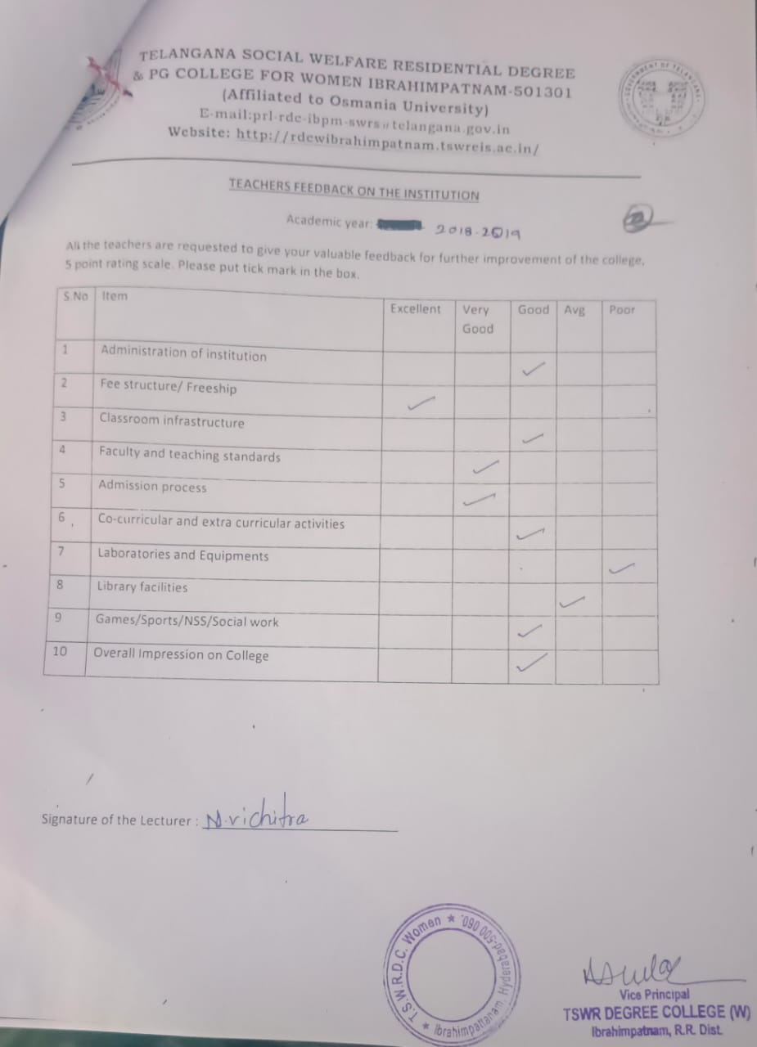

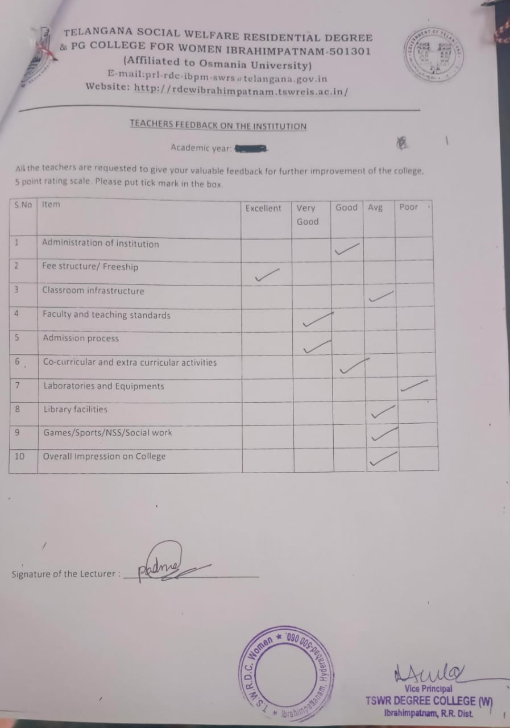

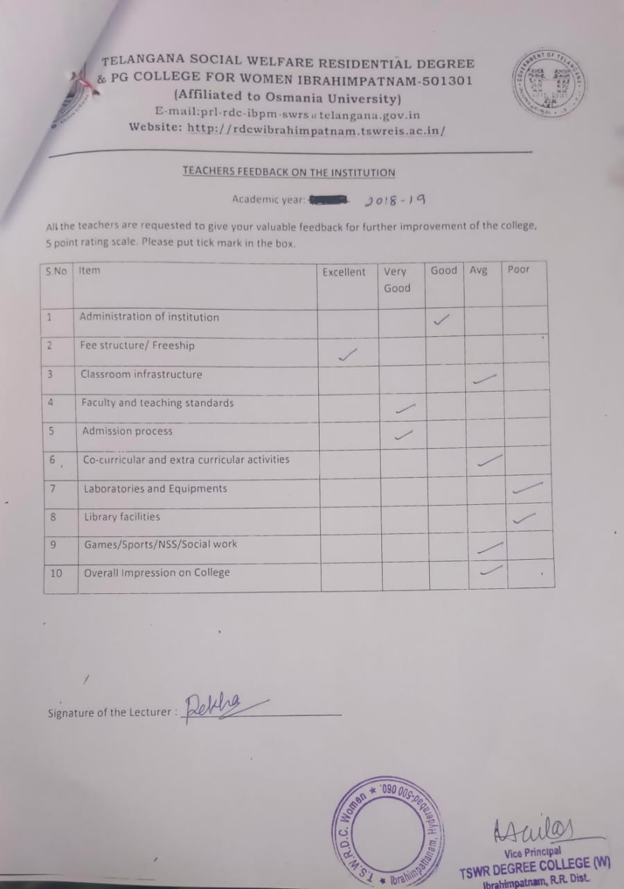

**TELANGANA SOCIAL WELFARE RESIDENTIAL DEGREE**

**& PG COLLEGE FOR WOMEN IBRAHIMPATNAM-501301**

**(Affiliated to Osmania University)**

**E-mail:prl-rdc-ibpm-swrs@telangana.gov.in**

**Website:** [**http://rdcwibrahimpatnam.tswreis.ac.in/**](http://rdcwibrahimpatnam.tswreis.ac.in/)

**Parents Feedback**

**A.Y.: 2018-2019**

| **S.No** | **Item** | **Excellent ( No.Of Responses)** | **Very Good** | **Good** | **Average** | **Poor** | **Total** |
| --- | --- | --- | --- | --- | --- | --- | --- |
| **1** | **Q.1** | 0 | 1 | 5 | 4 | 0 | 10 |
| **2** | **Q.2** | 0 | 2 | 8 | 0 | 0 | 10 |
| **3** | **Q.3** | 0 | 1 | 5 | 4 | 0 | 10 |
| **4** | **Q.4** | 0 | 2 | 7 | 1 | 0 | 10 |
| **5** | **Q.5** | 0 | 1 | 4 | 5 | 0 | 10 |
| **6** | **Q.6** | 0 | 1 | 4 | 5 | 0 | 10 |
| **7** | **Q.7** | 0 | 1 | 5 | 4 | 0 | 10 |

Note : The Numbers indicate the total number of Stakeholders voted for particular question.

