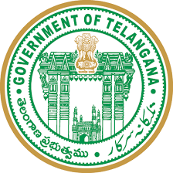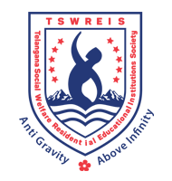

**OFFICE OF THE PRINCIPAL**

**TELANGANA SOCIAL WELFARE RESIDENTIAL DEGREE**

**& PG COLLEGE FOR WOMEN IBRAHIMPATNAM**

**AT ANKUSHAPUR**

**College Code: 61527 OU College Code : 2814**

**Dr H Radhika *Mcom, MBA, NET, SET, Ph.D***

**E-mail:prl-rdc-ibpm-swrs@telangana.gov.in**

**PRINCIPAL Mobile No.: 9121004526**

**3.4.2 Awards and recognitions received for extension activities from government / government recognised bodies**

Our Institution NSS UNIT-1 Programme officer Received Appreciation Award for Her contribution towards the elimination of gender discrimination in the eve of Women's Day Celebration

