**Certificate courses/ Add on courses certificates**

## **Telugu Literature-Personality development**

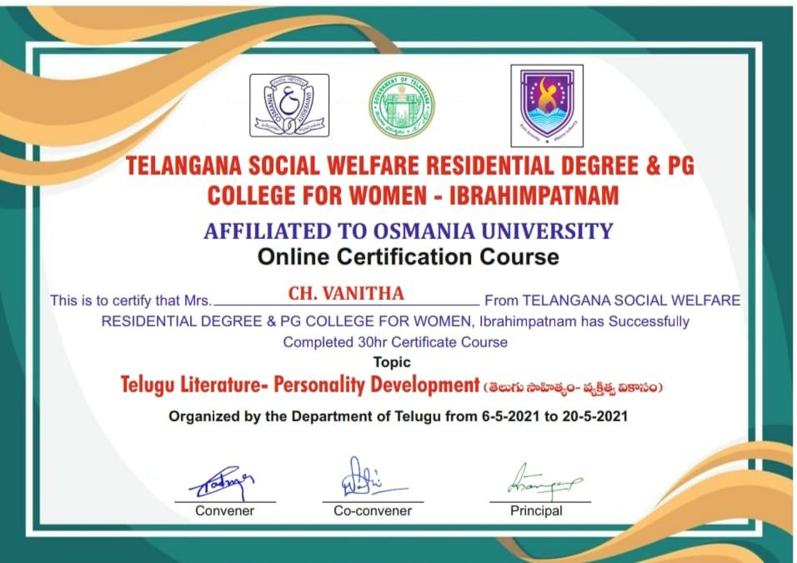

**Fundamentals of Information Technology**

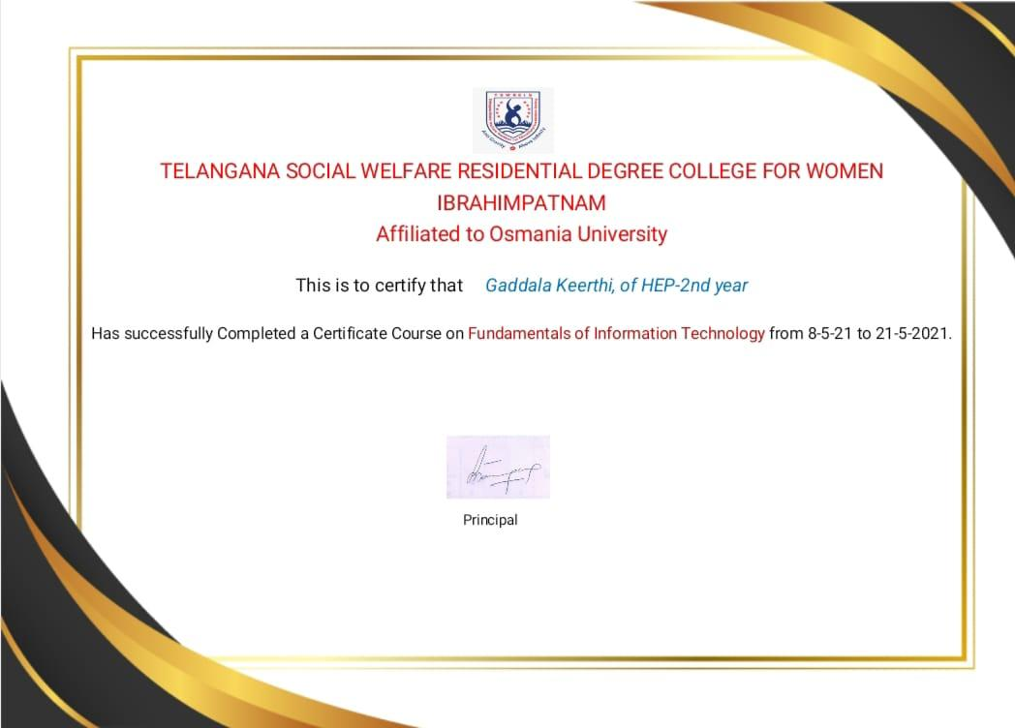

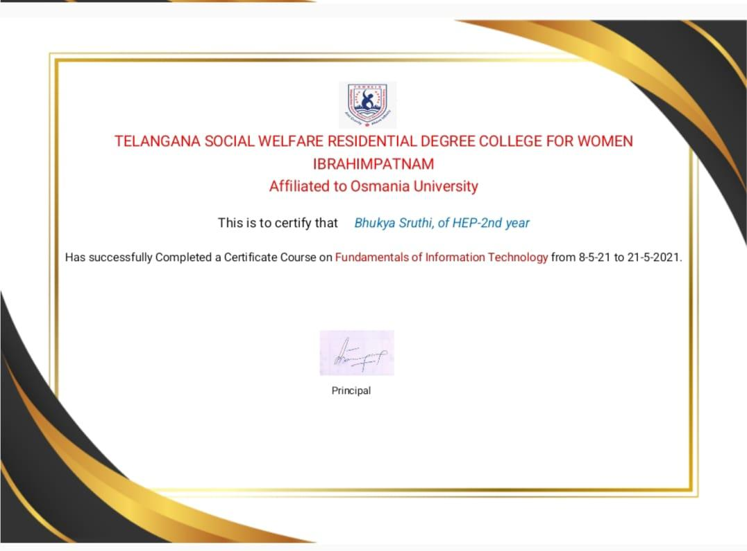

**GIRL BOSS CERTIFICATE**

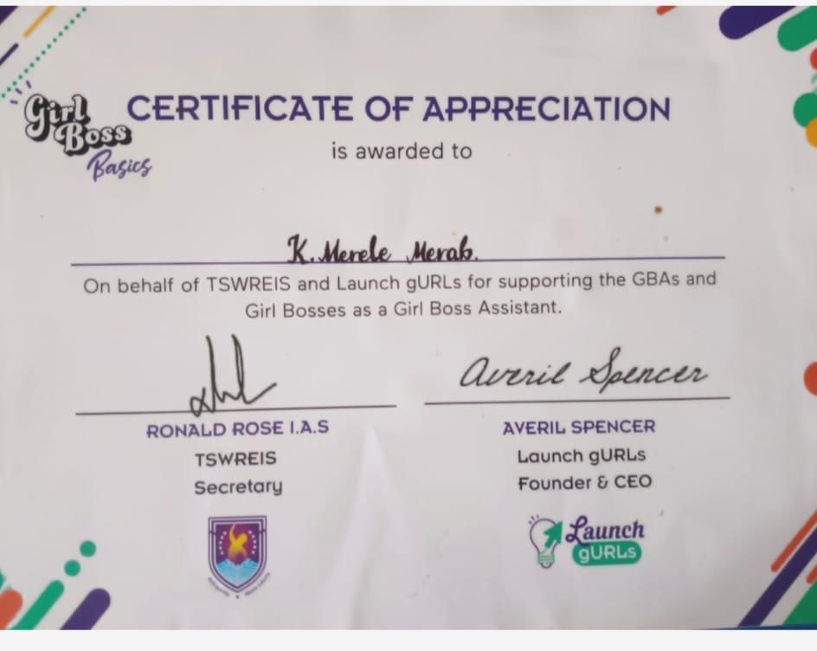

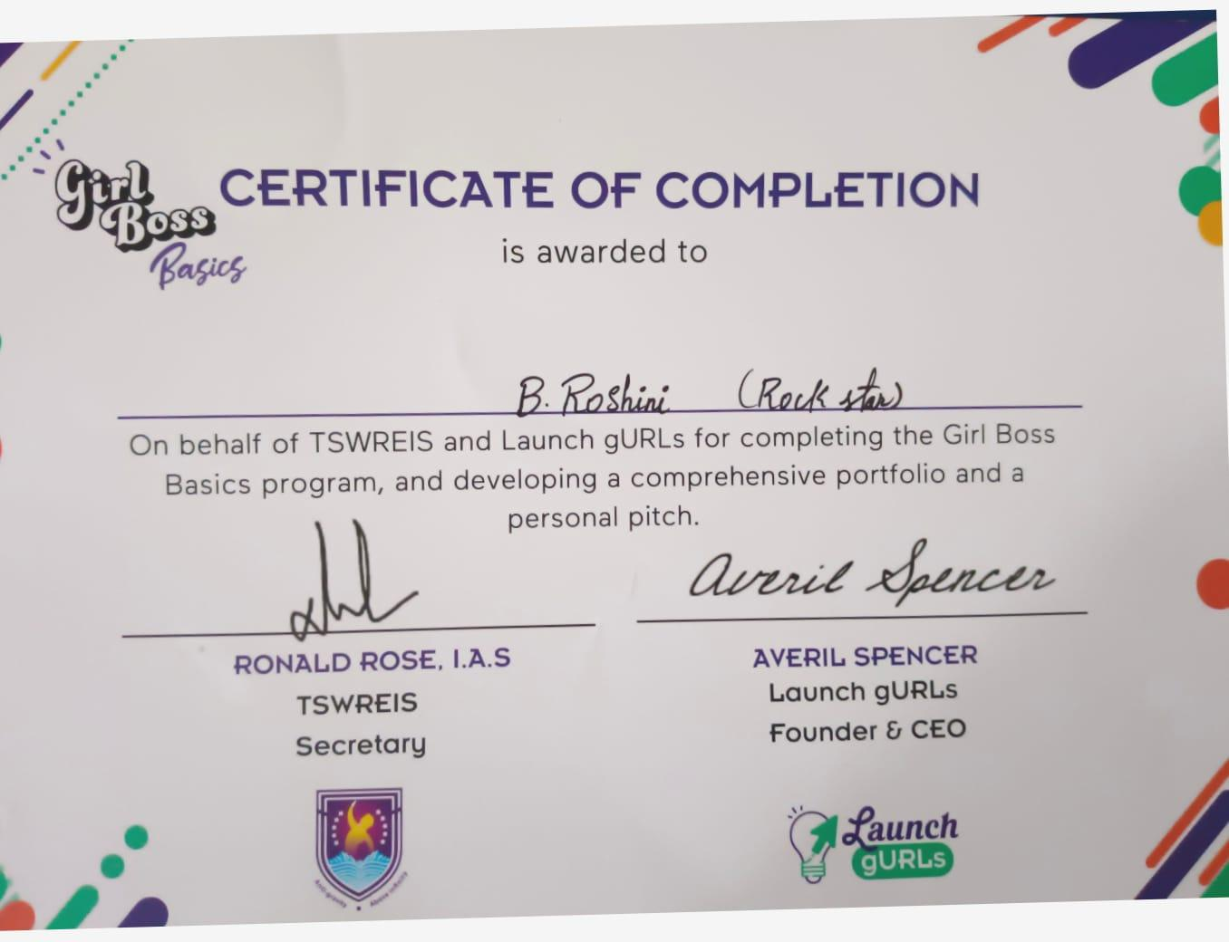

**Certificate of Public Speaking**

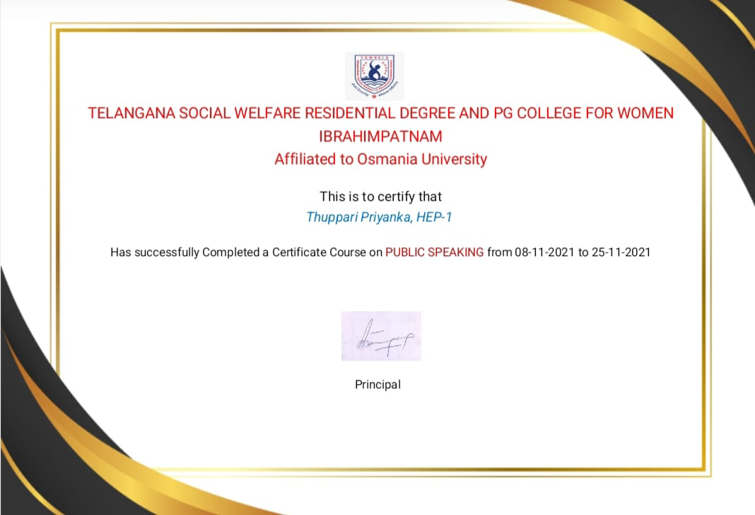

**FINANCIAL LITERACY CERTIFICATE**

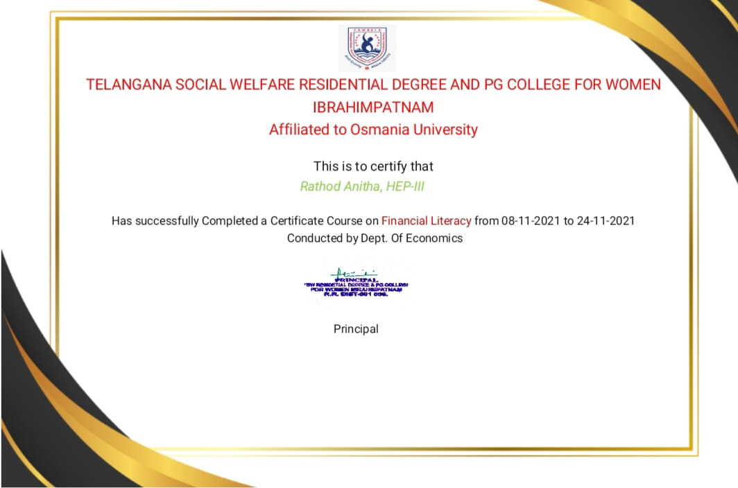

**ETHICS AND VALUE EDUCATION CERTIFICATE**

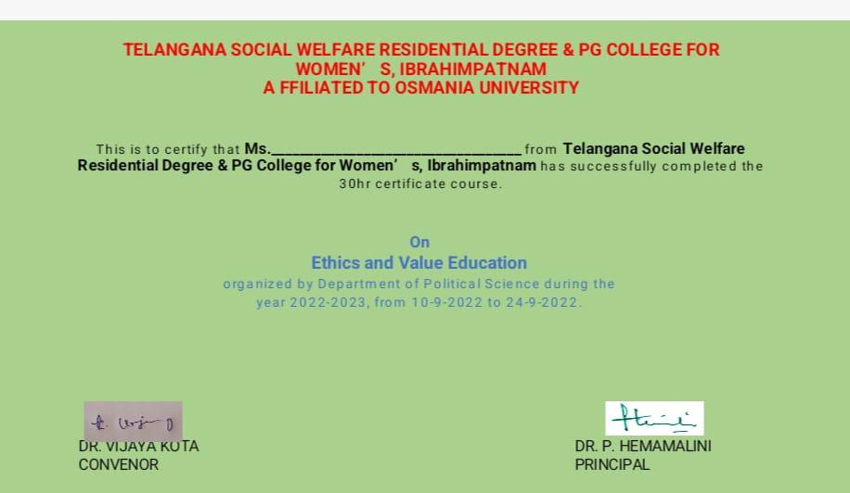

**INFORMATION TECHNOLOGY CERTIFICATE**

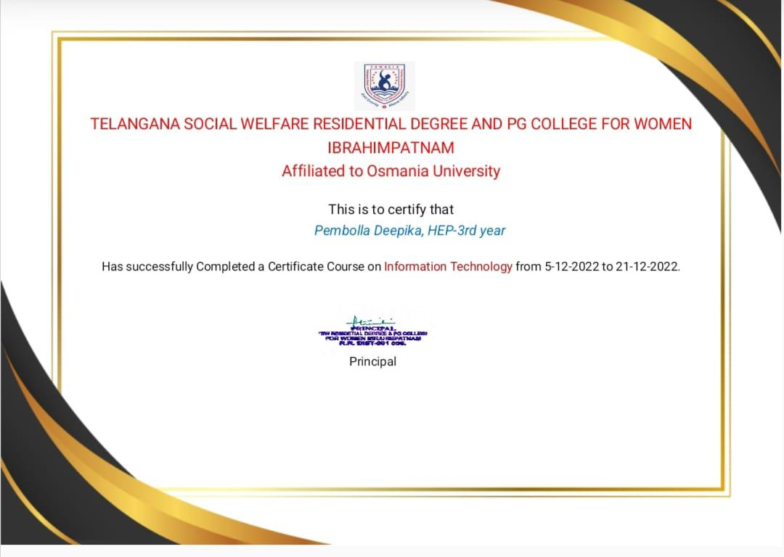

**NGO MANAGEMENT CERTIFICATE**

