**OFFICE OF THE PRINCIPAL** 

**TELANGANA SOCIAL WELFARE RESIDENTIAL DEGREE**

**& PG COLLEGE FOR WOMEN IBRAHIMPATNAM**

**AT ANKUSHAPUR**

**College Code: 61527                                           OU College Code : 2814**

**PRINCIPAL**

**Dr H Radhika *Mcom, MBA, NET, SET, Ph.D***

**E-mail:prl-rdc-ibpm-swrs@telangana.gov.in**

**Mobile No.: 9121004526**

**OUR BOTANICAL GARDEN**

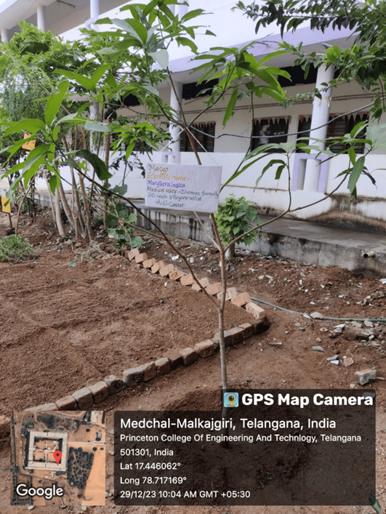



**OFFICE OF THE PRINCIPAL** 

**TELANGANA SOCIAL WELFARE RESIDENTIAL DEGREE**

**& PG COLLEGE FOR WOMEN IBRAHIMPATNAM**

**AT ANKUSHAPUR**

**College Code: 61527                                           OU College Code : 2814**

**PRINCIPAL**

**Dr H Radhika *Mcom, MBA, NET, SET, Ph.D***

**E-mail:prl-rdc-ibpm-swrs@telangana.gov.in**

**Mobile No.: 9121004526**

**Growing Vegetables:**

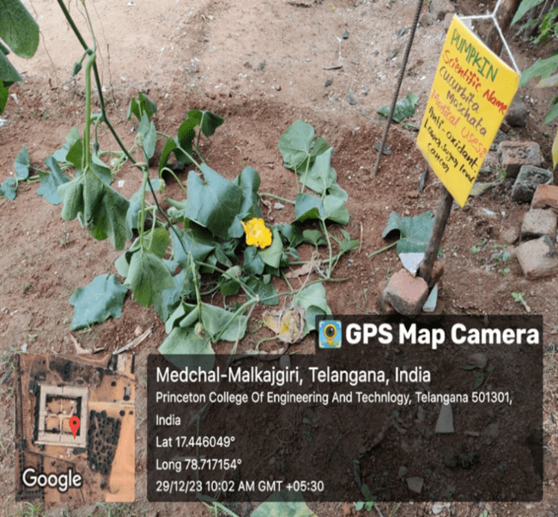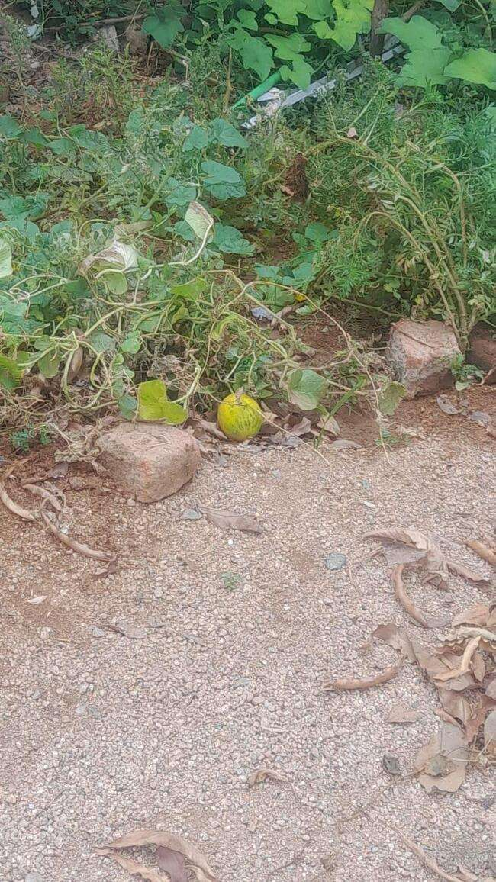

**Growing Herbal plants:**

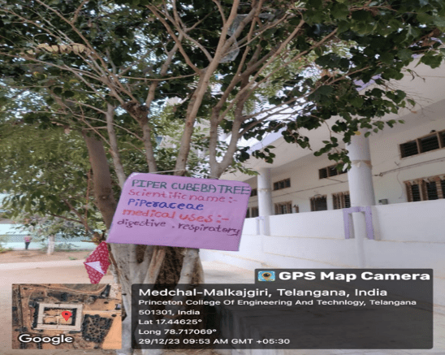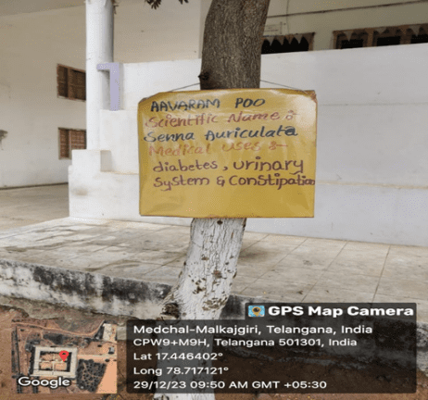



**OFFICE OF THE PRINCIPAL** 

**TELANGANA SOCIAL WELFARE RESIDENTIAL DEGREE**

**& PG COLLEGE FOR WOMEN IBRAHIMPATNAM**

**AT ANKUSHAPUR**

**College Code: 61527                                           OU College Code : 2814**

**PRINCIPAL**

**Dr H Radhika *Mcom, MBA, NET, SET, Ph.D***

**E-mail:prl-rdc-ibpm-swrs@telangana.gov.in**

**Mobile No.: 9121004526**

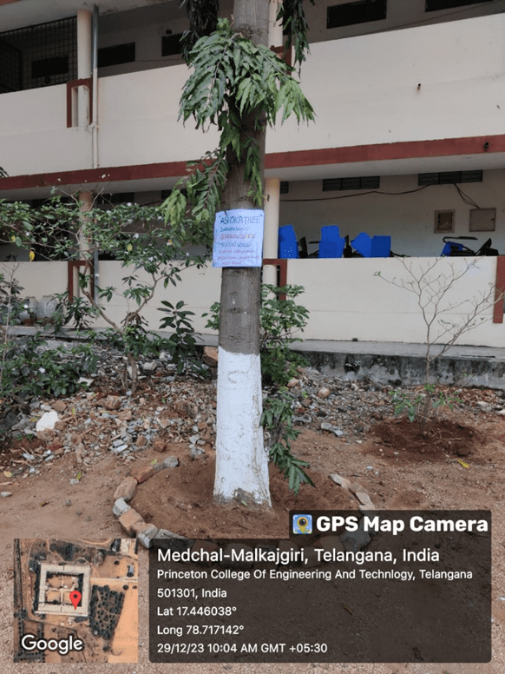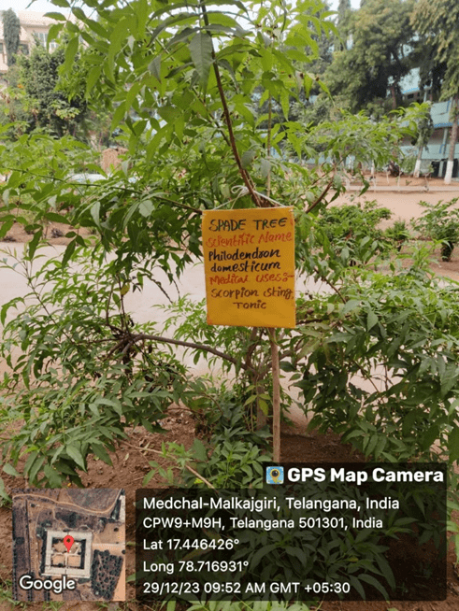

**Our Floral Garden**

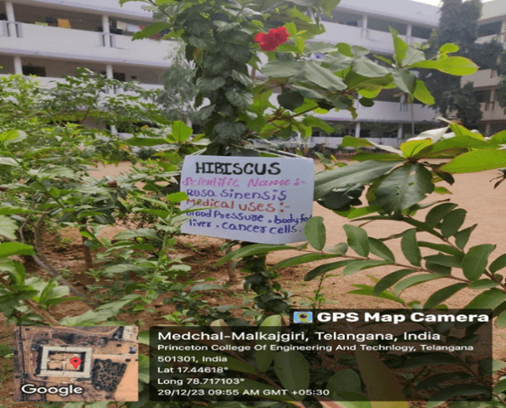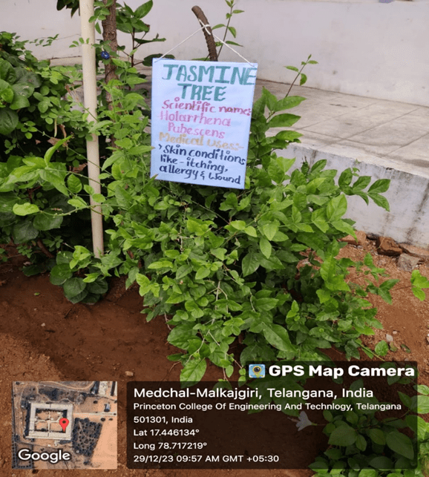



**OFFICE OF THE PRINCIPAL** 

**TELANGANA SOCIAL WELFARE RESIDENTIAL DEGREE**

**& PG COLLEGE FOR WOMEN IBRAHIMPATNAM**

**AT ANKUSHAPUR**

**College Code: 61527                                             OU College Code : 2814**

**PRINCIPAL**

**Dr H Radhika *Mcom, MBA, NET, SET, Ph.D***

**E-mail:prl-rdc-ibpm-swrs@telangana.gov.in**

**Mobile No.: 9121004526**

