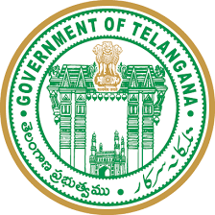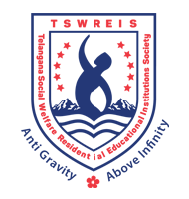**OFFICE OF THE PRINCIPAL**

**TELANGANA SOCIAL WELFARE RESIDENTIAL DEGREE**

**& PG COLLEGE FOR WOMEN IBRAHIMPATNAM**

**AT ANKUSHAPUR**

**College Code: 61527 OU College Code : 2814**

**Dr H Radhika *Mcom, MBA, NET, SET, Ph.D***

**E-mail:prl-rdc-ibpm-swrs@telangana.gov.in**

**PRINCIPAL Mobile No.: 9121004526**

ANTI RAGGING COMMITTEE

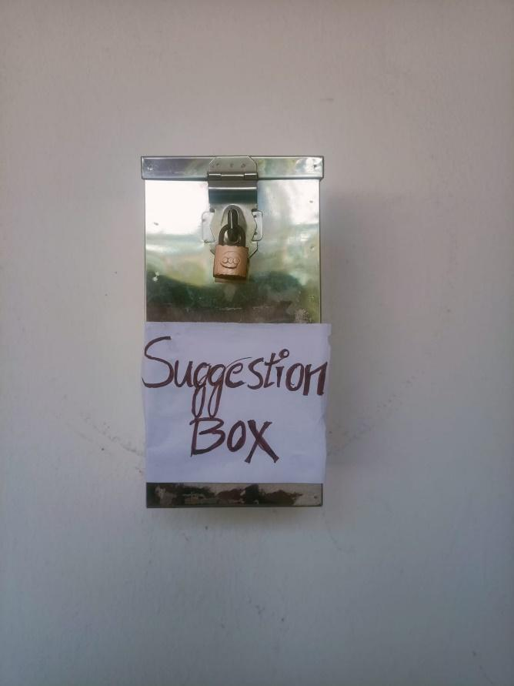

**Anti-ragging and disciplinary committee** ensures to maintain discipline in the college and creates a stress-free environment by driving away from the inhibitions whatsoever of the freshers. No incidents of ragging the students have been reported in the last five years.

**The following are the members of the committee:**

1. Chairman - (Principal)
2. Vice Chairman – (Vice Principal)
3. Member - Dr. K. Vijaya
4. Member - Dr. Padmavathi
5. Member - Dr. Padmamma



