**OFFICE OF THE PRINCIPAL**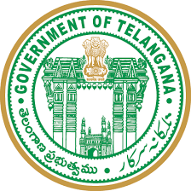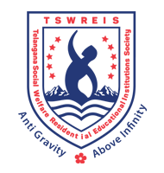

**TELANGANA SOCIAL WELFARE RESIDENTIAL DEGREE**

**& PG COLLEGE FOR WOMEN IBRAHIMPATNAM**

**AT ANKUSHAPUR**

**College Code: 61527 OU College Code : 2814**

**Dr H Radhika *Mcom, MBA, NET, SET, Ph.D***

**E-mail:prl-rdc-ibpm-swrs@telangana.gov.in**

**PRINCIPAL Mobile No.: 9121004526**

**Certificate course 2020-2021 on**

**TELUGU LITERATURE-PERSONALITY DEVELOPMENT**

**From 06-05-2021 to 20-05-2021**

**Organised by**

**The Department of Telugu**

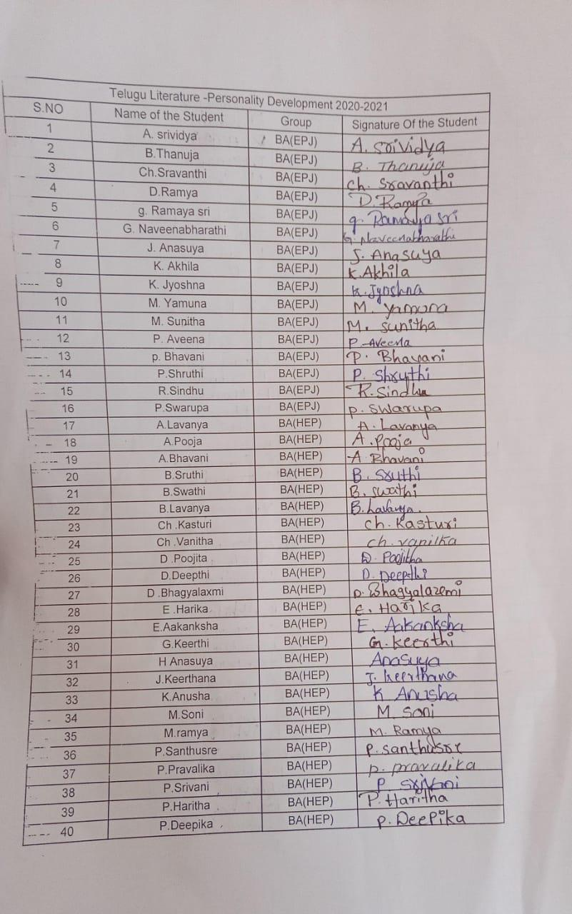

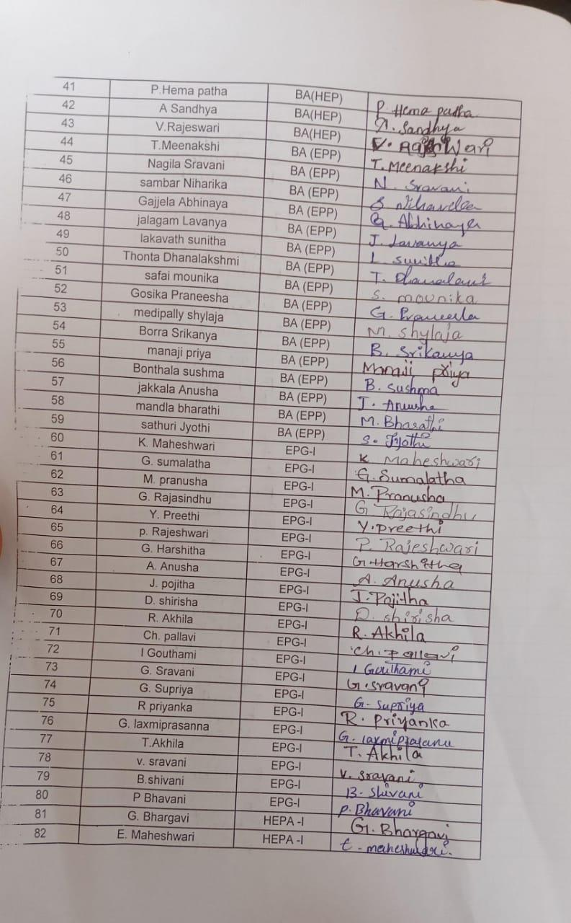

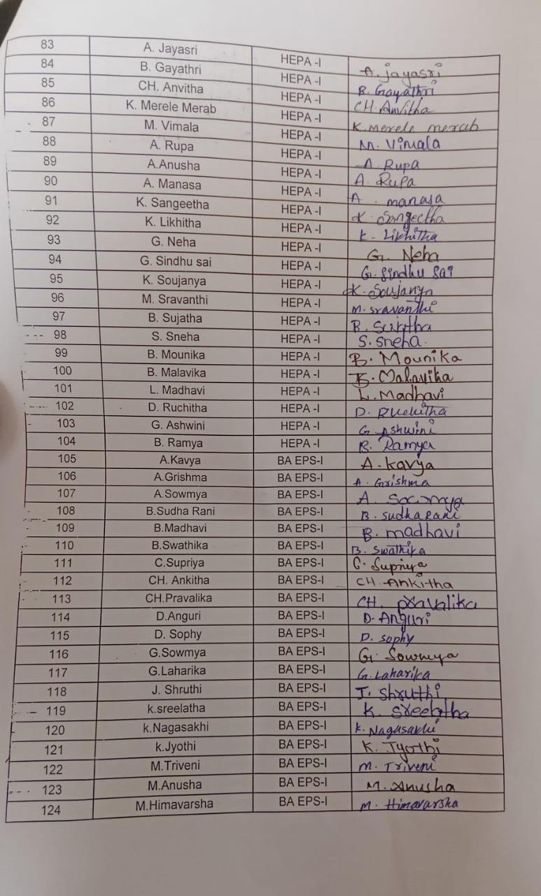

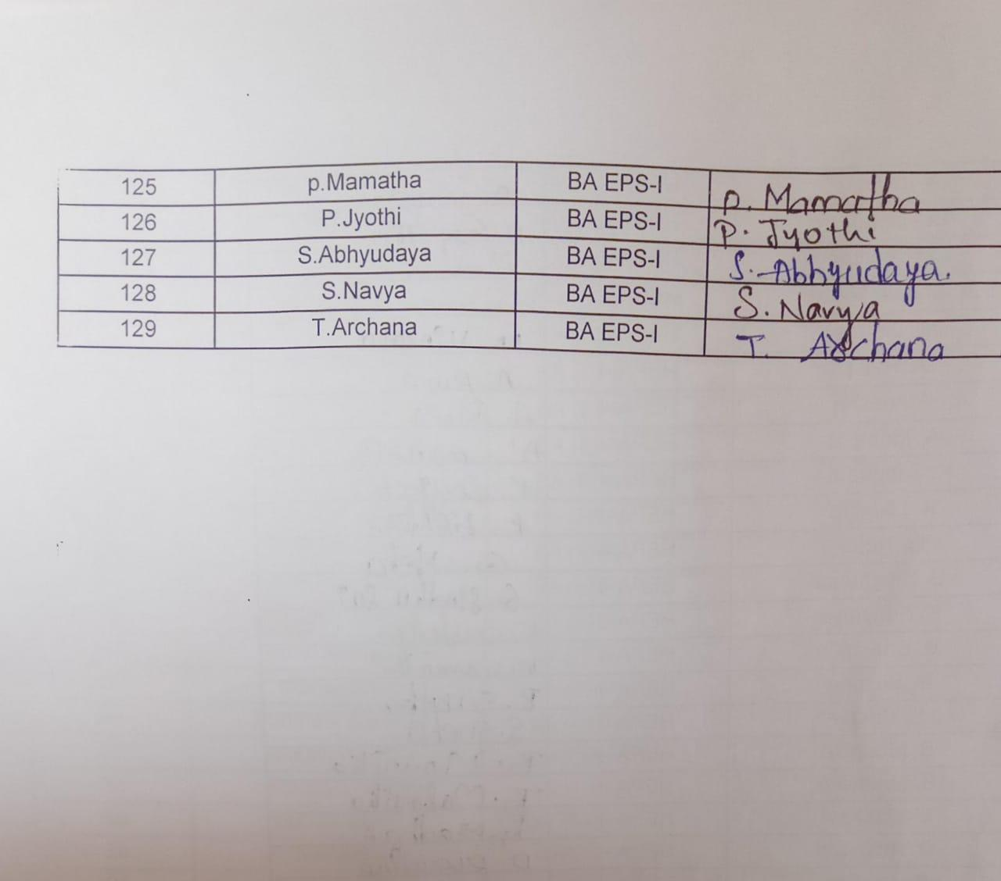

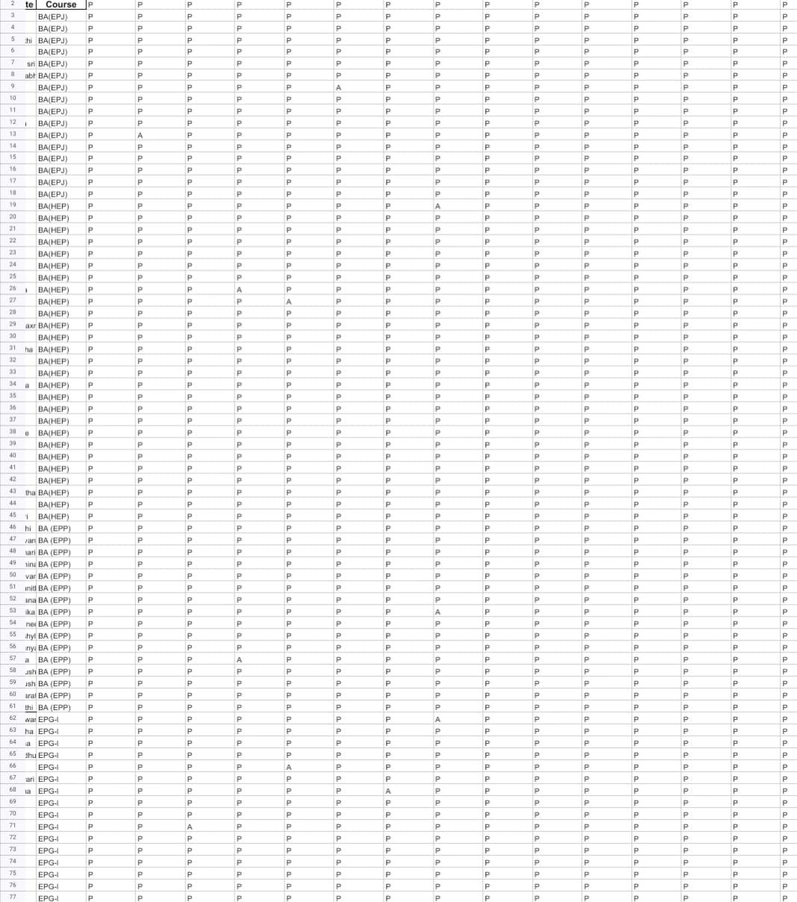

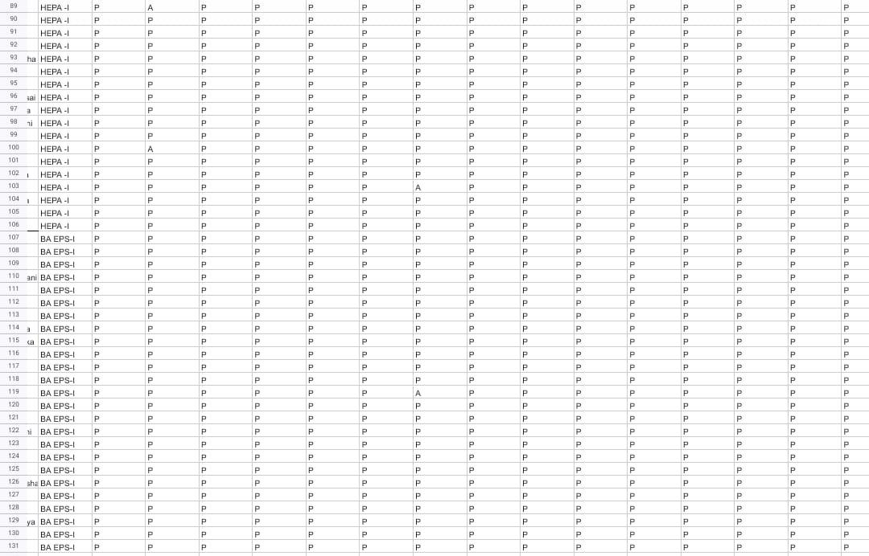

**OFFICE OF THE PRINCIPAL**

**TELANGANA SOCIAL WELFARE RESIDENTIAL DEGREE**

**& PG COLLEGE FOR WOMEN IBRAHIMPATNAM**

**AT ANKUSHAPUR**

**College Code: 61527 OU College Code : 2814**

**Dr H Radhika *Mcom, MBA, NET, SET, Ph.D***

**E-mail:prl-rdc-ibpm-swrs@telangana.gov.in**

**PRINCIPAL Mobile No.: 9121004526**

**Certificate course 2020-2021 on**

**FUNDAMENTALS OF INFORMATION TECHNOLOGY**

**From 08-05-2021 to 21-05-2021**

**organized by**

**Department of Journalism**

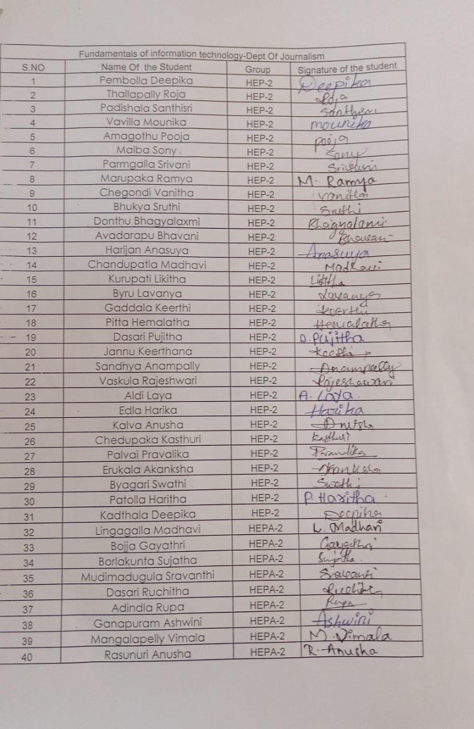

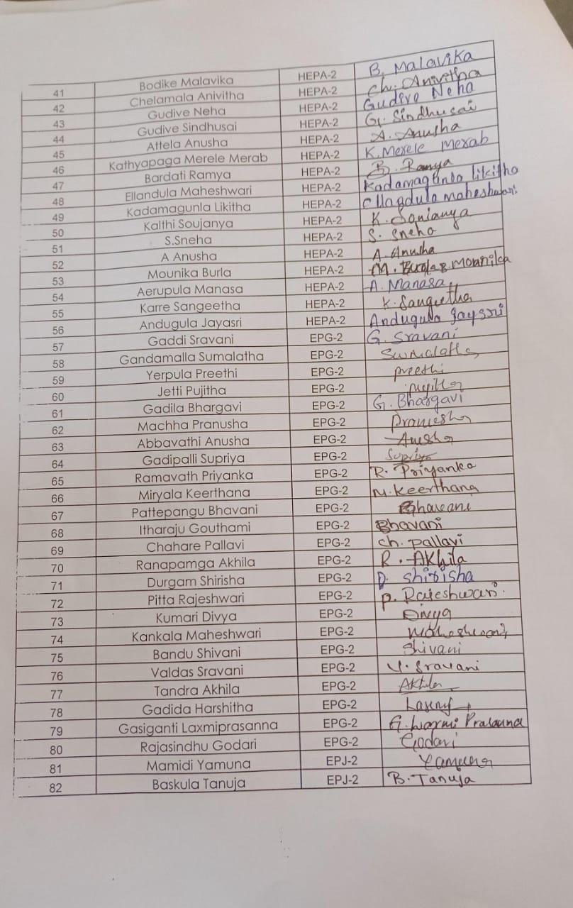

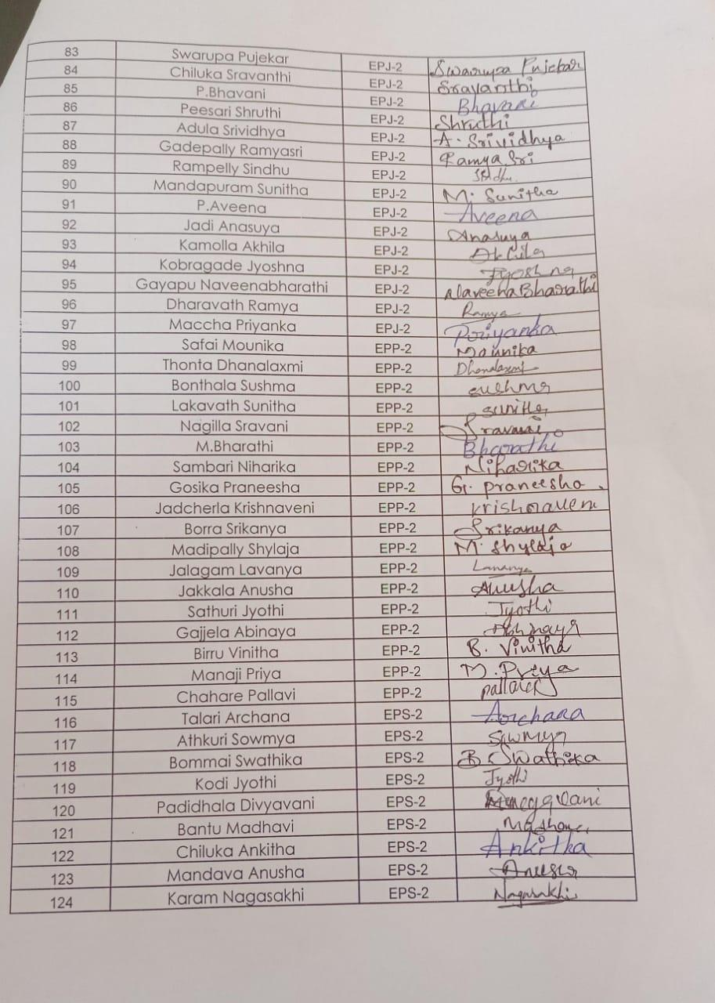

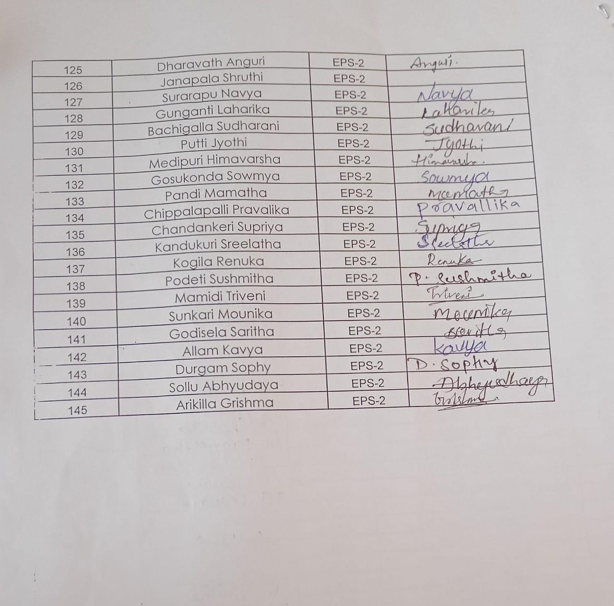

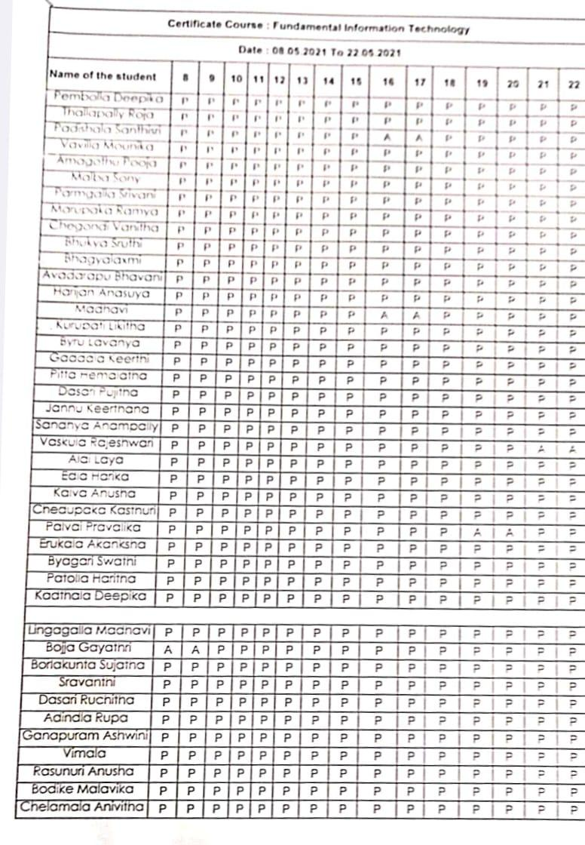

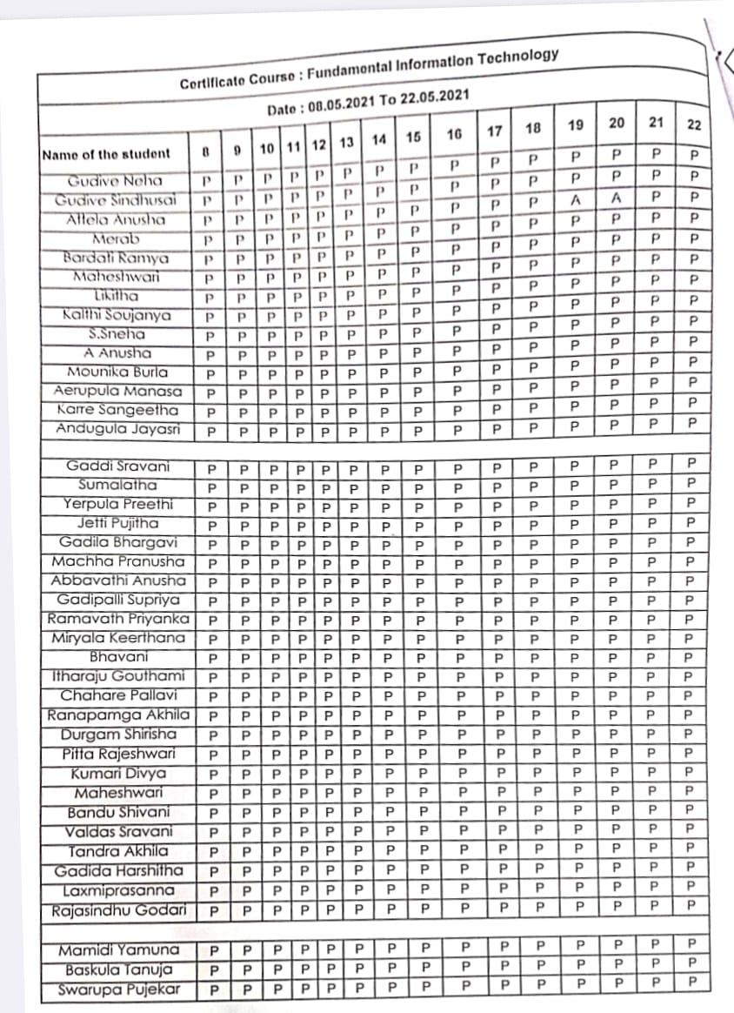

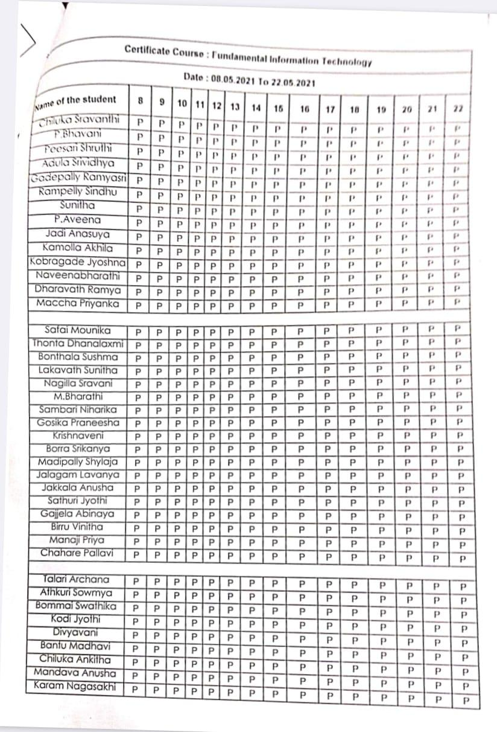

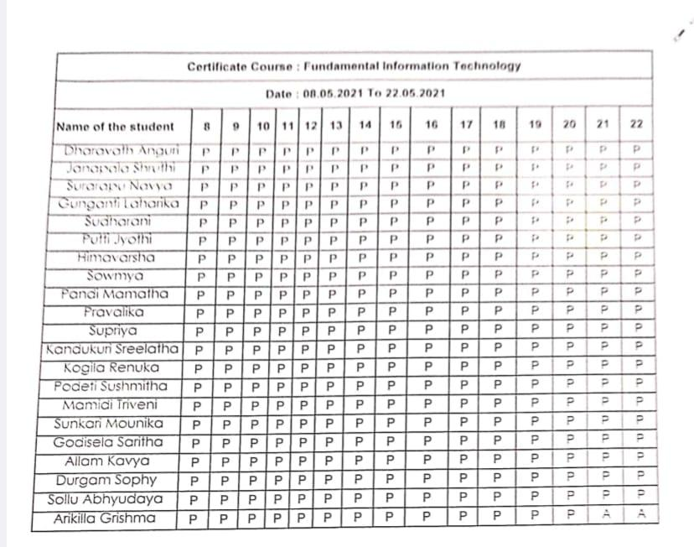

**OFFICE OF THE PRINCIPAL**

**TELANGANA SOCIAL WELFARE RESIDENTIAL DEGREE**

**& PG COLLEGE FOR WOMEN IBRAHIMPATNAM**

**AT ANKUSHAPUR**

**College Code: 61527 OU College Code : 2814**

**Dr H Radhika *Mcom, MBA, NET, SET, Ph.D***

**E-mail:prl-rdc-ibpm-swrs@telangana.gov.in**

**PRINCIPAL Mobile No.: 9121004526**

Add on course GIRL-BOSS attendance

2021-2022

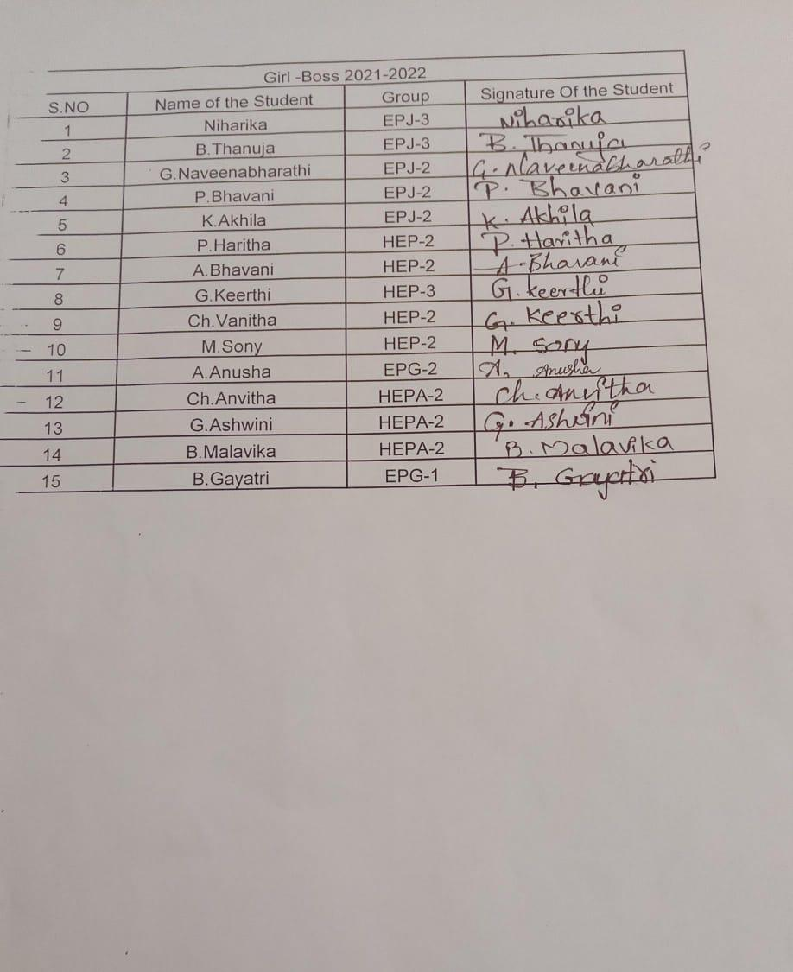

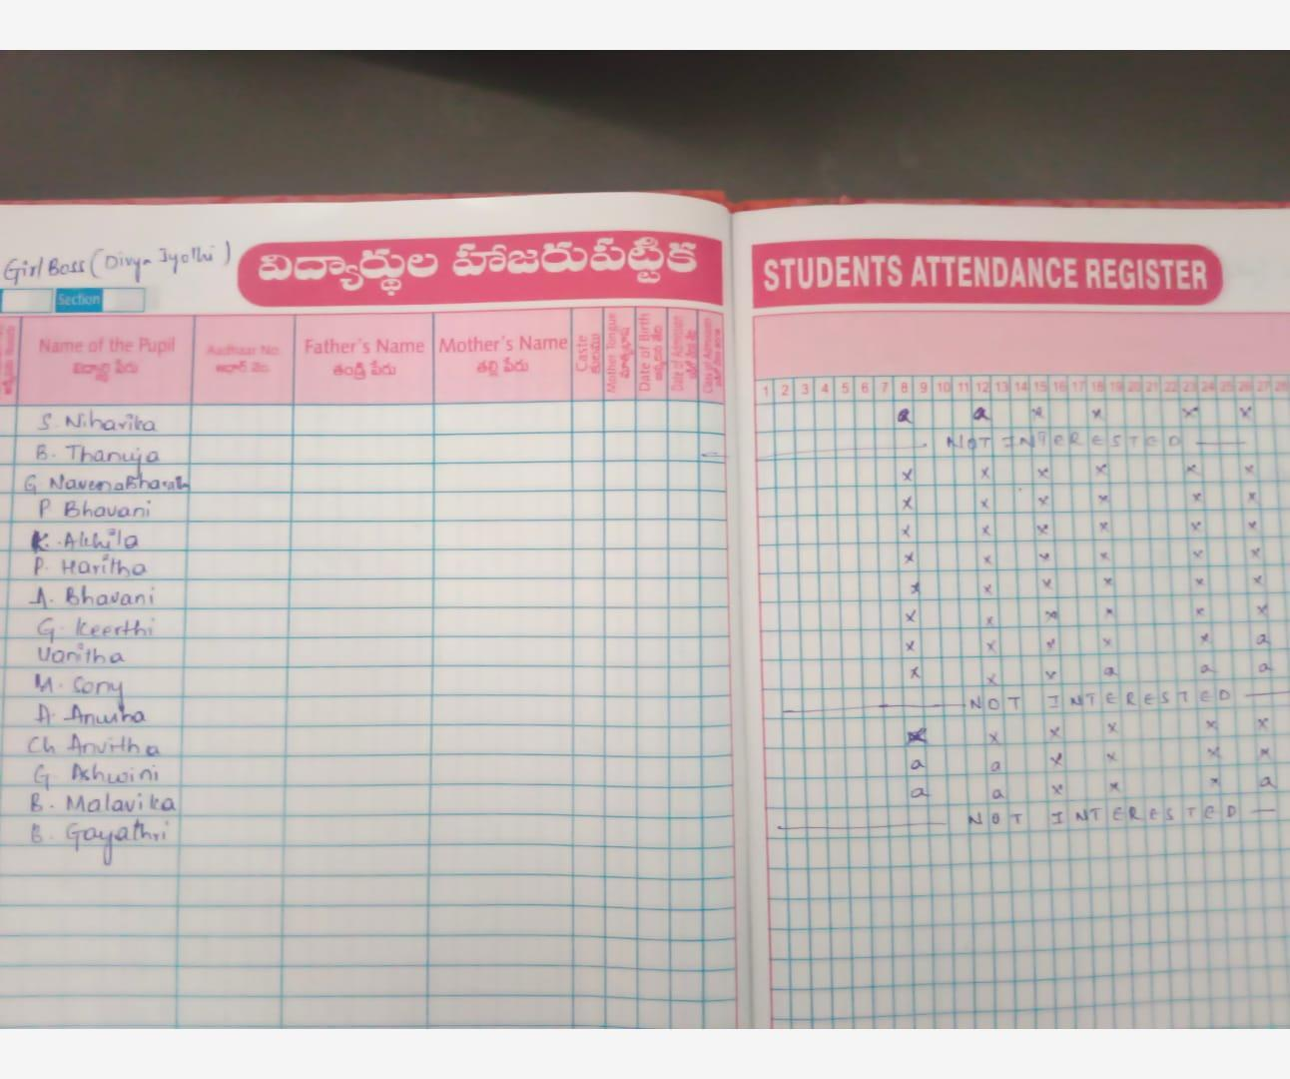

**OFFICE OF THE PRINCIPAL**

**TELANGANA SOCIAL WELFARE RESIDENTIAL DEGREE**

**& PG COLLEGE FOR WOMEN IBRAHIMPATNAM**

**AT ANKUSHAPUR**

**College Code: 61527 OU College Code : 2814**

**Dr H Radhika *Mcom, MBA, NET, SET, Ph.D***

**E-mail:prl-rdc-ibpm-swrs@telangana.gov.in**

**PRINCIPAL Mobile No.: 9121004526**

Certificate Course 2021-2022

PUBLIC SPEAKING Attendance

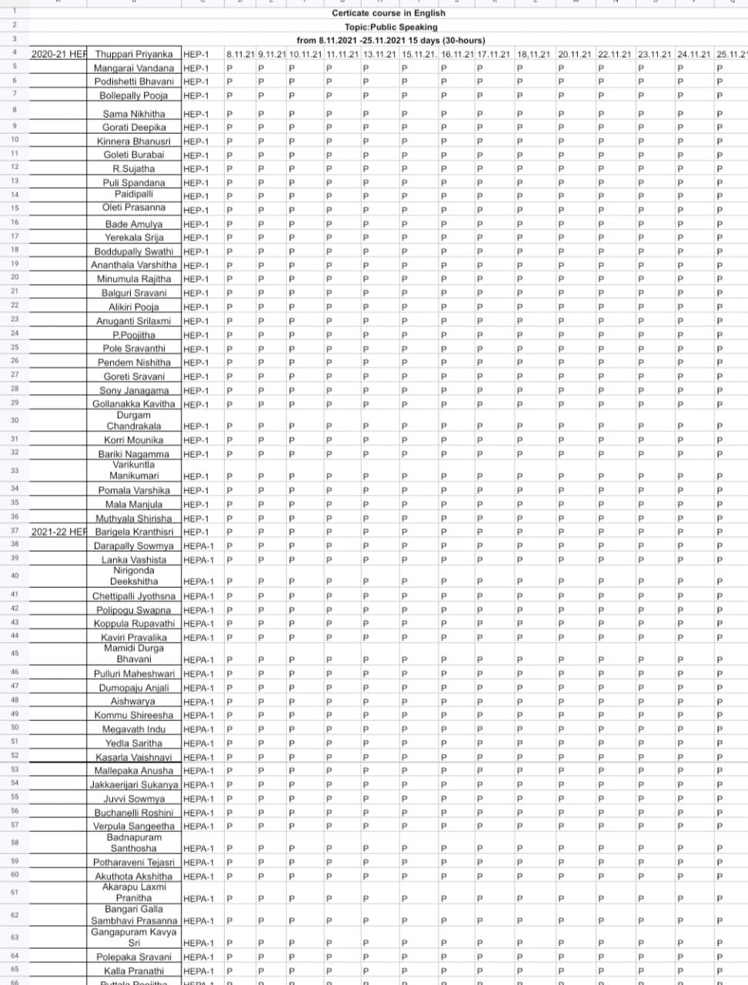

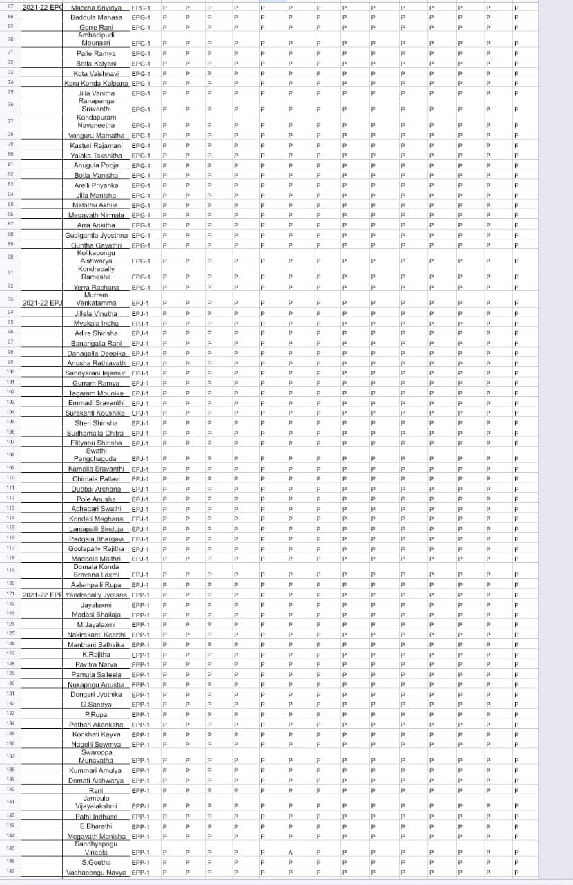

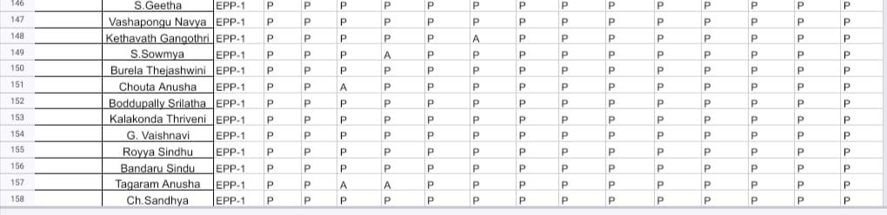

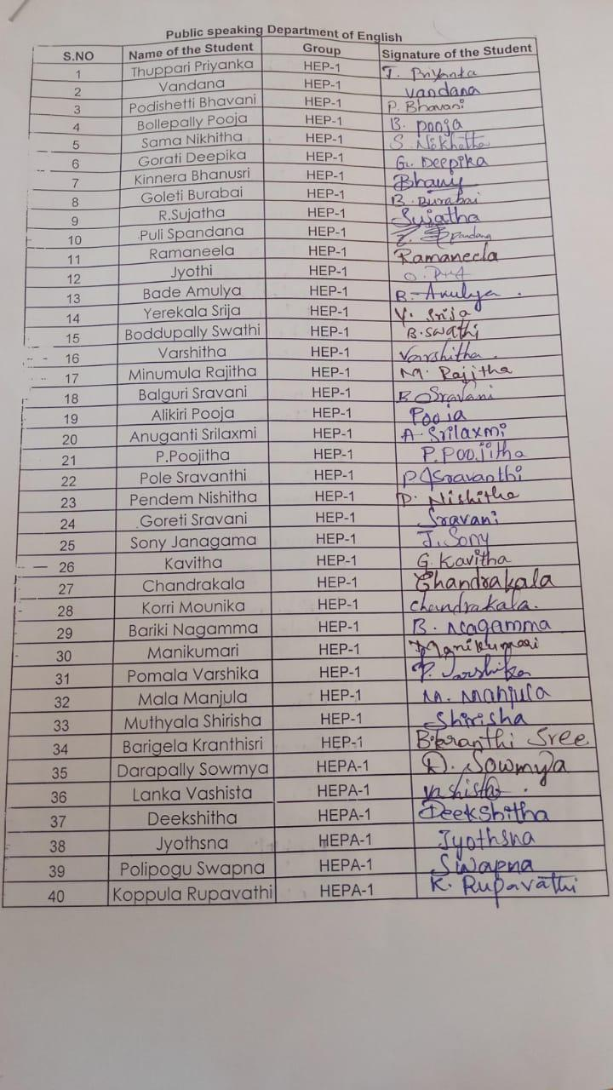

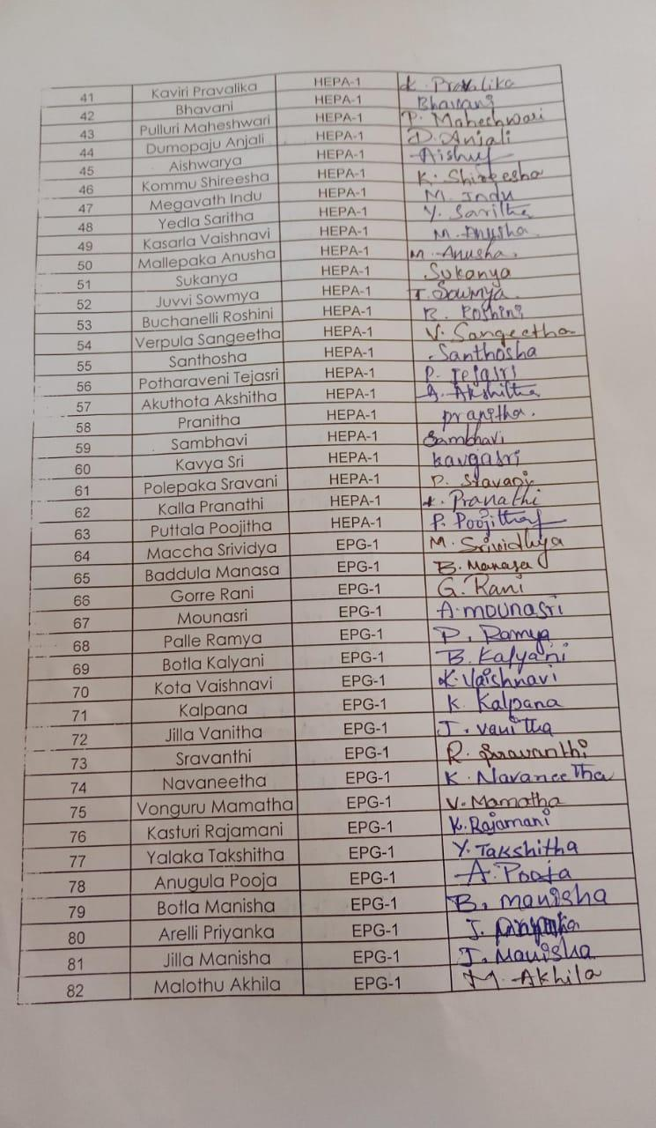

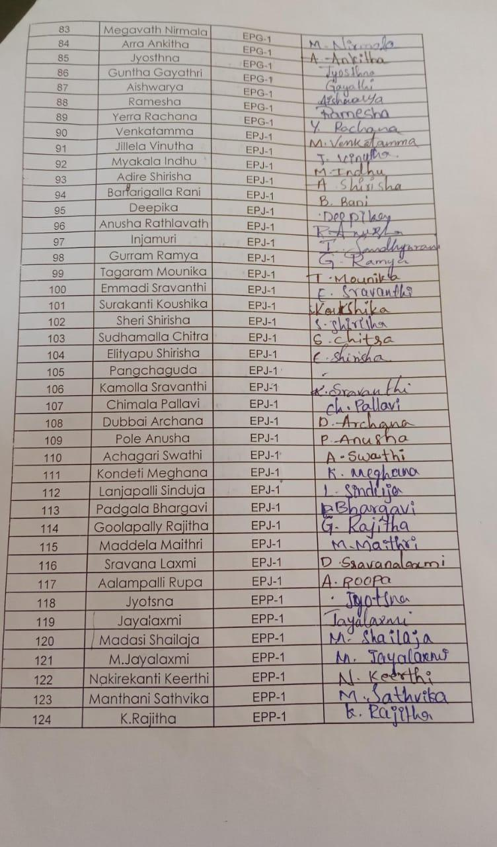

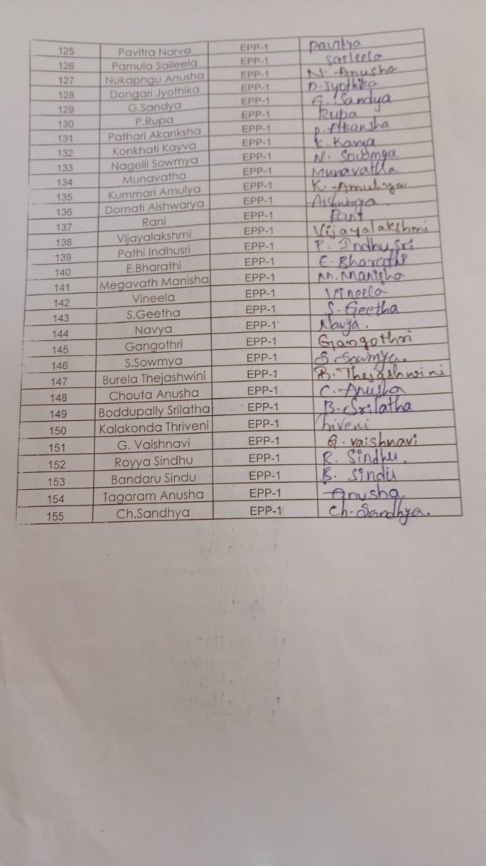

**OFFICE OF THE PRINCIPAL**

**TELANGANA SOCIAL WELFARE RESIDENTIAL DEGREE**

**& PG COLLEGE FOR WOMEN IBRAHIMPATNAM**

**AT ANKUSHAPUR**

**College Code: 61527 OU College Code : 2814**

**Dr H Radhika *Mcom, MBA, NET, SET, Ph.D***

**E-mail:prl-rdc-ibpm-swrs@telangana.gov.in**

**PRINCIPAL Mobile No.: 9121004526**

Certificate Course 2021-2022

Financial Literacy Attendance

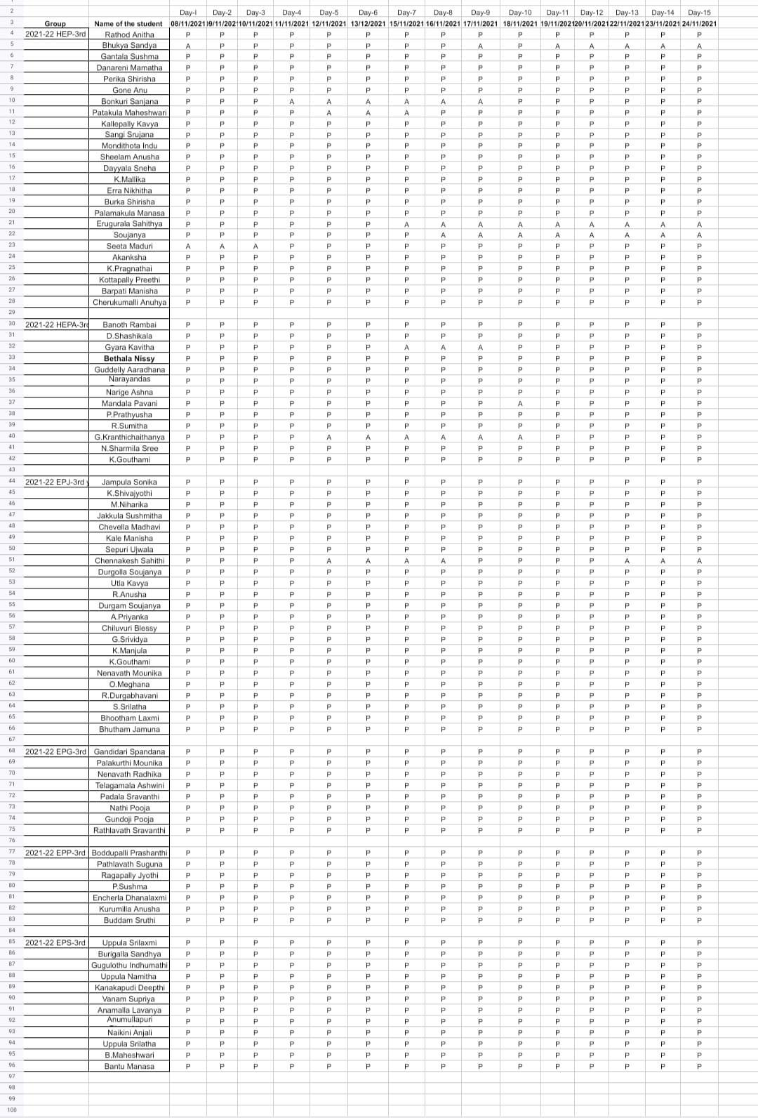

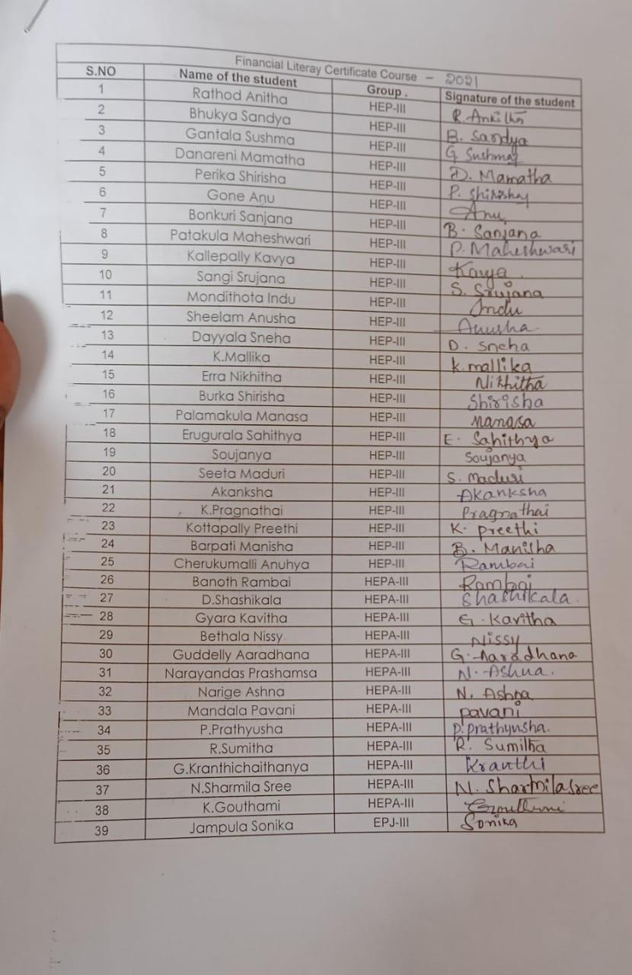

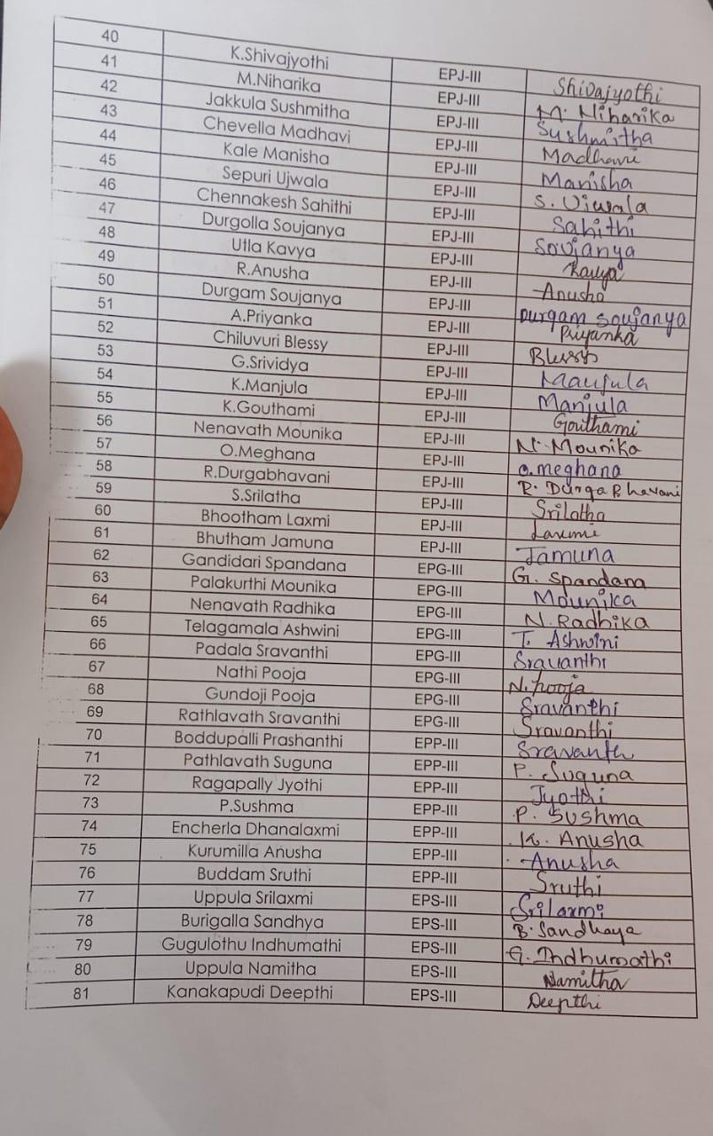

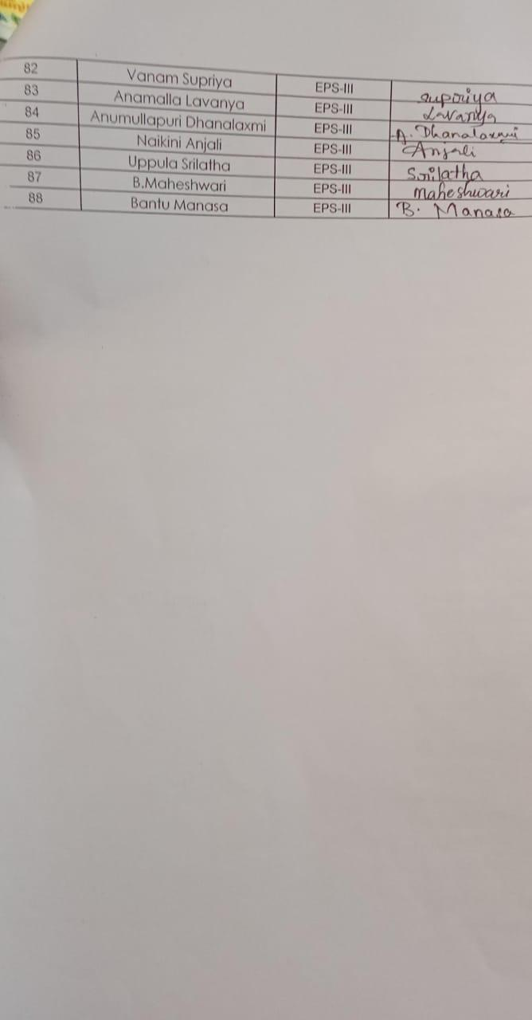

**OFFICE OF THE PRINCIPAL**

**TELANGANA SOCIAL WELFARE RESIDENTIAL DEGREE**

**& PG COLLEGE FOR WOMEN IBRAHIMPATNAM**

**AT ANKUSHAPUR**

**College Code: 61527 OU College Code : 2814**

**Dr H Radhika *Mcom, MBA, NET, SET, Ph.D***

**E-mail:prl-rdc-ibpm-swrs@telangana.gov.in**

**PRINCIPAL Mobile No.: 9121004526**

certificate course on

“ ETHICS AND VALUE EDUCATION”

From 10-09-2022 to 24-09-2022

organized by

Dr. Vijaya kota

Department of Political science

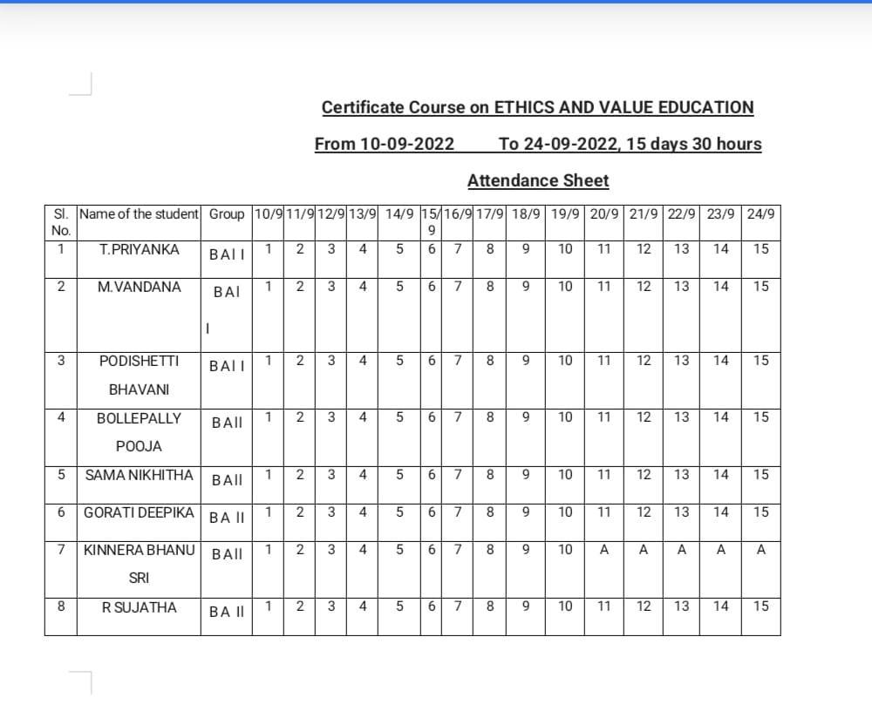

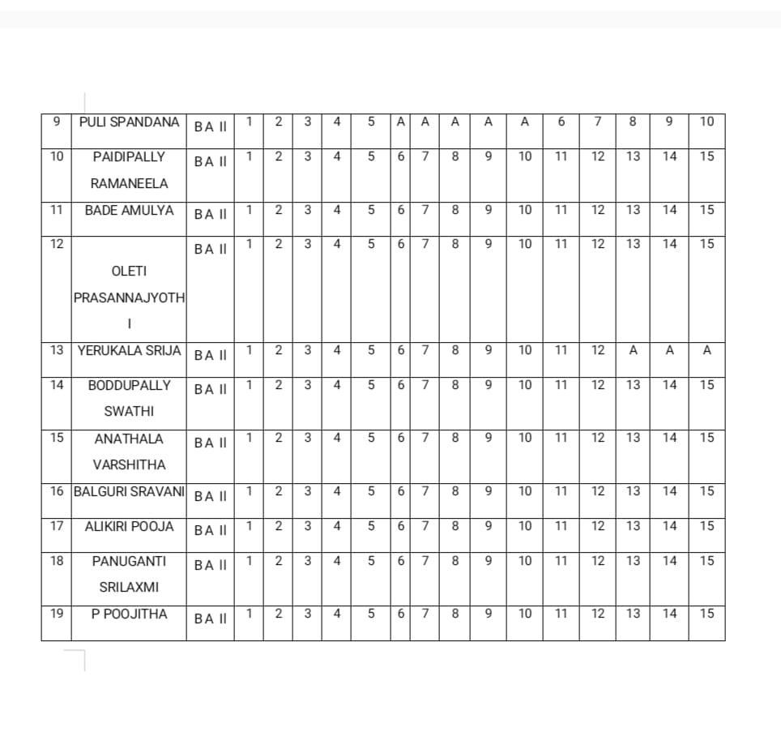

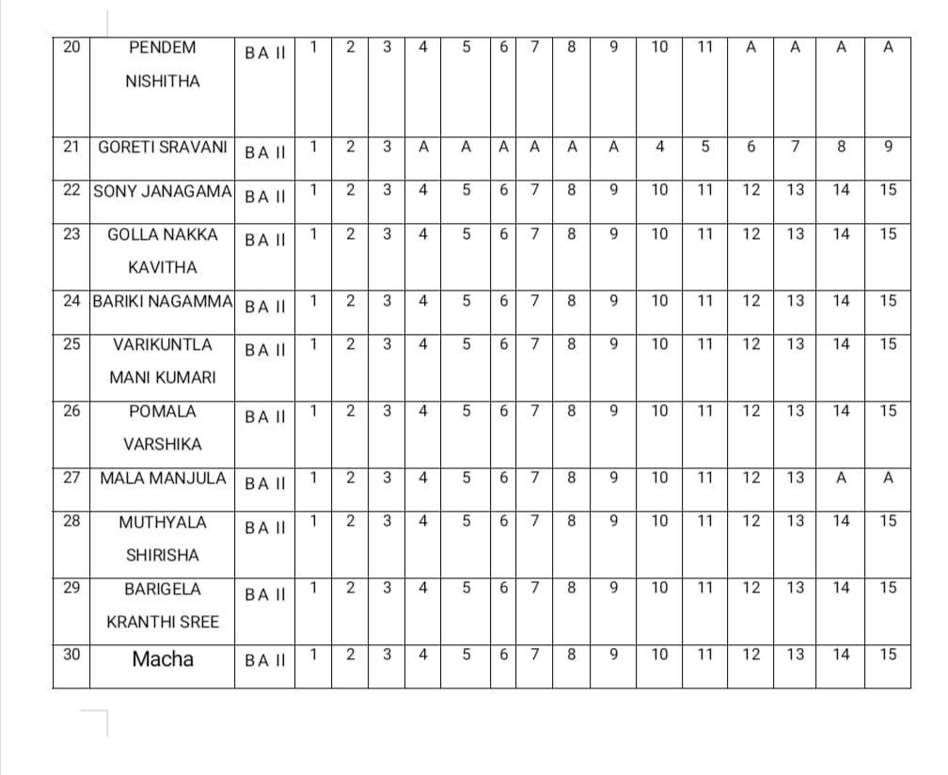

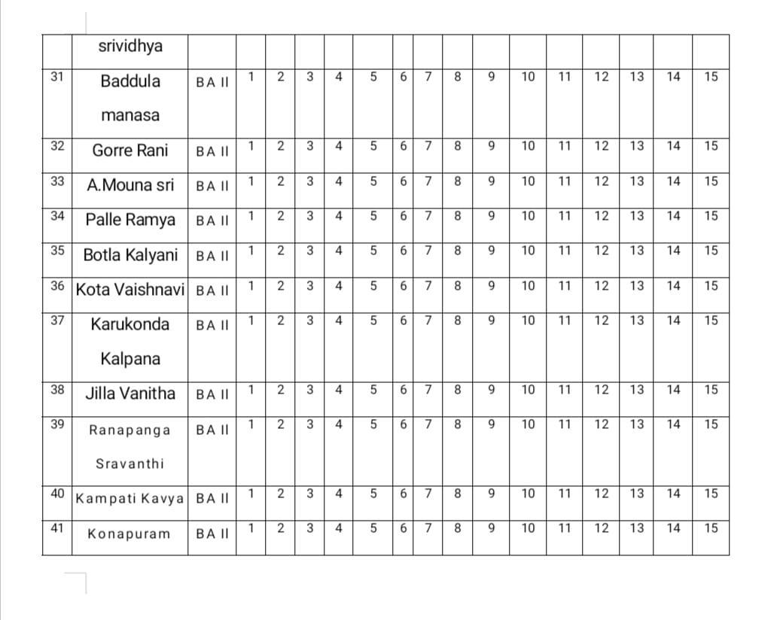

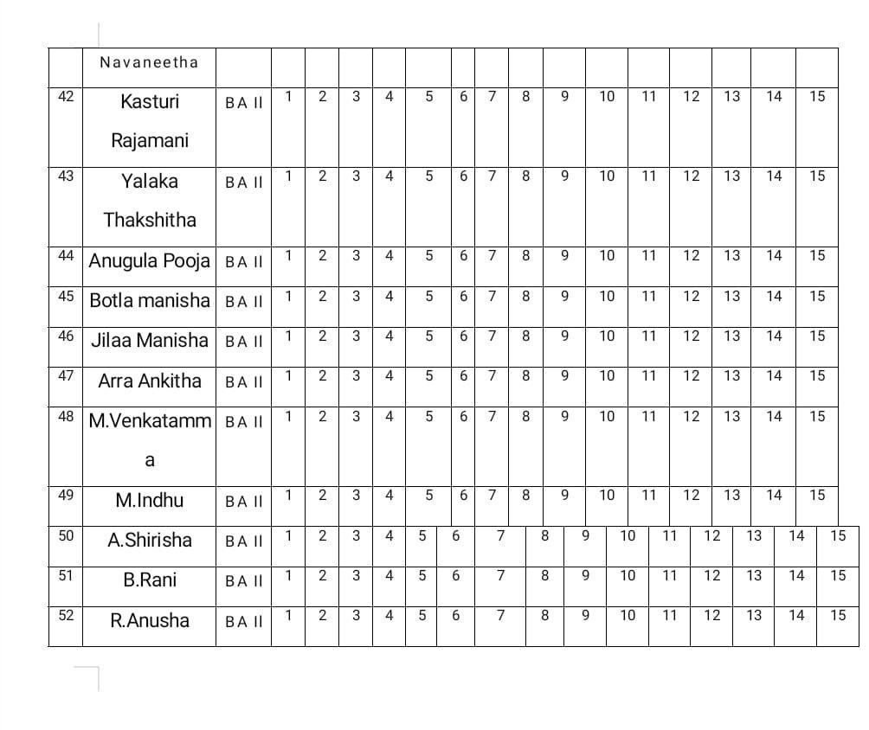

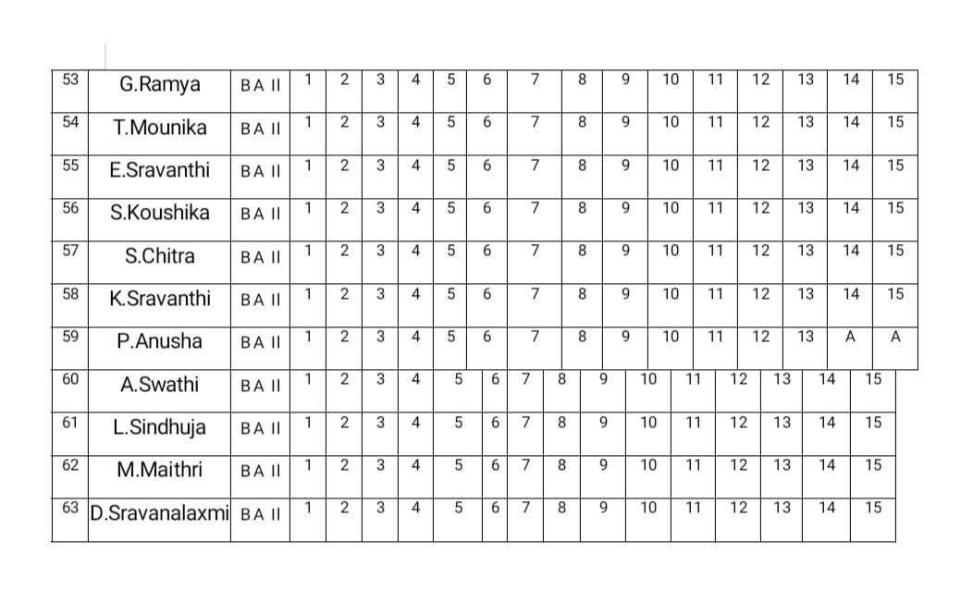

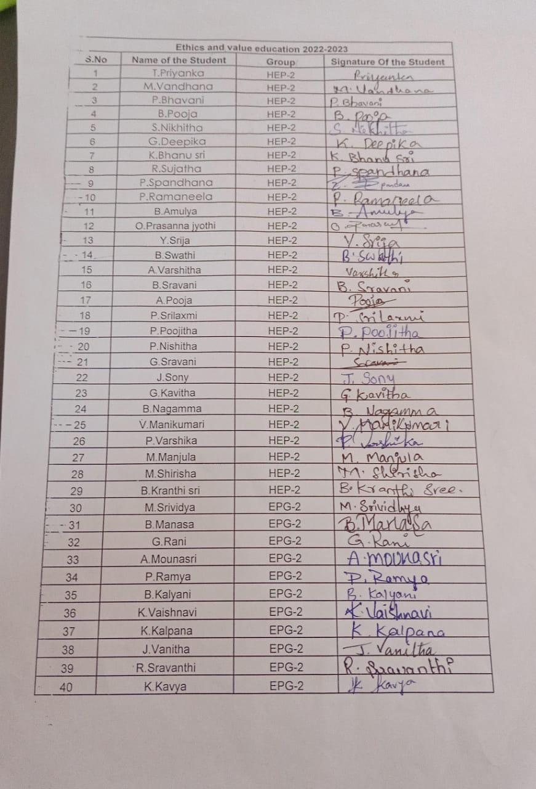

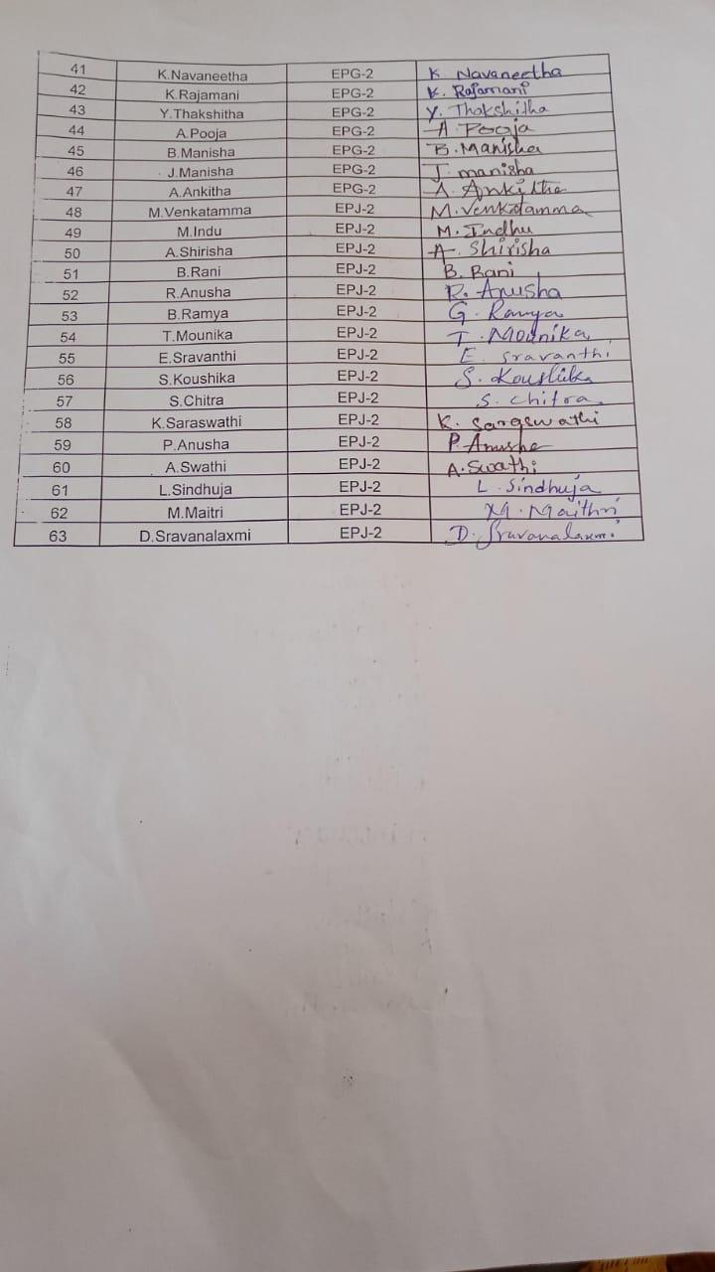

**OFFICE OF THE PRINCIPAL**

**TELANGANA SOCIAL WELFARE RESIDENTIAL DEGREE**

**& PG COLLEGE FOR WOMEN IBRAHIMPATNAM**

**AT ANKUSHAPUR**

**College Code: 61527 OU College Code : 2814**

**Dr H Radhika *Mcom, MBA, NET, SET, Ph.D***

**E-mail:prl-rdc-ibpm-swrs@telangana.gov.in**

**PRINCIPAL Mobile No.: 9121004526**

Girl-Boss 2022-2023

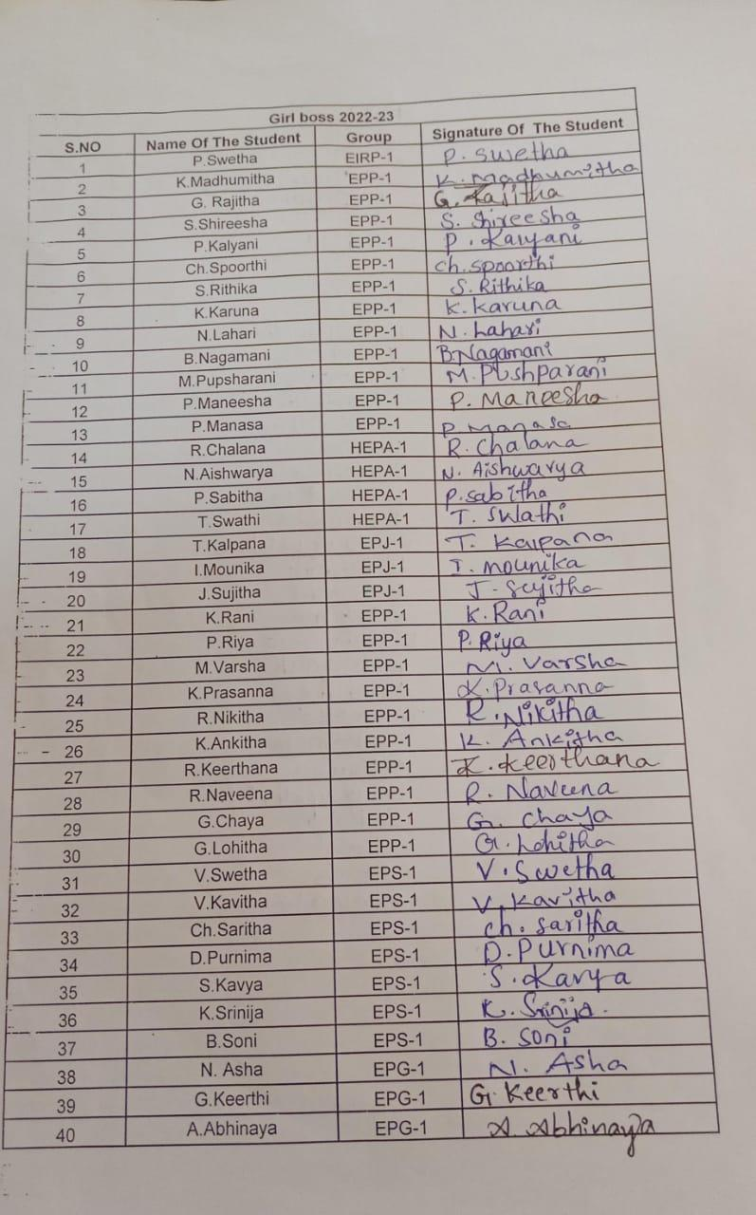

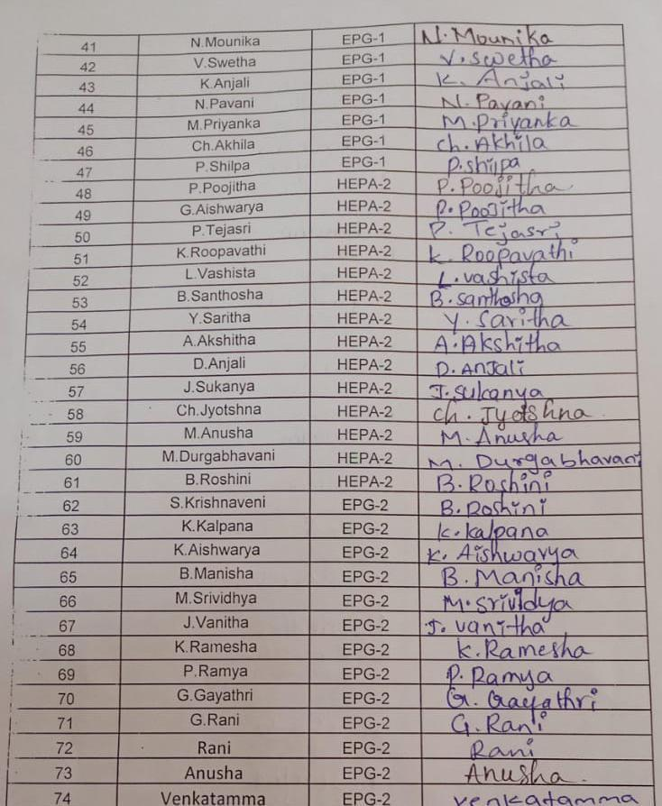

GIRL BOSS ATTENDANCE -2022

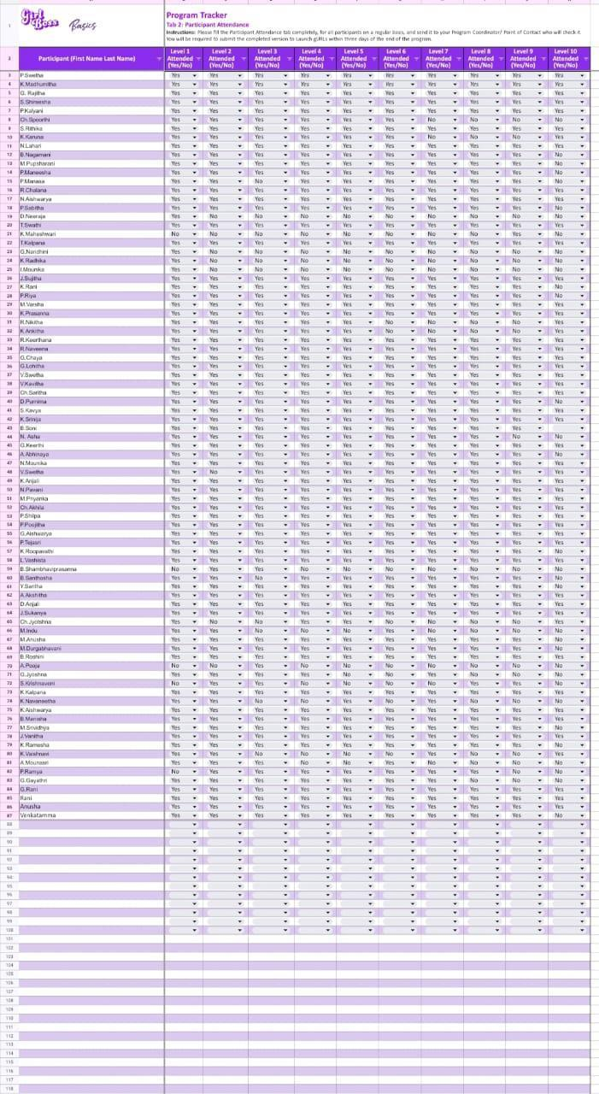

**OFFICE OF THE PRINCIPAL**

**TELANGANA SOCIAL WELFARE RESIDENTIAL DEGREE**

**& PG COLLEGE FOR WOMEN IBRAHIMPATNAM**

**AT ANKUSHAPUR**

**College Code: 61527 OU College Code : 2814**

**Dr H Radhika *Mcom, MBA, NET, SET, Ph.D***

**E-mail:prl-rdc-ibpm-swrs@telangana.gov.in**

**PRINCIPAL Mobile No.: 9121004526**

**Certificate course on**

**NGO MANAGEMENT**

From 1-11-2022 to 17-11-2022

Organised By:

G.Soujanya,

Department of Sociology

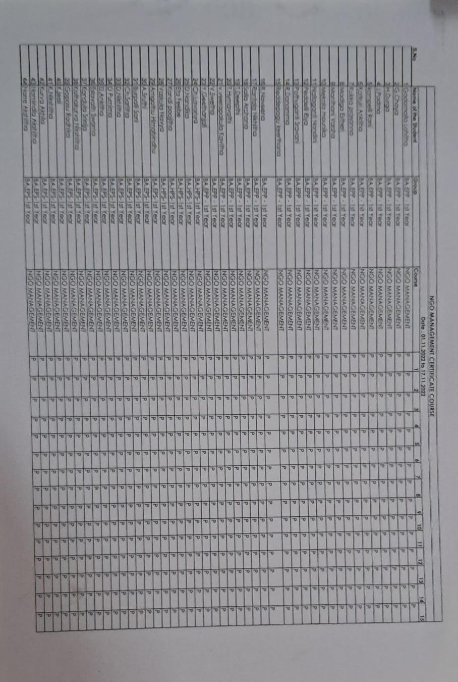

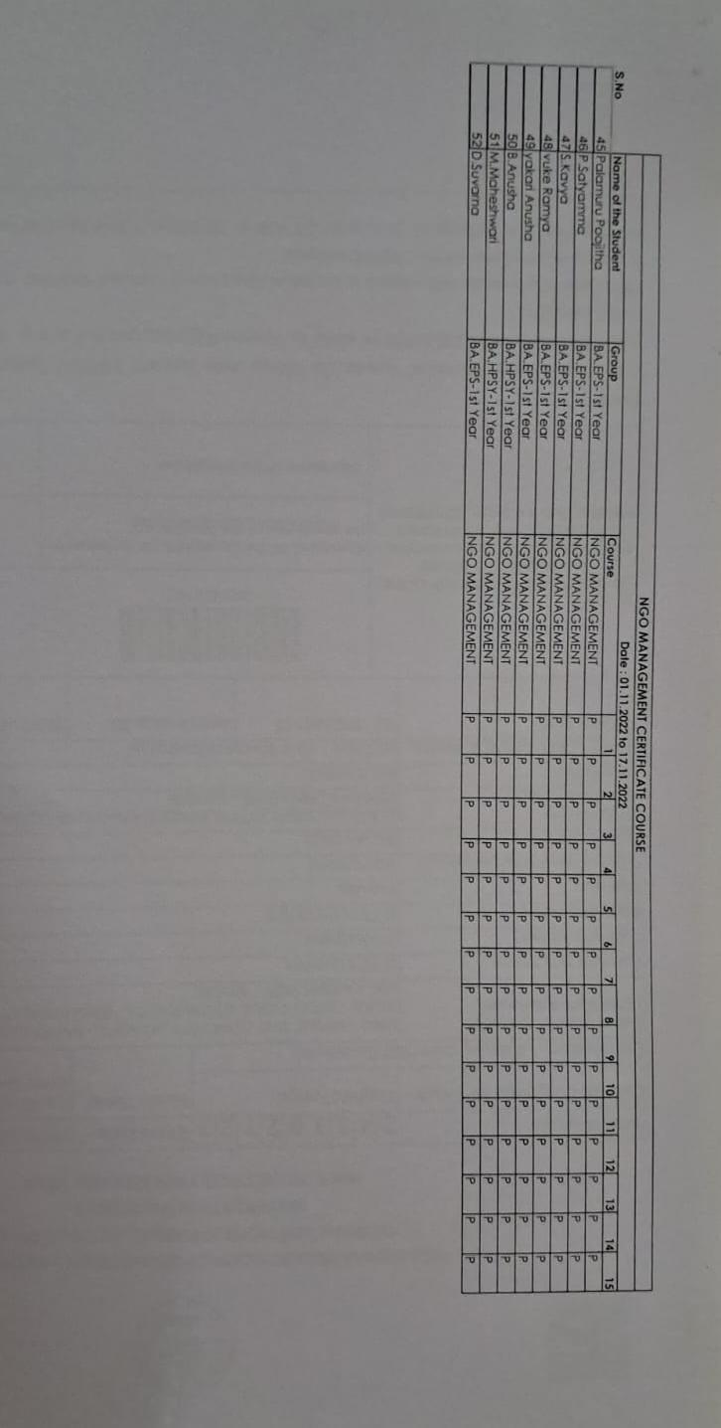

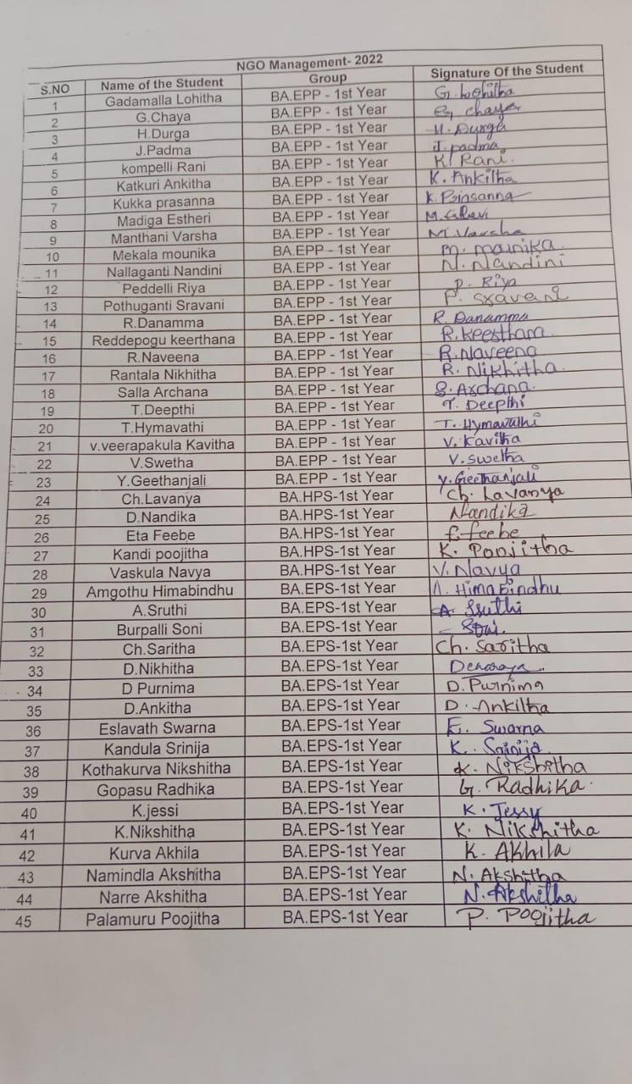

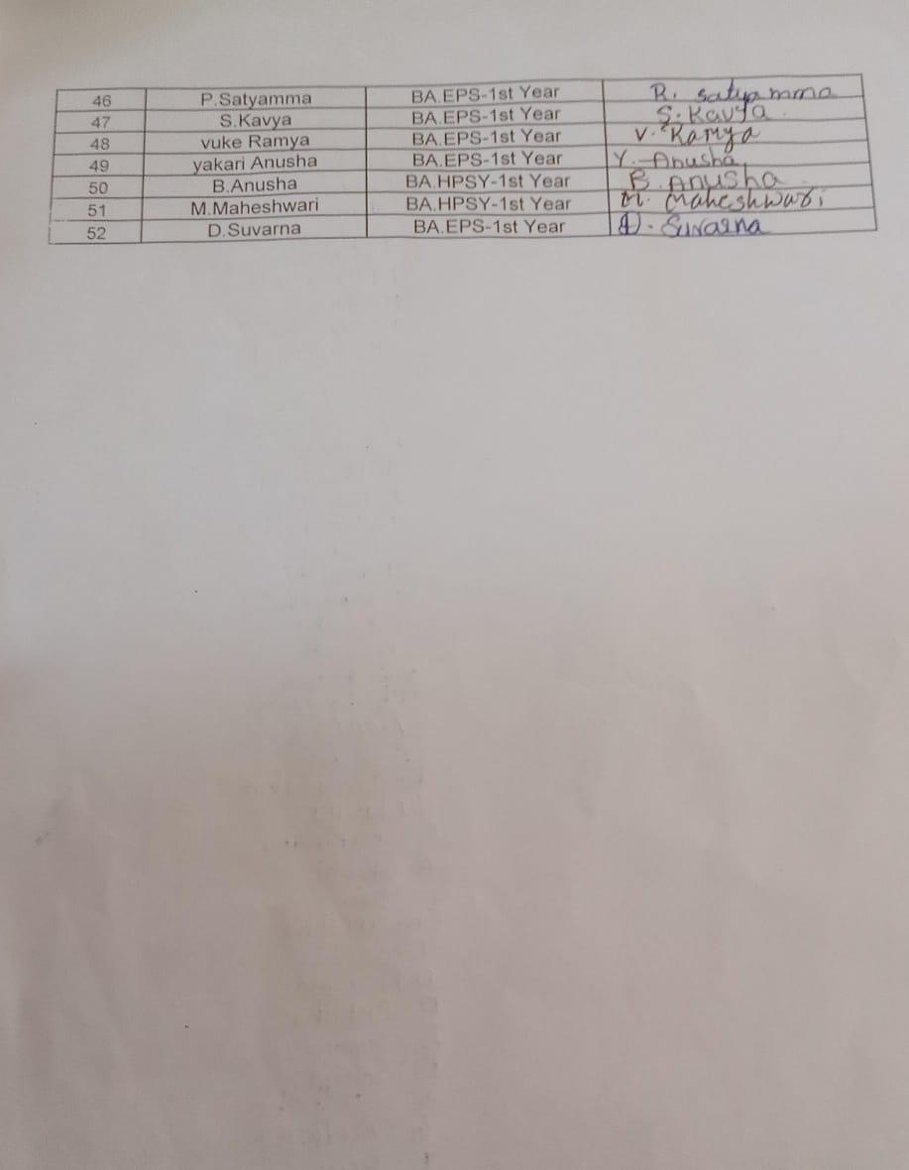

**OFFICE OF THE PRINCIPAL**

**TELANGANA SOCIAL WELFARE RESIDENTIAL DEGREE**

**& PG COLLEGE FOR WOMEN IBRAHIMPATNAM**

**AT ANKUSHAPUR**

**College Code: 61527 OU College Code : 2814**

**Dr H Radhika *Mcom, MBA, NET, SET, Ph.D***

**E-mail:prl-rdc-ibpm-swrs@telangana.gov.in**

**PRINCIPAL Mobile No.: 9121004526**

**Certificate course on**

**INFORMATION TECHNOLOGY**

From 05-12-2022 to 21-12-2022

