**TELANGANA SOCIAL WELFARE RESIDENTIAL DEGREE**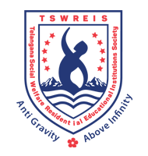

**& PG COLLEGE FOR WOMEN IBRAHIMPATNAM-501301**

**(Affiliated to Osmania University)**

**E-mail:prl-rdc-ibpm-swrs@telangana.gov.in**

**Website:** [**http://rdcwibrahimpatnam.tswreis.ac.in/**](http://rdcwibrahimpatnam.tswreis.ac.in/)

**Action Taken Report :**

**A.Y.: 2019-2020**

**Action Taken :**

* The Principal congratulated the Teaching staff who secures Excellent Score.
* The Principal advised the faculty who scored good marks to improve to excellent score.