**OFFICE OF THE PRINCIPAL**

TELANGANA SOCIAL WELFARE RESIDENTIAL DEGREE & PG COLLEGE FOR WOMEN IBRAHIMPATNAM

AT ANKUSHAPUR

College Code: 61527 OU College Code : 2814

**Dr H Radhika *Mcom, MBA, NET, SET, Ph.D***

**E-mail:prl-rdc-ibpm-**

[**swrs@telangana.gov.in**](mailto:swrs@telangana.gov.in)

**PRINCIPAL Mobile No.: 9121004526**

|  |  |  |  |  |  |  |  |  |  |
| --- | --- | --- | --- | --- | --- | --- | --- | --- | --- |
| ACADEM IC YEAR | GROUP S | GROUP S | GROUP S | GROUP S | GROUP S | GROUP S | GROUP S | GROUP S | GROUP S |
| 2017-18 | HEP | HEPA |  |  |  |  |  |  |  |
| 2018-19 | HEP | HEPA | EPG | EPJ |  |  |  |  |  |
| 2019-20 | HEP | HEPA | EPG | EPJ | EPP | EPS |  |  |  |
| 2020-21 | HEP | HEPA | EPG | EPJ | EPP | EPS |  |  |  |
| 2021-22 | HEP | HEPA | EPG | EPJ | EPP |  |  |  |  |
| 2022-23 | HEP | HEPA | EPG | EPJ | EPP | EIRP | HPYS | HPS |  |
| 2023-24 | HEP | HEPA | EPG | EPJ | EPP | EIRP | HPYS | HPS |  |



**OFFICE OF THE PRINCIPAL**

TELANGANA SOCIAL WELFARE RESIDENTIAL DEGREE & PG COLLEGE FOR WOMEN IBRAHIMPATNAM

AT ANKUSHAPUR

College Code: 61527 OU College Code : 2814

**Dr H Radhika *Mcom, MBA, NET, SET, Ph.D***

**E-mail:prl-rdc-ibpm-**

[**swrs@telangana.gov.in**](mailto:swrs@telangana.gov.in)

**PRINCIPAL Mobile No.: 9121004526**

------------------------------------------------------------------------------------------------------------------------------------------------------------------

AFFILIATION COPIES

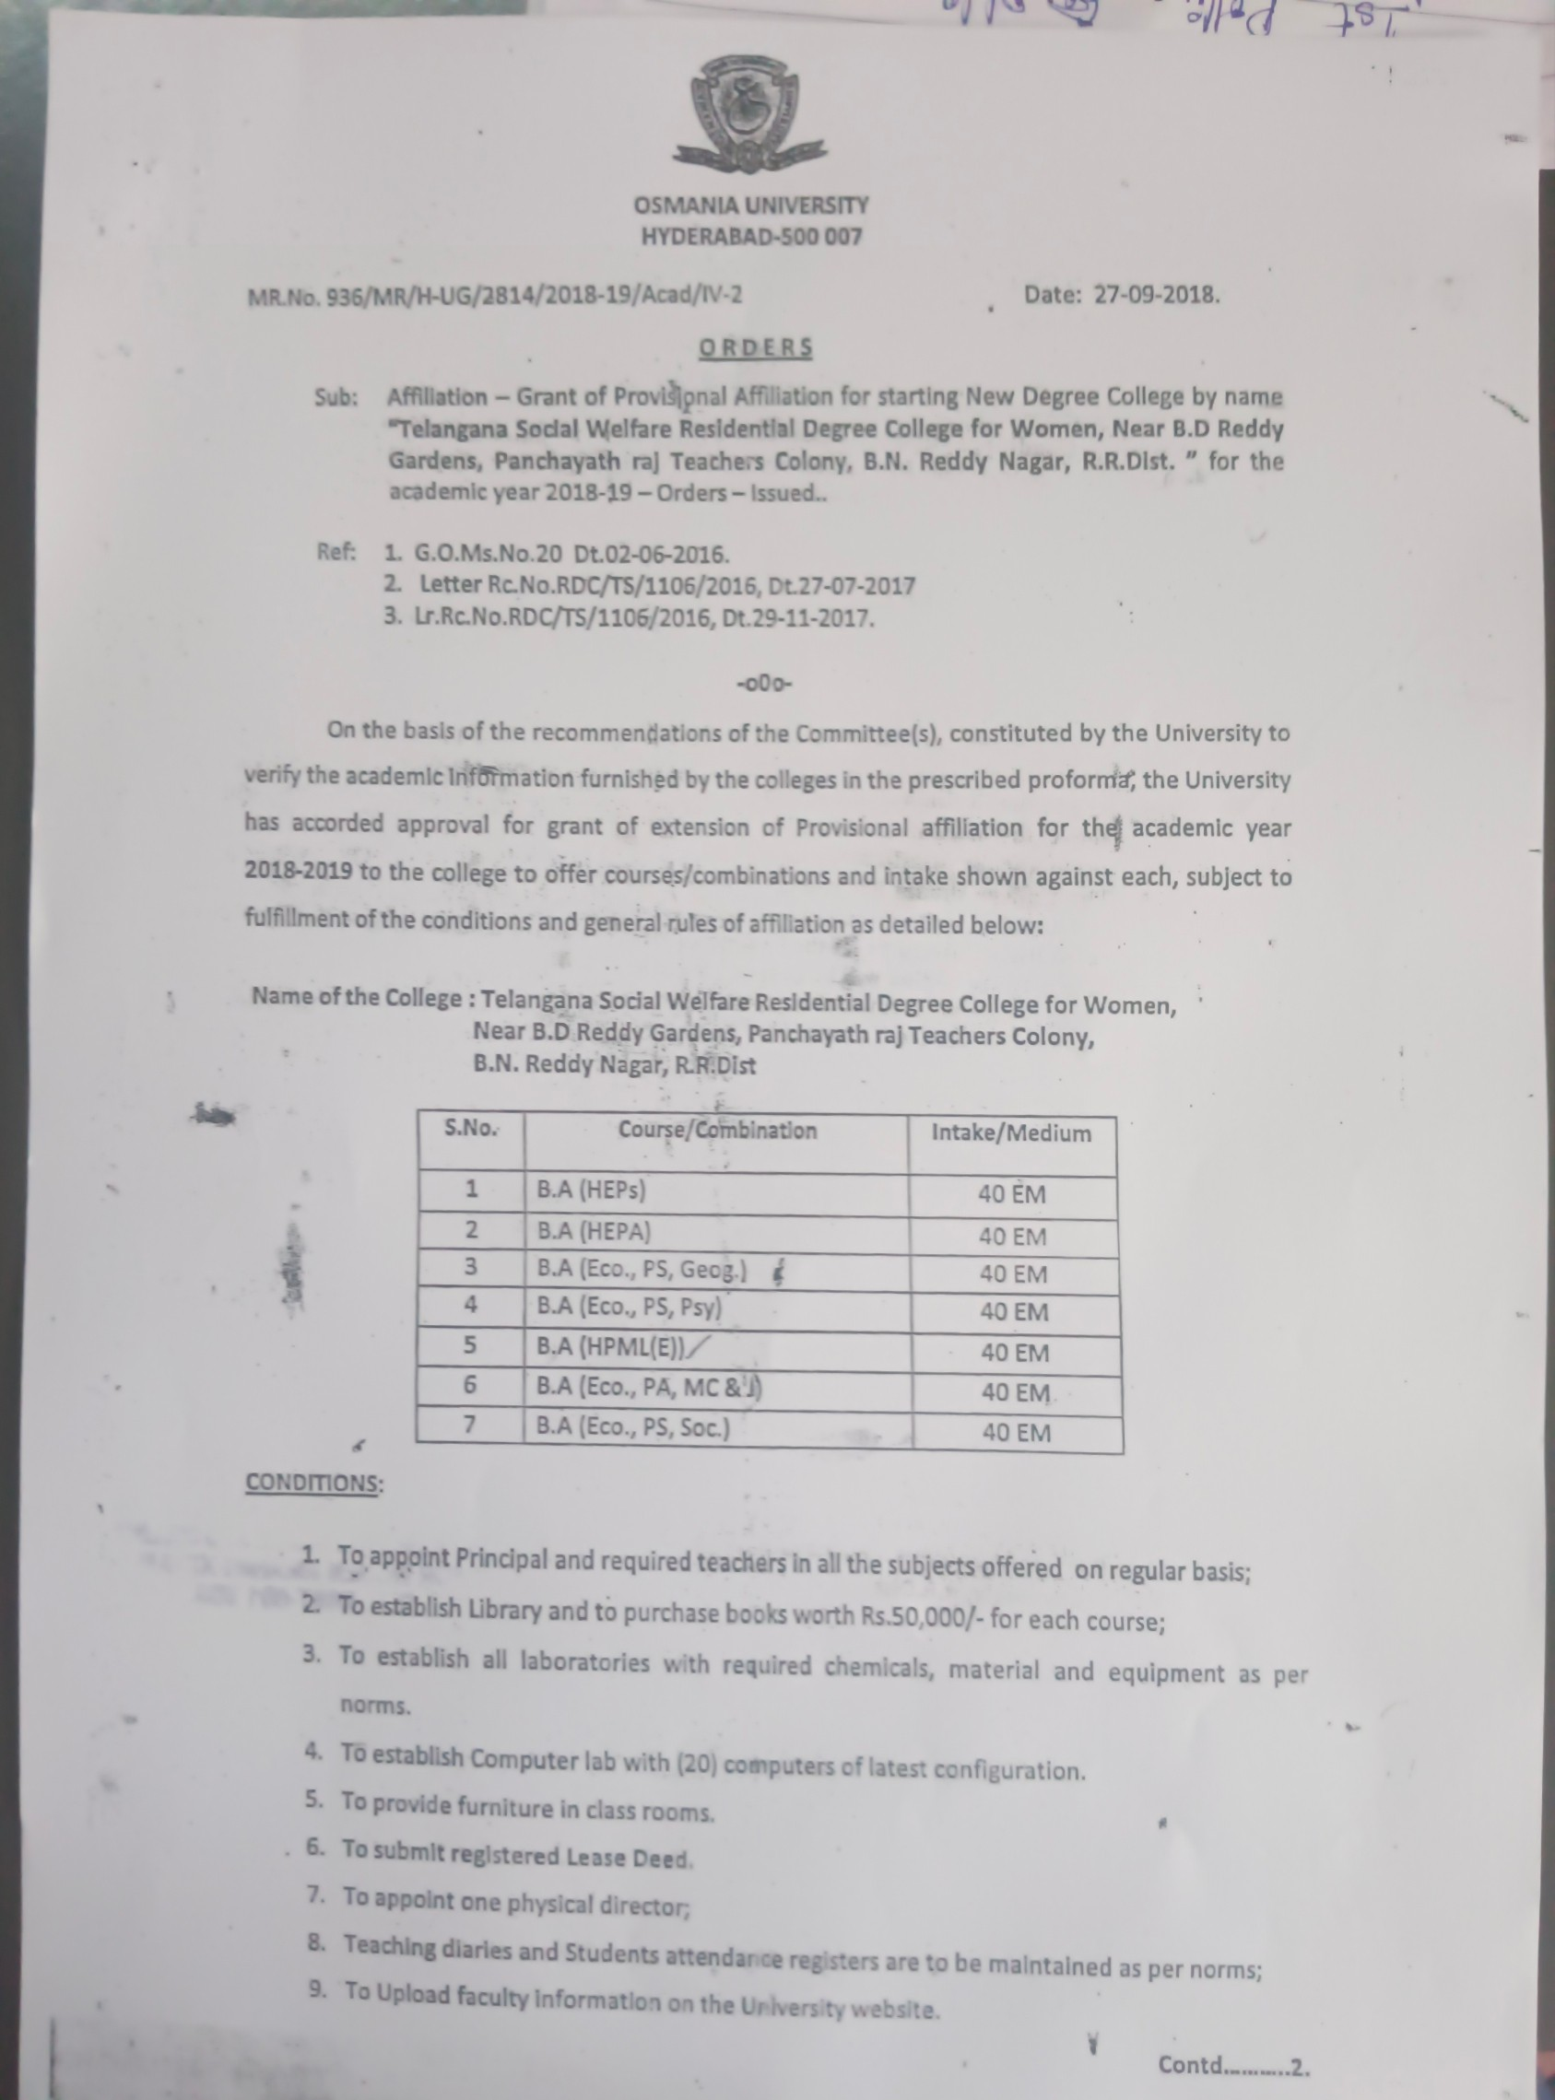

1

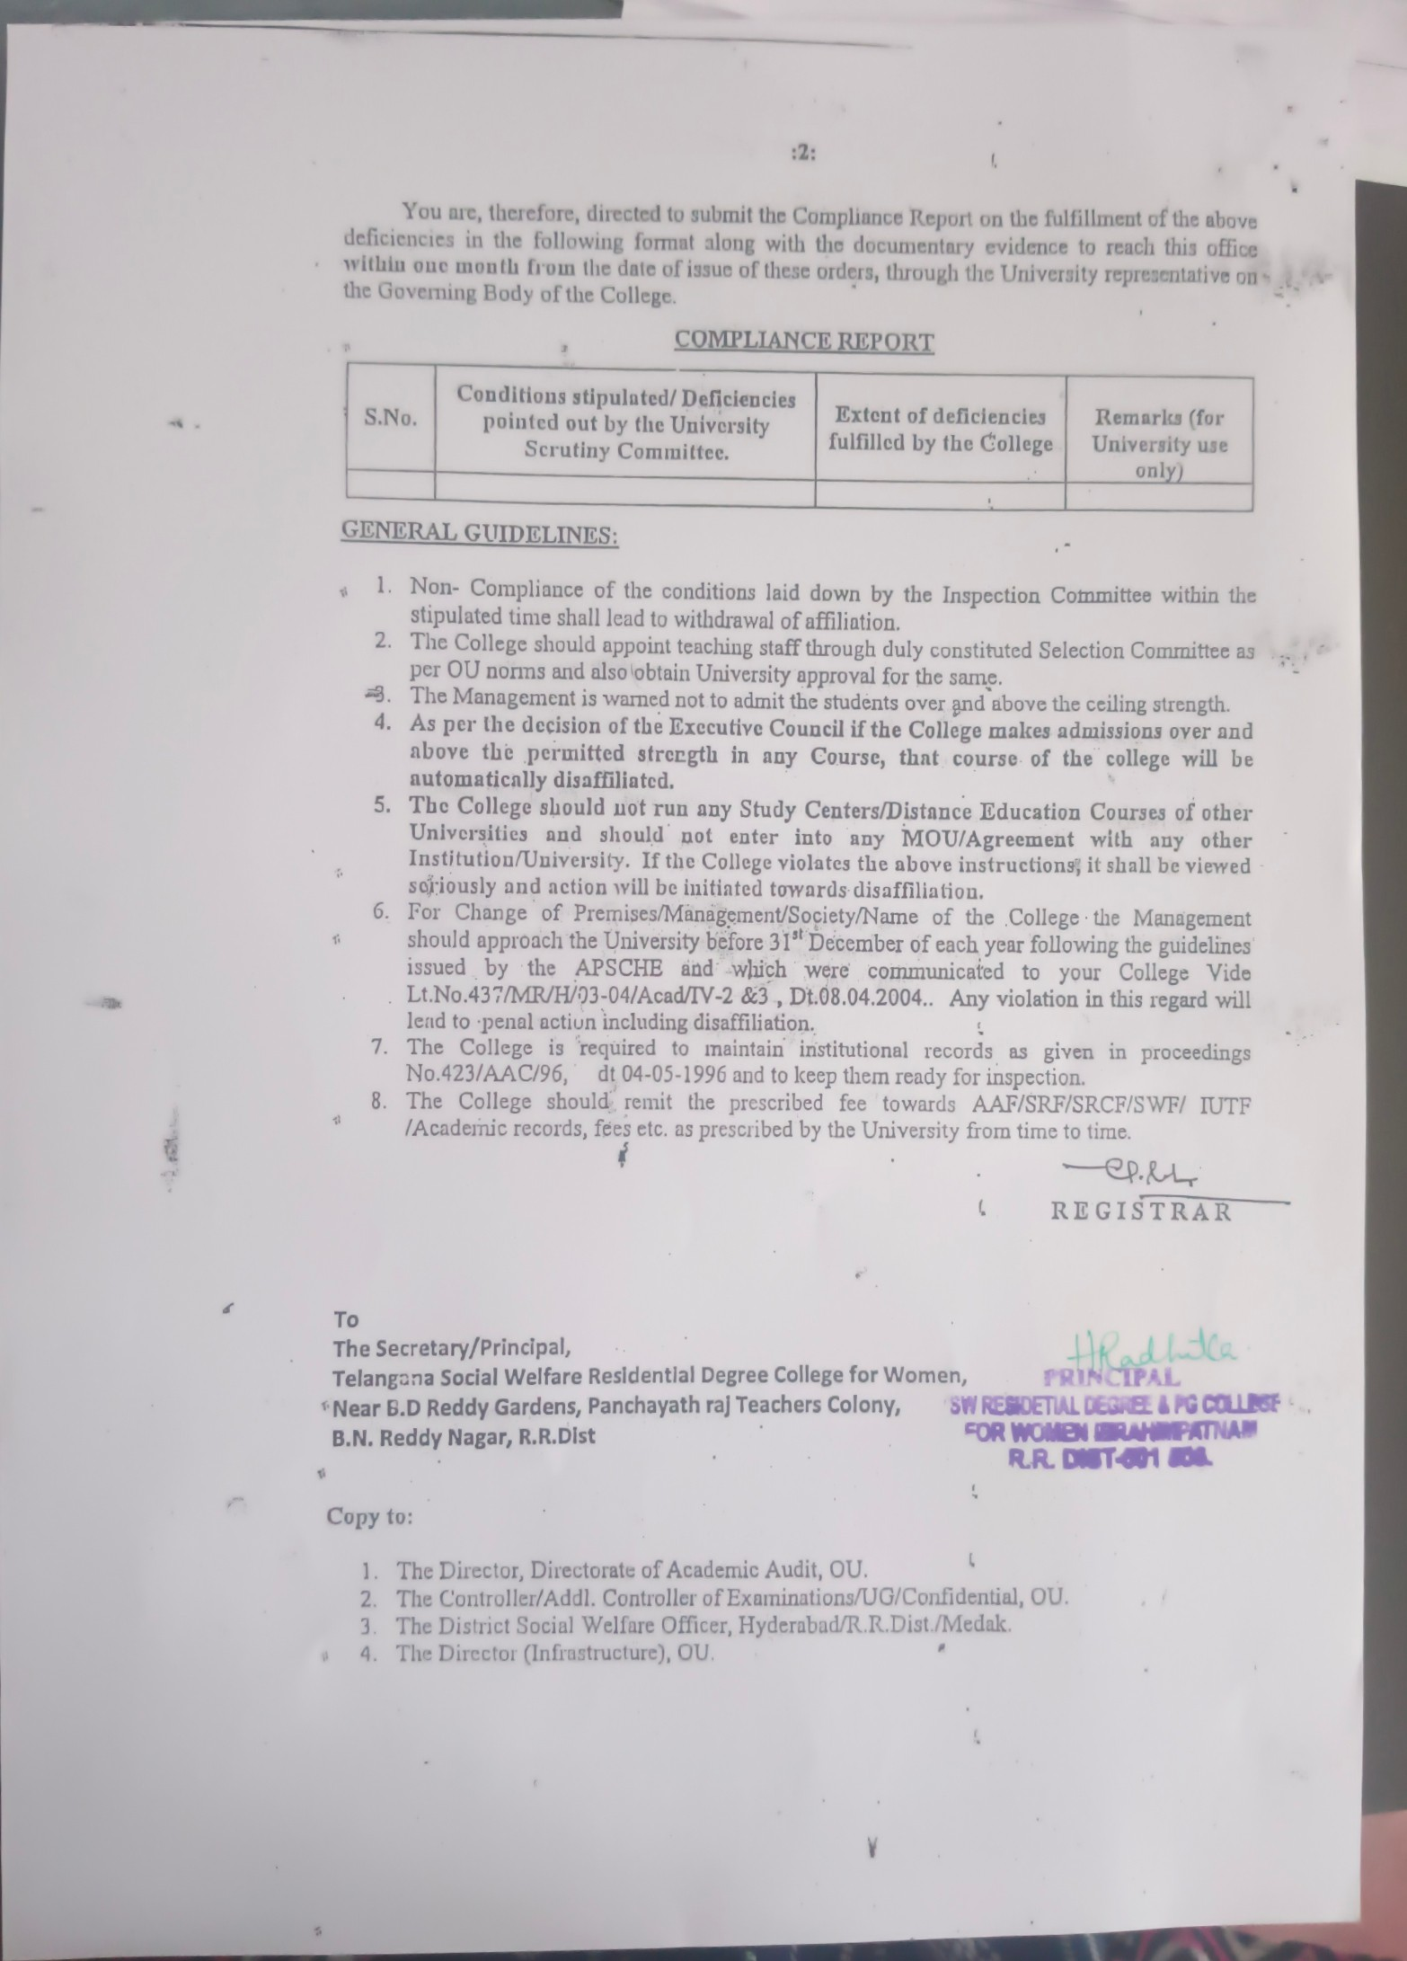

2

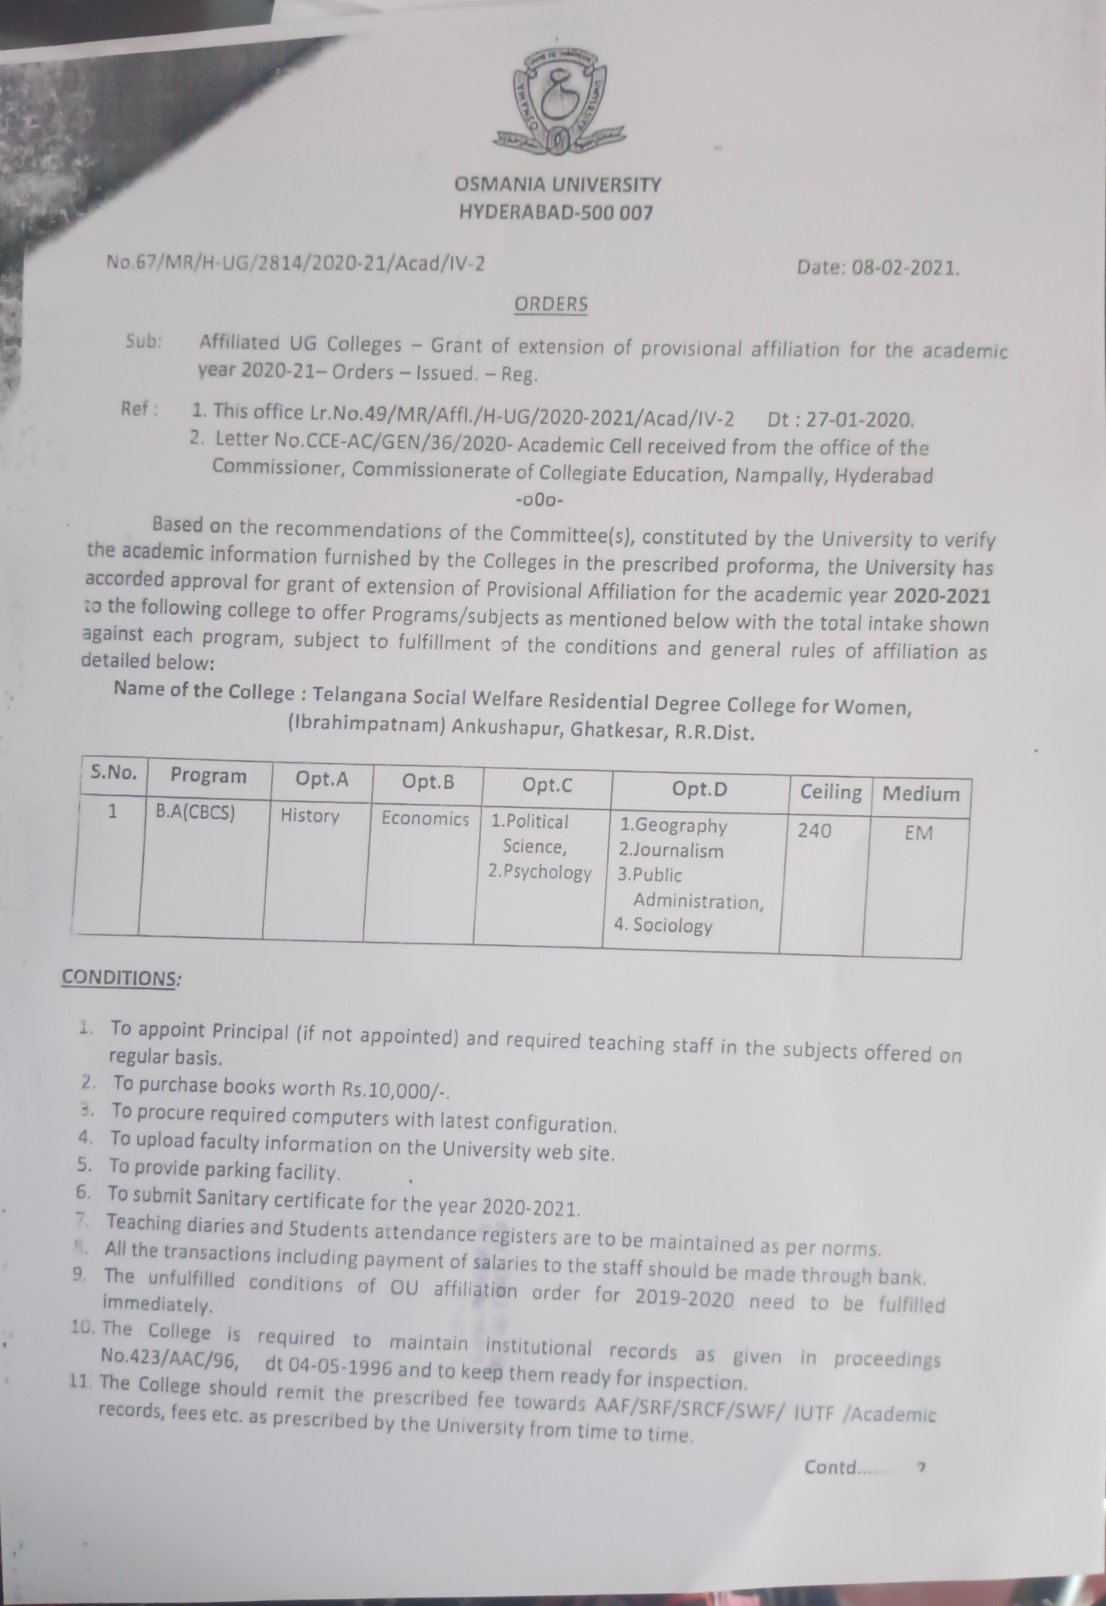

3

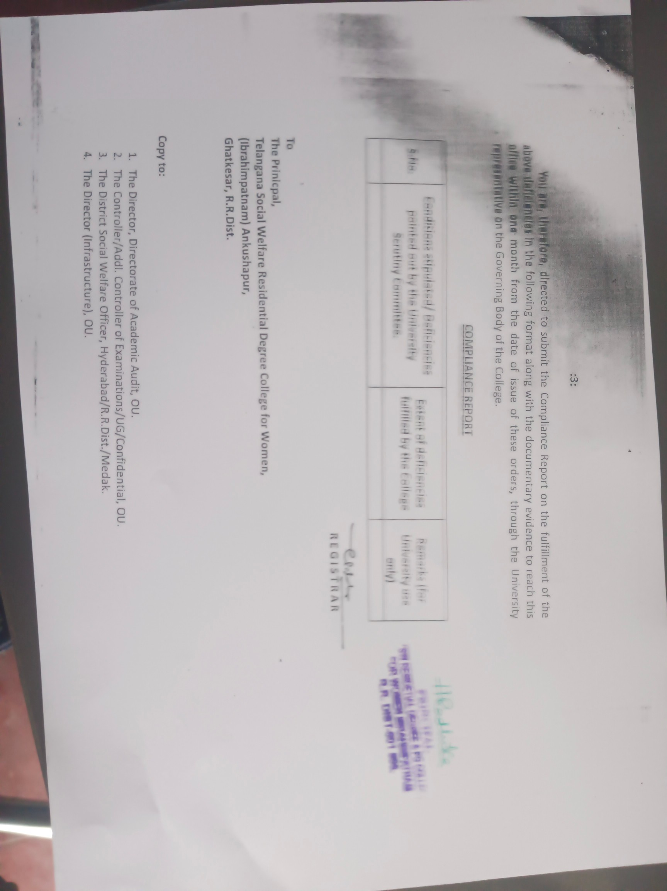

4

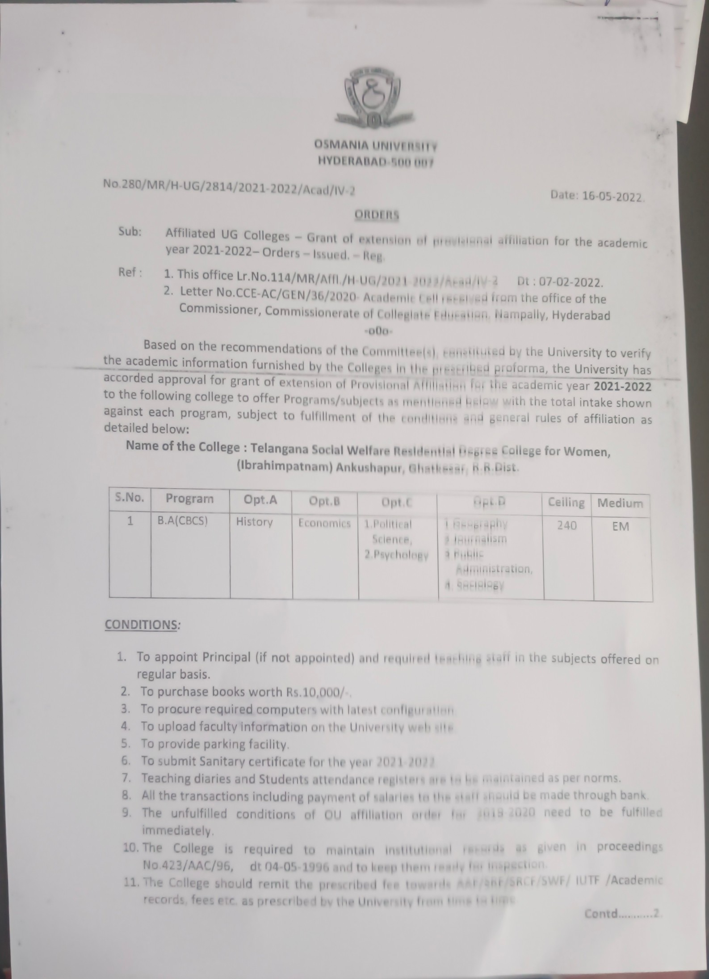

5

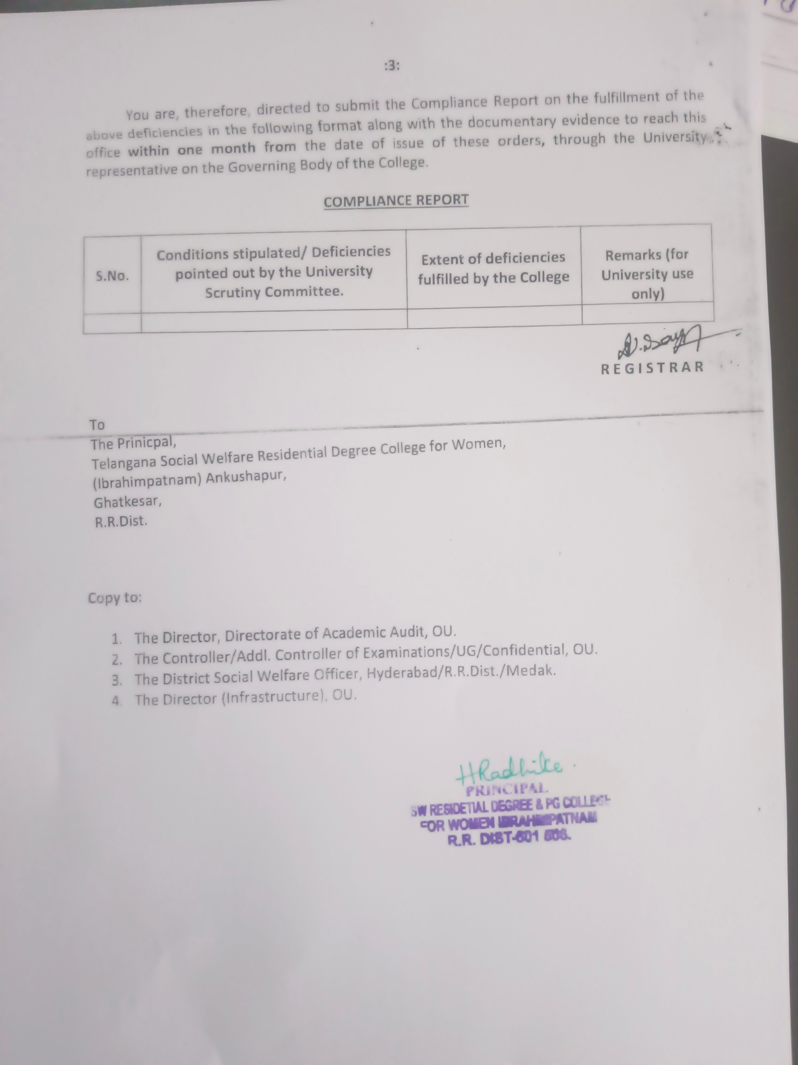

6

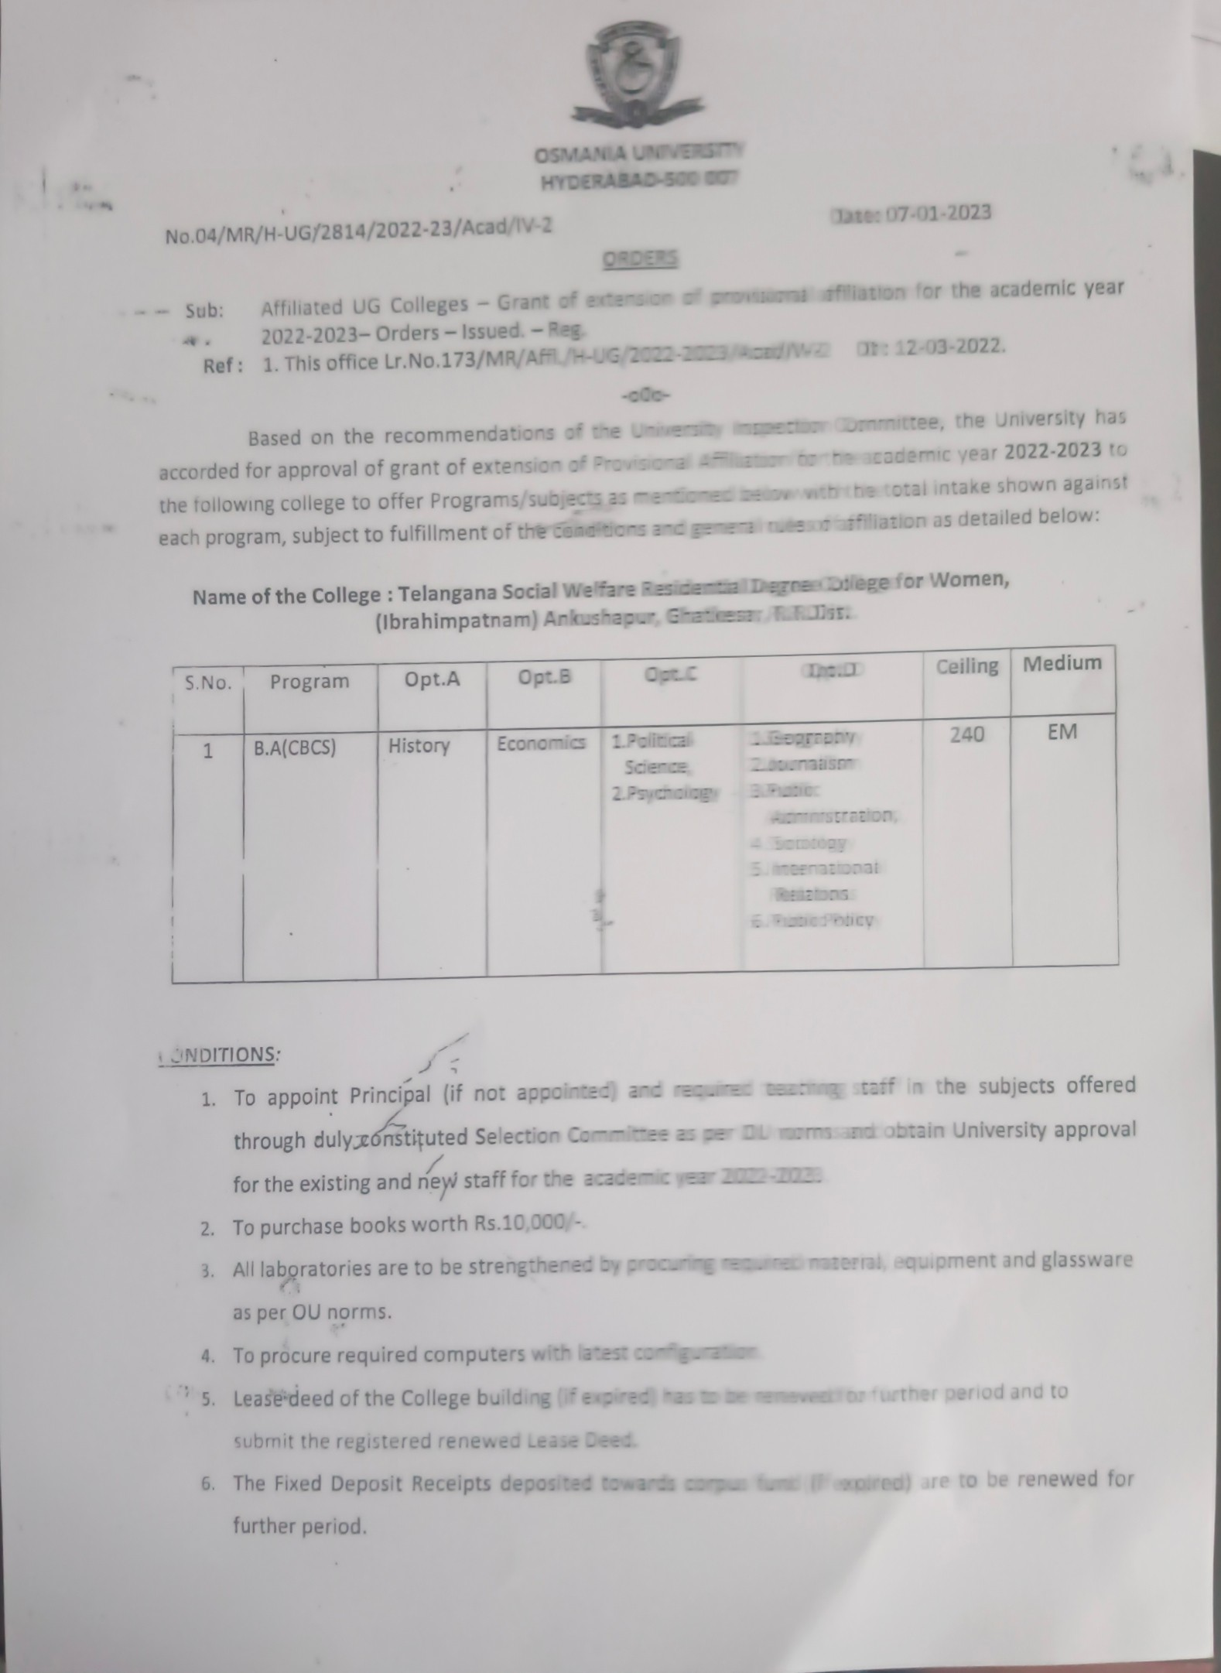

7

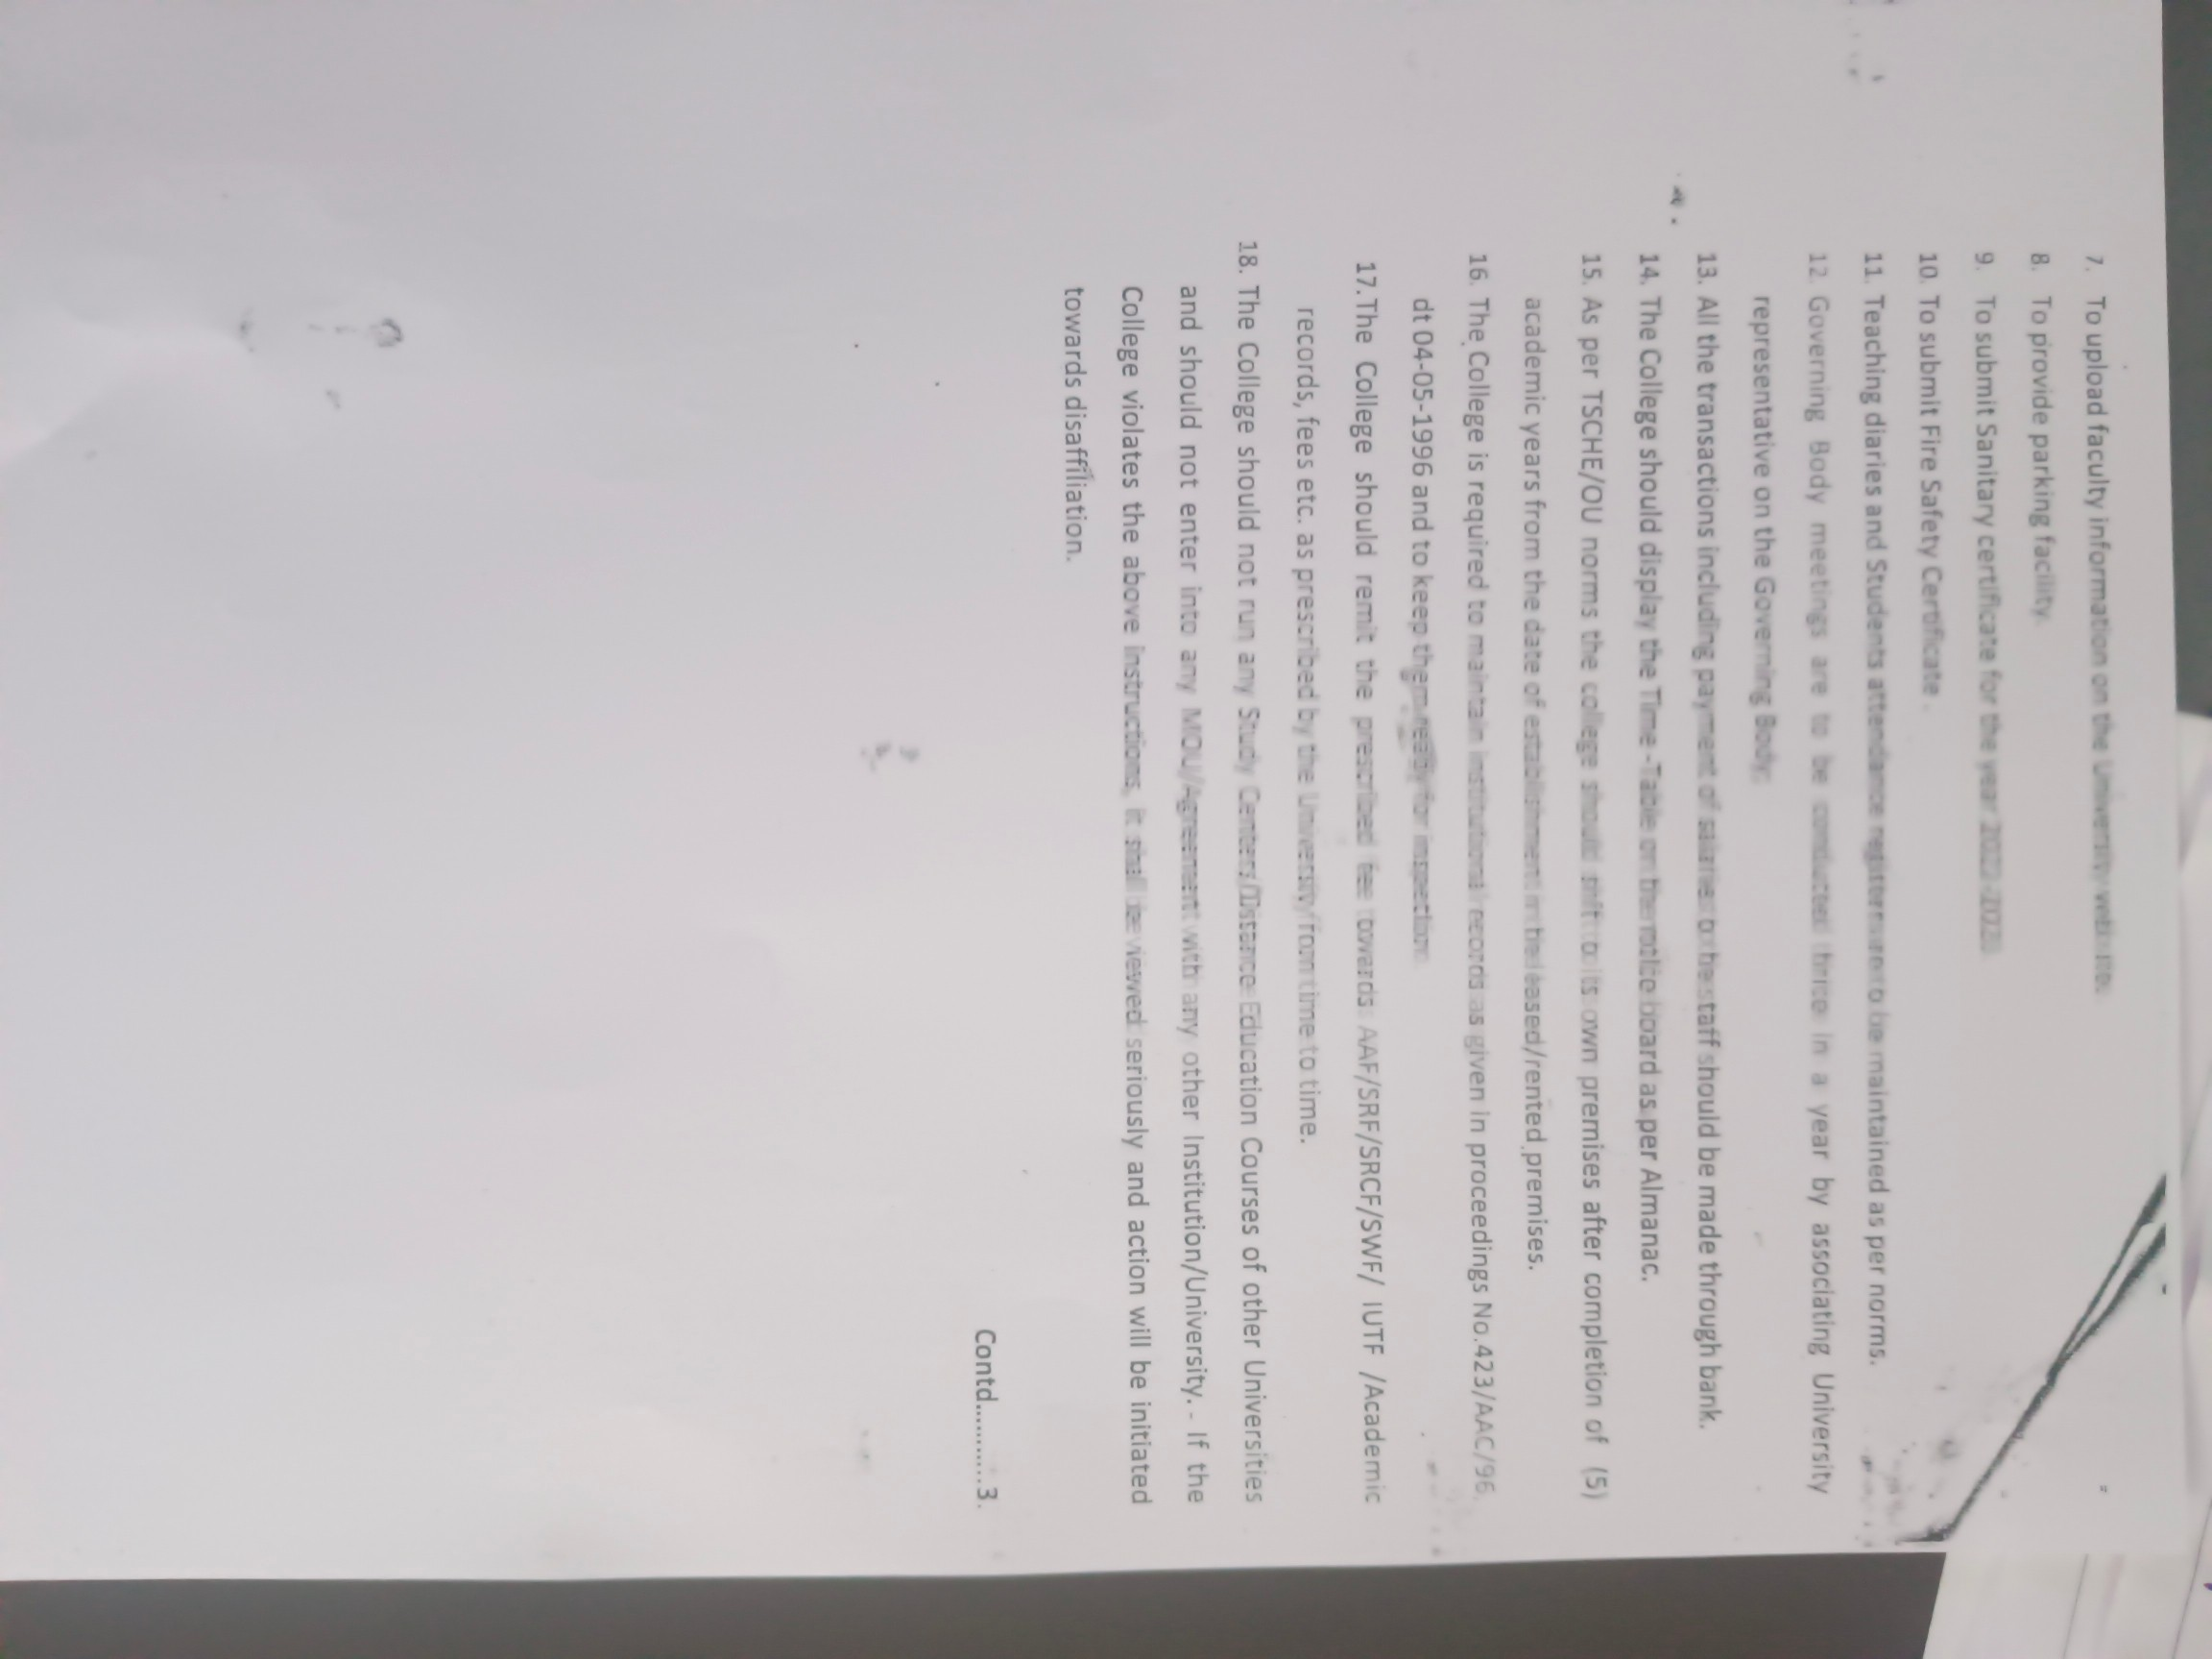

8

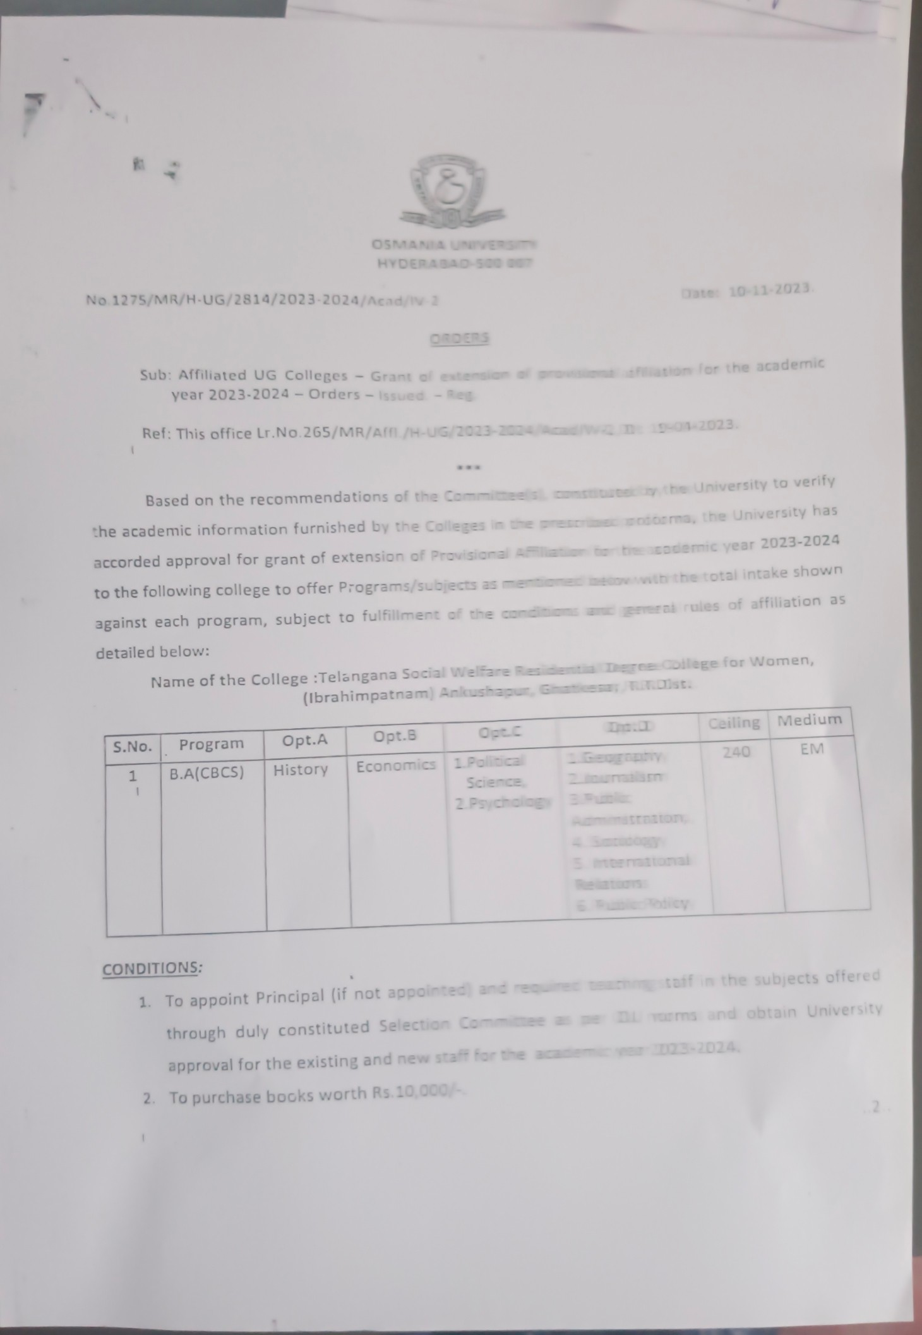

9

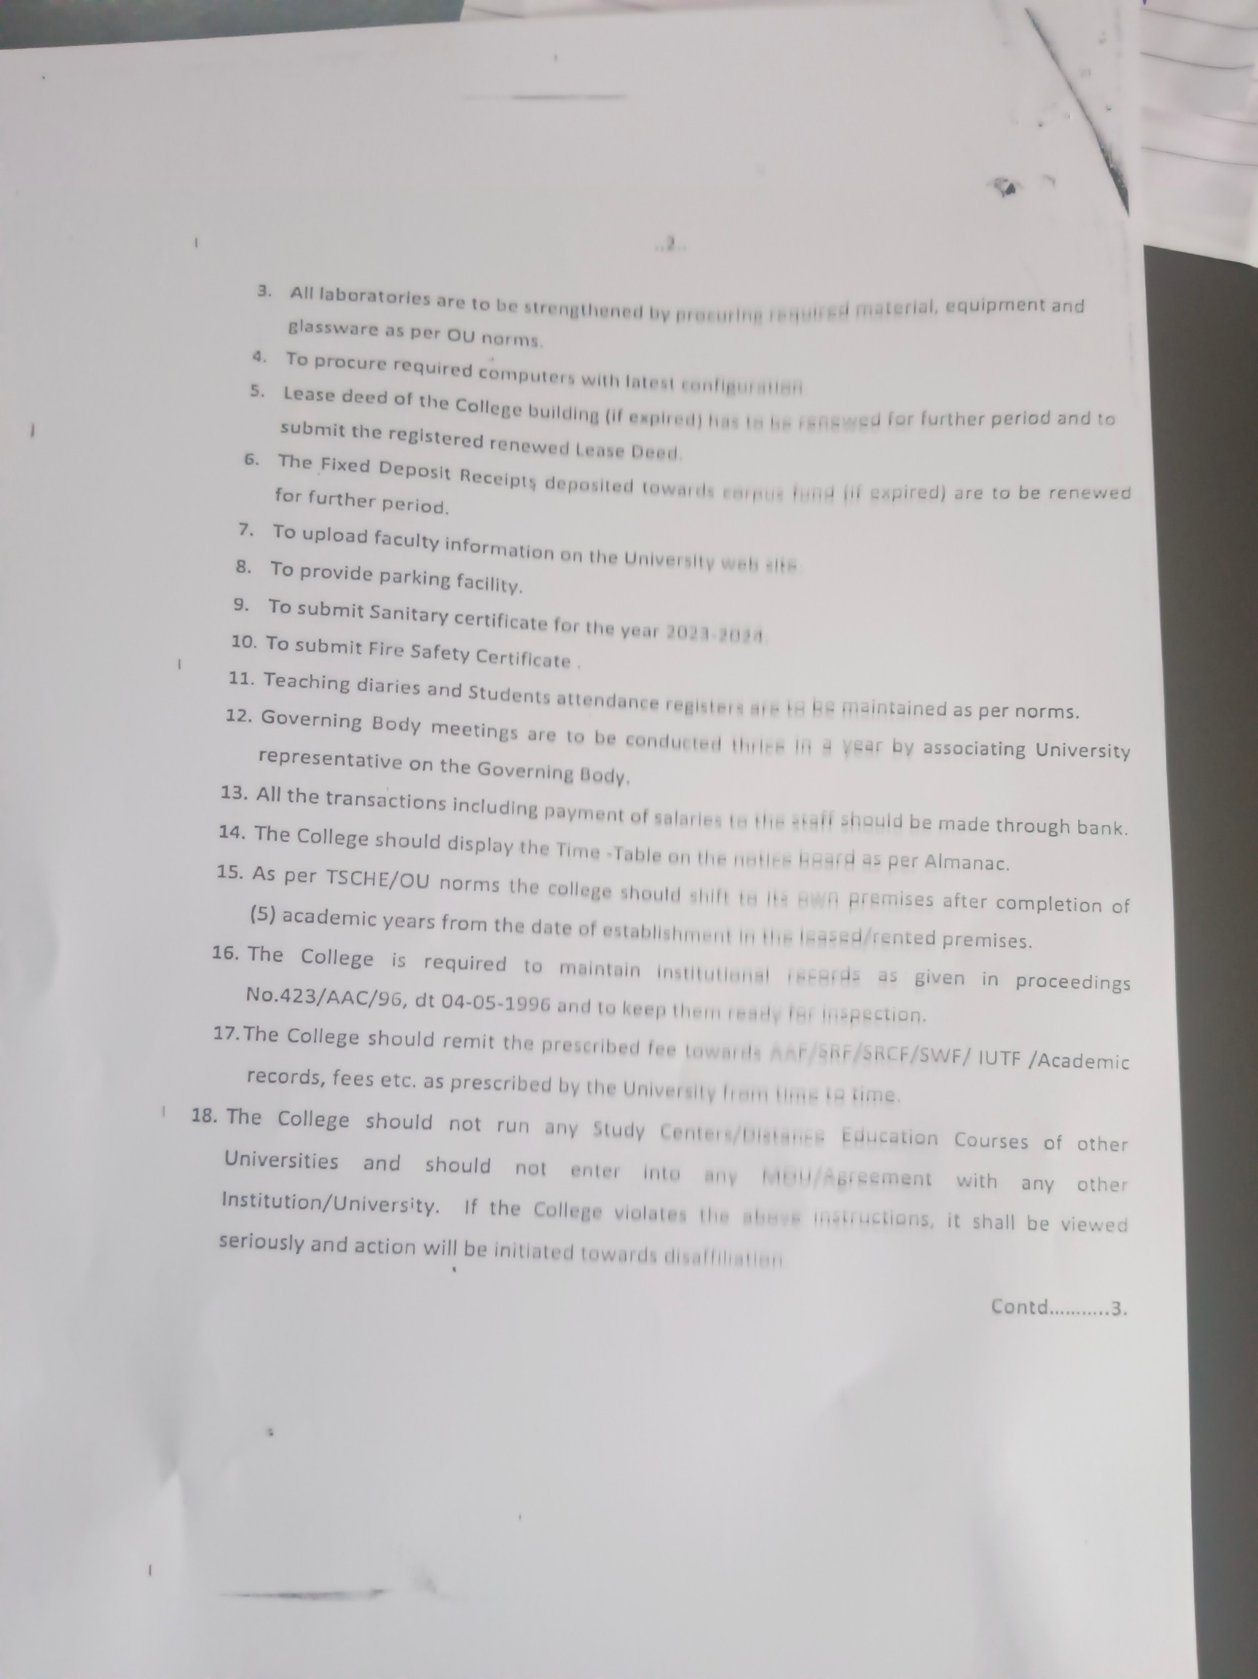

10

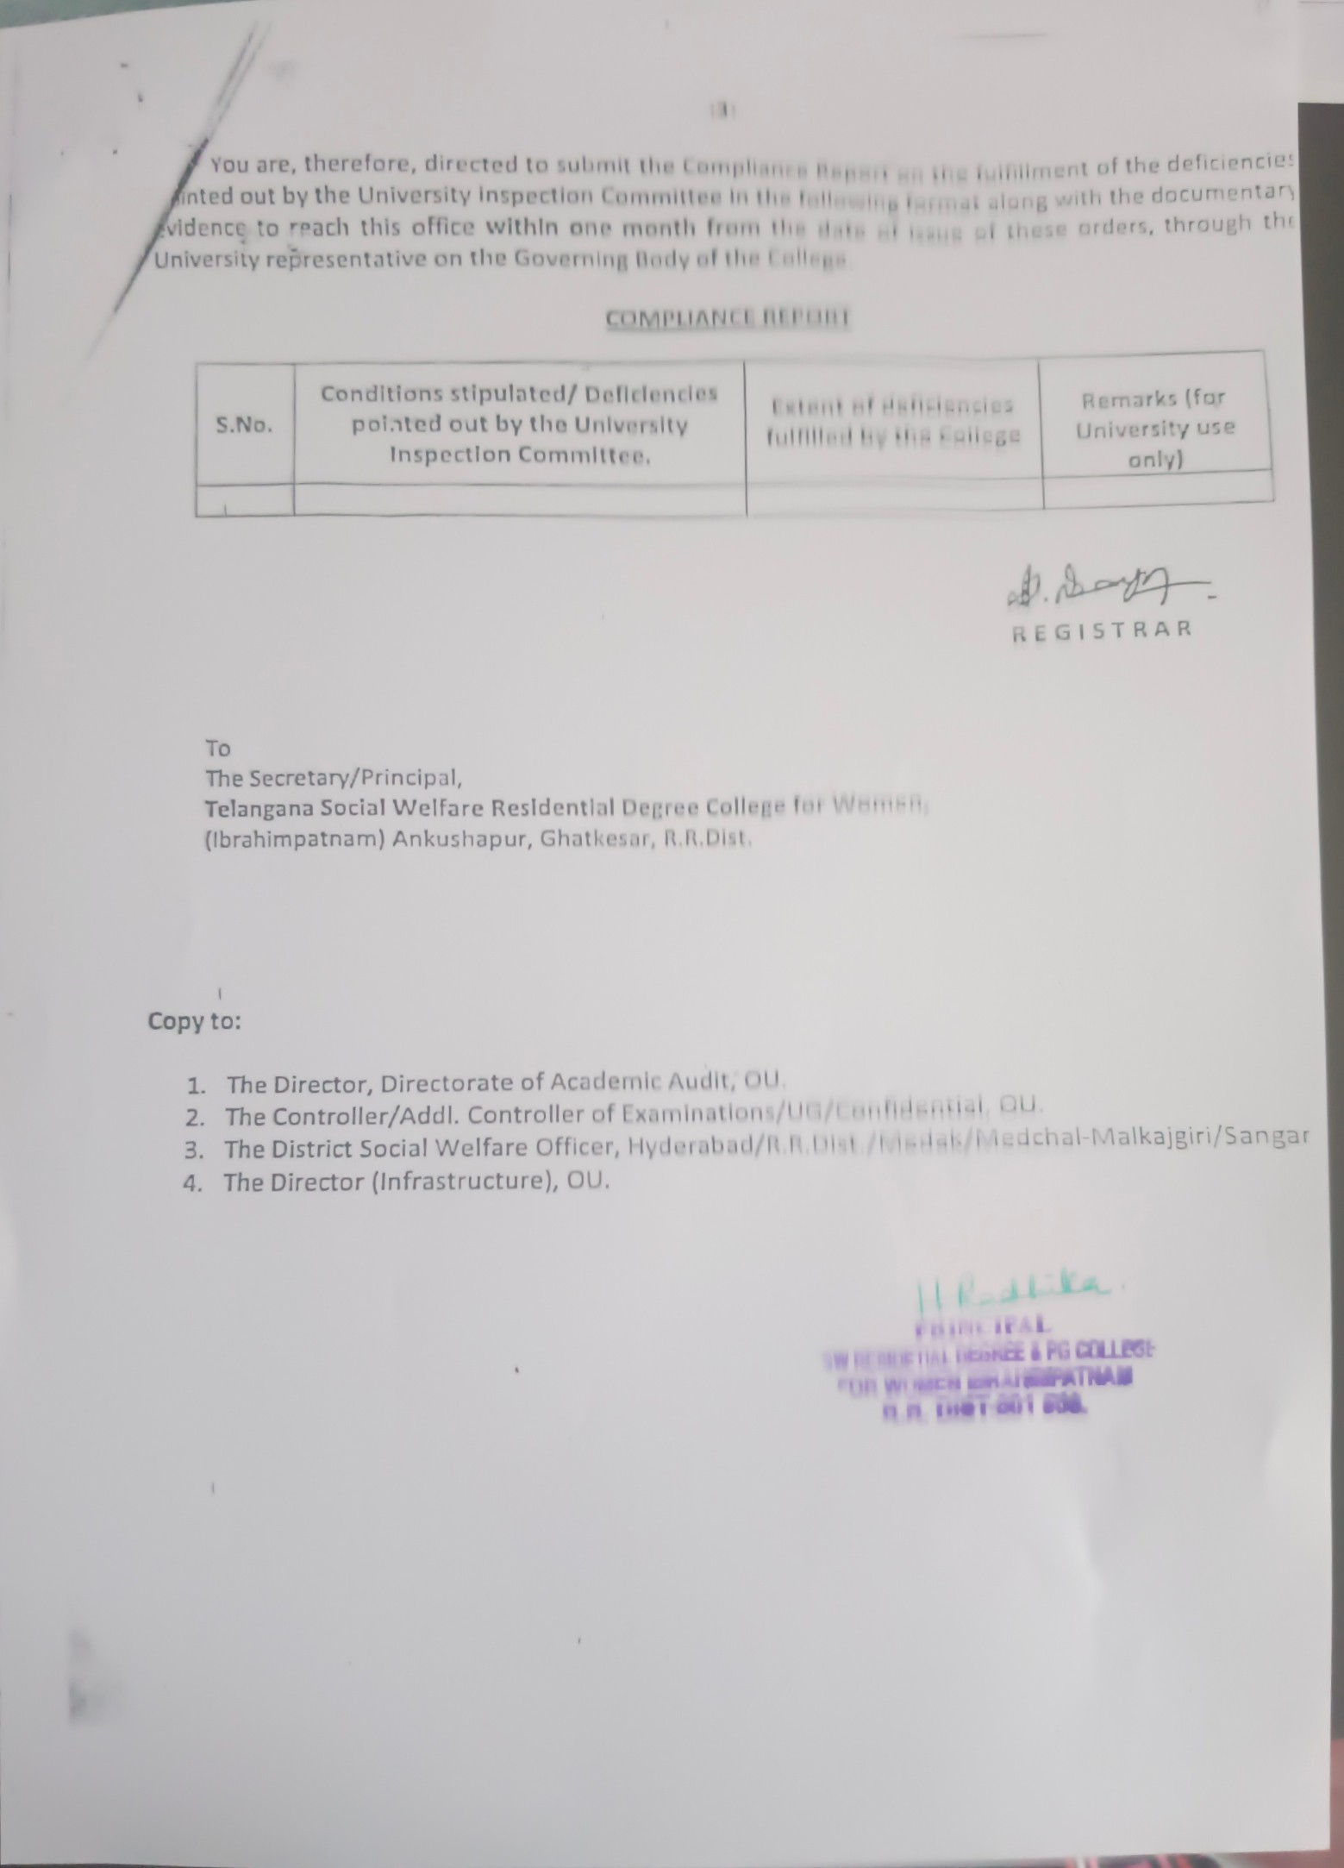

11