Institution has initiated the Gender Audit and measures for the promotion of gender equity during the last five years.

**SAFETY AND SECURITY**: The college is committed to providing a safe and secure academic environment to women students and employees. The campus is fully protected with the compound walls and security guard at the main gate during working hours. The ID cards are issued to all the staff and students.

* The premises and classrooms of the college are under continuous **CCTV surveillance** to ensure the safety and security of the students. The footage of CCTV is checked as and when necessary.

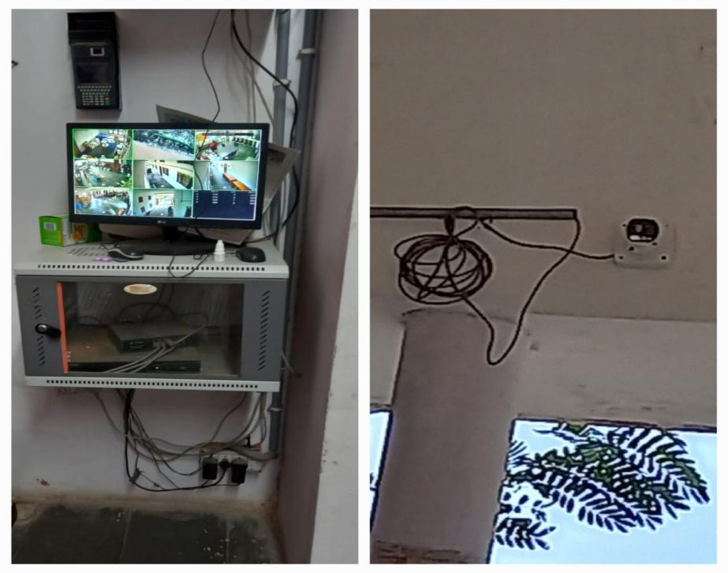

* **The** **Internal Complaints Committee (ICC)** has been constituted in the college. A complaint box is placed in the college to enable the students to drop their letters of grievances/complaints, if any, in the box anonymously. Internal Complaints Committee (ICC) takes follow- up action to redress the grievances on the complaints received.



* **Anti-ragging and disciplinary committee** ensures to maintain discipline in the college and creates a stress-free environment by driving away from the inhibitions whatsoever of the freshers. No incidents of ragging the students have been reported in the last five years.

**The following are the members of the committee:**

1. Chairman - Dr.Radhika(Principal)
2. Vice Chairman – Soujanya(Vice Principal)
3. Member - Dr. K. Vijaya
4. Member - Dr. Padmavathi
5. Member - Dr. Padmamma

7.1.1 Measures initiated by the Institution for the promotion of gender equity and Institutional initiatives to celebrate / organize national and international commemorative days, events and festivals during the last five years.

**Gender Equity in Curriculum:**

In the last five years, students have been studying gender sensitization course as part of their course in SEC(skill Enhancement course) and part of English syllabus of final semester includes gender sensitization through poems and contextual topics such as Third suggestion…

|  |  |
| --- | --- |
| page3image4127109888 | page3image27681520 |

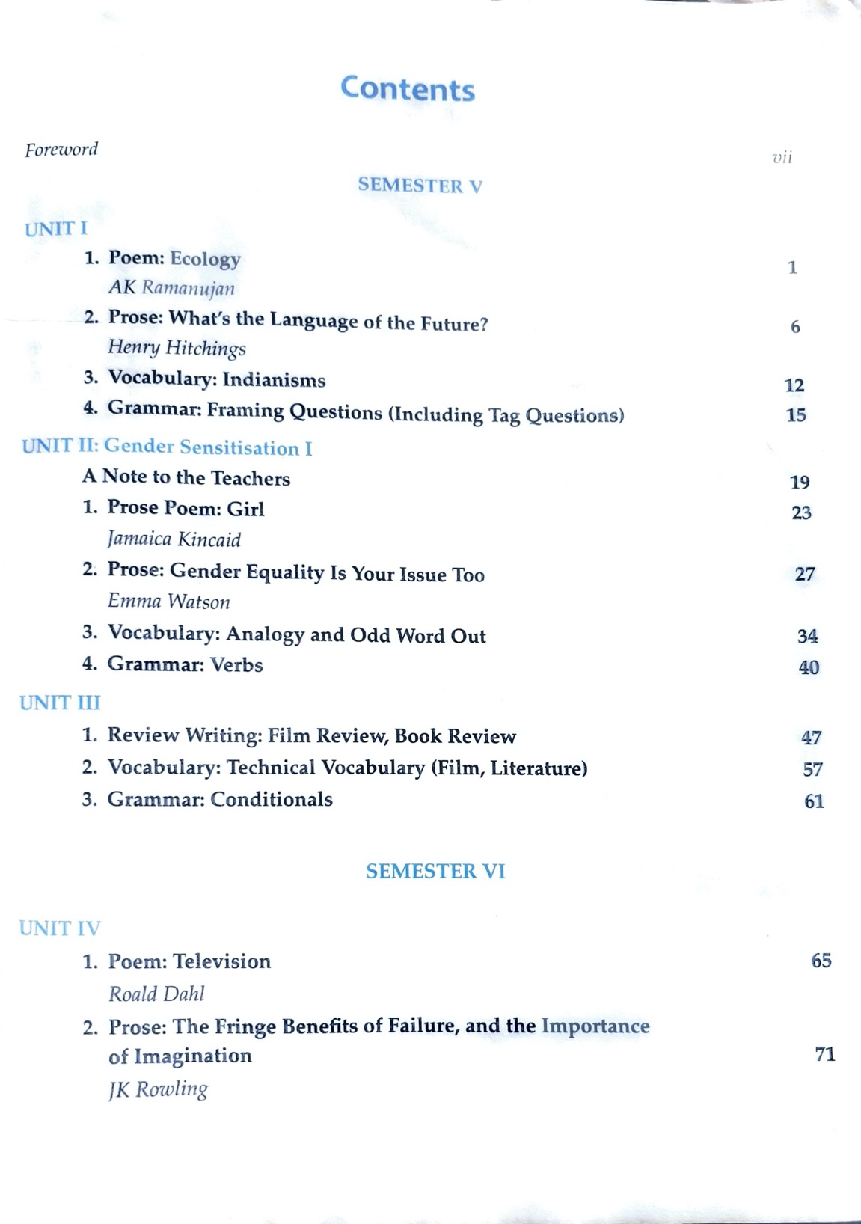

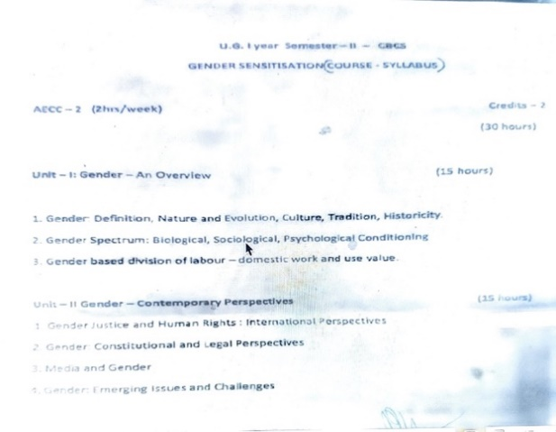

**Student attending sessions on Gender Parity**

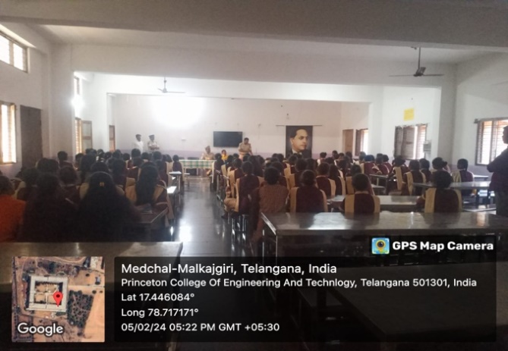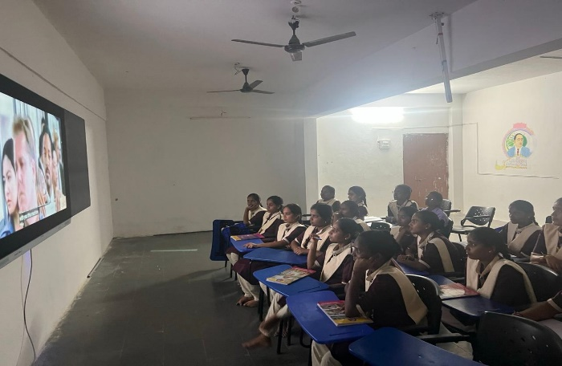

***SHO Ghatkesar guiding students on the safety measures to be taken on social media platforms and cyber crimes related issues***

**Awareness program on Gender Sensitization**

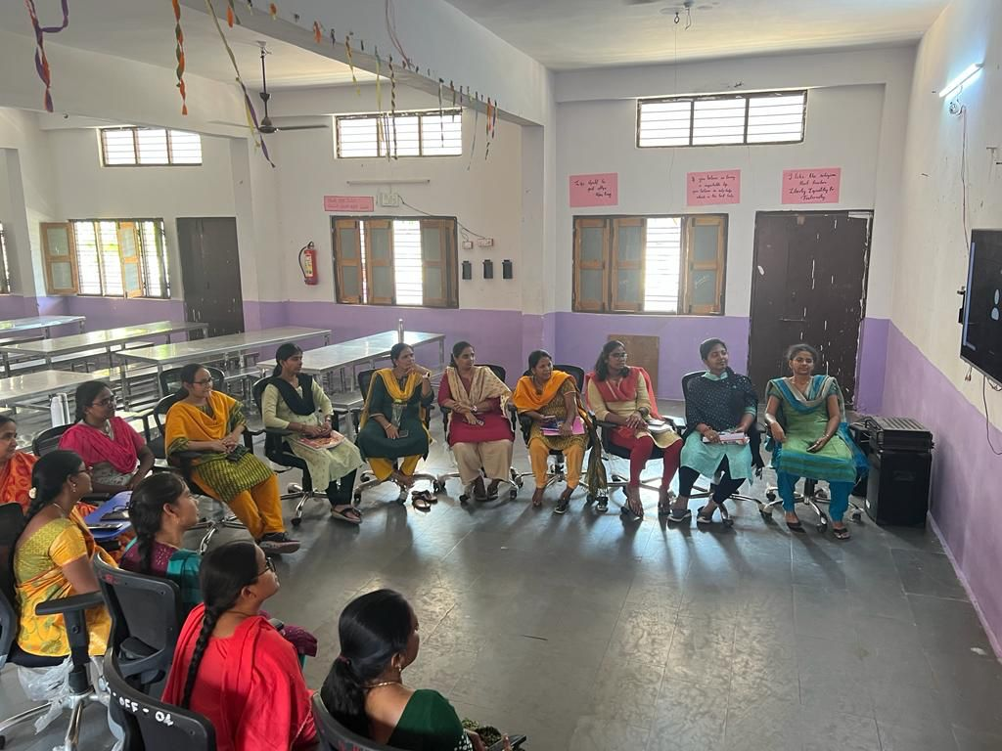

***Faculty attending online sessions on Gender parity***

**Important days celebrated to promote Gender equityunder Co-curricular activities:**

Our college has been Celebrating the following important days to promote gender equity under co-curricular activities .

|  |  |  |
| --- | --- | --- |
| **S.No** | **Name of the Event** | **Organizing Department** |
| 1 | Savitribai Phule Jayanthi | Dept.of Political Science |
| 2 | National Girl Child Day | Dept.of Political Science |
| 3 | International Womens day | Dept.of Political Science |
| 4 | అంతర్జాతీయ మాతృభాషా దినోత్సవం | Dept of Telugu |
| 5 | Bonalu celebrations | Dept of Telugu |
| 6 | Ugadi Celebrations | Dept of Telugu |
| 7 | World Aids Day | NSS |
| 8 | National Voters Day | Dept.of Political Science |
| 9 | International Womens day | Dept.of Political Science |
| 10 | Jyothirao Phule Jayanthi | Dept.of Political Science |
| 11 | Awareness Program on Cyber Stalking | Student Advisory Committee |

* **National Women Teachers Day (3 January, Savithri Bhai Phule’s Birthday)**

National Women Teachers' Day, is celebrated in various countries on different dates, recognizes the dedication, expertise, and pivotal role women educators play in shaping generations. It's a tribute to their commitment, empowering students through knowledge, mentorship, and guidance, fostering learning environments that shape a brighter future for all. Savitribai Phule's birthday, celebrated as National Women Teachers' Day in India, honors her pioneering contributions to education and women's rights. As the first female teacher in India, she championed girls' education, advocated for social reforms, and established schools, paving the way for inclusive education and gender equality.

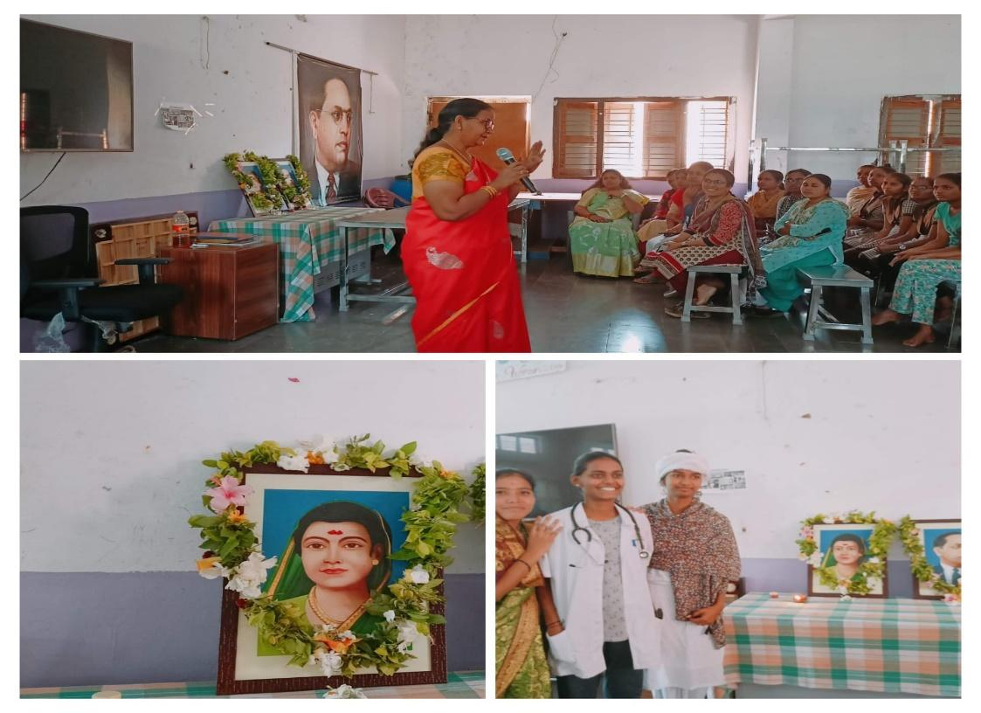

* **International Women’s Day (March 8)**

International Women's Day celebrates the social, economic, cultural, and political achievements of women globally. Observed annually on March 8th, it promotes gender equality and honors women's contributions to society. This day serves as a reminder of the ongoing fight for women's rights and highlights the need for a world free from discrimination. In our college women’s day celebrations, “Rachakonda commissionerate” -SHE Team DCP Smt.T. Usha Rani inaugurated Aakruthi- A Tailoring course in order to make our students financial independent apart from academics.

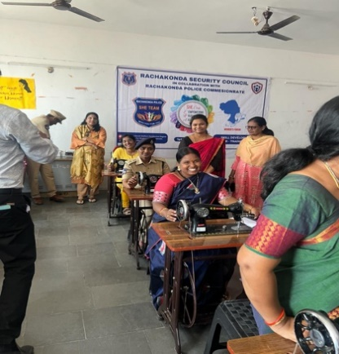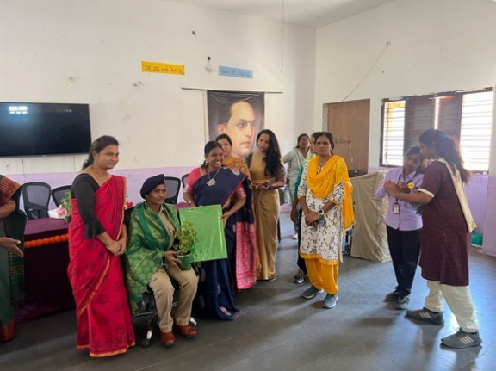

* **Gender Equality Month (April):** Gender Equity Month, celebrated in April, promotes awareness and action towards achieving gender equality. It features workshops, discussions, and campaigns that highlight gender disparities and advocate for inclusive practices. By engaging the community, it fosters dialogue, education, and progress towards a more equitable society for all genders.

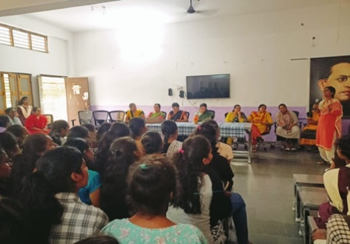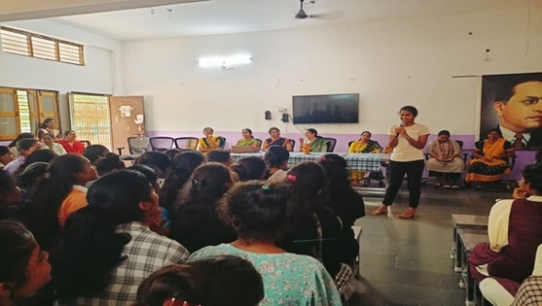

* **International Day of the Girl Child (October 11):** The International Day of the Girl Child, observed on October 11, highlights gender inequality issues faced by girls worldwide. It promotes girls' empowerment and the fulfillment of their human rights, emphasizing education, health, and freedom from violence. This day fosters global action to ensure girls achieve their full potential.

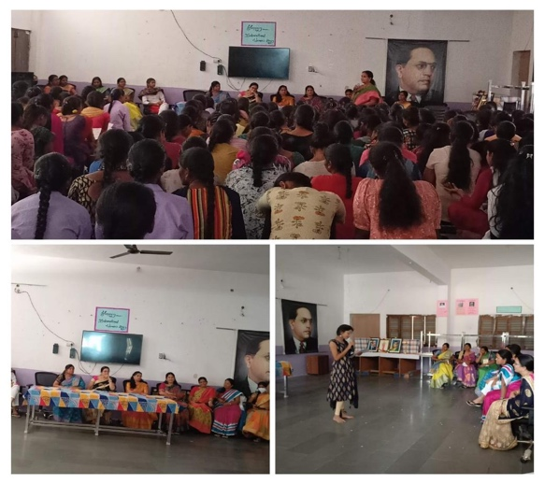

**అంతర్జాతీయ మాతృభాషా దినోత్సవం:** ప్రపంచంలో ఏ దేశమైనా వారి మాతృభాషను రక్షించు కోవాలని కవయిత్రీ డాక్టర్ కొండపల్లి నీహారిణి అన్నారు. అంకు షాపూర్ లోని తెలంగాణ సాంఘిక సంక్షేమ గురుకుల మహిళ డిగ్రీ కళాశాలలో బుధవారం నిర్వహించిన అంతర్జాతీయ భాషా దిన్సో వానికి ముఖ్యఅతిథిగా హాజరయ్యారు. ఈ సందర్భంగా ఆమె మాట్లాడుతూ భావాలు, అభిప్రాయాలను వెలిబుచ్చడానికి మాతృభాషను మించిన జ్ఞానం ఏ భాషలో లభించదన్నారు. కార్యక్రమంలో డాక్టర్ రాధిక, డాక్టర్ పద్మావతి, పద్మమ్మ, శ్రీదేవి, కళాశాల అధ్యాపకులు, విద్యార్థులు పాల్గొన్నారు

21 FEBRUARY 2024

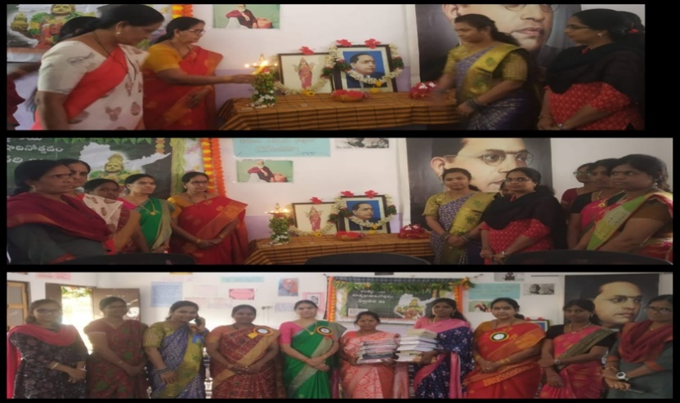

మాతృభాషను రక్షించుకోవాలి

.

**Cultural Diversity in relation to gender sensitivity:** Cultural diversity in relation to gender sensitivity emphasizes respecting and valuing different cultural perspectives on gender roles and identities. It involves understanding and addressing the unique challenges faced by various genders in different cultural contexts, promoting inclusive practices that honor cultural norms while advocating for gender equality and respect for feminine qualities.

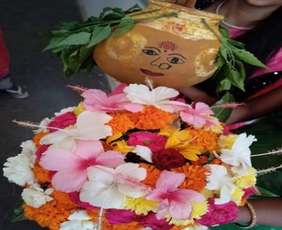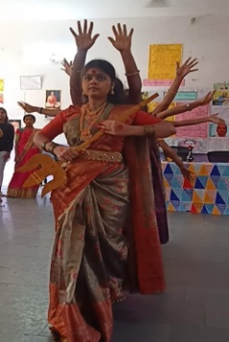

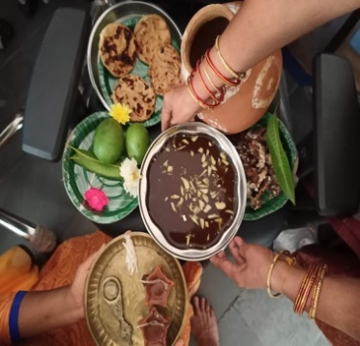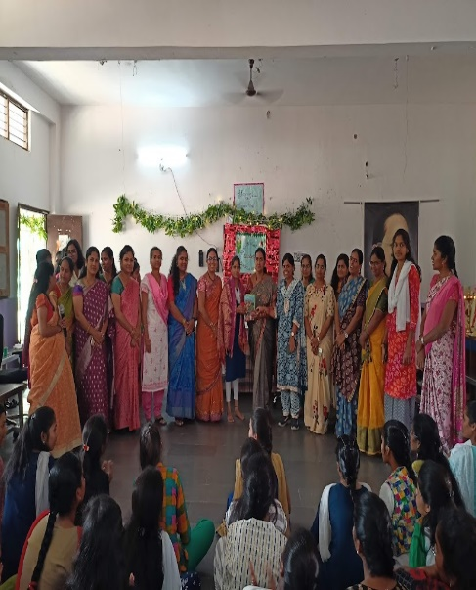

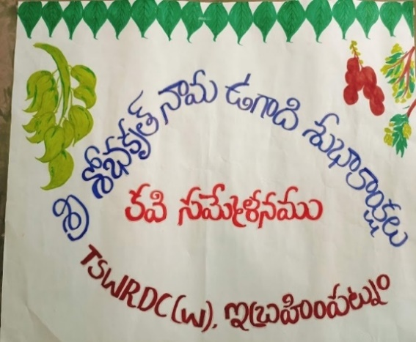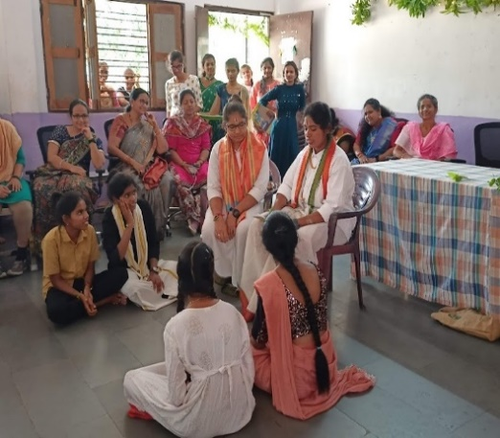

**World AIDS DAY**: World AIDS Day highlights the need for gender-sensitive approaches in HIV prevention, treatment, and care, addressing unique challenges faced by all genders.

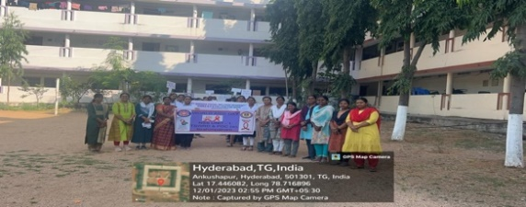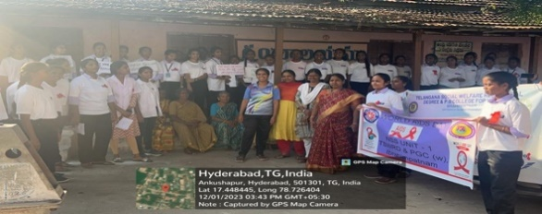

**National Voter’s day**:The Government of India has decided to celebrate 25th January every year as “National Voters Day”. It has been started from 25th January 2011 to mark the foundation day of Election Commission of India. It is also celebrated to create awareness among the youth and make them know that voting is their basic right.

The theme for the year 2024,National Voters Day **–“Nothing like Voting, I vote for sure”.**

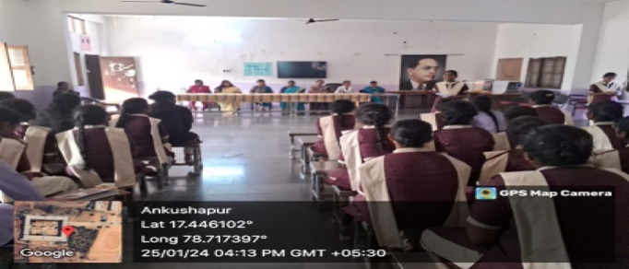

**Constitution Day:** Constitution Day, observed on November 26 in India, marks the adoption of the Indian Constitution in 1949. This day honors the foundational document that outlines the country's laws and principles. It celebrates democratic values, fundamental rights, and duties, reminding citizens of the importance of upholding and respecting the Constitution.

**National Education day:** National Education Day, celebrated in India on November 11, commemorates the birth anniversary of Maulana Abul Kalam Azad, the first education minister of independent India. The day highlights his contributions to education and promotes awareness about the importance of education, fostering a commitment to providing quality education for all.

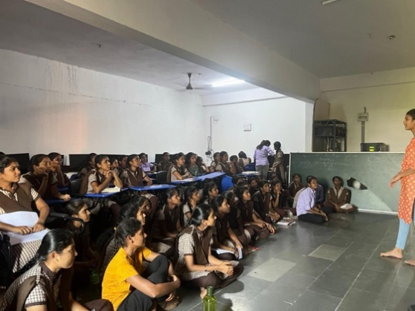

**National Youth Day**: This day is celebrated on January 12 in India, commemorates the birth anniversary of Swami Vivekananda. This day highlights his teachings and ideals, inspiring youth to contribute positively to society. It promotes the importance of education, character building, and the spirit of service, empowering young people to drive national development.As part of Azadi ka Amruth Mashotsav Students watching National youth Day celebrations by Ministry of Education.

